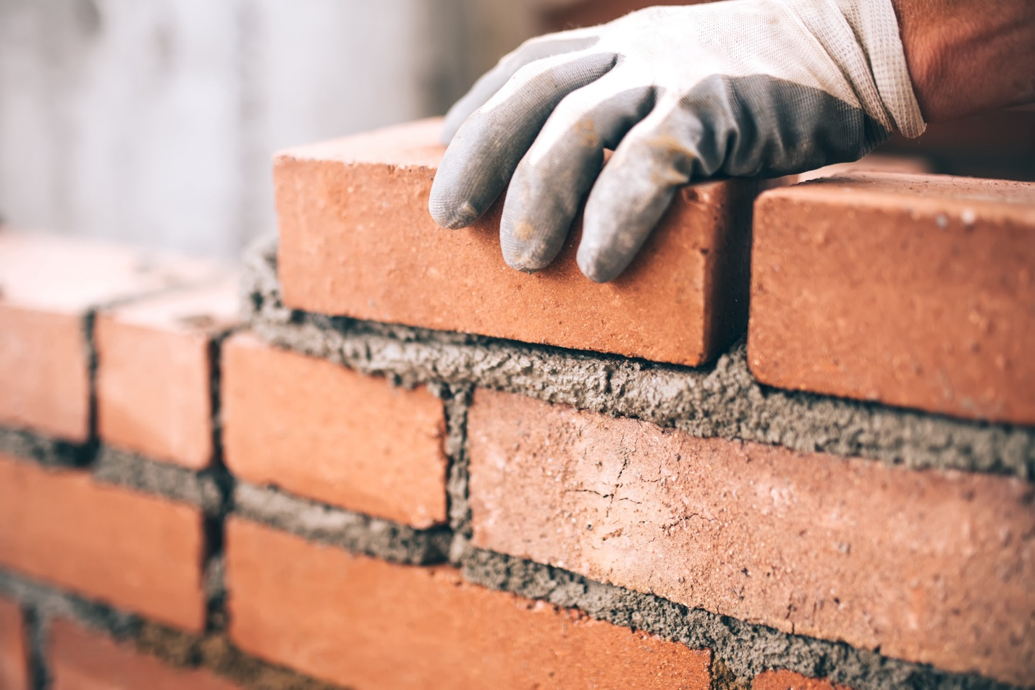



# Mason and Tile Setting Credentials of Value

July 2024

## Safety

* [OSHA 10 - Construction](https://www.osha.com/courses/10-hour-construction.html) OSHA

## Essential (one)

* [Hoisting Apprentice License](https://www.mass.gov/how-to/apply-for-a-hoisting-engineer-license) Commonwealth of Massachusetts
* [Hazards of Asbestos in the Workplace (Construction)](https://www.osha.com/courses/hazards-asbestos-workplace-construction.html) OSHA

## Supplemental

* [OSHA 30 Hour - Construction](https://www.osha.com/courses/30-hour-construction.html) OSHA
* [Confined Space Entry Training for Construction Certificate](https://www.osha.com/courses/confined-space-construction.html) OSHA
* [Competent Person Fall Protection Certificate](https://www.oshaeducationcenter.com/competent-person/fall-protection/) OSHA
* [1-Hour Fall Protection Certificate](https://www.oshaeducationcenter.com/compliance-training/fall-protection-certificate/) OSHA
* [Scaffold Safety in Construction](https://www.osha.com/courses/scaffold-safety-construction.html) OSHA
* [Excavation Safety Course](https://www.osha.com/courses/excavation-safety-construction.html) OSHA
* [Electric Pallet Jack Certification (Electric and Manual)](https://www.osha.com/courses/electrical-pallet-jack-training.html) OSHA
* [First Aid Certification](https://www.redcross.org/take-a-class/first-aid) American Red Cross
* [CPR Certification](https://www.redcross.org/take-a-class/cpr) American Red Cross
* [AED Certification](https://www.redcross.org/take-a-class/aed) American Red Cross

## Supplemental – Postsecondary

* [Forklift Certification - Stand Up](https://www.osha.com/courses/stand-forklift-operator-safety-course-online.html) OSHA
* [Forklift Certification - Sit Down](https://www.osha.com/courses/sit-down-forklift-operator-safety-training-online.html) OSHA
* [Certified Tile Installer (CTI)](https://www.ceramictilefoundation.org/certified-tile-installer-cti-program) Ceramic Tile Education Foundation
* [Advanced Certification for Tile Setters (ACT)](https://www.tilecertifications.com/) Ceramic Tile Education Foundation
* [Grouts Certification](applewebdata://294FE5BA-4ED8-4DDC-B749-45D6B5958E24/Mason%20Contractors%20Association%20of%20America%20(MCAA)) Ceramic Tile Education Foundation
* [Large Format Tile & Substrate Preparation Certification](https://www.tilecertifications.com/) Ceramic Tile Education Foundation
* [Membranes Certification](https://www.tilecertifications.com/) Ceramic Tile Education Foundation
* [Mortar (Mud) Floors Certification](https://www.tilecertifications.com/) Ceramic Tile Education Foundation
* [Mortar (Mud) Walls Certification](https://www.tilecertifications.com/) Ceramic Tile Education Foundation
* [Shower Receptors Certification](https://www.tilecertifications.com/) Ceramic Tile Education Foundation
* [Gauged Porcelain Tile and Gauged Porcelain Tile Panels/Slabs Certification](https://www.tilecertifications.com/) Ceramic Tile Education Foundation
* [Masonry Certification](https://masoncontractors.azurewebsites.net/Default?pageID=5279) Mason Contractors Association of America (MCAA)