Labor Market Analysis of Mason and Tile Setting Occupations in Massachusetts

## Construction Industry Overview

This analysis uses labor market data from the Massachusetts Department of Economic Research to provide perspective on two theaters related to the skilled trades in the construction field: the construction industry and thirteen occupations in the career pathway commonly referred to as the skilled trades:

1. Brickmasons and Blockmasons
2. Stonemasons
3. Carpenters
4. Tile and Stone Setters
5. Cement Masons and Concrete Finishers
6. Operating Engineers and Other Equipment Operators
7. Electricians
8. Painters, Construction, and Maintenance
9. Pipelayers
10. Plumbers, Pipefitters, and Steamfitters
11. Reinforcing Iron and Rebar Workers
12. Sheet Metal Workers
13. Structural Iron and Steel Workers

The industry should be understood as the employers in the Commonwealth whose primary line of business is construction. Those companies employ a spectrum of occupations, ranging from skilled tradesmen to real estate agents. While trends in the construction industry are not necessarily directly related to the skilled trades, the large majority of tradesmen work for construction companies, making its realities and trends a valuable backdrop against which to evaluate these careers in Massachusetts.

In public data systems, occupations are a set of tasks regularly performed by one individual on an employer’s payroll. In this analysis, the target occupations are profiled both as a set and individually as we seek to provide strategic value in the development and administration of related curriculum and the construction of compelling and instructive narratives that will introduce students to the world of the skilled trades in the 21st Century.

### The Construction Industry in Labor Market Data Systems

Construction (NAICS code 23) comprises all employers whose primary line of business is construction. The industry category is divided into three sub-industries:

* 236-Construction of Buildings
* 237-Heavy and Civil Engineering Construction
* 238-Specialty Trades Contractors

Each of these categories is further parsed into four-, five-, and ultimately six-digit level categories, and the Massachusetts Department of Economic Research produces employment and wage estimates for each.

#### Construction Industry Categories

* 236 Construction of Buildings
  + 236115 New Single-Family Housing Construction (except For-Sale Builders)
  + 236116 New Multifamily Housing Construction (except For-Sale Builders)
  + 236117 New Housing For-Sale Builders
  + 236118 Residential Remodelers
  + 236210 Industrial Building Construction
  + 236220 Commercial and Institutional Building Construction
* 237 Heavy and Civil Engineering Construction
  + 237110 Water and Sewer Line and Related Structures Construction
  + 237120 Oil and Gas Pipeline and Related Structures Construction
  + 237130 Power and Communication Line and Related Structures Construction
  + 237210 Land Subdivision
  + 237310 Highway, Street, and Bridge Construction
  + 237990 Other Heavy and Civil Engineering Construction
* 238 Specialty Trades Contractors
  + 238110 Poured Concrete Foundation and Structure Contractors
  + 238120 Structural Steel and Precast Concrete Contractors
  + 238130 Framing Contractors
  + 238140 Masonry Contractors
  + 238150 Glass and Glazing Contractors
  + 238160 Roofing Contractors
  + 238170 Siding Contractors
  + 238190 Other Foundation, Structure, and Building Exterior Contractors
  + 238210 Electrical Contractors and Other Wiring Installation Contractors
  + 238220 Plumbing, Heating, and Air-Conditioning Contractors
  + 238290 Other Building Equipment Contractors
  + 238310 Drywall and Insulation Contractors
  + 238320 Painting and Wall Covering Contractors
  + 238330 Flooring Contractors
  + 238340 Tile and Terrazzo Contractors
  + 238350 Finish Carpentry Contractors
  + 238390 Other Building Finishing Contractors

### Employment-Electricians

It is not surprising that at the most granular level available, the industry that most often employs electricians in Massachusetts is Electrical Contractors (NAICS 23821). Approximately three quarters of the Commonwealth’s electricians work in that industry. It is interesting to note, however, that the Temporary Help Services (56132) and Local Government (90399) sectors also rank in the top five for employment of electricians. The table below details the top five detailed industry sectors by the share of electricians who are employed in them.

#### Table 1: Top Detailed Industries for Electricians

|  |  |
| --- | --- |
| Industry | Share of Occupation Jobs |
| Electrical and Other Wiring Installation Contractors | 74.9% |
| Temporary Help Services | 3.4% |
| Plumbing, Heating, and Air-Conditioning Contractors | 2.3% |
| Commercial and Institutional Building Construction | 1.6% |
| Local Government | 1.4% |

### Employment Trends

The number of people employed in the Construction industry in Massachusetts has been steadily increasing over the last decade, except for a significant COVID-19-related decline in 2020. The net change has been an increase of 35.9% in jobs over the last decade.

#### Table 2: Average Annual Employment, Construction Industry, Massachusetts, 2014-2023

|  |  |
| --- | --- |
| Year | Jobs |
| 2014 | 128,919 |
| 2015 | 138,991 |
| 2016 | 146,503 |
| 2017 | 152,131 |
| 2018 | 158,656 |
| 2019 | 163,062 |
| 2020 | 152,366 |
| 2021 | 164,435 |
| 2022 | 170,026 |
| 2023 | 176,199 |

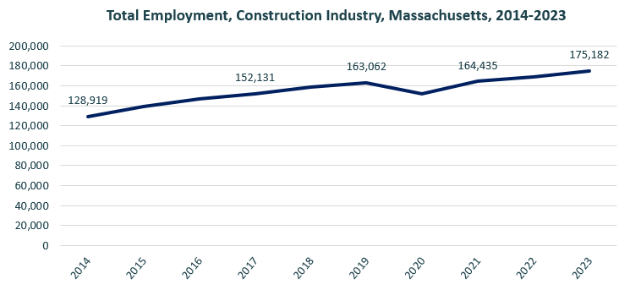

When we break down the growth of the Construction industry, we see that while growth has been seen in all three construction sectors, growth in both the total number of jobs and the percentage of jobs added has been led by the Specialty Trades Contractors sector.

#### Tables 3 and 4: Employment Change, Construction Industries, Massachusetts, 2014-2023

|  |  |  |  |  |  |  |  |
| --- | --- | --- | --- | --- | --- | --- | --- |
| Industry | 2014 | 2018 | 2019 | 2020 | 2021 | 2022 | 2023 |
| Construction of Buildings | 27,137 | 33,381 | 34,166 | 32,452 | 34,825 | 35,900 | 37,092 |
| Heavy/Civil Engineering Construction | 12,671 | 14,105 | 13,893 | 13,820 | 13,843 | 14,128 | 14,325 |
| Specialty Trade Contractors | 89,112 | 111,169 | 115,003 | 106,094 | 115,768 | 119,104 | 123,765 |

|  |  |  |
| --- | --- | --- |
| Industry | Change | % Change |
| Construction of Buildings | 9,955 | 36.7% |
| Heavy/Civil Engineering Construction | 1,654 | 13.1% |
| Specialty Trade Contractors | 34,654 | 38.9% |

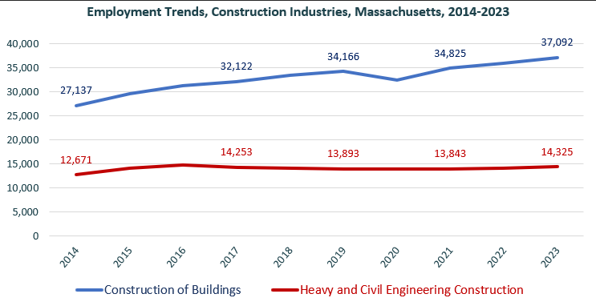

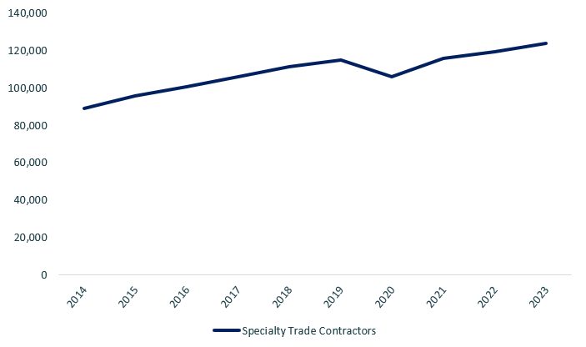

At the most detailed level available, we see that growth was led over the decade by Poured Concrete Contractors (NAICS 238110) and Residential Remodelers (NAICS 236118).

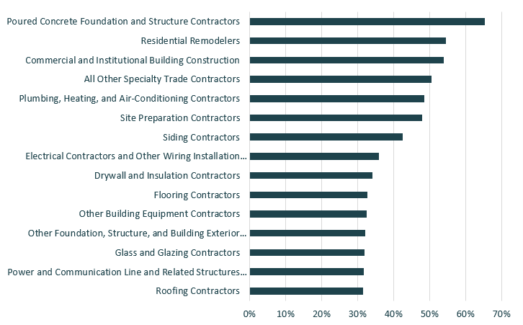

### Wages, Salaries and Proprietor Earnings

Among the detailed industry categories, the highest wages are found in the Industrial Building and Power Line Construction employers. The lowest are in Residential Remodelers and Painting Contractors.

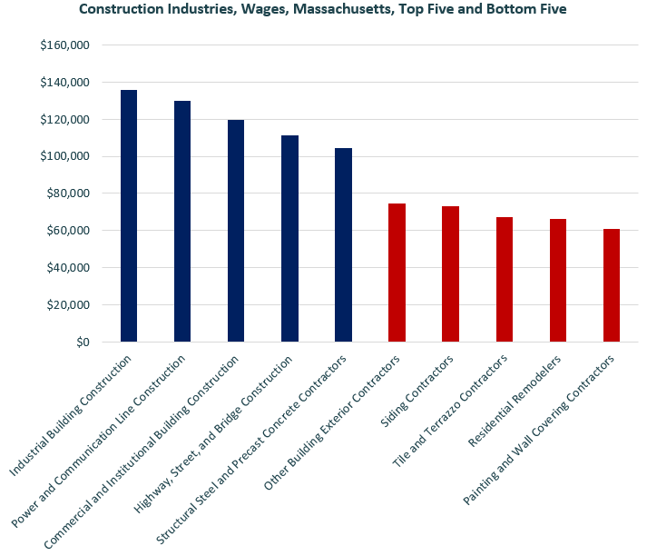

## The Pathways

### Electricity Occupations and Pathways

This section looks at the target occupation category: Electricians. It will also consider advancement opportunities in related careers that are not directly related to the program of study, but that illustrate opportunities that may be available to workers in this field with additional education and experience.

#### Table 5: Electricians, Massachusetts

|  |  |  |  |  |  |
| --- | --- | --- | --- | --- | --- |
| Occupation | 2023 Jobs | Turnover Rate | 2014 - 2023 Change | 2014 - 2023 % Change | Median Annual Earnings |
| Electricians | 18,498 | 51.0% | 3,832 | 26% | $82,222 |

While careers in these two occupations are certainly viable in their own rights, they also can serve as entry points to progressively more sophisticated and better-paying roles.

#### Table 6: Related Career Pathways

##### Job Zone Two Occupations

|  |  |  |  |
| --- | --- | --- | --- |
| Occupation | 2023 Jobs | Typical Education Requirement | Median Annual Earnings |
| Helpers-Electricians | 1,428 | High school | $45,906 |
| Solar Photovoltaic Installers | 982 | High school | $48,620 |

##### Job Zone Three Occupations

|  |  |  |  |
| --- | --- | --- | --- |
| Occupation | 2023 Jobs | Typical Education Requirement | Median Annual Earnings |
| Electricians | 18,498 | High school | $82,222 |
| Energy Auditors (data for building inspectors) | 3,835 | High school | $77,522 |
| Construction and Building Inspectors | 3,835 | High school | $77,522 |
| Solar Energy Installation Managers (data for construction supervisors) | 15,659 | High school | $98,592 |
| First-Line Supervisors of Construction Trades and Extraction Workers | 15,659 | High school | $98,592 |

##### Job Zone Four Occupations

|  |  |  |  |
| --- | --- | --- | --- |
| Occupation | 2023 Jobs | Typical Education Requirement | Median Annual Earnings |
| Energy Engineers (data for Engineers, All Other) | 3,229 | Bachelor’s | $112,690 |
| Construction Managers | 7,087 | Bachelor’s | $131,727 |

## Mason and Tile Setting-Related Occupation Profiles

The United States Department of Labor, Employment, and Training Administration created and regularly updates more than 800 occupational profiles with characteristics like skills, educational requirements, and daily tasks, based on the inputs of industry experts and people who are employed in the occupations.

### Brickmasons and Blockmasons

#### Description

Lay and bind building materials, such as brick, structural tile, concrete block, cinder block, glass block, and terra-cotta block, with mortar and other substances, to construct or repair walls, partitions, arches, sewers, and other structures.

#### Top Skills

* Using logic and reasoning to identify the strengths and weaknesses of alternative solutions, conclusions, or approaches to problems.
* Adjusting actions in relation to others' actions.
* Giving full attention to what other people are saying, taking time to understand the points being made, asking questions as appropriate, and not interrupting at inappropriate times.
* Talking to others to convey information effectively.
* Monitoring/Assessing performance of yourself, other individuals, or organizations to make improvements or take corrective action.
* Watching gauges, dials, or other indicators to make sure a machine is working properly.
* Conducting tests and inspections of products, services, or processes to evaluate quality or performance.
* Managing one's own time and the time of others.
* Using mathematics to solve problems.
* Understanding the implications of new information for both current and future problem-solving and decision-making.
* Identifying complex problems and reviewing related information to develop and evaluate options and implement solutions.
* Considering the relative costs and benefits of potential actions to choose the most appropriate one.

#### Top Daily Tasks

* Mark reference points on construction materials.
* Measure materials or objects for installation or assembly.
* Install masonry materials.
* Apply mortar.
* Plan layout of construction, installation, or repairs.
* Cut tile, stone, or other masonry materials.
* Estimate materials requirements for projects.
* Review blueprints or specifications to determine work requirements.
* Remove excess materials from finished construction projects.
* Clean surfaces in preparation for work activities.
* Inspect work sites to determine condition or necessary repairs.
* Mix substances or compounds needed for work activities.
* Align masonry materials.
* Remove worn, damaged, or outdated materials from work areas.
* Apply sealants or other protective coatings.

#### Additional Information

* Associated Builders and Contractors
* Associated General Contractors of America
* Home Builders Institute
* International Masonry Institute
* International Union of Bricklayers and Allied Craftworkers
* Mason Contractors Association of America
* National Association of Home Builders
* National Center for Construction Education and Research
* National Terrazzo and Mosaic Association
* Occupational Outlook Handbook: Masonry workers
* Operative Plasterers' and Cement Masons' International Association

#### Job Postings - Brickmasons and Blockmasons

P2C uses a third-party system that aggregates data from job postings to provide perspective on the skills and qualifications employers are prioritizing in their advertisements for these occupations.

* After controlling for multiple postings that likely referenced the same single opening, over the last year, we identified 69 unique job postings for Brickmasons and Blockmasons.
* We identified 20 unique employers who posted openings online.

##### Top Employers Advertising:

* Installed Building Products
* MP Masonry
* Welborn Cabinets
* Aerotek
* Architectural Fireplaces
* Atlantic Restoration
* Coughlin Masonry Restoration

##### Top Job Titles:

* Fireplace Installers
* Bricklayers
* Brick Masons
* Brick Specialists
* Mason Laborers
* Skilled Laborers
* Builders
* Masons
* Masonry Laborers
* Stone Masons
* Caulkers

##### Top Qualifications:

* Valid Driver's License
* OSHA 10 Hour Certification

##### Top Overall Skills:

* Construction
* Power tool operation

###### Defining Skills

* Masonry
* Hand Tools
* Tuckpointing

### Stonemasons

#### Description

Build stone structures, such as piers, walls, and abutments. Lay walks, curbstones, or special types of masonry for vats, tanks, and floors.

#### Top Skills

* Using logic and reasoning to identify the strengths and weaknesses of alternative solutions, conclusions, or approaches to problems.
* Adjusting actions in relation to others' actions.
* Managing one's own time and the time of others.
* Being aware of others' reactions and understanding why they react as they do.
* Identifying complex problems and reviewing related information to develop and evaluate options and implement solutions.
* Considering the relative costs and benefits of potential actions to choose the most appropriate one.
* Giving full attention to what other people are saying, taking time to understand the points being made, asking questions as appropriate, and not interrupting at inappropriate times.
* Talking to others to convey information effectively.
* Understanding the implications of new information for both current and future problem-solving and decision-making.
* Monitoring/Assessing performance of yourself, other individuals, or organizations to make improvements or take corrective action.

#### Top Daily Tasks

* Mark reference points on construction materials.
* Cut tile, stone, or other masonry materials.
* Align masonry materials.
* Apply mortar.
* Mix substances or compounds needed for work activities.
* Spread concrete or other aggregate mixtures.
* Apply decorative masonry finishes.
* Remove excess materials from finished construction projects.
* Install masonry materials.
* Smooth surfaces with abrasive materials or tools.
* Drill holes in construction materials.
* Operate cranes, hoists, or other moving or lifting equipment.
* Dig holes or trenches.
* Position construction forms or molds.
* Load materials into construction equipment.

#### Additional Information

* Associated Builders and Contractors
* Associated General Contractors of America
* Home Builders Institute
* International Masonry Institute
* International Union of Bricklayers and Allied Craftworkers
* Mason Contractors Association of America
* National Association of Home Builders
* National Center for Construction Education and Research
* National Concrete Masonry Association
* National Terrazzo and Mosaic Association

#### Job Postings - Stonemasons

P2C uses a third-party system that aggregates data from job postings to provide perspective on the skills and qualifications employers are prioritizing in their advertisements for these occupations.

* After controlling for multiple postings that likely referenced the same single opening, over the last year, we identified 74 unique job postings for Stonemasons.
* We identified 44 unique employers who posted openings online.

##### Top Employers Advertising:

* Riverside Services
* University of Massachusetts
* Tradesmen International
* Aerotek
* Contemporary Design and Construction
* City of Springfield
* Commonwealth of Massachusetts
* MP Masonry
* Dave’s Chimney

##### Top Job Titles:

* Stonemason

##### Top Qualifications:

* Valid Driver's License
* OSHA 10-Hour General Industry Card

##### Top Overall Skills:

* Construction
* Hand tools
* Power tools
* Tuckpointing

###### Defining Skills

* Masonry

### Tile and Stone Setters

#### Description

Apply hard tile, stone, and comparable materials to walls, floors, ceilings, countertops, and roof decks.

#### Top Skills

* Giving full attention to what other people are saying, taking time to understand the points being made, asking questions as appropriate, and not interrupting at inappropriate times.
* Talking to others to convey information effectively.
* Using mathematics to solve problems.
* Using logic and reasoning to identify the strengths and weaknesses of alternative solutions, conclusions, or approaches to problems.
* Adjusting actions in relation to others' actions.
* Identifying complex problems and reviewing related information to develop and evaluate options and implement solutions.
* Managing one's own time and the time of others.
* Understanding written sentences and paragraphs in work-related documents.
* Monitoring/Assessing performance of yourself, other individuals, or organizations to make improvements or take corrective action.
* Considering the relative costs and benefits of potential actions to choose the most appropriate one.

#### Top Daily Tasks

* Align masonry materials.
* Install masonry materials.
* Remove excess materials from finished construction projects.
* Apply mortar.
* Cut tile, stone, or other masonry materials.
* Mix substances or compounds needed for work activities.
* Spread concrete or other aggregate mixtures.
* Determine construction project layouts.
* Estimate materials requirements for projects.
* Review blueprints or specifications to determine work requirements.
* Mark reference points on construction materials.
* Measure work site dimensions.
* Apply adhesives to construction materials.
* Apply sealants or other protective coatings.
* Cut metal components for installation.
* Measure materials or objects for installation or assembly.
* Install building fixtures.
* Remove worn, damaged or outdated materials from work areas.
* Communicate with clients about products, procedures, and policies.
* Estimate construction project costs.
* Estimate construction project labor requirements.
* Clean surfaces in preparation for work activities.
* Cut carpet, vinyl, or other flexible materials.
* Smooth surfaces with abrasive materials or tools.
* Order construction or extraction materials or equipment.
* Select construction materials.

#### Additional Information

* Ceramic Tile Institute of America
* CFI
* Finishing Trades Institute International
* Home Builders Institute
* International Masonry Institute
* International Standards and Training Alliance (INSTALL)
* International Union of Bricklayers and Allied Craftworkers
* National Tile Contractors Association
* National Wood Flooring Association
* Occupational Outlook Handbook: Flooring installers and tile and stone setters

#### Job Postings - Tile and Stone Setters

P2C uses a third-party system that aggregates data from job postings to provide perspective on the skills and qualifications employers are prioritizing in their advertisements for these occupations.

* After controlling for multiple postings that likely referenced the same single opening, over the last year, we identified 36 unique job postings for Tile and Stone Setters.
* We identified 11 unique employers who posted openings online.

##### Top Employers Advertising:

* Living Baths
* Metropolitan Cabinets and Countertops
* Building Restoration Services
* Danek Flooring
* PetCo
* Creative Tile and Marble
* CAZ Finish Carpentry

##### Top Job Titles:

* Tile Installers
* Tile Setters
* Ceramic Tile Installers
* Deck Supervisors
* Fabricators/Installers
* Bathroom Fitters

##### Top Qualifications:

* Valid Driver’s License

##### Top Overall Skills:

* Ceramic Tile
* Flooring
* Subcontracting
* Tiling
* Lamination
* Vinyl Composition Tile
* Hand Tools
* Tile Cutting

###### Defining Skills

* Renovation

###### Differentiating Skills

* Tile Cutting

### Cement Masons and Concrete Finishers

#### Description

Smooth and finish surfaces of poured concrete, such as floors, walks, sidewalks, roads, or curbs using a variety of hand and power tools. Align forms for sidewalks, curbs, or gutters; patch voids; and use saws to cut expansion joints.

#### Top Skills

* Monitoring/Assessing performance of yourself, other individuals, or organizations to make improvements or take corrective action.
* Talking to others to convey information effectively.
* Adjusting actions in relation to others' actions.
* Conducting tests and inspections of products, services, or processes to evaluate quality or performance.
* Managing one's own time and the time of others.
* Giving full attention to what other people are saying, taking time to understand the points being made, asking questions as appropriate, and not interrupting at inappropriate times.
* Using logic and reasoning to identify the strengths and weaknesses of alternative solutions, conclusions, or approaches to problems.
* Identifying complex problems and reviewing related information to develop and evaluate options and implement solutions.
* Considering the relative costs and benefits of potential actions to choose the most appropriate one.
* Controlling operations of equipment or systems.
* Watching gauges, dials, or other indicators to make sure a machine is working properly.
* Using mathematics to solve problems.

#### Top Daily Tasks

* Inspect completed work to ensure proper installation.
* Position construction forms or molds.
* Finish concrete surfaces.
* Spread concrete or other aggregate mixtures.
* Monitor construction operations.
* Pour materials into or on designated areas.
* Signal equipment operators to indicate proper equipment positioning.
* Direct construction or extraction personnel.
* Apply sealants or other protective coatings.
* Compact materials to create level bases.
* Install masonry materials.
* Apply material to fill gaps in surfaces.
* Install building fixtures.
* Install metal structural components.
* Prepare surfaces for finishing.
* Mix substances or compounds needed for work activities.
* Apply decorative masonry finishes.
* Smooth surfaces with abrasive materials or tools.
* Break up rock, asphalt, or concrete.
* Drill holes in construction materials.
* Position structural components.
* Fabricate parts or components.
* Clean surfaces in preparation for work activities.
* Build construction forms or molds.
* Cut metal components for installation.
* Install roofing materials.

#### Additional Information

* American Concrete Institute
* American Concrete Pavement Association
* Associated Builders and Contractors
* Associated General Contractors of America
* Home Builders Institute
* International Masonry Institute
* International Union of Bricklayers and Allied Craftworkers
* Mason Contractors Association of America
* National Association of Home Builders
* National Center for Construction Education and Research

#### Job Postings - Cement Masons and Concrete Finishers

P2C uses a third-party system that aggregates data from job postings to provide perspective on the skills and qualifications employers are prioritizing in their advertisements for these occupations.

* After controlling for multiple postings that likely referenced the same single opening, over the last year, we identified 118 unique job postings for Electricians.
* We identified 48 unique employers who posted openings online.

##### Top Employers Advertising:

* Structural Group
* MEI Rigging and rafting
* PeopleReady
* Questmark
* RH White Construction
* Aerotek
* Century Paving and Construction
* Riley Brothers
* Centimark Corporation

##### Top Job Titles:

* Concrete Laborers
* Concrete Finishers
* Concrete Laborers/Finishers
* Masons
* Concrete Form Setters
* Cement Finishers
* Cement Masons
* Concrete Cutting Operators
* Skilled Laborers
* Floor Installers
* Equipment Operators
* Masonry Laborers

##### Top Qualifications:

* Valid Driver's License
* MA Class 2A Hoisting License

##### Top Overall Skills:

* Rebar
* Carpentry

###### Defining Skills

* Concrete forming
* Power tools
* Concrete finishing
* Rebar tying

###### Differentiating Skills

* Levelling
* Concrete placement