# **Labor Market Analysis of Skills Related to Medical and Health Assisting in Massachusetts**

## Table of Contents­­

Labor Market Analysis of Skills Related to Medical and Health Assisting in Massachusetts 0

Table of Contents 1

Overview 2

The Health Care Industry 2

The Health Care Industry in Labor Market Data Systems 2

Employment Trends 2

Wages, Salaries and Proprietor Earnings 6

The Pathways 6

Target Occupations and Pathways 6

Occupation Profile 8

Nursing Assistant 8

Medical Assistant 11

## Overview

This analysis uses labor market data from the Massachusetts Department of Economic Research to provide perspectives on two theaters related to these programs of study: the health care industry and the occupations in related career pathways.

The industry should be understood as the employers in the Commonwealth whose primary line of business is health care. Those companies employ a spectrum of occupations, ranging from doctors and nurses to lawyers and accountants. While trends in the health care industry do not necessarily directly relate to the specific occupations that are the subjects of these programs, the large majority of dental assistants, as well as health and medical assistants, work within the health care companies, making its realities and trends a valuable backdrop against which to evaluate these careers in Massachusetts.

In public data systems, occupations are a set of tasks regularly performed by one individual on an employer’s payroll. In this analysis, occupations related to the target programs of study are profiled in a career pathway framework as we seek to provide strategic value in the development and administration of curriculum and the construction of a compelling and instructive narrative that will introduce students to these exciting health care careers.

## The Health Care Industry

### The Health Care Industry in Labor Market Data Systems

Health Care and Social Assistance (NAICS code 62) comprises all employers whose primary line of business is health services. The industry category is divided into four sub-industries:

* 621 Ambulatory Health Care
* 622 Hospitals
* 623 Nursing and Residential Care Facilities
* 624 Social Assistance

Each of these categories is further parsed into four-, five-, and ultimately six-digit-level categories, and the Massachusetts Department of Economic Research produces employment and wage estimates for each.

#### Health Care Industry Categories

* 621 Ambulatory Health Care Services
  + 62111 Offices of Physicians
  + 62121 Offices of Dentists
  + 62131 Offices of Chiropractors
  + 62133 Offices of Mental Health Practitioners
  + 62134 Offices of Physical, Occupational and Speech Therapists, and Audiologists
  + 62139 Offices of All Other Health Practitioners
  + 62141 Family Planning Centers
  + 62142 Outpatient Mental Health and Substance Abuse Centers
  + 62149 Other Outpatient Care Centers
  + 62151 Medical and Diagnostic Laboratories
  + 62161 Home Health Care Services
  + 62191 Ambulance Services
  + 62199 All Other Ambulatory Health Care Services
* 622 Hospitals
  + 62211 General Medical and Surgical Hospitals
  + 62221 Psychiatric and Substance Abuse Hospitals
    - 622231 Specialty Hospitals (excluding Psychiatric and Substance Abuse Hospitals)
* 623 Nursing and Residential Care Facilities
  + 62311 Nursing Care Facilities
  + 62321 Residential Intellectual and Developmental Disability Facilities
  + 62322 Residential Mental Health and Substance Abuse Facilities
  + 62331 Continuing Care Retirement Communities and Assisted Living Facilities for the Elderly
  + 62399 Other Residential Care Facilities
* 624 Social Assistance
  + 62411 Child and Youth Services
  + 62412 Services for the Elderly and Persons with Disabilities
  + 62419 Other Individual and Family Services
  + 62421 Community Food Services
  + 62422 Community Housing Services
  + 62423 Emergency and Other Relief Services
  + 62431 Vocational Rehabilitation Services
  + 62441 Child Day Care Services

It is not surprising that in Massachusetts, the type of business that most often employs Dental Assistants is the Offices of Dentists (NAICS 62121). More than 90% work in that industry, while another 2% are employed at in Offices of Physicians (NAICS 62121). It is interesting to note that the third most common type of employer for these occupations is the federal government, which employs approximately 1 of every 100 Dental Assistants.

#### Table 1: Employment by Industry for Target Occupations

|  |  |
| --- | --- |
| **Industry** | **Share of Occupation Jobs** |
| Offices of Dentists | 91.2% |
| Offices of Physicians | 1.7% |
| Federal Government | 1.0% |

### Employment Trends

The number of people employed in the Ambulatory Health Services, Hospitals and Residential and Nursing Care Facilities industries in Massachusetts has been steadily increasing over the last decade, except for a significant COVID-19-related decline in 2020. The net change has been an increase of 6.3% in jobs over the last decade; however, employment levels have yet to return to their pre-pandemic highs.

#### Table 2: Average Annual Employment, Health Care Industry, Massachusetts, 2014-2023

|  |  |
| --- | --- |
| **Year** | **Jobs** |
| 2014 | 460,831 |
| 2015 | 472,309 |
| 2016 | 483,974 |
| 2017 | 489,457 |
| 2018 | 488,287 |
| 2019 | 492,370 |
| 2020 | 466,899 |
| 2021 | 475,882 |
| 2022 | 478,313 |
| 2023 | 489,652 |

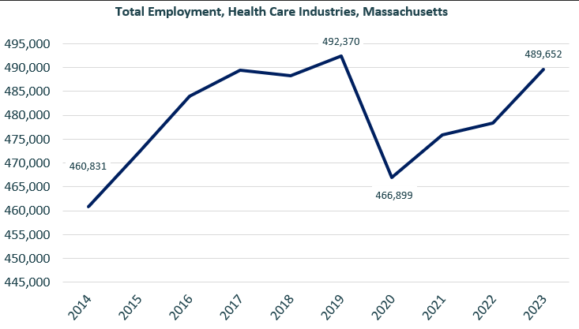

When we break down the growth of the Health Care industries, we see that while a net-positive change has been seen in two of the three Health Care sectors, the Nursing and Residential Care Facilities sector has experienced a net decline after shedding a large share of jobs during the COVID-19 pandemic and not recovering those jobs in the ensuing years.

#### Tables 3 and 4: Employment Change, Construction Industries, Massachusetts, 2014-2023

|  |  |  |  |  |  |  |  |
| --- | --- | --- | --- | --- | --- | --- | --- |
| Industry | 2014 | 2018 | 2019 | 2020 | 2021 | 2022 | 2023 |
| Ambulatory Health Care | 170,963 | 190,698 | 190,876 | 174,701 | 185,003 | 187,634 | 193,580 |
| Hospitals | 187,581 | 191,711 | 196,515 | 194,601 | 197,610 | 198,802 | 204,144 |
| Nursing & Residential Care Facilities | 102,287 | 105,877 | 104,979 | 97,596 | 93,268 | 91,877 | 91,928 |

|  |  |  |
| --- | --- | --- |
| Industry | Change | % Change |
| Ambulatory Health Care | 22,617 | 13.2% |
| Hospitals | 16,564 | 8.8% |
| Nursing & Residential Care Facilities | (10,359) | -10.1% |

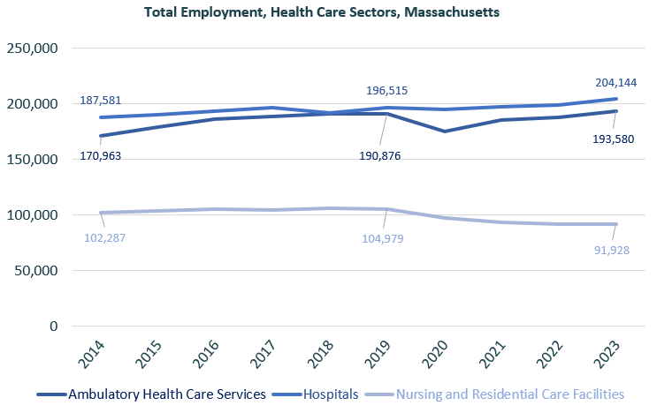

At the most detailed level available, we see that as a percentage of total employment, growth was led over the decade by Offices of Mental Health Practitioners (NAICS 62133) and Other Ambulatory Health Services (NAICS 62199). Residential Mental Health and Substance Abuse Facilities ranked third.

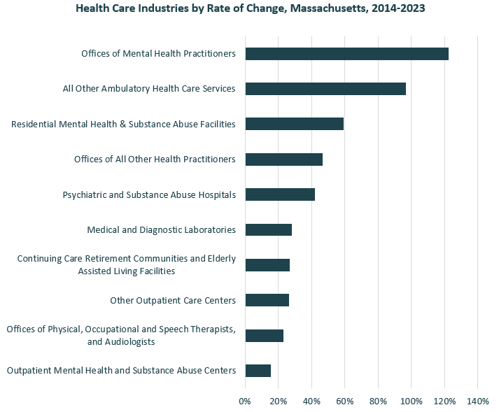

### Wages, Salaries and Proprietor Earnings

Among the detailed industry categories, the highest wages are found in employers from the Offices of Physicians (NAICS 62111) category. The lowest are in Continuing Care Retirement Communities and Elderly Assisted Living Facilities (62331).

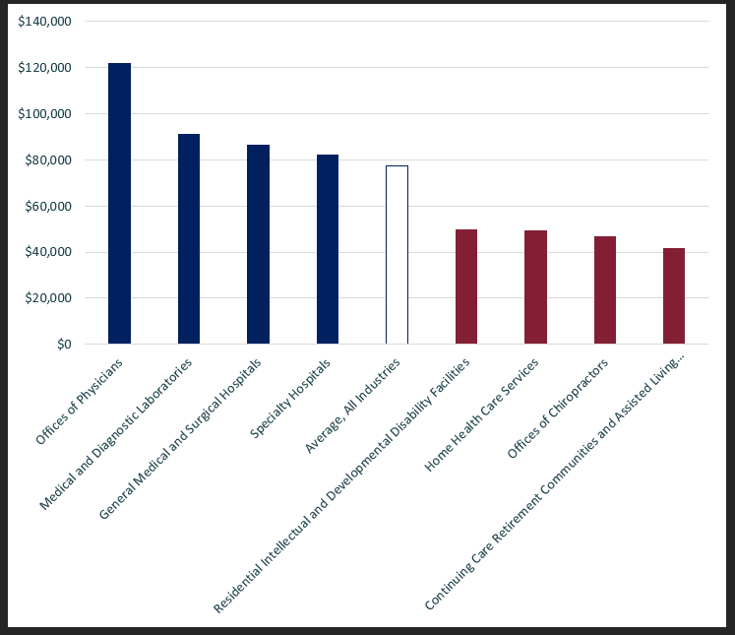

## The Pathways

### Target Occupations and Pathways

This section looks at the entry-level occupations associated with these programs of study: medical assistants and nursing assistants. It will also consider advancement opportunities in related careers that are not identified specifically as targets of these programs, but that illustrate opportunities that may be available with additional experience and education.

#### Table 5: Target Occupations, Massachusetts

|  |  |  |  |  |  |
| --- | --- | --- | --- | --- | --- |
| **Occupation** | **2023 Jobs** | **Turnover Rate** | **2014 - 2023 Change** | **2014 - 2023 % Change** | **Median Annual Earnings** |
| Medical Assistants | 14,180 | 63% | 696 | 5.2% | $45,698 |
| Nursing Assistants | 38,054 | 75% | (4,628) | (10.8%) | $39,166 |

While these occupations are certainly viable careers in their own rights, they also can serve as entry points to progressively more sophisticated and better-paying roles.

#### Table 6: Related Career Pathway

##### Job Zone Two Occupations

|  |  |  |  |
| --- | --- | --- | --- |
| **Occupation** | **2023 Jobs** | **Typical Education Requirement** | **Median Annual Earnings** |
| Nursing Assistant | 38,054 | Nondegree Award | $39,166 |
| Medical Assistants | 14,180 | Nondegree Award | $45,698 |
| Dietetic Technician | 486 | Associate's degree | $37,482 |
| Occupational Therapy Aides | 307 | High school diploma | $44,845 |
| Occupational Therapy Assistant | 1,793 | Associate's degree | $70,907 |
| Physical Therapy Assistant | 2,035 | Associate's degree | $71,490 |

##### Job Zone Three Occupations

|  |  |  |  |
| --- | --- | --- | --- |
| **Occupation** | **2023 Jobs** | **Typical Education Requirement** | **Median Annual Earnings** |
| Home Health and Personal Care Aides | 113,266 | High school diploma | $34,112 |
| Physical Therapy Aide | 554 | High school diploma | $35,942 |
| Psychiatric Aide | 700 | High school diploma | $39,957 |
| Orderlies | 1,331 | High school diploma | $36,816 |
| Medical Equipment Preparers | 1,819 | High school diploma | $49,837 |

## Occupation Profile

The United States Department of Labor, Employment and Training Administration created and regularly updates more than 800 occupational profiles with characteristics like skills, educational requirements and daily tasks, based on the inputs of industry experts and people who are employed in the occupations.

### Nursing Assistant

#### Top Skills

* Actively looking for ways to help people
* Giving full attention to what other people are saying, taking time to understand the points being made, asking questions as appropriate, and not interrupting at inappropriate times
* Being aware of others' reactions and understanding why they react as they do
* Monitoring/Assessing performance of yourself, other individuals, or organizations to make improvements or take corrective action
* Understanding written sentences and paragraphs in work-related documents
* Talking to others to convey information effectively
* Using logic and reasoning to identify the strengths and weaknesses of alternative solutions, conclusions, or approaches to problems
* Adjusting actions in relation to others' actions
* Understanding the implications of new information for both current and future problem-solving and decision-making
* Considering the relative costs and benefits of potential actions to choose the most appropriate one
* Managing one's own time and the time of others
* Communicating effectively in writing as appropriate for the needs of the audience
* Identifying complex problems and reviewing related information to develop and evaluate options and implement solutions

#### Top Daily Activities

* Adjust positions of patients on beds or tables
* Feed patients
* Record vital statistics or other health information
* Hold patients to ensure proper positioning or safety
* Assist patients with daily activities
* Monitor patients to detect health problems
* Analyze patient data to determine patient needs or treatment goals
* Assess physical conditions of patients to aid in diagnosis or treatment
* Dispose of biomedical waste in accordance with standards
* Interview patients to gather medical information
* Prepare medical instruments or equipment for use
* Collect medical information from patients, family members, or other medical professionals
* Clean patient rooms or patient treatment rooms
* Administer therapy treatments to patients using hands or physical treatment aids
* Stock medical or patient care supplies
* Assist practitioners to perform medical procedures
* Operate medical equipment
* Administer basic health care or medical treatments
* Give medications or immunizations
* Apply bandages, dressings, or splints
* Move patients to or from treatment areas
* Collect biological specimens from patients
* Explain technical medical information to patients
* Transport biological or other medical materials
* Provide basic information to guests, visitors, or clients

#### Additional Information

* National Association for Home Care and Hospice
* National Association of Health Care Assistants
* National Council of State Boards of Nursing
* National Network of Career Nursing Assistants
* Occupational Outlook Handbook: Nursing assistants and orderlies

#### Job Postings

P2C uses a third-party system that aggregates data from job postings to provide perspective on the skills and qualifications employers are prioritizing in their advertisements for these occupations.

* After controlling for multiple postings that likely referenced the same single opening, over the last year, we identified 18,987 unique job postings for nursing assistants in Massachusetts.
* We identified 1,069 unique employers who posted openings online.

##### Top Employers Advertising:

* connectRN
* Massachusetts General Hospital
* Beth Israel Lahey Health
* UMass Memorial Health
* Encompass Health
* Fresenius
* Boston Medical Center
* Benchmark Senior Living
* Boston Children's Hospital
* IntelyCare
* Spaulding Rehabilitation Hospital

##### Top Job Titles:

* Certified Nursing Assistants
* Certified Nursing Assistants/Home Health Aides
* Patient Care Associates
* Nursing Assistants
* Behavior Technicians
* Patient Care Technicians
* Patient Care Assistants
* Patient Observers
* Patient Care Assistants/Certified Nursing Assistants
* Clinical Assistants

##### Top Qualifications:

* Certified Nursing Assistants
* Cardiopulmonary Resuscitation
* Basic Life Support (BLS) Certification
* Certified Patient Care Technician
* Valid Driver’s License
* Licensed Practical Nurse

##### Top Skills:

* Communications
* English Language
* Interpersonal Communication
* Customer Service
* Computer Literacy

### Medical Assistant

#### Description

Perform administrative and certain clinical duties under the direction of a physician. Administrative duties may include scheduling appointments, maintaining medical records, billing, and coding information for insurance purposes. Clinical duties may include taking and recording vital signs and medical histories, preparing patients for examination, drawing blood, and administering medications as directed by physician.

#### Top Skills

* Being aware of others' reactions and understanding why they react as they do.
* Giving full attention to what other people are saying, taking time to understand the points being made, asking questions as appropriate, and not interrupting at inappropriate times.
* Talking to others to convey information effectively.
* Understanding written sentences and paragraphs in work-related documents.
* Using logic and reasoning to identify the strengths and weaknesses of alternative solutions, conclusions, or approaches to problems.
* Monitoring/Assessing performance of yourself, other individuals, or organizations to make improvements or take corrective action.
* Adjusting actions in relation to others' actions.
* Actively looking for ways to help people.
* Communicating effectively in writing as appropriate for the needs of the audience.
* Understanding the implications of new information for both current and future problem-solving and decision-making.

#### Top Daily Activities

* Assess physical conditions of patients to aid in diagnosis or treatment.
* Clean medical equipment.
* Dispose of biomedical waste in accordance with standards.
* Interview patients to gather medical information.
* Record vital statistics or other health information.
* Explain technical medical information to patients.
* Clean patient rooms or patient treatment rooms.
* Collect biological specimens from patients.
* Prepare patient treatment areas for use.
* Give medications or immunizations.
* Administer basic health care or medical treatments.
* Assist practitioners to perform medical procedures.
* Conduct diagnostic tests to determine patient health.
* Process medical billing information.
* Perform clerical work in medical settings.

#### Additional Information

* Accrediting Bureau of Health Education Schools
* American Association of Medical Assistants
* American Heart Association
* American Medical Technologists
* American Optometric Association
* American Society of Podiatric Medical Assistants
* Commission on Accreditation of Allied Health Education Programs
* Council for Accreditation in Occupational Hearing Conservation
* Joint Commission on Allied Health Personnel in Ophthalmology
* Medical Assistant Schools Directory

#### Job Postings

P2C uses a third-party system that aggregates data from job postings to provide perspective on the skills and qualifications employers are prioritizing in their advertisements for these occupations.

* After controlling for multiple postings that likely referenced the same single opening, over the last year, we identified 10,028 unique job postings for medical assistants in Massachusetts.
* We identified 740 unique employers who posted openings online.

##### Top Employers Advertising:

* Mass General Brigham
* Beth Israel Lahey Health
* Atrius Health
* UMass Memorial Health
* Massachusetts General Hospital
* UnitedHealth Group
* Boston Medical Center
* Convenientmd
* Tufts Medical Center
* Cooley Dickinson Hospital
* Spaulding Rehabilitation Hospital
* Reliant Medical

##### Top Job Titles:

|  |
| --- |
| * Medical Assistants |
| * Certified Medical Assistants |
| * Urgent Care Medical Assistants |
| * Primary Care Medical Assistants |
| * Pediatric Medical Assistants |
| * Family Medicine Medical Assistants |
| * Orthopedic Medical Assistants |
| * Internal Medicine Interns |
| * Cardiology Medical Assistants |
| * Hospital Assistants |

##### Top Qualifications:

* Basic Life Support (BLS) Certification
* Certified Medical Assistant (CMA)
* Certified Clinical Medical Assistant (CCMA)
* Cardiopulmonary Resuscitation (CPR) Certification
* Nurse Practitioner (APRN-CNP)
* NHA Certified
* American Medical Technologists (AMT) Certification
* Registered Medical Assistant (RMA)

##### Top Skills:

* Communications
* Customer Service
* Clerical Works
* Scheduling
* Operations
* Organizational Skills