Labor Market Analysis of Skills Related to Metal Fabrication and Joining Technologies in Massachusetts

Table of Contents­­

Labor Market Analysis of Skills Related to Metal Fabrication and Joining Technologies in Massachusetts 0

Overview 2

The Manufacturing Industry 2

The Manufacturing Industry in Labor Market Data Systems 2

Employment 4

Employment Trends 4

The Pathways 9

Metal Fabrication and Joining Technology Occupations and Pathways 9

Occupation Profile 12

Sheet Metal Workers 12

Welders, Cutters, Solderers, and Braziers 14

Welding, Soldering, and Brazing Machine Setters, Operators, and Tenders 15

Job Postings - Welders, Cutters, Solderers and Braziers 17

Job Postings - Sheet Metal Workers 19

## Overview

This analysis uses labor market data from the Massachusetts Department of Economic Research to provide perspective on two theaters related to Metal Fabrication and Joining: the Manufacturing (NAICS 31-33) industry and key occupations in the Production career pathway.

The industry should be understood as the employers in the Commonwealth who are primarily engaged in the mechanical, physical, or chemical transformation of materials, substances, or components into new products. Those companies employ a spectrum of occupations, ranging from machinists and technicians to account managers and lawyers.

In public data systems, occupations are a set of tasks regularly performed by one individual on an employer’s payroll. In this analysis, occupations related to Manufacturingare profiled in a career pathway framework as we seek to provide strategic value in the development and administration of Metal Fabrication and Joining curriculum and the construction of compelling and instructive narrative that will introduce students to the world of 21st Century manufacturing.

## The Manufacturing Industry

### The Manufacturing Industry in Labor Market Data Systems

Definitions of the terms in public labor market systems and the impact of emerging technologies create a challenge in providing perspective on the “advanced manufacturing” sector. The federal government’s Advanced Manufacturing National Program Office defines advanced manufacturing as “use of innovative technologies to create existing products and the creation of new products.” In this excerpt from manufacturing.gov, it clarifies that “advanced manufacturing can include production activities that depend on information, automation, computation, software, sensing, and networking.” By this definition, advanced manufacturing principles can be applied to the manufacture of almost any type of good, meaning that advanced manufacturing is more appropriately considered as a technology or a process within the manufacturing industry rather than as a separate type of business.

Manufacturing (NAICS code 31-33) comprises all employers whose primary line of business is the mechanical, physical, or chemical transformation of materials, substances, or components into new products. The industry category is divided into twenty-one sub-industries:

* 311 Food Manufacturing
* 312 Beverage and Tobacco Product Manufacturing
* 313 Textile Mills
* 314 Textile Product Mills
* 315 Apparel Manufacturing
* 316 Leather and Allied Product Manufacturing
* 321 Wood Product Manufacturing
* 322 Paper Manufacturing
* 323 Printing and Related Support Activities
* 324 Petroleum and Coal Products Manufacturing
* 325 Chemical Manufacturing
* 326 Plastics and Rubber Products Manufacturing
* 327 Nonmetallic Mineral Product Manufacturing
* 331 Primary Metal Manufacturing
* 332 Fabricated Metal Product Manufacturing
* 333 Machinery Manufacturing
* 334 Computer and Electronic Product Manufacturing
* 335 Electrical Equipment, Appliance, and Component Manufacturing
* 336 Transportation Equipment Manufacturing
* 337 Furniture and Related Product Manufacturing
* 339 Miscellaneous Manufacturing

Each of these categories is further parsed into four-, five-, and ultimately six-digit level categories, and the Massachusetts Department of Economic Research produces employment and wage estimates for each.

#### Manufacturing Industry Categories

* 31 Food, Beverage, and Apparel Manufacturing
  + 311 Food Manufacturing
  + 312 Beverage and Tobacco Product Manufacturing
  + 313 Textile Mills
  + 314 Textile Product Mills
  + 315 Apparel Manufacturing
  + 316 Leather and Allied Product Manufacturing
* 32 Wood, Chemical and Mineral Manufacturing
  + 321 Wood Product Manufacturing
  + 322 Paper Manufacturing
  + 323 Printing and Related Support Activities
  + 324 Petroleum and Coal Products Manufacturing
  + 325 Chemical Manufacturing
  + 326 Plastics and Rubber Products Manufacturing
  + 327 Nonmetallic Mineral Product Manufacturing
* 33 Metal Manufacturing
  + 331 Primary Metal Manufacturing
  + 332 Fabricated Metal Product Manufacturing
  + 333 Machinery Manufacturing
  + 334 Computer and Electronic Product Manufacturing
  + 335 Electrical Equipment, Appliance, and Component Manufacturing
  + 336 Transportation Equipment Manufacturing
  + 337 Furniture and Related Product Manufacturing
  + 339 Miscellaneous Manufacturing

### Employment

More than 150,000 people in Massachusetts are employed in Production Occupations (SOC 51-0000) including Sheet Metal Workers (47-2211), Welders, Cutters, Solderers and Braziers (51-4121) and Welding, Soldering and Brazing Machine Setters, Operators and Tenders (51-4122). It is not surprising that almost half (48.3%) of total employment in these occupations is found in the Manufacturing industry. Another third are in the Construction industry. At a more detailed level, we find that 29.3% of total employment in these occupations is found in the Specialty Trades Contractors sector (NAICS 238). Fabricated Metal Product Manufacturing (332) employs the second largest share at 24.5%. Another 11.1% work for Machinery Manufacturers (333). Food manufacturing (311), Administrative and Support Services (561) and Machinery Manufacturing (333) round out the top five.

#### Table 1: Top Detailed Industries for Target Occupations

|  |  |
| --- | --- |
| Industry | Share of Occupation Jobs |
| Specialty Trade Contractors | 29.3% |
| Fabricated Metal Product Manufacturing | 24.5% |
| Machinery Manufacturing | 11.1% |
| Computer and Electronic Product Manufacturing | 4.4% |
| Administrative and Support Services | 4.3% |

### Employment Trends

The number of people employed in the Manufacturing industry in Massachusetts was remarkably steady from 2015 to 2019, but the COVID-19 pandemic appears to have had a significant impact with a one-year decrease of approximately 6%. As of the second quarter of 2023, employment in the industry has yet to return to pre-pandemic levels. The net change has been a decrease of 3.8% in jobs over the last decade.

#### Table 2: Average Annual Employment, Manufacturing Industry, Massachusetts, 2014-2023

|  |  |
| --- | --- |
| **Year** | **Jobs** |
| 2014 | 250,300 |
| 2015 | 249,084 |
| 2016 | 245,759 |
| 2017 | 244,647 |
| 2018 | 245,091 |
| 2019 | 244,258 |
| 2020 | 229,741 |
| 2021 | 232,786 |
| 2022 | 238,513 |
| 2023 | 240,781 |

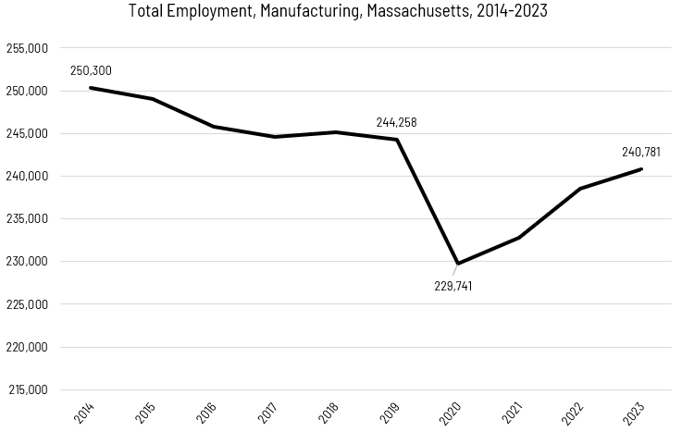When we break down the growth of the Manufacturing industry, we see that the largest growth of employment has been in the Breweries sector (NAICS 31212), which has added more than 2,800 jobs over that span. Growth as a percentage of total employment has also been fastest in the Breweries sector (436%).

Tables 3 and 4: Employment Change, Manufacturing Industries, Massachusetts, 2014-2023

|  |  |  |  |  |  |  |  |
| --- | --- | --- | --- | --- | --- | --- | --- |
| Industry | 2014 | 2018 | 2019 | 2020 | 2021 | 2022 | 2023 |
| Breweries | 647 | 985 | 1,339 | 1,651 | 2,199 | 2,705 | 2,226 |
| Navigational, Measuring, Electromedical, and Control Instruments Manufacturing | 24,754 | 24,735 | 24,871 | 24,364 | 25,200 | 25,538 | 25,623 |
| Industrial Machinery Manufacturing | 4,111 | 3,998 | 3,945 | 4,258 | 4,382 | 4,363 | 4,157 |
| Seafood Product Preparation and Packaging | 2,251 | 2,292 | 2,286 | 2,226 | 2,457 | 2,780 | 2,835 |

|  |  |  |
| --- | --- | --- |
| Industry | 2014-2023 Change | 2014-2023 % Change |
| Breweries | 2,821 | 436% |
| Navigational, Measuring, Electromedical, and Control Instruments Manufacturing | 2,372 | 10% |
| Industrial Machinery Manufacturing | 1,694 | 41% |
| Seafood Product Preparation and Packaging | 1,392 | 62% |

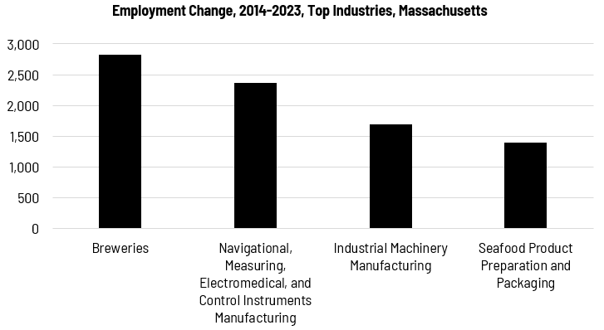

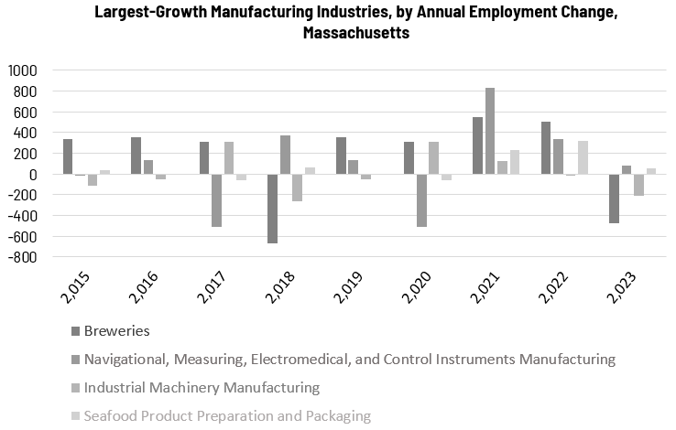

##### Wages, Salaries and Proprietor Earnings

Among the detailed industry categories, the highest wages are found among the Computer and Peripheral Equipment employers. Audio and Video Equipment Manufacturing ranks third for average wages, although the total number of workers in that sector is relatively low. The lowest wages are in Bread and Bakery Products Manufacturing.

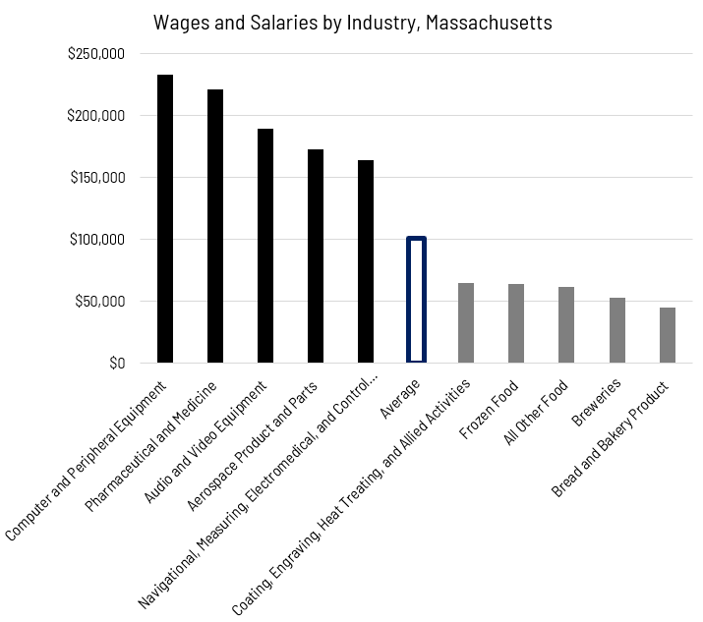

## The Pathways

### Metal Fabrication and Joining Technology Occupations and Pathways

This section looks at three target occupation categories: Welders, Solderers, and Braziers; Welding Machine Setters and Operators; and Sheet Metal Workers. It will also consider advancement opportunities in related careers that are not directly related to the program of study, but that illustrate opportunities that may be available to workers in these occupations with additional education and experience.

#### Table 5: Metal Fabrication and Joining Technology Occupations, Massachusetts

|  |  |  |  |  |  |
| --- | --- | --- | --- | --- | --- |
| Occupation | 2023 Jobs | Turnover Rate | 2014 - 2023 Change | 2014 - 2023 % Change | Median Annual Earnings |
| Sheet Metal Workers | 2,227 | 47.8% | -1,193 | -34.9% | $72,259 |
| Welders, Cutters, Solderers, and Braziers | 3,880 | 48.4% | 978 | 33.7% | $53,706 |
| Welding, Soldering, and Brazing Machine Setters, Operators, and Tenders | 671 | 46.1% | -386) | -36.5% | $48,755 |

While careers in these three occupations are certainly viable in their own rights, they also can serve as entry points to progressively more sophisticated and better-paying roles.  
Table 6: Related Career Pathways

##### Job Zone Two Occupations

|  |  |  |  |
| --- | --- | --- | --- |
| Occupation | 2023 Jobs | Typical Education Requirement | Median Annual Earnings |
| Layout Workers, Metal and Plastic | 67 | High school | $59,892 |
| Heat Treating Equipment Setters, Operators, and Tenders, Metal and Plastic | 211 | High school | $50,461 |
| Welding, Soldering and Brazing Machine Setters, Operators and Tenders | 671 | High school | $48,693 |
| Welders, Cutters, Solderers and Braziers | 3,880 | High school | $57,533 |
| Multiple Machine Tool Setters, Operators, and Tenders, Metal and Plastic | 2,616 | High school | $46,592 |
| Milling and Planing Machine Setters, Operators and Tenders | 280 | High school | $49,629 |
| Lathe and Turning Machine Setters, Operators and Tenders | 305 | High school | $58,094 |
| Drilling and Boring Machine Setters, Operators and Tenders | 73 | High school | $57,845 |
| Cutting, Punching and Press Machine Setters, Operators and Tenders | 2,159 | High school | $44,782 |
| Sheet Metal Workers | 2,227 | High school | $77,355 |

##### Job Zone Three Occupations

|  |  |  |  |
| --- | --- | --- | --- |
| Occupation | 2023 Jobs | Typical Education Requirement | Median Annual Earnings |
| Structural Metal Fabricators and Fitters | 1,437 | High school | $55,973 |
| First-Line Supervisors of Production and Operating Workers | 12,109 | High school | $74,069 |

## Occupation Profile

The United States Department of Labor, Employment and Training Administration created and regularly updates more than 800 occupational profiles with characteristics like skills, educational requirements, and daily tasks, based on the inputs of industry experts and people who are employed in the occupations.

### Sheet Metal Workers

#### Description

Fabricate, assemble, install, and repair sheet metal products and equipment, such as ducts, control boxes, drainpipes, and furnace casings. Work may involve any of the following: setting up and operating fabricating machines to cut, bend, and straighten sheet metal; shaping metal over anvils, blocks, or forms using hammer; operating soldering and welding equipment to join sheet metal parts; or inspecting, assembling, and smoothing seams and joints of burred surfaces. Includes sheet metal duct installers who install prefabricated sheet metal ducts used for heating, air conditioning, or other purposes.

#### Top Skills

* Understanding written sentences and paragraphs in work-related documents.
* Using logic and reasoning to identify the strengths and weaknesses of alternative solutions, conclusions, or approaches to problems.
* Monitoring/Assessing performance of yourself, other individuals, or organizations to make improvements or take corrective action.
* Adjusting actions in relation to others' actions.
* Giving full attention to what other people are saying, taking time to understand the points being made, asking questions as appropriate, and not interrupting at inappropriate times.
* Talking to others to convey information effectively.
* Using mathematics to solve problems.
* Considering the relative costs and benefits of potential actions to choose the most appropriate one.
* Managing one's own time and the time of others.
* Understanding the implications of new information for both current and future problem-solving and decision-making.

#### Top Daily Tasks

* Inspect completed work to ensure proper installation.
* Maintain construction tools or equipment.
* Fabricate parts or components.
* Plan layout of construction, installation, or repairs.
* Weld metal components.
* Assemble products or production equipment.
* Install building fixtures.
* Install plumbing or piping.
* Move construction or extraction materials to locations where they are needed.
* Direct construction or extraction personnel.
* Train construction or extraction personnel.
* Mark reference points on construction materials.
* Measure materials or objects for installation or assembly.
* Position structural components.
* Review blueprints or specifications to determine work requirements.
* Create construction or installation diagrams.

#### Additional Information

* [American Welding Society](https://www.aws.org/)
* [Associated Builders and Contractors](https://www.abc.org/)
* [Fabricators & Manufacturers Association International](https://www.fmanet.org/)
* [International Association of Sheet Metal, Air, Rail and Transportation Workers](https://www.smart-union.org/)
* [International Training Institute for the Sheet Metal and Air Conditioning Industry](https://www.sheetmetal-iti.org/)
* [National Center for Construction Education and Research](https://www.nccer.org/)
* [Occupational Outlook Handbook: Sheet metal workers](https://www.bls.gov/ooh/construction-and-extraction/sheet-metal-workers.htm)

### Welders, Cutters, Solderers, and Braziers

#### Description

Use hand-welding, flame-cutting, hand-soldering, or brazing equipment to weld or join metal components or to fill holes, indentations, or seams of fabricated metal products.

#### Top Skills

* Conducting tests and inspections of products, or processes to evaluate quality or performance.
* Monitoring/Assessing performance of yourself, other individuals, or organizations to make improvements or take corrective action.
* Using logic and reasoning to identify the strengths and weaknesses of alternative solutions, conclusions, or approaches to problems.
* Considering the relative costs and benefits of potential actions to choose the most appropriate one.
* Watching gauges, dials, or other indicators to make sure a machine is working properly.
* Managing one's own time and the time of others.
* Giving full attention to what other people are saying, taking time to understand the points being made, asking questions as appropriate, and not interrupting at inappropriate times.
* Talking to others to convey information effectively.
* Controlling operations of equipment or systems.
* Understanding written sentences and paragraphs in work-related documents.
* Identifying complex problems and reviewing related information to develop and evaluate options and implement solutions.
* Determining causes of operating errors and deciding what to do about it.
* Adjusting actions in relation to others' actions.
* Understanding the implications of new information for both current and future problem-solving and decision-making.
* Being aware of others' reactions and understanding why they react as they do.
* Determining the kind of tools and equipment needed to do a job.
* Determining how a system should work and how changes in conditions, operations, and the environment will affect outcomes.
* Using mathematics to solve problems.

#### Top Daily Tasks

* Measure dimensions of completed products or workpieces to verify conformance to specifications.
* Operate welding equipment.
* Notify others of equipment repair or maintenance needs.
* Watch operating equipment to detect malfunctions.
* Select production equipment according to product specifications.
* Clean workpieces or finished products.
* Determine metal or plastic production methods.
* Mark products, workpieces, or equipment with identifying information.
* Align parts or workpieces to ensure proper assembly.
* Melt metal, plastic, or other materials to prepare for production.
* Solder parts or workpieces.
* Adjust equipment controls to regulate gas flow.
* Monitor equipment operation to ensure that products are not flawed.
* Mount materials or workpieces onto production equipment.

#### Additional Information

* American Welding Society
* ASM International
* Fabricators & Manufacturers Association International
* International Association of Bridge, Structural, Ornamental and Reinforcing Iron Workers
* International Association of Machinists and Aerospace Workers
* International Brotherhood of Boilermakers
* IPC
* Precision Machined Products Association

### Welding, Soldering, and Brazing Machine Setters, Operators, and Tenders

#### Description

Set up, operate, or tend welding, soldering, or brazing machines or robots that weld, braze, solder, or heat treat metal products, components, or assemblies. Includes workers who operate laser cutters or laser-beam machines.

#### Top Skills

* Watching gauges, dials, or other indicators to make sure a machine is working properly.
* Giving full attention to what other people are saying, taking time to understand the points being made, asking questions as appropriate, and not interrupting at inappropriate times.
* Talking to others to convey information effectively.
* Using logic and reasoning to identify the strengths and weaknesses of alternative solutions, conclusions, or approaches to problems.
* Controlling operations of equipment or systems.
* Monitoring/Assessing performance of yourself, other individuals, or organizations to make improvements or take corrective action.
* Identifying complex problems and reviewing related information to develop and evaluate options and implement solutions.
* Understanding written sentences and paragraphs in work-related documents.
* Adjusting actions in relation to others' actions.
* Considering the relative costs and benefits of potential actions to choose the most appropriate one.

#### Top Daily Tasks

* Measure dimensions of completed products or workpieces to verify conformance to specifications.
* Read work orders or other instructions to determine product specifications or materials requirements.
* Review blueprints or other instructions to determine operational methods or sequences.
* Load materials into production equipment.
* Feed materials or products into or through equipment.
* Monitor equipment operation to ensure proper functioning.
* Assemble metal or plastic parts or products.
* Align parts or workpieces to ensure proper assembly.
* Operate welding equipment.
* Record operational or production data.
* Lay out parts to prepare for assembly.
* Calculate specific material, equipment, or labor requirements for production.
* Enter commands, instructions, or specifications into equipment.
* Adjust equipment controls to regulate gas flow.
* Adjust flow of electricity to tools or production equipment.

#### Additional Information

* Association for Manufacturing Technology
* Fabricators & Manufacturers Association International
* International Association of Sheet Metal, Air, Rail and Transportation Workers
* International Union, United Automobile, Aerospace and Agricultural Implement Workers of America
* National Institute for Metalworking Skills
* National Tooling and Machining Association
* Occupational Outlook Handbook: Metal and plastic machine workers
* Precision Machined Products Association
* Precision Metalforming Association
* United Steelworkers

### Job Postings - Welders, Cutters, Solderers and Braziers

P2C uses a third-party system that aggregates data from job postings to provide perspective on the skills and qualifications employers are prioritizing in their advertisements for these occupations.

* After controlling for multiple postings that likely referenced the same single opening, over the last year, we identified 873 unique job postings for Automotive Body and Related Repairers.
* We identified 206 unique employers who posted openings online.

#### Top Employers Advertising:

* Aerotek
* Clean Harbors
* Tradesmen International
* Randstad
* Adecco
* Republic Services
* Bodycote
* Boyd Corp
* Lockheed Martin
* Siemens
* Waste Connections
* Entegee
* Ametek

#### Top Job Titles:

* Welders
* Welders/Fabricators
* TIG Welders
* Fitters/Welders
* Brazers
* MIG/TIG Welders
* Production Welders
* Solderers
* Orbital Analysts
* Container Shop Welders
* Soldering Technicians
* Mechanics/Welders

#### Top Qualifications:

* Valid Driver's License
* Certified Welding Inspector
* Certified Welder
* Forklift Certification
* 10-Hour OSHA General Industry Card
* Secret Clearance
* American Welding Society Certification
* Security Clearance
* American Society of Mechanical Engineers (ASME) Certified
* CDL Class A License

#### Top Skills:

* Welding
* Gas Tungsten Arc Welding
* Metal Inert Gas (MIG) Welding
* Fabrication
* Welding Equipment
* Aluminum
* Hand Tools

### Job Postings - Sheet Metal Workers

P2C uses a third-party system that aggregates data from job postings to provide perspective on the skills and qualifications employers are prioritizing in their advertisements for these occupations.

* After controlling for multiple postings that likely referenced the same single opening, over the last year, we identified 402 unique job postings for Automotive Body and Related Repairers.
* We identified 132 unique employers who posted openings online.

#### Top Employers Advertising:

* Skyworks Solutions
* Tradesmen International
* Summit Careers
* Adecco
* Eaton Corporation
* Skyworks
* Amtrak
* Ferguson Enterprises
* ASML
* Tradesource
* Keolis Commuter Services
* Massachusetts Water Resources Authority

#### Top Job Titles:

* Fabrication Technicians
* Metal Fabricators
* Fabricators
* Sheet Metal Workers
* Sheet Metal Fabricators
* Sheet Metal Mechanics
* Metal Fabricators/Welders
* Sheet Metal Installers
* Field Installers
* Sheet Metal Technicians

#### Top Qualifications:

* Valid Driver's License
* 10-Hour OSHA General Industry Card
* Hoisting License
* Commercial Driver's License (CDL)
* EPA Universal Certification
* AVIXA Certified Technology Specialist
* Secret Clearance
* EPA Type II Certification

#### Top Skills:

* Sheet Metal
* Fabrication
* Hand Tools
* Welding
* Machinery
* Blueprinting
* Shears
* Sawing