# Labor Market Analysis of Radio and Television Broadcasting Careers in Massachusetts

## Overview

This analysis uses labor market data from the Massachusetts Department of Economic Research to provide perspective on multiple theaters related to the field of Radio and Television Broadcasting in the Commonwealth:

Two Occupations

* Broadcast Technicians
* Audio and Visual Technicians

Four Industries

* Radio and Television Broadcasting Stations (NAICS 5161)
* Sound Recording Industries (NAICS 5122)
* Motion Picture and Video Industries (NAICS 5121)
* Media Streaming Distribution Services, Social Networks, and Other Media Networks and Content Providers (NAICS 5162)

**The Occupations** are the specific jobs into which graduates of the Radio and Television Broadcasting program will hopefully enter after graduation. In public data systems, occupations are a set of tasks regularly performed by one individual on an employer’s payroll. In this analysis, the target occupations are profiled in addition to the broad spectrum of industries that employ them as we seek to provide strategic value in the development and administration of related curriculum and the construction of compelling and instructive narratives that will introduce students to the world of Radio and Television Broadcasting in the 21st Century.

**The Industries** which employ the target occupations are defined by their primary lines of business. The most common industry in which to find these occupations is Radio and Television Broadcasting Stations (NAICS 5161), which is home to more than 40% of these jobs in Massachusetts. Of the top seven industries for Broadcast Technicians and Audio/Visual Technicians, four are components of the larger Information Services (NAICS 51), and another three are components of the Arts, Entertainment and Recreation industry (NAICS 71).

Radio and Television Broadcasting Stations

*This industry group comprises establishments operating radio or television broadcasting stations for the programming and transmission of programs to the public. Programming may originate in their own studio, from an affiliated network, or from external sources.*

Sound Recording Industries

*This industry group comprises establishments primarily engaged in producing and distributing musical recordings, publishing music, or providing sound recording and related services.*

Motion Picture and Video Industries

*This industry group comprises establishments primarily engaged in the production and/or distribution of motion pictures, videos, television programs, or commercials; in the exhibition of motion pictures; or in the provision of postproduction and related services.*

Media Streaming Distribution Services, Social Networks, and Other Media Networks and Content Providers

*This industry comprises establishments primarily providing media streaming distribution services, operating social network sites, operating media broadcasting and cable television networks, and supplying information, such as news reports, articles, pictures, and features, to the news media. These establishments distribute textual, audio, and/or video content of general or specific interest.*

### Target Occupations

#### Broadcast Technicians and Audio and Video Technicians

##### Jobs

Two occupations are the primary targets for the Radio and Television Broadcasting program: Broadcast Technicians (SOC 27-4012) and Audio and Video Technicians (SOC 27-4011).

Closely related occupations include:

* Camera Operators-Television/Video/Film (27-4031)
* Film and Video Editors (27-4032)
* Sound Engineering Technicians (27-4014)
* Broadcast Announcers and Radio Disc Jockeys (27-3011)
* Producers and Directors (27-2012), which includes Media Technical Directors and Managers

Combined, more than 7,600 people are employed in these jobs in Massachusetts.

###### Table 1: Occupations

|  |  |  |  |
| --- | --- | --- | --- |
| **Occupation** | **2023 Jobs** | **Median Annual Earnings** | **Typical Entry Level Education** |
| Producers and Directors | 3,753 | $82,451 | Bachelor's degree |
| **Audio and Video Technicians** | **1,503** | **$60,091** | **Nondegree award** |
| Camera Operators, Television, Video, and Film | 763 | $44,096 | Bachelor's degree |
| **Broadcast Technicians** | **571** | **$64,750** | **Associate's degree** |
| Broadcast Announcers and Radio Disc Jockeys | 490 | $47,944 | Bachelor's degree |
| Film and Video Editors | 415 | $79,206 | Bachelor's degree |
| Sound Engineering Technicians | 175 | $81,370 | Nondegree award |

Total 7,669

### Employment Trends

#### Table 2: Employment, Audio and Video Technicians, Massachusetts, 2014-2023

|  |  |
| --- | --- |
| **Year** | **Jobs** |
| 2014 | 1,728 |
| 2015 | 1,828 |
| 2016 | 2,029 |
| 2017 | 2,126 |
| 2018 | 2,289 |
| 2019 | 2,302 |
| 2020 | 1,858 |
| 2021 | 1,599 |
| 2022 | 1,491 |
| 2023 | 1,503 |

#### Table 3: Employment, Broadcast Technicians, Massachusetts, 2014-2023

|  |  |
| --- | --- |
| **Year** | **Jobs** |
| 2014 | 523 |
| 2015 | 551 |
| 2016 | 584 |
| 2017 | 559 |
| 2018 | 543 |
| 2019 | 491 |
| 2020 | 412 |
| 2021 | 414 |
| 2022 | 577 |
| 2023 | 571 |

### Employment, by Year, Massachusetts, 2014-2023

The total number of jobs within the Audio and Visual Technicians category has decreased significantly since 2019, with a net change of -34.7%.

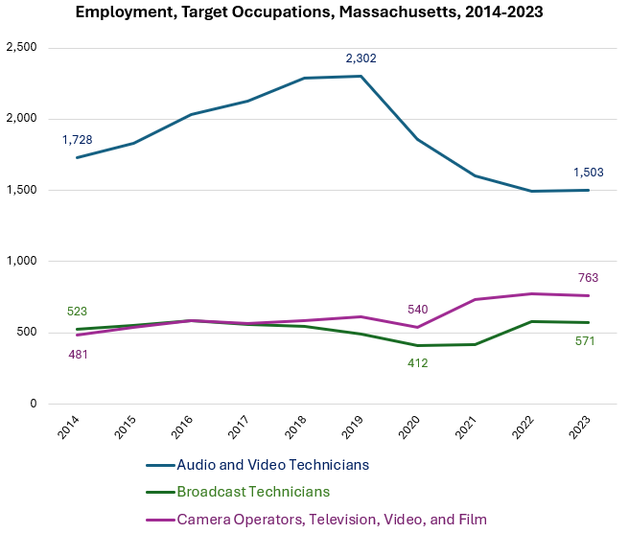

### Wages

Each of the target occupations has seen a rise in average wages since 2020, and the highest are now found among Broadcast Technicians.

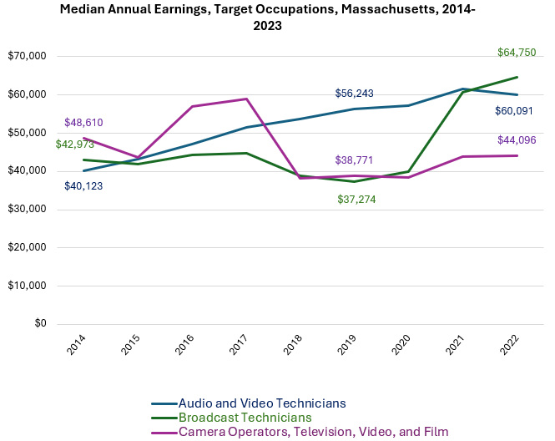

### Inverse Staffing Patterns

The industries that most often employ these occupations are generally subsets of the Information (NAICS 51) and Arts, Entertainment and Recreation (NAICS 71) industry categories.

#### Table 4: Employment of Target Occupations, by Industry, Massachusetts

|  |  |  |
| --- | --- | --- |
| **NAICS Code** | **Industry** | **Share of Jobs in Industry** |
| 5161 | Radio and Television Broadcasting Stations | 40.7% |
| 5122 | Sound Recording Industries | 29.8% |
| 5121 | Motion Picture and Video Industries | 27.0% |
| 5162 | Media Streaming Distribution Services, Social Networks, and Other Media Networks and Content Providers | 20.9% |
| 7115 | Independent Artists, Writers, and Performers | 12.6% |
| 7111 | Performing Arts Companies | 9.4% |
| 7113 | Promoters of Performing Arts, Sports, and Similar Events | 6.5% |

## The Radio and Television Broadcasting Stations Industry

### Priority Industries in Labor Market Data Systems

The InformationIndustry (NAICS 51) comprises a broad range of services. This general industry category is parsed into three-, four-, five-, and ultimately six-digit categories, and the Lightcast system produces employment and wage estimates for each based on data from the Massachusetts Department of Economic Research. The industry categories profiled in this report are at from the four-digit level of the North American Industry Classification System.

#### Radio and Television Broadcasting Stations Industry Taxonomy

51 Information

* 512 Motion Picture and Sound Recording Industries
  + 5121 Motion Picture and Video
  + 5122 Sound Recording Industries
* 513 Publishing Industries
* 516 Broadcasting and Content Providers
  + 5161 Radio and Television Broadcasting Stations
  + 5162 Media Streaming Distribution Services, Social Networks, Other Media Networks/Content Providers
* 517 Telecommunications
* 518 Data Processing, Hosting and Related Services
* 519 Web Search Portals, Libraries, Archives, and Other Information Services

### Employment Trends

The number of people employed in the Radio and Television Broadcasting Stations industry in Massachusetts had been steadily increasing over the last decade, until a moderate COVID-19-related decline. Between 2019 and 2020, the industry shed approximately 4.6% of its total employment. The number of jobs in the industry has not returned to pre-COVID levels.

#### Table 5: Average Annual Employment, Radio and Television Broadcasting Stations, Massachusetts, 2014-2023

|  |  |
| --- | --- |
| **Year** | **Jobs** |
| 2014 | 3,646 |
| 2015 | 3,717 |
| 2016 | 3,682 |
| 2017 | 3,776 |
| 2018 | 3,757 |
| 2019 | 3,685 |
| 2020 | 3,256 |
| 2021 | 3,155 |
| 2022 | 3,154 |
| 2023 | 3,118 |

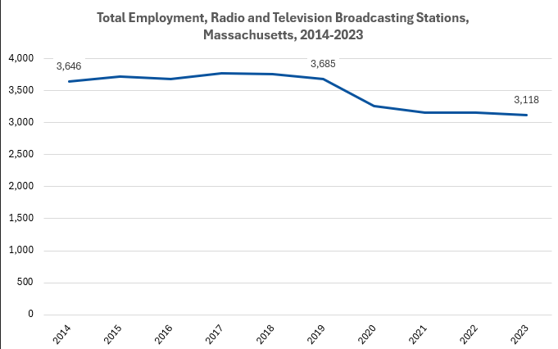

### Wages, Salaries and Proprietor Earnings

Wages, Salaries and Proprietor Earnings in the Radio and Television Broadcasting Stations industry have trended upward over the last decade, but the rate of growth accelerated somewhat in 2017, and the average is now at an all-time high and is 30.2% higher than the 2014 value.

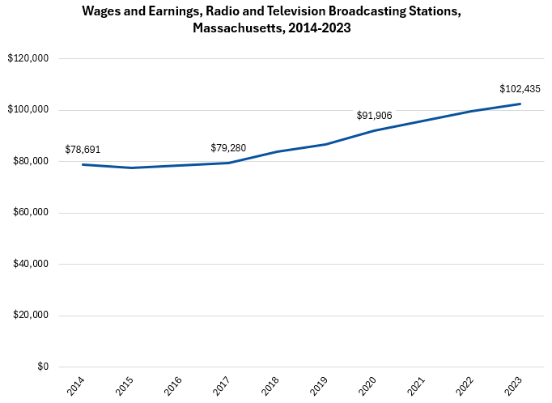

Across all occupations in the target industries, the highest earnings are found in the Streaming Distribution Services, Social Networks, and Other Media Networks and Content Providers industry. The lowest are found in Motion Picture and Video industries.

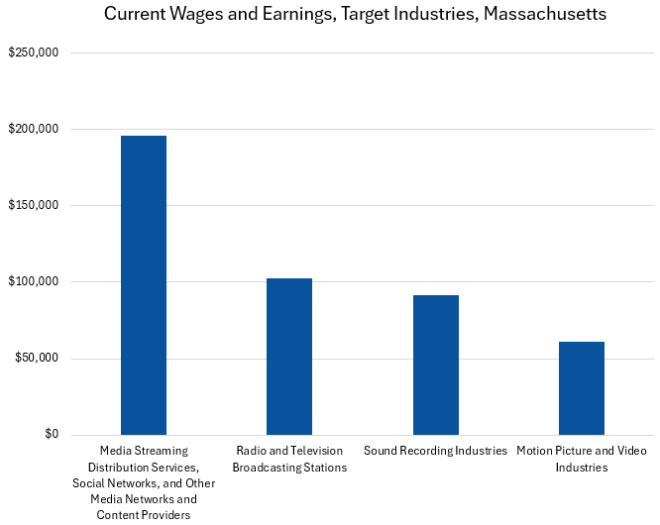

## The Media Streaming Distribution Services, Social Networks, and Other Media Networks and Content Providers Industry

### Priority Industries in Labor Market Data Systems

The InformationIndustry (NAICS 51) comprises a broad range of services. This general industry category is parsed into three-, four-, five-, and ultimately six-digit categories, and the Lightcast system produces employment and wage estimates for each based on data from the Massachusetts Department of Economic Research. The industry categories profiled in this report are at from the four-digit level of the North American Industry Classification System.

#### The Media Streaming Distribution Services, Social Networks, and Other Media Networks and Content Providers Industry Taxonomy

51 Information

* 512 Motion Picture and Sound Recording Industries
  + 5121 Motion Picture and Video
  + 5122 Sound Recording Industries
* 513 Publishing Industries
* 516 Broadcasting and Content Providers
  + 5161 Radio and Television Broadcasting Stations
  + 5162 Media Streaming Distribution Services, Social Networks, Other Media Networks/Content Providers
* 517 Telecommunications
* 518 Data Processing, Hosting and Related Services
* 519 Web Search Portals, Libraries, Archives, and Other Information Services

### Employment Trends

The number of people employed in the Media Streaming Distribution Services, Social Networks, and Other Media Networks and Content Providers industry in Massachusetts has experienced uneven employment levels over the last decade. A dramatic downturn in 2020 gave way to a new high of 4,259 jobs in 2021. Total employment now sits at 4,224, a net increase of 6.7%.

#### Table 6: Average Annual Employment, Streaming Distribution Services, Social Networks, and Other Media Networks and Content Providers Industry, Massachusetts, 2014-2023

|  |  |
| --- | --- |
| **Year** | **Jobs** |
| 2014 | 3,956 |
| 2015 | 4,081 |
| 2016 | 3,886 |
| 2017 | 3,951 |
| 2018 | 3,971 |
| 2019 | 4,187 |
| 2020 | 4,018 |
| 2021 | 4,259 |
| 2022 | 4,165 |
| 2023 | 4,224 |

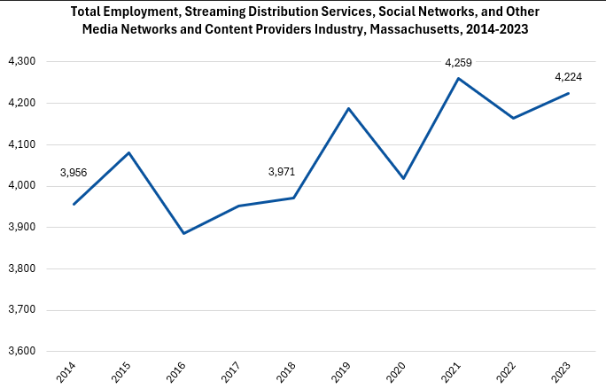

### Wages, Salaries and Proprietor Earnings

Wages, Salaries and Proprietor Earnings in the Streaming Distribution Services, Social Networks, and Other Media Networks and Content Providers industry began trending upward in 2017, but the rate of growth accelerated significantly in 2019, and the average is now at an all-time high and is 78.2% higher than the 2014 value.

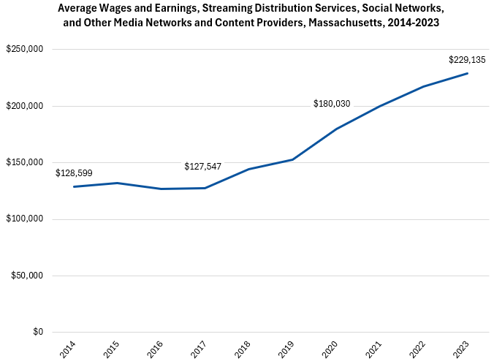

Across all occupations in the target industries, the highest earnings are found in the Streaming Distribution Services, Social Networks, and Other Media Networks and Content Providers industry. The lowest are found in Motion Picture and Video industries.

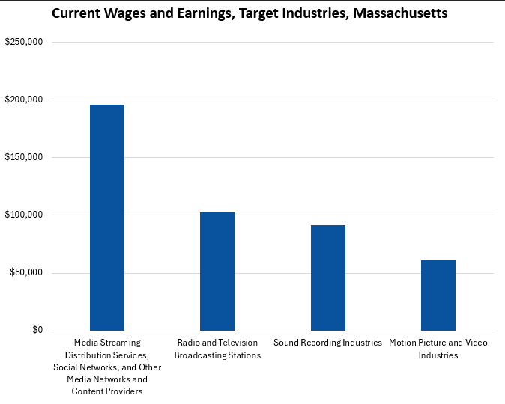

## The Pathway

### Occupations and Pathways

This section looks at the target occupations and pathways and also considers advancement opportunities in related careers that are not directly related to the program of study, but that illustrate opportunities that may be available to workers in these fields with additional education and experience.

While careers in these occupations are certainly viable in their own rights, they also can serve as entry points to progressively more sophisticated and better-paying roles.

The United States Department of Labor Employment and Training Administration organizes occupations into an index of “job zones,” which reflect the levels of preparation typically required to enter employment in the occupation.

#### Table 7: Pathways

##### Job Zone Three Occupations

|  |  |  |  |
| --- | --- | --- | --- |
| Occupation | 2023 Jobs | Typical Education Requirement | Median Annual Earnings |
| Audio and Video Technicians | 1,503 | Nondegree award | $60,091 |
| Photographers | 813 | High School | $51,418 |
| Camera Operators, Television, Video and Film | 763 | Bachelor's | $44,096 |
| Broadcast Technicians | 571 | Associate's | $64,750 |
| Sound Engineering Technicians | 175 | Nondegree award | $81,370 |

##### Job Zone Four Occupations

|  |  |  |  |
| --- | --- | --- | --- |
| Occupation | 2023 Jobs | Typical Education Requirement | Median Annual Earnings |
| Producers and Directors (including Media Technical Directors/Managers) | 3,753 | Bachelor's | $82,451 |
| Special Effects Artists and Animators | 790 | Bachelor's | $77,563 |
| Broadcast Announcers and Radio Disc Jockeys | 490 | Bachelor's | $47,944 |
| Film and Video Editors | 415 | Bachelor's | $79,206 |

## Occupation Profiles

### Broadcast Technicians

#### Description

Set up, operate, and maintain the electronic equipment used to acquire, edit, and transmit audio and video for radio or television programs. Control and adjust incoming and outgoing broadcast signals to regulate sound volume, signal strength, and signal clarity. Operate satellite, microwave, or other transmitter equipment to broadcast radio or television programs.

#### Skills

* Using logic and reasoning to identify the strengths and weaknesses of alternative solutions, conclusions, or approaches to problems.
* Giving full attention to what other people are saying, taking time to understand the points being made, asking questions as appropriate, and not interrupting at inappropriate times.
* Monitoring/assessing performance of yourself, other individuals, or organizations to make improvements or take corrective action.
* Watching gauges, dials, or other indicators to make sure a machine is working properly.
* Communicating effectively in writing as appropriate for the needs of the audience.
* Identifying complex problems and reviewing related information to develop and evaluate options and implement solutions.
* Understanding written sentences and paragraphs in work-related documents.
* Talking to others to convey information effectively.
* Understanding the implications of new information for both current and future problem-solving and decision-making.
* Performing routine maintenance on equipment and determining when and what kind of maintenance is needed.
* Considering the relative costs and benefits of potential actions to choose the most appropriate one.

#### Tasks

* Design layout of art or product exhibits, displays, or promotional materials.
* Collaborate with others to develop or refine designs.
* Review art or design materials.
* Design layouts for print publications.
* Create computer-generated graphics or animation.
* Operate photographic developing or print production equipment.
* Perform administrative or clerical tasks.
* Confer with clients to determine needs.
* Collect data about customer needs.
* Conduct market research.
* Conduct research to inform art, designs, or other work.
* Draw detailed or technical illustrations.
* Maintain records, documents, or other files.
* Research new technologies.
* Edit written materials.
* Operate still or video cameras or related equipment.
* Write advertising or promotional material.

#### Job Postings: Broadcast Technicians

##### Frequency

* We found 267 unique job postings from the last year in Massachusetts.
* We identified 104 employers actively posting openings for this occupation.

##### Employers

* Eversource Energy
* Lockheed Martin
* Videolink
* NBC
* Boston University
* Analog Devices
* Emerson College
* Harvard University
* The Hire Culture
* National Grid
* Showcase Cinemas
* Evident

##### Skills

###### Common:

* Communication
* Problem Solving
* Operations
* Customer Service

###### Specialized:

* Radio Frequency
* Project Management
* Workflow Management
* Media Production
* Automation
* Video Production
* Transmission

##### Job Titles

* Radio Frequency Test Technicians
* Media Technicians
* Production Technicians
* Studio Technicians
* Board Operators
* Broadcast Systems Engineers
* Master Control Operators
* Broadcast Technicians
* Production Test Technicians
* Construction Representatives
* Transmission Managers
* Shift Technicians
* Media Technology Specialists
* Transmission System Operators
* Transmission Operators
* Video Production Technicians
* Transmission Technicians

##### Additional Information

* Audio Engineering Society
* Audiovisual and Integrated Experience Association
* National Association of Broadcasters
* National Association of Broadcast Employees and Technicians - Communications Workers of America
* Society of Broadcast Engineers

### Occupation Profile: Audio and Video Technicians

#### Description

Set up, maintain, and dismantle audio and video equipment, such as microphones, sound speakers, connecting wires and cables, sound and mixing boards, video cameras, video monitors and servers, and related electronic equipment for live or recorded events, such as concerts, meetings, conventions, presentations, podcasts, news conferences, and sporting events.

#### Skills

* Monitoring/assessing performance of yourself, other individuals, or organizations to make improvements or take corrective action.
* Understanding written sentences and paragraphs in work-related documents.
* Using logic and reasoning to identify the strengths and weaknesses of alternative solutions, conclusions, or approaches to problems.
* Watching gauges, dials, or other indicators to make sure a machine is working properly.
* Identifying complex problems and reviewing related information to develop and evaluate options and implement solutions.
* Giving full attention to what other people are saying, taking time to understand the points being made, asking questions as appropriate, and not interrupting at inappropriate times.
* Communicating effectively in writing as appropriate for the needs of the audience.
* Talking to others to convey information effectively.
* Adjusting actions in relation to others' actions.
* Actively looking for ways to help people.
* Understanding the implications of new information for both current and future problem-solving and decision-making.
* Being aware of others' reactions and understanding why they react as they do.
* Controlling operations of equipment or systems.
* Considering the relative costs and benefits of potential actions to choose the most appropriate one.
* Determining how a system should work and how changes in conditions, operations, and the environment will affect outcomes.

#### Tasks

* Notify others of equipment problems.
* Maintain recording or broadcasting equipment.
* Maintain records, documents, or other files.
* Convert data among multiple digital or analog formats.
* Coordinate activities of production personnel.
* Operate communications, transmissions, or broadcasting equipment.
* Monitor broadcasting operations to ensure proper functioning.
* Operate control consoles for sound, lighting, or video.
* Mix sound inputs.
* Edit audio or video recordings.
* Operate audio recording equipment.
* Coordinate logistics for productions or events.
* Set up still or video cameras or related equipment.
* Construct distinctive physical objects for artistic, functional, or commercial purposes.
* Determine technical requirements of productions or projects.
* Draw detailed or technical illustrations.
* Collaborate with others to determine technical details of productions.
* Train others on work processes.
* Maintain inventories of materials, equipment, or products.
* Study details of musical compositions.
* Inform viewers, listeners, or audiences.
* Write material for artistic or entertainment purposes.
* Compile technical information or documentation.
* Maintain logs of production activities.
* Write informational material.

#### Job Postings: Audio and Video Technicians

##### Frequency

* We found 971 unique job postings from the last year in Massachusetts.
* We identified 288 employers actively posting openings for this occupation.

##### Employers

* Encore
* Encore Global
* AVI-SPL
* Diversified Agency
* Harvard University
* Avi Systems
* Tritech Communications
* Insight Global
* A &V Services
* Roomready
* Compass Group
* Modis
* University of Massachusetts
* Worldwide TechServices
* Allegis Group
* Stefanini
* Event And Media Technologies
* New Era Technology, Us
* Roxbury Community College

##### Skills

###### Common:

* Problem Solving
* Customer Service
* Communication
* Operations
* Professionalism

###### Specialized:

* Crestron (A/V Systems)
* Project Management
* Zoom
* Control Systems
* Audiovisual Equipment
* Audio-Visual Technology

##### Job Titles

* Radio Frequency Test Technicians
* Media Technicians
* Production Technicians
* Studio Technicians
* Board Operators
* Broadcast Systems Engineers
* Master Control Operators
* Broadcast Technicians
* Production Test Technicians
* Construction Representatives
* Transmission Managers
* Shift Technicians
* Media Technology Specialists
* Transmission System Operators
* Transmission Operators
* Video Production Technicians
* Transmission Technicians

##### Additional Information

* Audio Engineering Society
* Audiovisual and Integrated Experience Association
* Cinema Audio Society
* Educational Technology Collaborative
* National Association of Broadcasters
* International Alliance of Theatrical Stage Employees, Moving Picture Technicians, Artists, and Allied Crafts
* National Association of Broadcast Employees and Technicians - Communications Workers of America
* National Education Association
* Society of Broadcast Engineers