Labor Market Analysis of Painting and Design Technology-Related Careers in Massachusetts

## Overview

This analysis uses labor market data from the Massachusetts Department of Economic Research to provide perspective on two theaters related to the skilled trades in the construction field: the construction industry and thirteen occupations in the career pathway commonly referred to as the Skilled Trades:

1. Brickmasons and Blockmasons
2. Stonemasons
3. Carpenters
4. Tile and Stone Setters
5. Cement Masons and Concrete Finishers
6. Operating Engineers and Other Equipment Operators
7. Electricians
8. Painters, Construction, and Maintenance
9. Pipelayers
10. Plumbers, Pipefitters, and Steamfitters
11. Reinforcing Iron and Rebar Workers
12. Sheet Metal Workers
13. Structural Iron and Steel Workers

The industry should be understood as the employers in the Commonwealth whose primary line of business is construction. Those companies employ a spectrum of occupations, ranging from skilled tradesmen to real estate agents. While trends in the construction industry are not necessarily directly related to the skilled trades, the large majority of tradesmen work for construction companies, making its realities and trends a valuable backdrop against which to evaluate these careers in Massachusetts.

In public data systems, occupations are a set of tasks regularly performed by one individual on an employer’s payroll. In this analysis, the target occupations are profiled both as a set and individually as we seek to provide strategic value in the development and administration of related curriculum and the construction of compelling and instructive narratives that will introduce students to the world of the skilled trades in the 21st Century.

## The Construction Industry

### The Construction Industry in Labor Market Data Systems

Construction (NAICS code 23) comprises all employers whose primary line of business is construction. The industry category is divided into three sub-industries:

* 236-Construction of Buildings
* 237-Heavy and Civil Engineering Construction
* 238-Specialty Trades Contractors

Each of these categories is further parsed into four-, five-, and ultimately six-digit level categories, and the Massachusetts Department of Economic Research produces employment and wage estimates for each.

#### Construction Industry Categories

* 236 Construction of Buildings
  + 236115 New Single-Family Housing Construction (except For-Sale Builders)
  + 236116 New Multifamily Housing Construction (except For-Sale Builders)
  + 236117 New Housing For-Sale Builders
  + 236118 Residential Remodelers
  + 236210 Industrial Building Construction
  + 236220 Commercial and Institutional Building Construction
* 237 Heavy and Civil Engineering Construction
  + 237110 Water and Sewer Line and Related Structures Construction
  + 237120 Oil and Gas Pipeline and Related Structures Construction
  + 237130 Power and Communication Line and Related Structures Construction
  + 237210 Land Subdivision
  + 237310 Highway, Street, and Bridge Construction
  + 237990 Other Heavy and Civil Engineering Construction
* 238 Specialty Trades Contractors
  + 238110 Poured Concrete Foundation and Structure Contractors
  + 238120 Structural Steel and Precast Concrete Contractors
  + 238130 Framing Contractors
  + 238140 Masonry Contractors
  + 238150 Glass and Glazing Contractors
  + 238160 Roofing Contractors
  + 238170 Siding Contractors
  + 238190 Other Foundation, Structure, and Building Exterior Contractors
  + 238210 Electrical Contractors and Other Wiring Installation Contractors
  + 238220 Plumbing, Heating, and Air-Conditioning Contractors
  + 238290 Other Building Equipment Contractors
  + 238310 Drywall and Insulation Contractors
  + 238320 Painting and Wall Covering Contractors
  + 238330 Flooring Contractors
  + 238340 Tile and Terrazzo Contractors
  + 238350 Finish Carpentry Contractors
  + 238390 Other Building Finishing Contractors

### Employment-Electricians

It is not surprising that at the most granular level available, the industry that most often employs electricians in Massachusetts is Electrical Contractors (NAICS 23821). Approximately three quarters of the Commonwealth’s electricians work in that industry. It is interesting to note, however, that the Temporary Help Services (56132) and Local Government (90399) sectors also rank in the top five for employment of electricians. The table below details the top five detailed industry sectors by the share of electricians who are employed in them.

#### Table 2: Top Detailed Industries for Electricians

|  |  |
| --- | --- |
| Industry | Share of Occupation Jobs |
| Electrical and Other Wiring Installation Contractors | 74.9% |
| Temporary Help Services | 3.4% |
| Plumbing, Heating, and Air-Conditioning Contractors | 2.3% |
| Commercial and Institutional Building Construction | 1.6% |
| Local Government | 1.4% |

### Employment Trends

The number of people employed in the Construction industry in Massachusetts has been steadily increasing over the last decade, except for a significant COVID-19-related decline in 2020. The net change has been an increase of 35.9% in jobs over the last decade.

#### Table 3: Average Annual Employment, Construction Industry, Massachusetts, 2014-2023

|  |  |
| --- | --- |
| Year | Jobs |
| 2014 | 128,919 |
| 2015 | 138,991 |
| 2016 | 146,503 |
| 2017 | 152,131 |
| 2018 | 158,656 |
| 2019 | 163,062 |
| 2020 | 152,366 |
| 2021 | 164,435 |
| 2022 | 170,026 |
| 2023 | 176,199 |

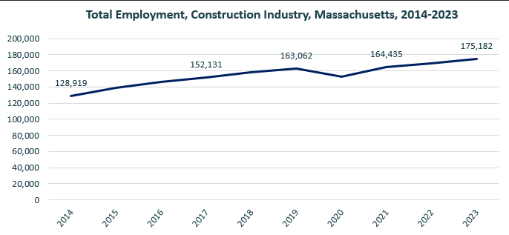

When we break down the growth of the Construction industry, we see that while growth has been seen in all three construction sectors, growth in both the total number of jobs and the percentage of jobs added has been led by the Specialty Trades Contractors sector.

#### Table 4: Employment Change, Construction Industries, Massachusetts, 2014-2023

|  |  |  |  |  |  |  |  |
| --- | --- | --- | --- | --- | --- | --- | --- |
| Industry | 2014 | 2018 | 2019 | 2020 | 2021 | 2022 | 2023 |
| Construction of Buildings | 27,137 | 33,381 | 34,166 | 32,452 | 34,825 | 35,900 | 37,092 |
| Heavy/Civil Engineering Construction | 12,671 | 14,105 | 13,893 | 13,820 | 13,843 | 14,128 | 14,325 |
| Specialty Trade Contractors | 89,112 | 111,169 | 115,003 | 106,094 | 115,768 | 119,104 | 123,765 |

|  |  |  |
| --- | --- | --- |
| Industry | Change | % Change |
| Construction of Buildings | 9,955 | 36.7% |
| Heavy/Civil Engineering Construction | 1,654 | 13.1% |
| Specialty Trade Contractors | 34,654 | 38.9% |

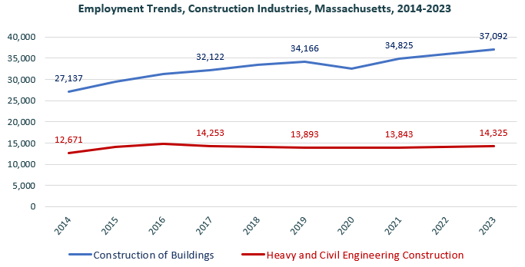

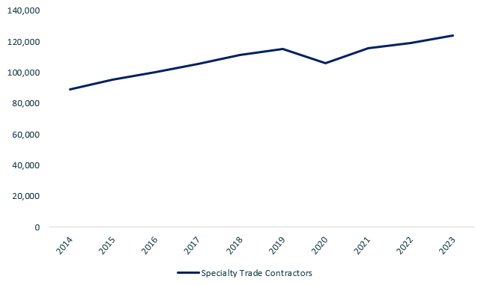

At the most detailed level available, we see that growth was led over the decade by Poured Concrete Contractors (NAICS 238110) and Residential Remodelers (NAICS 236118).

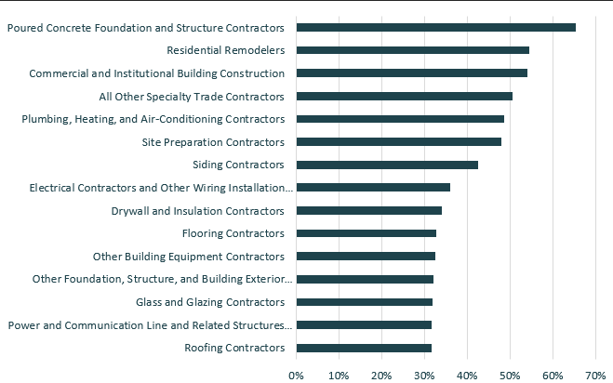

### Wages, Salaries and Proprietor Earnings

Among the detailed industry categories, the highest wages are found in the Industrial Building and Power Line Construction employers. The lowest are in Residential Remodelers and Painting Contractors.

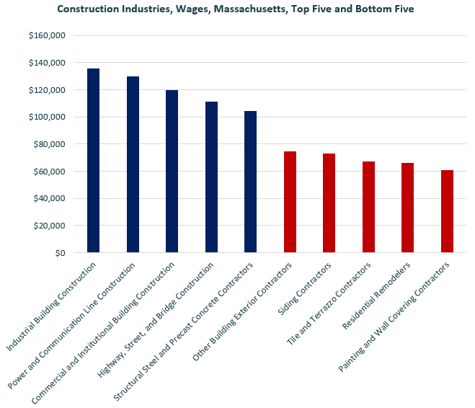

## The Pathways

### Electricity Occupations and Pathways

This section looks at the target occupation category: Electricians. It will also consider advancement opportunities in related careers that are not directly related to the program of study, but that illustrate opportunities that may be available to workers in this field with additional education and experience.

#### Table 5: Electricians, Massachusetts

|  |  |  |  |  |  |
| --- | --- | --- | --- | --- | --- |
| Occupation | 2023 Jobs | Turnover Rate | 2014 - 2023 Change | 2014 - 2023 % Change | Median Annual Earnings |
| Electricians | 18,498 | 51.0% | 3,832 | 26% | $82,222 |

While careers in these two occupations are certainly viable in their own rights, they also can serve as entry points to progressively more sophisticated and better-paying roles.

#### Table 6: Related Career Pathways

##### Job Zone Two Occupations

|  |  |  |  |
| --- | --- | --- | --- |
| Occupation | 2023 Jobs | Typical Education Requirement | Median Annual Earnings |
| Helpers-Electricians | 1,428 | High school | $45,906 |
| Solar Photovoltaic Installers | 982 | High school | $48,620 |

##### Job Zone Three Occupations

|  |  |  |  |
| --- | --- | --- | --- |
| Occupation | 2023 Jobs | Typical Education Requirement | Median Annual Earnings |
| Electricians | 18,498 | High school | $82,222 |
| Energy Auditors (data for building inspectors) | 3,835 | High school | $77,522 |
| Construction and Building Inspectors | 3,835 | High school | $77,522 |
| Solar Energy Installation Managers (data for construction supervisors) | 15,659 | High school | $98,592 |
| First-Line Supervisors of Construction Trades and Extraction Workers | 15,659 | High school | $98,592 |

##### Job Zone Four Occupations

|  |  |  |  |
| --- | --- | --- | --- |
| Occupation | 2023 Jobs | Typical Education Requirement | Median Annual Earnings |
| Energy Engineers (data for Engineers, All Other) | 3,229 | Bachelor’s | $112,690 |
| Construction Managers | 7,087 | Bachelor’s | $131,727 |

## Occupation Profiles

The United States Department of Labor, Employment, and Training Administration created and regularly updates more than 800 occupational profiles with characteristics like skills, educational requirements, and daily tasks, based on the inputs of industry experts and people who are employed in the occupations.

### Painters, Construction, and Maintenance

#### Description

Paint walls, equipment, buildings, bridges, and other structural surfaces, using brushes, rollers, and spray guns. May remove old paint to prepare surface prior to painting. May mix colors or oils to obtain desired color or consistency.

#### Top Skills

* Giving full attention to what other people are saying, taking time to understand the points being made, asking questions as appropriate, and not interrupting at inappropriate times.
* Using logic and reasoning to identify the strengths and weaknesses of alternative solutions, conclusions, or approaches to problems.
* Being aware of others' reactions and understanding why they react as they do.
* Managing one's own time and the time of others.
* Understanding written sentences and paragraphs in work-related documents.
* Monitoring/assessing performance of yourself, other individuals, or organizations to make improvements or take corrective action.
* Adjusting actions in relation to others' actions.
* Considering the relative costs and benefits of potential actions to choose the most appropriate one.
* Talking to others to convey information effectively.
* Actively looking for ways to help people.
* Understanding the implications of new information for both current and future problem-solving and decision-making.
* Identifying complex problems and reviewing related information to develop and evaluate options and implement solutions.
* Watching gauges, dials, or other indicators to make sure a machine is working properly.
* Conducting tests and inspections of products, services, or processes to evaluate quality or performance.

#### Top Daily Tasks

* Protect structures or surfaces near work areas to avoid damage.
* Apply material to fill gaps in surfaces.
* Smooth surfaces with abrasive materials or tools.
* Review blueprints or specifications to determine work requirements.
* Prepare surfaces for finishing.
* Apply paint to surfaces.
* Assemble temporary equipment or structures.
* Mix substances or compounds needed for work activities.
* Estimate construction project costs.
* Estimate materials requirements for projects.
* Clean surfaces in preparation for work activities.
* Order construction or extraction materials or equipment.
* Select construction equipment.
* Apply sealants or other protective coatings.
* Apply decorative or textured finishes or coverings.
* Cut carpet, vinyl, or other flexible materials.
* Operate heating or drying equipment.

#### Additional Information

* Associated Builders and Contractors
* Associated General Contractors of America
* Home Builders Institute
* International Union of Painters and Allied Trades
* National Center for Construction Education and Research
* Occupational Outlook Handbook: Painters, Construction, and Maintenance
* Painting and Decorating Contractors of America

#### Job Postings - Painters, Construction, and Maintenance

P2C uses a third-party system that aggregates data from job postings to provide perspective on the skills and qualifications employers are prioritizing in their advertisements for these occupations.

* After controlling for multiple postings that likely referenced the same single opening, over the last year, we identified 766 unique job postings for Painters, Construction, and Maintenance.
* We identified 242 unique employers who posted openings online.

##### Top Employers Advertising:

* Aerotek
* Works By Jesse Debenedictis
* State of Massachusetts
* PeopleReady
* Cosmos Painting
* JLL
* Northern Lights Painting
* Mass General Brigham
* Stanley Black & Decker
* Re:Fab
* Andrews Painting
* Stewart Painting
* AvalonBay Communities
* Tradesmen International
* Westfield Electroplating Company
* Beth Israel Lahey Health
* Takeda Pharmaceutical Company
* First Nick Companies
* Adecco
* Bridgewater State University
* Woodmeister Master Builders
* Rodenhiser Home Services
* Transdev
* Total Limited
* Securitas
* May Institute
* Tufts Medical Center

##### Top Job Titles:

* Painters
* Experience Coordinators
* Exterior Painters
* Spray Painters
* Residential Painters
* Commercial Painters
* Lead Painters
* Automotive Painters
* Painters Helpers
* Maintenance Painters
* Painting Foremen
* Interior Painters

##### Top Qualifications:

* Valid Driver's License
* 10-Hour OSHA General Industry Card
* Operator Certification
* Advanced Cardiovascular Life Support (ACLS) Certification
* Permit To Work (PTW)
* Automotive Service Excellence (ASE) Certification
* Forklift Certification
* Certified Loss Control Specialist
* System Operator Certification
* Security Clearance
* Transportation Worker Identification Credential (TWIC) Card

##### Top Overall Skills:

* Painting
* Furniture Cleaning
* Caulking
* Spray Painting
* Hand Tools

###### Defining Skills

* Abrasive Blasting

###### Differentiating Skills

* Spray Painting
* Exterior Painting
* Lacquer
* Refinishing