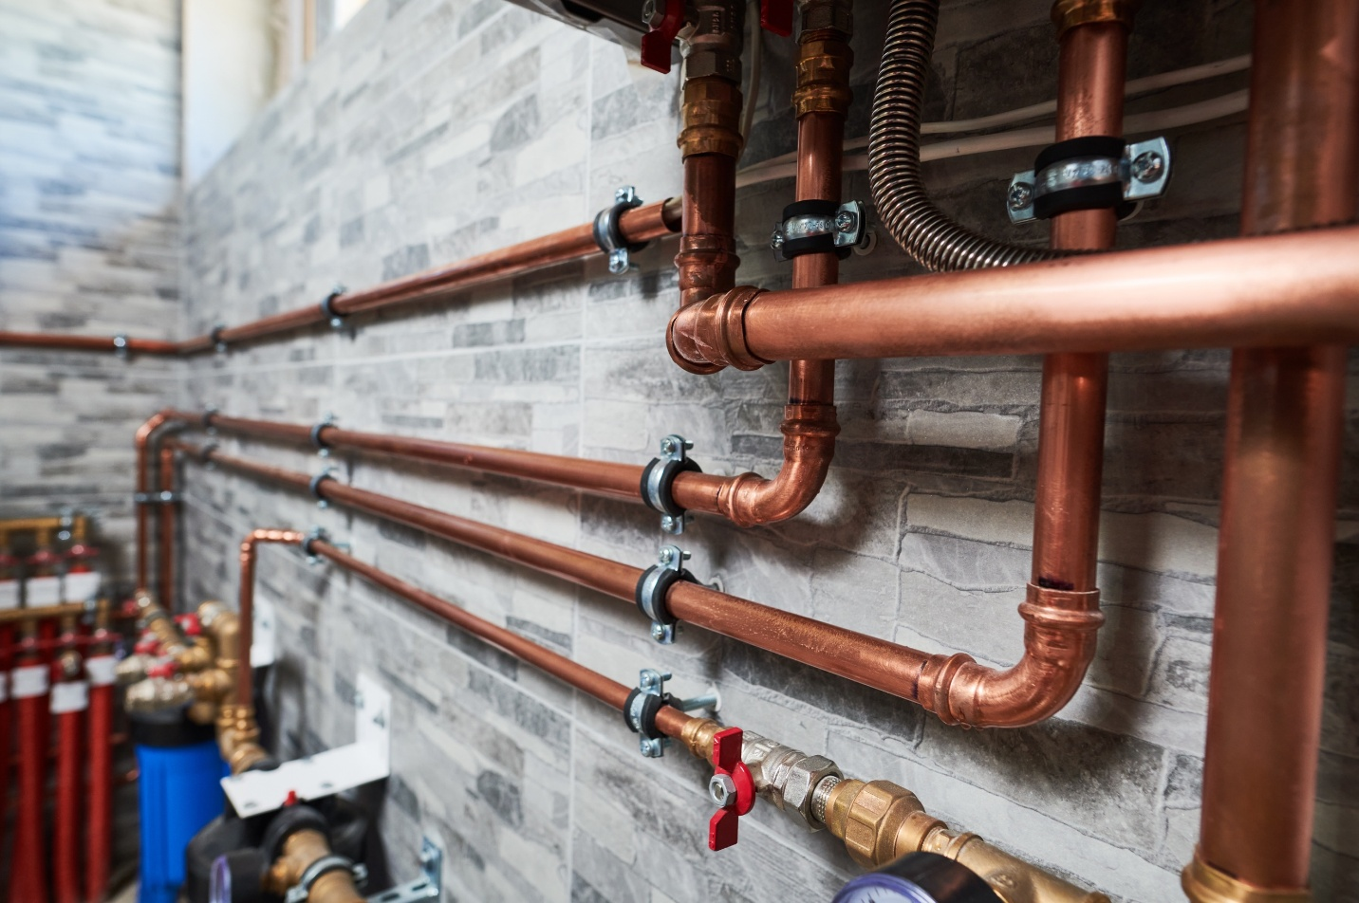

# Plumbing Credentials of Value

October 2023

## Certifications and Certifying Organization

### Safety

* [OSHA 10 - Construction](https://www.oshaeducationcenter.com/osha-10-hour-training/?lgr=c2206475-bedc-e111-b998-000e0c4c5fe4&cq_src=google_ads&cq_cmp=82723731&cq_con=62837110292&cq_term=osha%2010%20general%20industry&cq_med=&cq_plac=&cq_net=g&cq_plt=gp&gad_source=1&gclid=EAIaIQobChMIjOrK3r2chgMV_KJaBR0P-gBqEAAYAiAAEgLDBvD_BwE), OSHA
* [Hot Work Safety Certification](https://www.nfpa.org/for-professionals/training-for-me/industrial-hazards-training/hot-work-safety-certificate-online-training), National Fire Protection Association (NFPA)

### Essential

* [Credit toward Massachusetts Plumbing License,](https://www.mass.gov/plumbers-gasfitters-and-lp-installers-license-applications-and-renewals) Plumbing License (248 CMR 11 Education and Work Experience Standards), Commonwealth of Massachusetts

### Supplemental

* [OSHA 30 Construction](https://www.oshaeducationcenter.com/osha-30-hour-training/?lgr=c2206475-bedc-e111-b998-000e0c4c5fe4&cq_src=google_ads&cq_cmp=82724691&cq_con=59218487492&cq_term=osha%2030%20construction&cq_med=&cq_plac=&cq_net=g&cq_plt=gp&gad_source=1&gclid=EAIaIQobChMIkZDCx76chgMVloBaBR00MQi9EAAYASAAEgJGNvD_BwE), OSHA
* [CPR/AED Certification](https://www.redcross.org/take-a-class?scode=PSG00000E017&ds_rl=1289062cid=generator&med=cpc&source=google&gad_source=1&gclid=EAIaIQobChMIpfKEz76chgMV455aBR3ZsAgBEAAYAiAAEgIE0vD_BwE&gclsrc=aw.ds), American Red Cross or American Heart Association
* [First Aid Certification](https://www.redcross.org/take-a-class/first-aid/first-aid-training/first-aid-certification), American Red Cross or American Heart Association
* [Confined Space Permit](https://www.osha.gov/confined-spaces), OSHA
* [Plumbing Levels 1 -2,](https://www.nccer.org/craft-catalog/plumbing/) National Center for Construction Education and Research (NCCER)

### Supplemental - Postsecondary

* [Backflow Prevention Program Specialist,](http://www.iapmodwbp.org/bpi/training-certification) International Association of Plumbing and Mechanical Officials
* [Residential Potable Water Fire Protection Certification,](https://www.iapmo.org/asse/personnel-certification/7000) International Association of Plumbing and Mechanical Officials
* [Medical Gas Certification,](https://www.asse-plumbing.org/asse/personnel-certification/6000) International Association of Plumbing and Mechanical Officials
* [Rainwater Catchment Systems Certification](https://www.iapmo.org/asse/personnel-certification/21000), International Association of Plumbing and Mechanical Officials
* [Backflow Prevention Assembly Repairer Certification,](http://www.iapmodwbp.org/bpi/training-certification) International Association of Plumbing and Mechanical Officials
* [Backflow Prevention Cross-Connection Control Surveyor Certification](http://www.iapmodwbp.org/bpi/training-certification), International Association of Plumbing and Mechanical Officials
* [Water-Based Fire Protection Certification,](https://www.asse-plumbing.org/asse/personnel-certification/15000) International Association of Plumbing and Mechanical Officials
* [Infection Control & Water Quality Certification](https://www.asse-plumbing.org/personnel-certification/certifications/infection-control-water-quality/), International Association of Plumbing and Mechanical Officials
* [Fluid Power Connector and Conductor](https://www.ifps.org/connector-conductor-3), International Fluid Power Society
* [Plumbing, Levels 3-4](https://www.nccer.org/craft-catalog/plumbing/), National Center for Construction Education and Research (NCCER)
* [UPC Journeyman Plumber](https://nationalitc.com/Uniform-Plumbling-Code), National Inspection, Testing and Certification Corporation