Labor Market Analysis of Skills Related to Plumbing in Massachusetts

Table of Contents­­

Overview 2

The Construction Industry 2

The Construction Industry in Labor Market Data Systems 2

Employment-Plumbers 3

Employment Trends 4

Wages, Salaries and Proprietor Earnings 8

The Pathways 8

Plumbing Occupations and Pathways 8

Occupation Profile 9

Plumbers, Pipefitters and Steamfitters 10

Helpers-Pipelayers, Plumbers, Pipefitters and Steamfitters 12

## Overview

This analysis uses labor market data from the Massachusetts Department of Economic Research to provide perspective on two theaters related to plumbing: the construction industry and the occupations in the career pathway.

The industry should be understood as the employers in the Commonwealth whose primary line of business is construction. Those companies employ a spectrum of occupations, ranging from skilled tradesmen to real estate agents. While trends in the construction industry are not necessarily directly related to plumbing, the large majority of plumbers work for construction companies, making its realities and trends a valuable backdrop against which to evaluate plumbing careers in Massachusetts.

In public data systems, occupations are a set of tasks regularly performed by one individual on an employer’s payroll. In this analysis, occupations related to plumbing are profiled in a career pathway framework, as we seek to provide strategic value in the development and administration of plumbing curriculum and the construction of compelling and instructive narrative that will introduce students to the world of plumbing.

## The Construction Industry

### The Construction Industry in Labor Market Data Systems

Construction (NAICS code 23) comprises all employers whose primary line of business is construction. The industry category is divided into three sub-industries:

* 236-Construction of Buildings
* 237-Heavy and Civil Engineering Construction
* 238-Specialty Trades Contractors

Each of these categories is further parsed into four-, five-, and ultimately six-digit level categories, and the Massachusetts Department of Economic Research produces employment and wage estimates for each.

#### Construction Industry Categories

* 236 Construction of Buildings
  + 236115 New Single-Family Housing Construction (except For-Sale Builders)
  + 236116 New Multifamily Housing Construction (except For-Sale Builders)
  + 236117 New Housing For-Sale Builders
  + 236118 Residential Remodelers
  + 236210 Industrial Building Construction
  + 236220 Commercial and Institutional Building Construction
* 237 Heavy and Civil Engineering Construction
  + 237110 Water and Sewer Line and Related Structures Construction
  + 237120 Oil and Gas Pipeline and Related Structures Construction
  + 237130 Power and Communication Line and Related Structures Construction
  + 237210 Land Subdivision
  + 237310 Highway, Street, and Bridge Construction
  + 237990 Other Heavy and Civil Engineering Construction
* 238 Specialty Trades Contractors
  + 238110 Poured Concrete Foundation and Structure Contractors
  + 238120 Structural Steel and Precast Concrete Contractors
  + 238130 Framing Contractors
  + 238140 Masonry Contractors
  + 238150 Glass and Glazing Contractors
  + 238160 Roofing Contractors
  + 238170 Siding Contractors
  + 238190 Other Foundation, Structure, and Building Exterior Contractors
  + 238210 Electrical Contractors and Other Wiring Installation Contractors
  + 238220 Plumbing, Heating, and Air-Conditioning Contractors
  + 238290 Other Building Equipment Contractors
  + 238310 Drywall and Insulation Contractors
  + 238320 Painting and Wall Covering Contractors
  + 238330 Flooring Contractors
  + 238340 Tile and Terrazzo Contractors
  + 238350 Finish Carpentry Contractors
  + 238390 Other Building Finishing Contractors

### Employment-Plumbers

It is not surprising that the type of business that most often employs plumbers in Massachusetts is Specialty Trades Contractors (NAICS 238). More than 80% work in that industry. It is interesting to note, however, that the Utilities (221) and Local Government (903) sectors also rank in the top five for employment of plumbers. The table below details the top five detailed industry sectors by the share of plumbers who are employed in them.

#### Table 1: Top Detailed Industries for Plumbers

|  |  |
| --- | --- |
| Industry | Share of Occupation Jobs |
| Plumbing, Heating, and Air-Conditioning Contractors | 77.3% |
| Natural Gas Distribution | 2.1% |
| Commercial and Institutional Building Construction | 1.6% |
| Local Government | 1.6% |
| Temporary Help Services | 1.3% |

### Employment Trends

The number of people employed in the Construction industry in Massachusetts has been steadily increasing over the last decade, except for a significant COVID-19-related decline in 2020. The net change has been an increase of 35.9% in jobs over the last decade.

#### Table 2: Average Annual Employment, Construction Industry, Massachusetts, 2014-2023

|  |  |
| --- | --- |
| Year | Jobs |
| 2014 | 128,919 |
| 2015 | 138,991 |
| 2016 | 146,503 |
| 2017 | 152,131 |
| 2018 | 158,656 |
| 2019 | 163,062 |
| 2020 | 152,366 |
| 2021 | 164,435 |
| 2022 | 169,132 |
| 2023 | 175,182 |

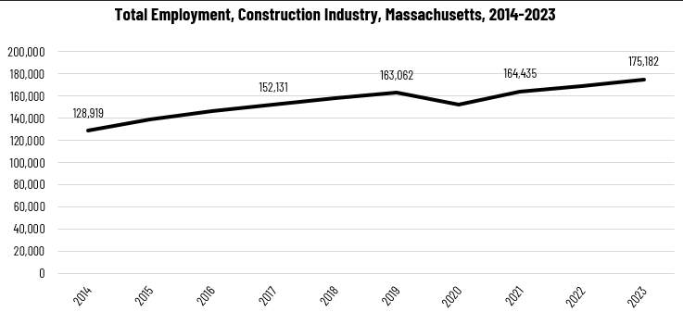

When we break down the growth of the Construction industry, we see that while increases have been seen in all three construction sectors, growth in both the total number of jobs and the percentage of jobs added has been led by the Specialty Trades Contractors sector.

#### Tables 3 and 4: Employment Change, Construction Industries, Massachusetts, 2014-2023

|  |  |  |  |  |  |  |  |
| --- | --- | --- | --- | --- | --- | --- | --- |
| Industry | 2014 | 2018 | 2019 | 2020 | 2021 | 2022 | 2023 |
| Construction of Buildings | 27,137 | 33,381 | 34,166 | 32,452 | 34,825 | 35,900 | 37,092 |
| Heavy/Civil Engineering Construction | 12,671 | 14,105 | 13,893 | 13,820 | 13,843 | 14,128 | 14,325 |
| Specialty Trade Contractors | 89,112 | 111,169 | 115,003 | 106,094 | 115,768 | 119,104 | 123,765 |

|  |  |  |
| --- | --- | --- |
| Industry | Change | % Change |
| Construction of Buildings | 9,955 | 36.7% |
| Heavy/Civil Engineering Construction | 1,654 | 13.1% |
| Specialty Trade Contractors | 34,654 | 38.9% |

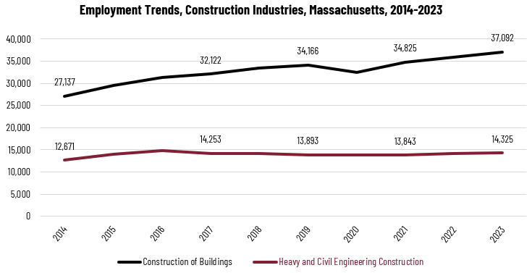

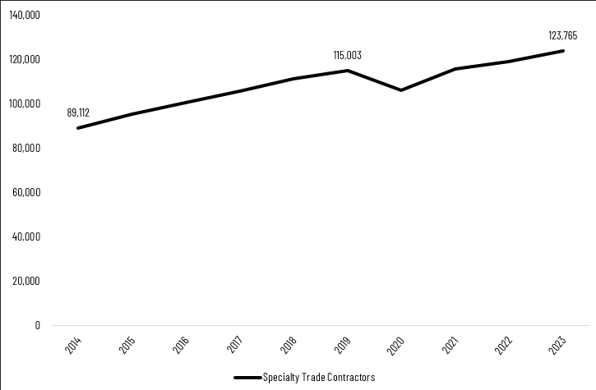

At the most detailed level available, we see that growth was led over the decade by Poured Concrete Contractors (NAICS 238110) and Residential Remodelers (NAICS 236118). Plumbing, Heating and Air-conditioning Contractors ranked fifth with more than 48% growth.

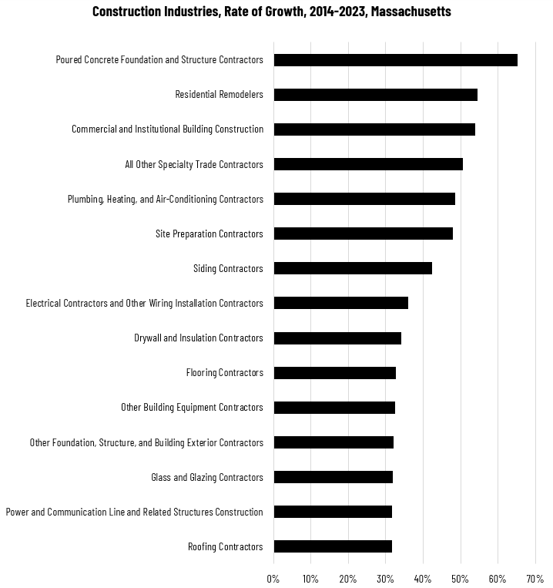

### Wages, Salaries and Proprietor Earnings

Among the detailed industry categories, the highest wages are found in the Industrial Building and Power Line Construction employers. The lowest are in Residential Remodelers and Painting Contractors.

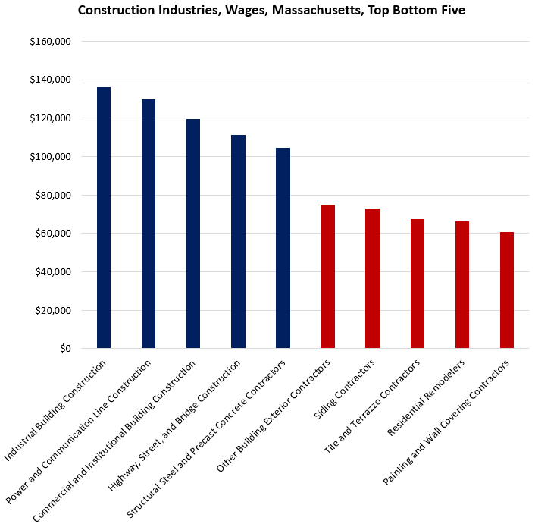

## The Pathways

### Plumbing Occupations and Pathways

This section looks at two entry-level occupations, Plumber Helpers and Plumbers, Pipefitters and Steamfitters, which is the most granular occupation category available in public labor market data systems. It will also consider advancement opportunities in related careers that are not purely plumbing related, but that illustrate opportunities that may be available to plumbers with additional experience and education.

#### Table 5: Plumbing Occupations, Massachusetts

|  |  |  |  |  |  |
| --- | --- | --- | --- | --- | --- |
| Occupation | 2023 Jobs | Turnover Rate | 2014 - 2023 Change | 2014 - 2023 % Change | Median Annual Earnings |
| Plumber Helpers | 493 | 56.1% | (280) | (36.2%) | $43,826 |
| Plumbers, Pipefitters &  Steamfitters | 15,064 | 49.8% | 3,984 | 36.0% | $79,830 |

While plumbing-related occupations are certainly viable careers in their own rights, they also can serve as entry points to progressively more sophisticated and better-paying roles.

#### Table 6: Related Career Pathways

##### Job Zone Two Occupations

|  |  |  |  |
| --- | --- | --- | --- |
| Occupation | 2023 Jobs | Typical Education Requirement | Median Annual Earnings |
| Helpers-Pipelayers, Plumbers, Pipefitters and Steamfitters | 493 | High School | $43,826 |
| Pipelayer | 200 | No formal education | $56,264 |

##### Job Zone Three Occupations

|  |  |  |  |
| --- | --- | --- | --- |
| Occupation | 2023 Jobs | Typical Education Requirement | Median Annual Earnings |
| Plumbers, Pipefitters and Steamfitters | 15,064 | High School | $79,830 |
| First-Line Supervisors of Construction Workers | 15,659 | Postsecondary Certificate | $98,114 |

##### Job Zone Four Occupations

|  |  |  |  |
| --- | --- | --- | --- |
| Occupation | 2023 Jobs | Typical Education Requirement | Median Annual Earnings |
| Cost Estimators | 5,069 | Bachelor’s Degree | $98,842 |
| Construction Managers | 7,087 | Bachelor’s Degree | $119,413 |

## Occupation Profile

The United States Department of Labor, Employment and Training Administration created and regularly updates more than 800 occupational profiles with characteristics like skills, educational requirements, and daily tasks, based on the inputs of industry experts and people who are employed in the occupations.

### Plumbers, Pipefitters and Steamfitters

Assemble, install, alter, and repair pipelines or pipe systems that carry water, steam, air, or other liquids or gases. May install heating and cooling equipment and mechanical control systems. Includes sprinkler fitters.

#### Top Skills

* Using logic and reasoning to identify the strengths and weaknesses of alternative solutions, conclusions, or approaches to problems
* Determining causes of operating errors and deciding what to do about them
* Repairing machines or systems using the needed tools
* Considering the relative costs and benefits of potential actions to choose the most appropriate one
* Monitoring/Assessing performance of yourself, other individuals, or organizations to make improvements or take corrective action
* Talking to others to convey information effectively
* Adjusting actions in relation to others' actions
* Identifying complex problems and reviewing related information to develop and evaluate options and implement solutions
* Watching gauges, dials, or other indicators to make sure a machine is working properly
* Controlling operations of equipment or systems
* Managing one's own time and the time of others
* Understanding written sentences and paragraphs in work-related documents

#### Top Daily Activities

* Install plumbing or piping
* Maintain plumbing structures or fixtures
* Weld metal components
* Mark reference points on construction materials
* Measure materials or objects for installation or assembly
* Create construction or installation diagrams
* Cut metal components for installation
* Fabricate parts or components
* Plan layout of construction, installation, or repairs
* Inspect plumbing systems or fixtures
* Review blueprints or specifications to determine work requirements
* Select construction materials
* Direct construction or extraction personnel
* Clean equipment or facilities
* Estimate construction project costs
* Estimate construction project labor requirements
* Install gauges or controls
* Record operational or environmental data
* Inspect work sites to determine condition or necessary repairs
* Repair worn, damaged, or defective mechanical parts
* Remove parts or components from equipment
* Replace worn, damaged, or defective mechanical parts
* Cut openings in existing structures
* Inspect work sites to identify potential environmental or safety hazards
* Install green plumbing or water handling systems
* Operate pumps or compressors

#### Additional Information

* American Fire Sprinkler Association external site
* American Welding Society external site
* Home Builders Institute external site
* International Association of Machinists and Aerospace Workers external site
* International Brotherhood of Electrical Workers external site
* Mechanical Contractors Association of America external site
* National Association of Home Builders external site
* National Center for Construction Education and Research external site
* National Fire Protection Association external site
* National Fire Sprinkler Association

#### Job Postings

P2C uses a third-party system that aggregates data from job postings to provide perspective on the skills and qualifications employers are prioritizing in their advertisements for these occupations.

* After controlling for multiple postings that likely referenced the same single opening, over the last year, we identified 1,272 unique job postings for plumbers, pipefitters, and steamfitters in Massachusetts.
* We identified 239 unique employers who posted openings online.

##### Top Employers Advertising:

* Tradesmen International
* Roto-Rooter Service
* State of Massachusetts
* Work With Your Handz
* GPAC
* Harvard University
* Barrell Plumbing and Heating
* Mass General Brigham
* Bath Fitter

##### Top Job Titles:

* Plumbers
* Licensed Plumbers
* Pipefitters
* Journeyman Plumbers
* Plumbing Service Technicians
* Plumbing Technicians
* Plumbers/Steamfitters
* Steamfitters
* Plumbers/Pipefitters
* Licensed Journeyman Plumbers
* Fitters
* Pipe Welders

##### Top Qualifications:

* Valid Driver's License
* 10-Hour OSHA General Industry Card
* EPA 608 Technician Certification
* National Center for Construction Education & Research (NCCER) Certification
* Wastewater Operator Certification
* Asbestos Abatement Worker License/Certification
* Certified Pool & Spa Operator
* NICET Level II Certification

##### Top Skills:

* Communications
* Customer Service
* Troubleshooting
* Operations
* Lifting Ability

### Helpers-Pipelayers, Plumbers, Pipefitters and Steamfitters

Help plumbers, pipefitters, steamfitters, or pipelayers by performing duties requiring less skill. Duties include using, supplying, or holding materials or tools, and cleaning work area and equipment.

#### Top Skills

* Giving full attention to what other people are saying, taking time to understand the points being made, asking questions as appropriate, and not interrupting at inappropriate times
* Using logic and reasoning to identify the strengths and weaknesses of alternative solutions, conclusions, or approaches to problems
* Monitoring/Assessing performance of yourself, other individuals, or organizations to make improvements or take corrective action
* Considering the relative costs and benefits of potential actions to choose the most appropriate one
* Adjusting actions in relation to others' actions
* Understanding the implications of new information for both current and future problem-solving and decision-making
* Identifying complex problems and reviewing related information to develop and evaluate options and implement solutions
* Repairing machines or systems using the needed tools
* Talking to others to convey information effectively
* Being aware of others' reactions and understanding why they react as they do

#### Top Daily Tasks

* Measure, cut, thread and assemble new pipe, placing the assembled pipe in hangers or other supports
* Cut or drill holes in walls or floors to accommodate the passage of pipes
* Perform rough-ins, repair and replace fixtures and water heaters, and locate, repair, or remove leaking or broken pipes
* Assist pipe fitters in the layout, assembly, and installation of piping for air, ammonia, gas, and water systems
* Cut pipe and lift up to fitters
* Fit or assist in fitting valves, couplings, or assemblies to tanks, pumps, or systems, using hand tools
* Requisition tools and equipment, select type and size of pipe, and collect and transport materials and equipment to work site
* Mount brackets and hangers on walls and ceilings to hold pipes, and set sleeves or inserts to provide support for pipes
* Excavate and grade ditches, and lay and join pipe for water and sewer service
* Disassemble and remove damaged or worn pipe
* Clean shop, work area, and machines, using solvent and rags

#### Additional Information

* Laborers' International Union of North America
* National Center for Construction Education and Research
* Plumbing-Heating-Cooling Contractors Association
* United Association of Journeymen and Apprentices of the Plumbing and Pipe Fitting Industry