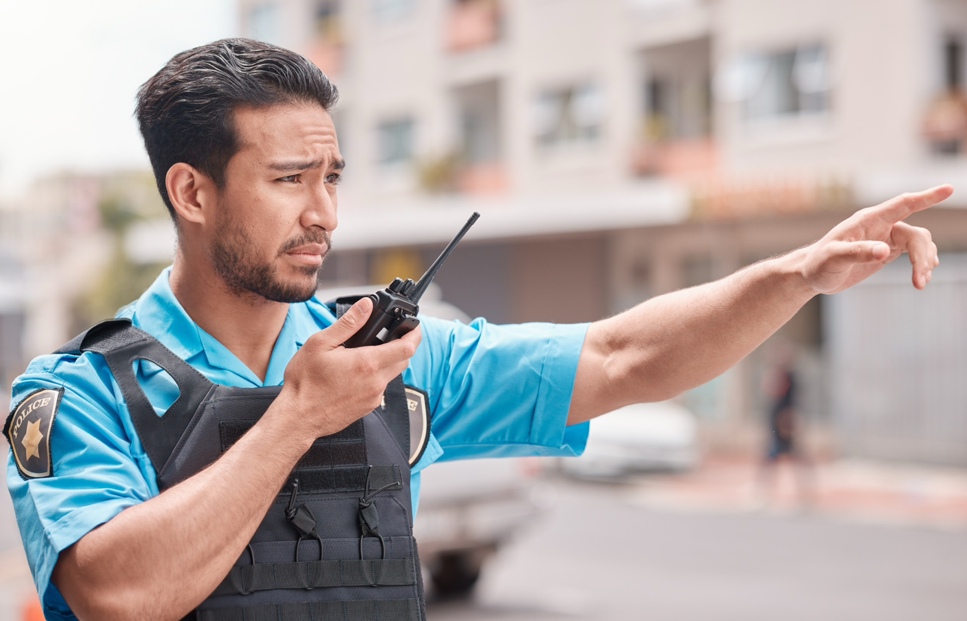

# Public Safety Credentials of Value

February 2025

## Credentials of Value

### Safety

[OSHA 10 - General Industry](https://www.osha.com/courses/10-hour-construction.html), OSHA

### Essential (one)

[Telecommunicator Certification](https://www.mass.gov/info-details/telecommunicator-certification-program-tcp), Commonwealth of Massachusetts

[Basic Life Support (BLS) Certification](https://cpr.heart.org/en/cpr-courses-and-kits/healthcare-professional/basic-life-support-bls-training), American Heart Association

[Heartsaver First Aid Certification,](https://cpr.heart.org/en/cpr-courses-and-kits/heartsaver/heartsaver-first-aid-training) American Heart Association

### Supplemental - Postsecondary

[Emergency Medical Dispatch (EMD)](https://www.apcointl.org/courses/emergency-medical-dispatch-5th-ed-version-4-virtual-classroom-72432/), APCO

[Fire Service Communications](https://www.apcointl.org/courses/fire-service-communications-3rd-edition-online-72752/), APCO

[Law Enforcement Communications](https://www.apcointl.org/courses/law-enforcement-communications-1st-ed-online-72740/), APCO

[ETC (Emergency Telecommunicator), International Academies of Emergency Dispatch (IAED)](https://www.emergencydispatch.org/what-we-do/courses-and-training?tab=etc-tab)

[Emergency Medical Dispatch](https://www.emergencydispatch.org/what-we-do/courses-and-training?tab=medical-tab), IAED

[Emergency Fire Dispatch](https://www.emergencydispatch.org/what-we-do/courses-and-training?tab=fire-tab), IAED

[Emergency Police Dispatch](https://www.emergencydispatch.org/what-we-do/courses-and-training?tab=police-tab), IAED

[24 Hour Hazardous Materials Technician](https://www.osha.com/courses/24-hour-hazardous-materials-technician-online.html), OSHA