# Labor Market Analysis of Sheet Metal Workers in Massachusetts

## Overview

This analysis uses labor market data from the Massachusetts Department of Economic Research to provide perspective on two theaters related to the skilled trades in the construction field: the construction industry and thirteen occupations in the career pathway commonly referred to as the Skilled Trades:

1. Brickmasons and Blockmasons
2. Stonemasons
3. Carpenters
4. Tile and Stone Setters
5. Cement Masons and Concrete Finishers
6. Operating Engineers and Other Equipment Operators
7. Electricians
8. Painters, Construction, and Maintenance
9. Pipelayers
10. Plumbers, Pipefitters, and Steamfitters
11. Reinforcing Iron and Rebar Workers
12. Sheet Metal Workers
13. Structural Iron and Steel Workers

The industry should be understood as the employers in the Commonwealth whose primary line of business is construction. Those companies employ a spectrum of occupations, ranging from skilled tradesmen to real estate agents. While trends in the construction industry are not necessarily directly related to the skilled trades, the large majority of tradesmen work for construction companies, making its realities and trends a valuable backdrop against which to evaluate these careers in Massachusetts.

In public data systems, occupations are a set of tasks regularly performed by one individual on an employer’s payroll. In this analysis, the target occupations are profiled both as a set and individually as we seek to provide strategic value in the development and administration of related curriculum and the construction of compelling and instructive narratives that will introduce students to the world of the skilled trades in the 21st Century.

## The Construction Industry

### The Construction Industry in Labor Market Data Systems

Construction (NAICS code 23) comprises all employers whose primary line of business is construction. The industry category is divided into three sub-industries:

* 236-Construction of Buildings
* 237-Heavy and Civil Engineering Construction
* 238-Specialty Trades Contractors

Each of these categories is further parsed into four-, five-, and ultimately six-digit level categories, and the Massachusetts Department of Economic Research produces employment and wage estimates for each.

#### Construction Industry Categories

* 236 Construction of Buildings
  + 236115 New Single-Family Housing Construction (except For-Sale Builders)
  + 236116 New Multifamily Housing Construction (except For-Sale Builders)
  + 236117 New Housing For-Sale Builders
  + 236118 Residential Remodelers
  + 236210 Industrial Building Construction
  + 236220 Commercial and Institutional Building Construction
* 237 Heavy and Civil Engineering Construction
  + 237110 Water and Sewer Line and Related Structures Construction
  + 237120 Oil and Gas Pipeline and Related Structures Construction
  + 237130 Power and Communication Line and Related Structures Construction
  + 237210 Land Subdivision
  + 237310 Highway, Street, and Bridge Construction
  + 237990 Other Heavy and Civil Engineering Construction
* 238 Specialty Trades Contractors
  + 238110 Poured Concrete Foundation and Structure Contractors
  + 238120 Structural Steel and Precast Concrete Contractors
  + 238130 Framing Contractors
  + 238140 Masonry Contractors
  + 238150 Glass and Glazing Contractors
  + 238160 Roofing Contractors
  + 238170 Siding Contractors
  + 238190 Other Foundation, Structure, and Building Exterior Contractors
  + 238210 Electrical Contractors and Other Wiring Installation Contractors
  + 238220 Plumbing, Heating, and Air-Conditioning Contractors
  + 238290 Other Building Equipment Contractors
  + 238310 Drywall and Insulation Contractors
  + 238320 Painting and Wall Covering Contractors
  + 238330 Flooring Contractors
  + 238340 Tile and Terrazzo Contractors
  + 238350 Finish Carpentry Contractors
  + 238390 Other Building Finishing Contractors

### Employment-Electricians

It is not surprising that at the most granular level available, the industry that most often employs electricians in Massachusetts is Electrical Contractors (NAICS 23821). Approximately three quarters of the Commonwealth’s electricians work in that industry. It is interesting to note, however, that the Temporary Help Services (56132) and Local Government (90399) sectors also rank in the top five for employment of electricians. The table below details the top five detailed industry sectors by the share of electricians who are employed in them.

#### Table 1: Top Detailed Industries for Electricians

|  |  |
| --- | --- |
| Industry | Share of Occupation Jobs |
| Electrical and Other Wiring Installation Contractors | 74.9% |
| Temporary Help Services | 3.4% |
| Plumbing, Heating, and Air-Conditioning Contractors | 2.3% |
| Commercial and Institutional Building Construction | 1.6% |
| Local Government | 1.4% |

### Employment Trends

The number of people employed in the Construction industry in Massachusetts has been steadily increasing over the last decade, except for a significant COVID-19-related decline in 2020. The net change has been an increase of 35.9% in jobs over the last decade.

#### Table 3: Average Annual Employment, Construction Industry, Massachusetts, 2014-2023

|  |  |
| --- | --- |
| Year | Jobs |
| 2014 | 128,919 |
| 2015 | 138,991 |
| 2016 | 146,503 |
| 2017 | 152,131 |
| 2018 | 158,656 |
| 2019 | 163,062 |
| 2020 | 152,366 |
| 2021 | 164,435 |
| 2022 | 170,026 |
| 2023 | 176,199 |

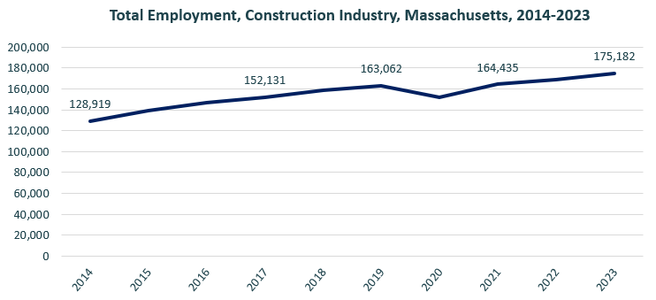

When we break down the growth of the Construction industry, we see that while growth has been seen in all three construction sectors, growth in both the total number of jobs and the percentage of jobs added has been led by the Specialty Trades Contractors sector.

#### Tables 4 and 5: Employment Change, Construction Industries, Massachusetts, 2014-2023

|  |  |  |  |  |  |  |  |
| --- | --- | --- | --- | --- | --- | --- | --- |
| Industry | 2014 | 2018 | 2019 | 2020 | 2021 | 2022 | 2023 |
| Construction of Buildings | 27,137 | 33,381 | 34,166 | 32,452 | 34,825 | 35,900 | 37,092 |
| Heavy/Civil Engineering Construction | 12,671 | 14,105 | 13,893 | 13,820 | 13,843 | 14,128 | 14,325 |
| Specialty Trade Contractors | 89,112 | 111,169 | 115,003 | 106,094 | 115,768 | 119,104 | 123,765 |

|  |  |  |
| --- | --- | --- |
| Industry | Change | % Change |
| Construction of Buildings | 9,955 | 36.7% |
| Heavy/Civil Engineering Construction | 1,654 | 13.1% |
| Specialty Trade Contractors | 34,654 | 38.9% |

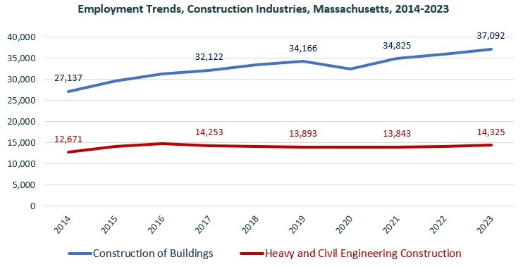

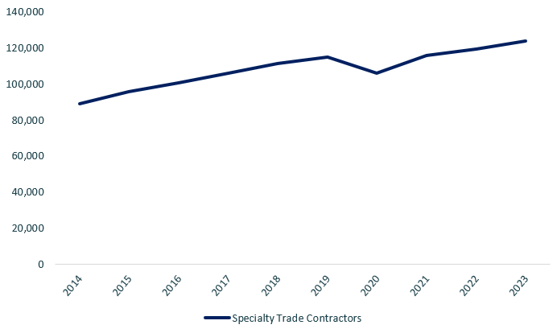

At the most detailed level available, we see that growth was led over the decade by Poured Concrete Contractors (NAICS 238110) and Residential Remodelers (NAICS 236118).

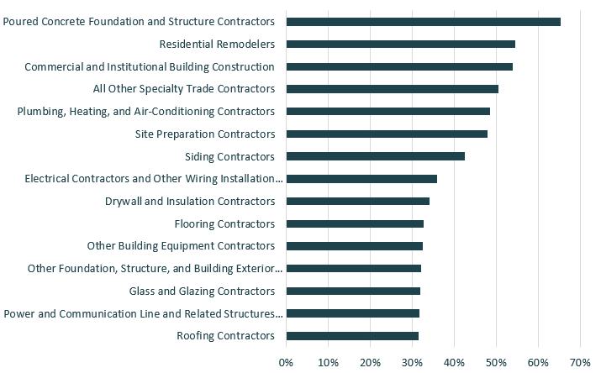

### Wages, Salaries and Proprietor Earnings

Among the detailed industry categories, the highest wages are found in the Industrial Building and Power Line Construction employers. The lowest are in Residential Remodelers and Painting Contractors.

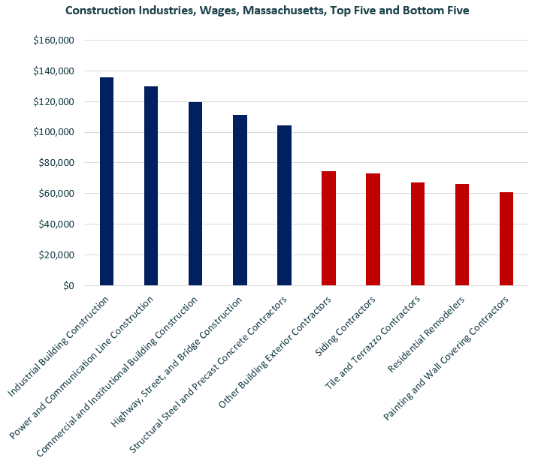

## The Pathways

### Electricity Occupations and Pathways

This section looks at the target occupation category: Electricians. It will also consider advancement opportunities in related careers that are not directly related to the program of study, but that illustrate opportunities that may be available to workers in this field with additional education and experience.

#### Table 5: Electricians, Massachusetts

|  |  |  |  |  |  |
| --- | --- | --- | --- | --- | --- |
| Occupation | 2023 Jobs | Turnover Rate | 2014 - 2023 Change | 2014 - 2023 % Change | Median Annual Earnings |
| Electricians | 18,498 | 51.0% | 3,832 | 26% | $82,222 |

While careers in these two occupations are certainly viable in their own rights, they also can serve as entry points to progressively more sophisticated and better-paying roles.

#### Table 6: Related Career Pathways

##### Job Zone Two Occupations

|  |  |  |  |
| --- | --- | --- | --- |
| Occupation | 2023 Jobs | Typical Education Requirement | Median Annual Earnings |
| Helpers-Electricians | 1,428 | High school | $45,906 |
| Solar Photovoltaic Installers | 982 | High school | $48,620 |

##### Job Zone Three Occupations

|  |  |  |  |
| --- | --- | --- | --- |
| Occupation | 2023 Jobs | Typical Education Requirement | Median Annual Earnings |
| Electricians | 18,498 | High school | $82,222 |
| Energy Auditors (data for building inspectors) | 3,835 | High school | $77,522 |
| Construction and Building Inspectors | 3,835 | High school | $77,522 |
| Solar Energy Installation Managers (data for construction supervisors) | 15,659 | High school | $98,592 |
| First-Line Supervisors of Construction Trades and Extraction Workers | 15,659 | High school | $98,592 |

##### Job Zone Four Occupations

|  |  |  |  |
| --- | --- | --- | --- |
| Occupation | 2023 Jobs | Typical Education Requirement | Median Annual Earnings |
| Energy Engineers (data for Engineers, All Other) | 3,229 | Bachelor’s | $112,690 |
| Construction Managers | 7,087 | Bachelor’s | $131,727 |

## Occupation Profiles

The United States Department of Labor, Employment, and Training Administration created and regularly updates more than 800 occupational profiles with characteristics like skills, educational requirements, and daily tasks, based on the inputs of industry experts and people who are employed in the occupations.

### Sheet Metal Workers

#### Description

Fabricate, assemble, install, and repair sheet metal products and equipment, such as ducts, control boxes, drainpipes, and furnace casings. Work may involve any of the following: setting up and operating fabricating machines to cut, bend, and straighten sheet metal; shaping metal over anvils, blocks, or forms using hammer; operating soldering and welding equipment to join sheet metal parts; or inspecting, assembling, and smoothing seams and joints of burred surfaces. Includes sheet metal duct installers who install prefabricated sheet metal ducts used for heating, air conditioning, or other purposes.

#### Top Skills

* Understanding written sentences and paragraphs in work-related documents.
* Using logic and reasoning to identify the strengths and weaknesses of alternative solutions, conclusions, or approaches to problems.
* Monitoring/Assessing performance of yourself, other individuals, or organizations to make improvements or take corrective action.
* Adjusting actions in relation to others' actions.
* Giving full attention to what other people are saying, taking time to understand the points being made, asking questions as appropriate, and not interrupting at inappropriate times.
* Talking to others to convey information effectively.
* Using mathematics to solve problems.
* Considering the relative costs and benefits of potential actions to choose the most appropriate one.
* Managing one's own time and the time of others.
* Understanding the implications of new information for both current and future problem-solving and decision-making.
* Teaching others how to do something.
* Identifying complex problems and reviewing related information to develop and evaluate options and implement solutions.
* Watching gauges, dials, or other indicators to make sure a machine is working properly.
* Controlling operations of equipment or systems.
* Performing routine maintenance on equipment and determining when and what kind of maintenance is needed.
* Determining causes of operating errors and deciding what to do about it.
* Repairing machines or systems using the needed tools.
* Conducting tests and inspections of products, services, or processes to evaluate quality or performance.
* Determining the kind of tools and equipment needed to do a job.
* Installing equipment, machines, wiring, or programs to meet specifications.
* Motivating, developing, and directing people as they work, identifying the best people for the job.
* Selecting and using training/instructional methods and procedures appropriate for the situation when learning or teaching new things.
* Being aware of others' reactions and understanding why they react as they do.
* Determining how a system should work and how changes in conditions, operations, and the environment will affect outcomes.
* Communicating effectively in writing as appropriate for the needs of the audience.
* Actively looking for ways to help people.
* Identifying measures or indicators of system performance and the actions needed to improve or correct performance, relative to the goals of the system.

#### Top Daily Tasks

* Inspect completed work to ensure proper installation.
* Maintain construction tools or equipment.
* Fabricate parts or components.
* Plan layout of construction, installation, or repairs.
* Weld metal components.
* Assemble products or production equipment.
* Install building fixtures.
* Install plumbing or piping.
* Move construction or extraction materials to locations where they are needed.
* Direct construction or extraction personnel.
* Train construction or extraction personnel.
* Mark reference points on construction materials.
* Measure materials or objects for installation or assembly.
* Position structural components.
* Review blueprints or specifications to determine work requirements.
* Create construction or installation diagrams.
* Select construction materials.
* Evaluate construction projects to determine compliance with external standards or regulations.
* Smooth surfaces with abrasive materials or tools.
* Install roofing materials.
* Inspect industrial or commercial equipment to ensure proper operation.

#### Additional Information

* American Welding Society
* Associated Builders and Contractors
* Fabricators & Manufacturers Association International
* International Association of Sheet Metal, Air, Rail and Transportation Workers
* International Training Institute for the Sheet Metal and Air Conditioning Industry
* National Center for Construction Education and Research
* Occupational Outlook Handbook: Sheet metal workers

### Job Postings- Sheet Metal Workers

P2C uses a third-party system that aggregates data from job postings to provide perspective on the skills and qualifications employers are prioritizing in their advertisements for these occupations.

* After controlling for multiple postings that likely referenced the same single opening, over the last year, we identified 402 unique job postings for Automotive Body and Related Repairers.
* We identified 132 unique employers who posted openings online.

#### Top Employers Advertising:

* Skyworks Solutions
* Tradesmen International
* Summit Careers
* Adecco
* Eaton Corporation
* Skyworks
* Amtrak
* Ferguson Enterprises
* ASML
* Tradesource
* Keolis Commuter Services
* Massachusetts Water Resources Authority

#### Top Job Titles:

* Fabrication Technicians
* Metal Fabricators
* Fabricators
* Sheet Metal Workers
* Sheet Metal Fabricators
* Sheet Metal Mechanics
* Metal Fabricators/Welders
* Sheet Metal Installers
* Field Installers
* Sheet Metal Technicians

#### Top Qualifications:

* Valid Driver's License
* 10-Hour OSHA General Industry Card
* Hoisting License
* Commercial Driver's License (CDL)
* EPA Universal Certification
* AVIXA Certified Technology Specialist
* Secret Clearance
* EPA Type II Certification

#### Top Skills:

* Sheet Metal
* Fabrication
* Hand Tools
* Welding
* Machinery
* Blueprinting
* Shears
* Sawing

### Structural Iron and Steel Workers

#### Description

Raise, place, and unite iron or steel girders, columns, and other structural members to form completed structures or structural frameworks. May erect metal storage tanks and assemble prefabricated metal buildings.

#### Top Skills

* Adjusting actions in relation to others' actions.
* Watching gauges, dials, or other indicators to make sure a machine is working properly.
* Controlling operations of equipment or systems.
* Giving full attention to what other people are saying, taking time to understand the points being made, asking questions as appropriate, and not interrupting at inappropriate times.
* Using logic and reasoning to identify the strengths and weaknesses of alternative solutions, conclusions, or approaches to problems.
* Talking to others to convey information effectively.
* Understanding the implications of new information for both current and future problem-solving and decision-making.
* Monitoring/assessing performance of yourself, other individuals, or organizations to make improvements or take corrective action.
* Identifying complex problems and reviewing related information to develop and evaluate options and implement solutions.
* Conducting tests and inspections of products, services, or processes to evaluate quality or performance.
* Considering the relative costs and benefits of potential actions to choose the most appropriate one.
* Managing one's own time and the time of others.
* Selecting and using training/instructional methods and procedures appropriate for the situation when learning or teaching new things.
* Being aware of others' reactions and understanding why they react as they do.
* Teaching others how to do something.
* Motivating, developing, and directing people as they work, identifying the best people for the job.
* Understanding written sentences and paragraphs in work-related documents.
* Actively looking for ways to help people.
* Determining causes of operating errors and deciding what to do about it.

#### Top Daily Tasks

* Review blueprints or specifications to determine work requirements.
* Install metal structural components.
* Operate cranes, hoists, or other moving or lifting equipment.
* Signal equipment operators to indicate proper equipment positioning.
* Verify alignment of structures or equipment.
* Cut metal components for installation.
* Weld metal components.
* Position structural components.
* Load or unload materials used in construction or extraction.
* Assemble temporary equipment or structures.
* Fabricate parts or components.
* Dismantle equipment or temporary structures.
* Assist skilled construction or extraction personnel.
* Install electrical components, equipment, or systems.
* Install gauges or controls.
* Install insulation in equipment or structures.
* Position safety or support equipment.
* Rivet metal components.

#### Additional Information

* American Welding Society
* Associated Builders and Contractors
* Associated General Contractors of America
* Association for Iron and Steel Technology
* International Association of Bridge, Structural, Ornamental, and Reinforcing Iron Workers
* National Center for Construction Education and Research
* National Commission for Certification of Crane Operators
* National Institute of Steel Detailing
* Occupational Outlook Handbook: Ironworkers

### Job Postings - Structural Iron and Steel Workers

P2C uses a third-party system that aggregates data from job postings to provide perspective on the skills and qualifications employers are prioritizing in their advertisements for these occupations.

* After controlling for multiple postings that likely referenced the same single opening, over the last year, we identified 31 unique job postings for Structural Steel and Iron Workers.
* We identified 18 unique employers who posted openings online.

#### Top Employers Advertising:

* Tradesmen International
* Centene
* John Wood Group
* State Auto Insurance Companies
* BrandSafway
* United Steel
* Lamar Advertising Company
* Tradespeople USA Corp
* Cec Steel
* 360 Industrial Services
* Emerald Iron Works
* Mass Crane & Hoist Service
* H.L Foster
* Ericsson
* Brand Energy & Infrastructure Services
* Liberty Mutual
* Amec Foster Wheeler International Limited

#### Top Job Titles:

* Ironworkers
* Journeyman Ironworkers
* Scaffold Erectors
* Steel Erectors
* Drivers/Laborers
* Billboard Installers
* Tower Hands
* Steel Fabricators

#### Top Qualifications:

* Valid Driver's License
* OSHA 10-Hour General Industry

#### Top Overall Skills:

* Hand Tools
* Structural Steel
* Blueprinting
* Sheeted Metal Arc Welding
* Manlifts
* PowerTools
* AWS Codes
* Welding

##### Defining Skills

* Structural Steel
* Welding
* Hoisting
* Girders

##### Differentiating Skills

* Turnbuckles