Labor Market Analysis of Stationary Engineering Careers in Massachusetts

## Overview

This analysis uses labor market data from the Massachusetts Department of Economic Research to provide perspective on multiple theaters related to the field of Manufacturing in the Commonwealth:

### The Production Occupation Family

There are 105 occupation categories in this family, ranging from Inspectors, Testers, Sorters, Samplers and Weighers (10,500 jobs in Massachusetts) to Semiconductor Processing Technicians (1,600 jobs) and Dental Laboratory Technicians (230 jobs).

### Seven primary industries

* Navigational, Measuring, Electromedical, and Control Instruments Manufacturing
* Semiconductor and Other Electronic Component Manufacturing
* Plastics Product Manufacturing
* Bakeries and Tortilla Manufacturing
* Medical Equipment and Supplies Manufacturing
* Pharmaceutical and Medicine Manufacturing
* Machine Shops; Turned Product; and Screw, Nut, and Bolt Manufacturing

**The Occupations** are the specific jobs into which graduates of the Manufacturing programs will hopefully enter after graduation. In public data systems, occupations are a set of tasks regularly performed by one individual on an employer’s payroll. In this analysis, the target occupations are profiled in addition to the broad spectrum of industries that employ them as we seek to provide strategic value in the development and administration of related curriculum and the construction of compelling and instructive narratives that will introduce students to the world of Manufacturing in the 21st Century.

**The Industries** which employ the target occupations are defined by their primary lines of business. The manufacturing industry in Massachusetts is defined as “establishments engaged in the mechanical, physical, or chemical transformation of materials, substances, or components into new products.” The industry employes more than 237,000 people in the Commonwealth, and those jobs are spread across abroad spectrum of manufacturing types. In terms of total employment, there are seven manufacturing industries which employ 10,000 or more people in Massachusetts:

* Navigational, Measuring, Electromedical, and Control Instruments Manufacturing
* Semiconductor and Other Electronic Component Manufacturing
* Plastics Product Manufacturing
* Bakeries and Tortilla Manufacturing
* Medical Equipment and Supplies Manufacturing
* Pharmaceutical and Medicine Manufacturing
* Machine Shops; Turned Product; and Screw, Nut, and Bolt Manufacturing

Navigational, Measuring, Electromedical, and Control Instruments Manufacturing

Establishments primarily engaged in manufacturing navigational, measuring, electromedical, and control instruments. Examples of products made by these establishments are aeronautical instruments, appliance regulators and controls (except switches), laboratory analytical instruments, navigation and guidance systems, and physical properties testing equipment.

Semiconductor and Other Electronic Component Manufacturing

Establishments primarily engaged in manufacturing semiconductors and other components for electronic applications. Examples of products made by these establishments are capacitors, resistors, microprocessors, bare and loaded printed circuit boards, electron tubes, electronic connectors, and computer modems.

Plastics Product Manufacturing

Establishments Primarily Engaged in Processing New or Spent (I.E., Recycled) Plastics Resins into intermediate or final products, using such processes as compression molding; extrusion molding; injection molding; blow molding; and casting. Within most of these industries, the production process is such that a wide variety of products can be made.

Bakeries and Tortilla Manufacturing

Establishments primarily engaged in one of the following: (1) manufacturing fresh and frozen bread and other bakery products; (2) retailing bread and other bakery products not for immediate consumption made on the premises from flour, not from prepared dough; (3) manufacturing cookies, crackers, and dry pasta; (4) manufacturing prepared flour mixes or dough from flour ground elsewhere; or (5) manufacturing tortillas.

Medical Equipment and Supplies Manufacturing

Establishments primarily engaged in manufacturing medical equipment and supplies. Examples of products made by these establishments are surgical and medical instruments, surgical appliances and supplies, dental equipment and supplies, orthodontic goods, ophthalmic goods, dentures, and orthodontic appliances.

Pharmaceutical and Medicine Manufacturing

Establishments primarily engaged in one or more of the following: (1) manufacturing biological and medicinal products; (2) processing (i.e., grading, grinding, and milling) botanical drugs and herbs; (3) isolating active medicinal principals from botanical drugs and herbs; and (4) manufacturing pharmaceutical products intended for internal and external consumption in such forms as ampoules, tablets, capsules, vials, ointments, powders, solutions, and suspensions.

Machine Shops; Turned Product; and Screw, Nut, and Bolt Manufacturing

Establishments known as machine shops primarily engaged in machining metal and plastic parts and parts of other composite materials on a job or order basis. Generally, machine shop jobs are low volume using machine tools, such as lathes (including computer numerically controlled); automatic screw machines; and machines for boring, grinding, milling, and additive manufacturing.

## The Industries

The Federal system of labor market data defines 86 specific manufacturing industries at the four-digit NAICS (North American Industry Classification System level), allowing for a detailed analysis of the various types of manufacturing operations that make up this critical sector of the Massachusetts economy.

### Table #1 Largest Manufacturing Industries, Massachusetts, 2023

|  |  |  |
| --- | --- | --- |
| Industry | 2023 Jobs | Median Annual Earnings |
| Navigational, Measuring, Electromedical, and Control Instruments Manufacturing | 26,515 | $134,520 |
| Semiconductor and Other Electronic Component Manufacturing | 14,797 | $134,340 |
| Plastics Product Manufacturing | 11,941 | $75,103 |
| Bakeries and Tortilla Manufacturing | 11,313 | $47,710 |
| Medical Equipment and Supplies Manufacturing | 10,893 | $109,089 |
| Pharmaceutical and Medicine Manufacturing | 10,495 | $162,738 |
| Machine Shops; Turned Product; and Screw, Nut, and Bolt Manufacturing | 10,463 | $79,549 |
| Aerospace Product and Parts Manufacturing | 9,575 | $139,713 |
| Other Miscellaneous Manufacturing | 7,976 | $85,671 |
| Printing and Related Support Activities | 7,868 | $78,017 |
| Beverage Manufacturing | 6,635 | $65,228 |
| Computer and Peripheral Equipment Manufacturing | 6,194 | $197,582 |
| Industrial Machinery Manufacturing | 5,920 | $134,020 |
| Converted Paper Product Manufacturing | 5,315 | $77,660 |
| Architectural and Structural Metals Manufacturing | 4,964 | $84,812 |
| Other Food Manufacturing | 4,367 | $73,219 |

Total 155,231

### Employment Trends

The total number of jobs in the Massachusetts manufacturing sector has declined in recent years, but with more than 237,000 jobs, remains a critical component of the Massachusetts economy. These businesses shed six percent of their total employment during the COVID-19 pandemic and have yet to return to pre-COVID levels.

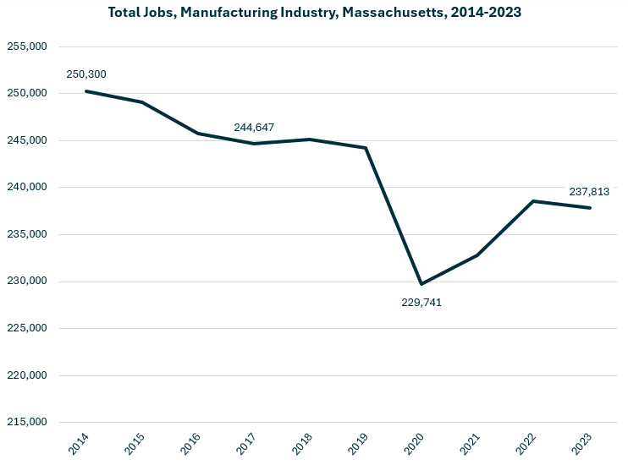

Growth in employment has been led by the Breweries (NAICS 312120) industry, which has added more than 2,600 jobs over the last decade. Analytical Laboratory Instrument Manufacturing (334516), Retail Bakeries (311811), Semiconductors (333242) and Seafood Products (311710) round out the top five.

#### Table #2 Detailed (6DL) Industries, by Largest Ten-Year Increase in Employment, Massachusetts, 2014-2023

|  |  |  |
| --- | --- | --- |
| Industry | Ten-Year Change | Ten-Year % Change |
| Breweries | 2,685 | 415% |
| Analytical Laboratory Instrument Manufacturing | 2,447 | 37% |
| Retail Bakeries | 1,474 | 39% |
| Semiconductor Machinery Manufacturing | 1,361 | 58% |
| Seafood Product Preparation and Packaging | 1,330 | 59% |
| Electromedical and Electrotherapeutic Apparatus Manufacturing | 1,250 | 33% |
| Biological Product (except Diagnostic) Manufacturing | 909 | 135% |
| Frozen Specialty Food Manufacturing | 808 | 137% |
| Other Electronic Component Manufacturing | 760 | 31% |
| Meat Processed from Carcasses | 552 | 32% |
| All Other Miscellaneous Electrical Equipment and Component Manufacturing | 535 | 36% |
| All Other Industrial Machinery Manufacturing | 529 | 41% |
| Soft Drink Manufacturing | 511 | 32% |
| Mayonnaise, Dressing, and Other Prepared Sauce Manufacturing | 477 | 52% |
| Custom Architectural Woodwork and Millwork Manufacturing | 452 | 82% |
| All Other Plastics Product Manufacturing | 411 | 6% |
| Cut and Sew Apparel Contractors | 404 | 137% |
| Rubber Product Manufacturing for Mechanical Use | 375 | 114% |
| All Other Miscellaneous Food Manufacturing | 360 | 93% |
| Commercial and Service Industry Machinery Manufacturing | 345 | 12% |

The industries experiencing the largest decrease in total employment include Computer Storage Device Manufacturing and Commercial Printing.

#### Table #3 Detailed (6DL) Industries, by Largest Ten-Year Decrease in Employment, Massachusetts, 2014-2023

|  |  |  |
| --- | --- | --- |
| Industry | Ten-Year Change | Ten-Year % Change |
| Computer Storage Device Manufacturing | (3,596) | (44.8%) |
| Commercial Printing (except Screen and Books) | (2,864) | (36.4%) |
| Commercial Bakeries | (1,661) | (26.9%) |
| Electronic Computer Manufacturing | (1,637) | (53.7%) |
| Search, Detection, Navigation, Guidance, Aeronautical, and Nautical System and Instrument Manufacturing | (1,211) | (23.8%) |
| Cut and Sew Apparel Manufacturing (except Contractors) | (1,063) | (53.6%) |
| Computer Terminal and Other Computer Peripheral Equipment Manufacturing | (974) | (73.5%) |
| Fruit and Vegetable Canning | (971) | (74.3%) |
| Audio and Video Equipment Manufacturing | (901) | (36.3%) |
| Pharmaceutical Preparation Manufacturing | (867) | (11.3%) |
| Aircraft Engine and Engine Parts Manufacturing | (840) | (20.3%) |
| Instruments and Related Products Manufacturing for Measuring, Displaying, and Controlling Industrial Process Variables | (679) | (15.3%) |
| Plastics Material and Resin Manufacturing | (676) | (31.9%) |
| Relay and Industrial Control Manufacturing | (663) | (44.6%) |
| Fluid Milk Manufacturing | (659) | (45.2%) |
| Jewelry and Silverware Manufacturing | (587) | (39.2%) |
| Paper Mills | (565) | (33.9%) |
| Perishable Prepared Food Manufacturing | (550) | (36.5%) |
| Industry | Ten-Year Change | Ten-Year % Change |
| Knit Fabric Mills | (509) | (89.0%) |
| Paper Bag and Coated and Treated Paper Manufacturing | (495) | (19.6%) |

### Comparative Advantage

An employment Location Quotient (LQ) is a value in which the concentration of a region’s employment in a particular industry is indexed against the national norm. For example, if the percentage of a region’s workforce that is employed in the Aerospace Manufacturing sector were identical to the national average, that industry would return an LQ of 1.0. If the region’s workforce were employed in that industry at a rate double the national average, that would return an LQ of 2.0.

We estimated Location Quotients for detailed manufacturing industries in Massachusetts, using that value to highlight industries that are part of the unique fabric of regional economies, regardless of total employment. This critical exercise affords a valuable perspective by looking at the manufacturing industries uniquely important to the economic prospects of the Commonwealth.

#### Table #4 Detailed (6DL) Manufacturing Industry by Location Quotient (LQ) and Jobs

|  |  |  |
| --- | --- | --- |
| Detailed (6DL) Manufacturing Industry | LQ | Jobs |
| Computer Storage Device Manufacturing | 13.11 | 4,427 |
| Analytical Laboratory Instrument Manufacturing | 8.05 | 9,033 |
| Fabric Coating Mills | 6.75 | 1,091 |
| Metal Kitchen Cookware, Utensil, Cutlery, and Flatware Manufacturing | 6.23 | 1,439 |
| Semiconductor Machinery Manufacturing | 5.20 | 3,712 |
| Footwear Manufacturing | 4.63 | 1,293 |
| Seafood Product Preparation and Packaging | 4.51 | 3,581 |
| Audio and Video Equipment Manufacturing | 3.49 | 1,579 |
| Abrasive Product Manufacturing | 3.38 | 798 |
| Irradiation Apparatus Manufacturing | 3.19 | 1,066 |
| Saw Blade and Handtool Manufacturing | 3.19 | 2,004 |
| Guided Missile and Space Vehicle Manufacturing | 3.16 | 5,916 |
| Electromedical and Electrotherapeutic Apparatus Manufacturing | 2.78 | 4,981 |
| Instruments for Measuring, Displaying, Controlling Industrial Process Variables | 2.76 | 3,760 |
| Other Communication and Energy Wire Manufacturing | 2.74 | 854 |

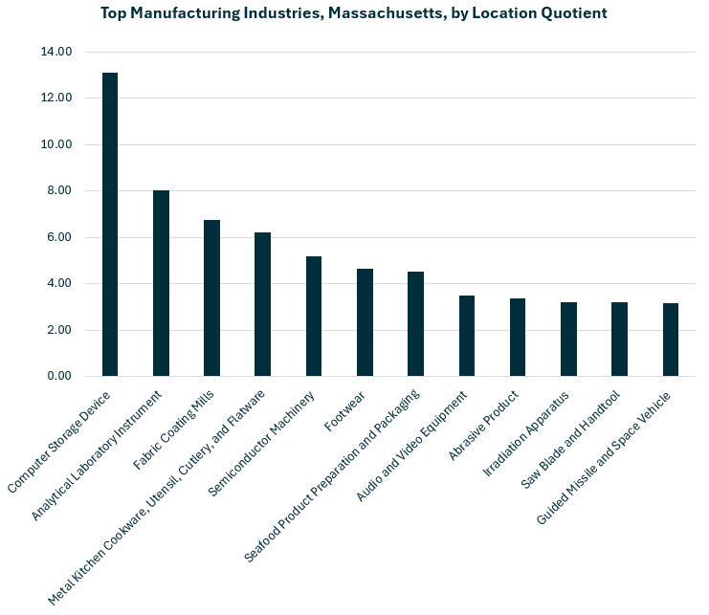

### Economic Activity

Manufacturing is one of the Commonwealth’s five largest private-sector contributors to the regional economy, accounting for approximately one of every thirteen dollars generated. In 2023 the sector contributed $56 billion to the state’s Gross Domestic Product.

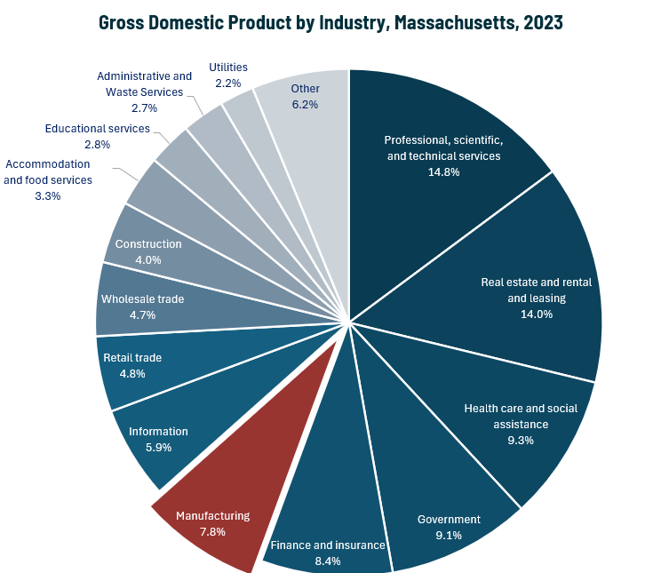

### Earnings

Earnings per manufacturing job in Massachusetts are well above the national average. The national average salary for Manufacturing in an area this size is $99,673, while in Massachusetts it is $123,029. The average has increased steadily over the last decade and now reflects an average 20.7% higher than in 2014.

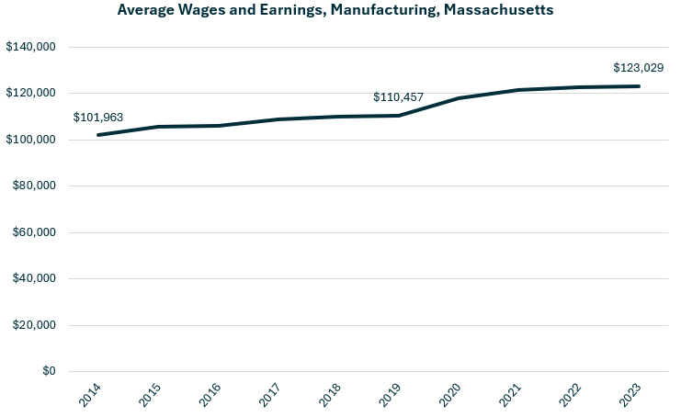

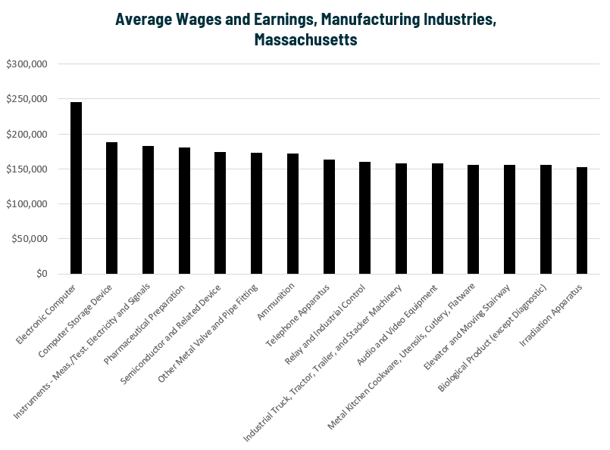

### Staffing Patterns

The occupations most commonly employed by manufacturers in Massachusetts are from the Production (SOC 51-0000). Occupations from the Management (11-0000), Engineering (17-0000) and Computer and Mathematical (15-0000) families are also found in the top ten.

#### Table #5 Top Occupations, Manufacturing Industry, Massachusetts

|  |  |  |
| --- | --- | --- |
| SOC Code | Occupation | % of Jobs in Industry |
| 51-2098 | Miscellaneous Assemblers and Fabricators | 4.0% |
| 51-1011 | First-Line Supervisors of Production and Operating Workers | 3.9% |
| 51-2028 | Electrical, Electronic, and Electromechanical Assemblers | 3.9% |
| 11-1021 | General and Operations Managers | 3.1% |
| 51-4041 | Machinists | 2.8% |
| 51-9061 | Inspectors, Testers, Sorters, Samplers, and Weighers | 2.8% |
| 17-2112 | Industrial Engineers | 2.8% |
| 15-1252 | Software Developers | 2.2% |
| 41-4012 | Sales Representatives, Wholesale and Manufacturing | 2.0% |
| 51-9111 | Packaging and Filling Machine Operators and Tenders | 1.9% |
| 43-5071 | Shipping, Receiving, and Inventory Clerks | 1.9% |
| 51-3092 | Food Batchmakers | 1.8% |
| 11-3051 | Industrial Production Managers | 1.7% |
| 53-7062 | Laborers and Freight, Stock, and Material Movers, Hand | 1.7% |
| 51-4072 | Molding, Coremaking, Casting Machine Setters, Operators, Metal & Plastic | 1.7% |
| 53-7064 | Packers and Packagers, Hand | 1.6% |
| 51-9161 | Computer Numerically Controlled Tool Operators | 1.5% |

## Program Profiles – Stationary Engineering

### Introduction

The number of boilermakers in Massachusetts is small and has declined in recent years. Median wages for this occupation are well above the average.

#### Table #6 Boilermakers

|  |  |  |  |  |
| --- | --- | --- | --- | --- |
| SOC | Description | 2023 Jobs | Median Annual Earnings | Typical Entry Level Education |
| 47-2011 | Boilermakers | 118 | $102,730 | High school |

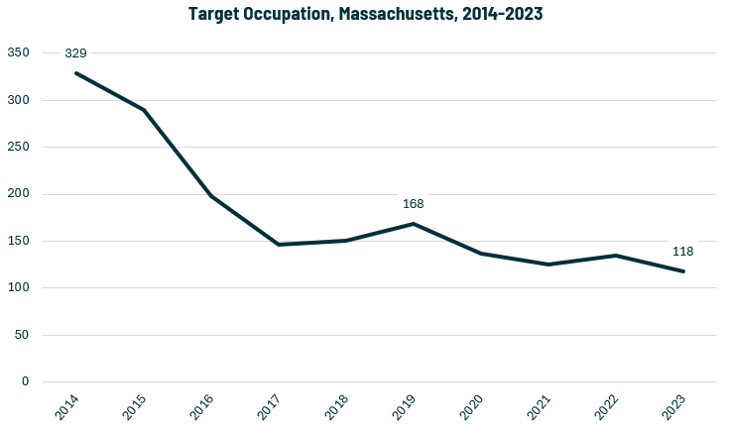

### Occupational Profile – Boilermaker

#### Description:

Construct, assemble, maintain, and repair stationary steam boilers and boiler house auxiliaries. Align structures or plate sections to assemble boiler frame tanks or vats, following blueprints. Work involves use of hand and power tools, plumb bobs, levels, wedges, dogs, or turnbuckles. Assist in testing assembled vessels. Direct cleaning of boilers and boiler furnaces. Inspect and repair boiler fittings, such as safety valves, regulators, automatic-control mechanisms, water columns, and auxiliary machines.

#### Skills:

* Watching gauges, dials, or other indicators to make sure a machine is working properly.
* Controlling operations of equipment or systems.
* Using logic and reasoning to identify the strengths and weaknesses of alternative solutions, conclusions, or approaches to problems.
* Performing routine maintenance on equipment and determining when and what kind of maintenance is needed.
* Conducting tests and inspections of products, services, or processes to evaluate quality or performance.
* Determining causes of operating errors and deciding what to do about it.
* Repairing machines or systems using the needed tools.
* Understanding written sentences and paragraphs in work-related documents.
* Monitoring/assessing performance of yourself, other individuals, or organizations to make improvements or take corrective action.
* Determining the kind of tools and equipment needed to do a job.

#### Tasks:

* Operate cranes, hoists, or other moving or lifting equipment.
* Signal equipment operators to indicate proper equipment positioning.
* Review blueprints or specifications to determine work requirements.
* Maintain mechanical equipment.
* Mark reference points on construction materials.
* Measure materials or objects for installation or assembly.
* Weld metal components.
* Install metal structural components.
* Position structural components.
* Fabricate parts or components.
* Assemble products or production equipment.
* Install gauges or controls.
* Inspect industrial or commercial equipment to ensure proper operation.
* Install masonry materials.
* Clean equipment or facilities.

#### Job Postings- Boilermaker

##### Frequency:

* We found 12 unique job postings from the last year in Massachusetts.
* We identified 8 employers actively posting openings for this occupation.

##### Employers:

* Tradesmen International
* Industrial Steel & Boiler Services
* Cranney Home Services
* Wheelabrator Technologies
* Fieldcore Service Solutions
* Oil Delivery
* Fraser Engineering Co.

##### Skills:

###### Common:

* Troubleshooting
* Organization
* Communication
* Problem solving
* Mathematics

###### Specialized:

* Boilers
* Oil and Gas
* Electrical networks
* Machinery
* Safety standards

##### Job Titles:

* Boilermakers
* Boiler Technicians
* Boiler Mechanics
* Boilermaker Welders
* Boiler Inspectors

##### Top Qualifications:

* Valid Driver's License
* 10-Hour OSHA General Industry Card
* EPA Universal Certification
* NATE Certification (North American Technician Excellence)

##### Additional Information:

###### National Associations:

* American Society of Mechanical Engineers
* American Welding Society
* National Association of Construction Boilermaker Employees

###### Accreditation, Certification, & Unions:

* Boilermakers National Apprenticeship Program
* International Brotherhood of Boilermakers
* National Center for Construction Education and Research
* United Association of Journeymen and Apprentices of the Plumbing and Pipe Fitting Industry