# Technical Guidance for Submitting Competency Determination (CD) Policy and Local Graduation Requirements in GEM$

Technical Guidance for Submitting Competency Determination Policy and Local Graduation Requirements in GEM$ 1

Quick Start Instructions 2

How to Assign Roles in GEM$ 2

LEA CD Policy Writer 2

LEA Superintendent/Chief Executive 2

How to Locate the Application Supplement 2

How to Begin Entering Data in the Application Supplement 3

Save Your Work at Regular Intervals! 3

How to Submit your Application Supplement in GEM$ 3

Instructions for LEA CD Policy Writer(s) 3

Instructions for LEA Superintendent/Chief Executive 4

## Quick Start Instructions

1. Be sure you have the *LEA CD Policy Writer* role
2. Log into GEM$ using your email and password
3. Select **Application Supplement**from the gray menu at the left of your screen
4. Set Fiscal Year to 2026
5. Select **CD Policy and Local Graduation Requirements** from list of application supplements
6. Change Status from *Not Started* to *Application Supplement Started*
7. Select a section of **CD Policy and Local Graduation Requirements**
8. Begin entering information into a section of **CD Policy and Local Graduation Requirements**
9. Remember to save your work at regular intervals!

## How to Assign Roles in GEM$

The User Access Administrator must assign at least one person the *LEA CD Policy Writer* role in GEM$. There are only two GEM$ roles involved in completing and approving **CD Policy and Local Graduation Requirements**, the*LEA CD Policy Writer* and the *LEA Superintendent/Chief Executive* (likely already assigned).

### LEA CD Policy Writer

The *LEA CD Policy Writer* enters data into the **CD Policy and Local Graduation Requirements** in GEM$.

* More than one person may be assigned this role.
* The *LEA CD Policy Writer* is the only role with permissions to enter data into the application supplement.
* Superintendents must be assigned the *LEA CD Policy Writer* role, in addition to the *LEA Superintendent/Chief Executive* role, if they would like to directly edit/enter information in the template.

### LEA Superintendent/Chief Executive

The *LEA Superintendent/Chief Executive* is the superintendent or her/his designee. This role can return the application supplement to the *LEA CD Policy Writer* for edits or approve theapplication supplement. When the *LEA Superintendent/Chief Executive* approves the application supplement in GEM$, DESE will receive an email indicating that it has been submitted for review.

## How to Locate the Application Supplement

1. Sign into GEM$ using your email address and password: <https://mass.egrantsmanagement.com/>
2. Click **Application Supplement** in the gray, left-hand navigation panel.

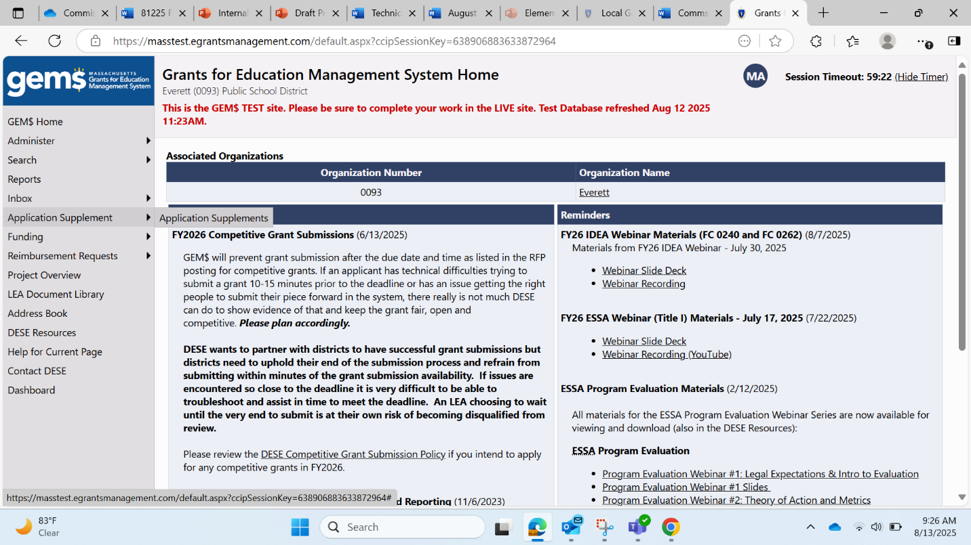

1. Once the **Application Supplements** page opens, click on **CD Policy and Local Graduation Requirements**. Please make sure that the Fiscal Year is set to 2026.

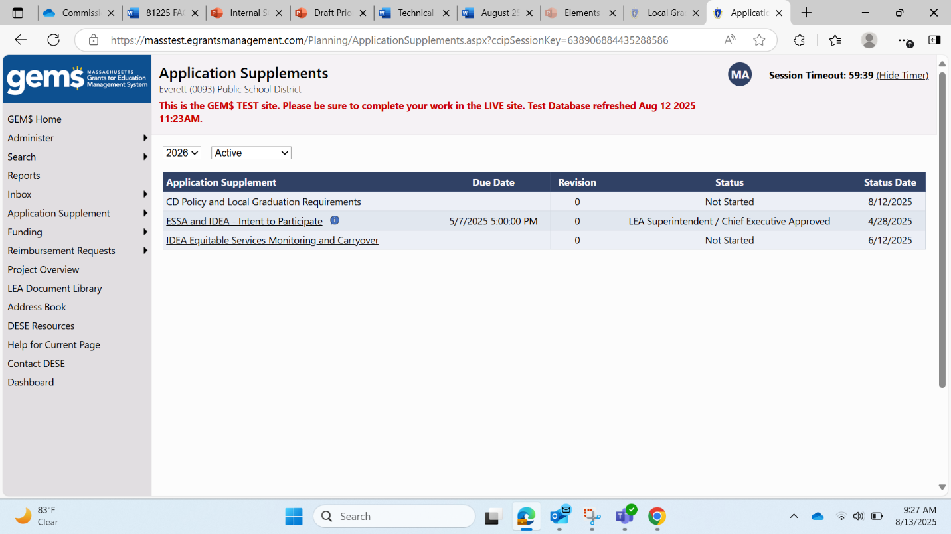

1. The **CD Policy and Local Graduation Requirements** sections page will open. From this page you can navigate to any section of the progress report by clicking on the section name. You may complete the sections in any order.

## How to Begin Entering Data in the Application Supplement

* When you first open the application supplement, your Status indicates *Not Started*.
* To begin typing in the supplement, you need to start the application supplement by moving your cursor to the **Change Status To:** line and clicking on Application Supplement Started.

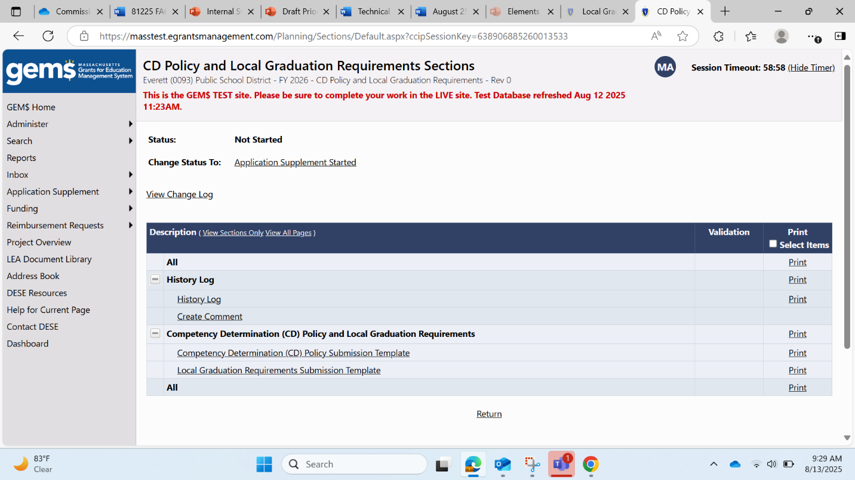

*Note: If you forget to complete this step, you will be able to see the instructions and items in the template, but the data entry screens will not open.*

* A Status Change Confirmation page will appear. Click **Confirm** to change your status to *Application Supplement Started*. Once you have done that, your status will be updated on the **CD Policy and Local Graduation Requirements** Sections page. You may begin entering data into your plan by clicking on the section you would like to work on first.

## Save Your Work at Regular Intervals!

* **Your work is not automatically saved by GEM$.** You will need to save your progress whenever you move from section to section and before you log out of GEM$. Do that by clicking the Save And Go To at the top of the section you are working on and indicate whether you want to continue working on Current Page or move to another section. If you want to save changes on the page you are working on, choose “Save and Go To > Current Page.” Clicking on Sections will take you back to the **CD Policy and Local Graduation Requirements** Sections page.

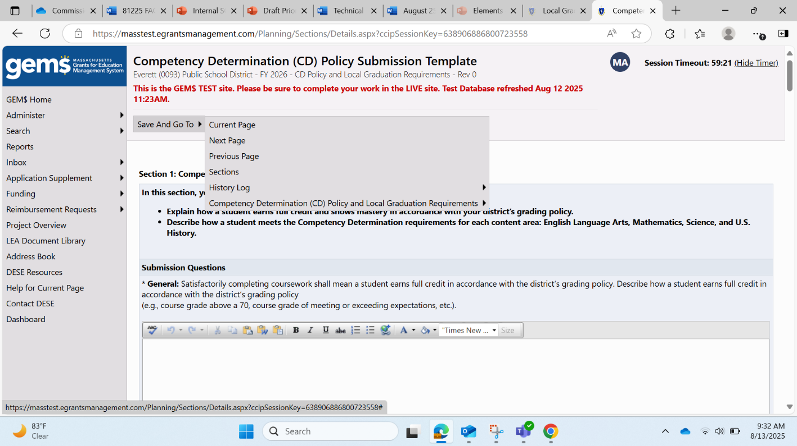

* **Be sure to monitor the Session Timeout indicator in the upper right corner.** GEM$ automatically sets sessions for 60 minutes. You should receive an on-screen warning when there are 10 minutes left in your session. Any work that has not been saved will be lost if your GEM$ session times out.

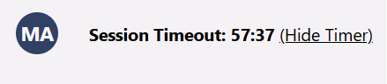

## How to Submit your Application Supplement in GEM$

### Instructions for LEA CD Policy Writer(s)

Once the application supplement is fully entered into GEM$, the next step in the GEM$ workflow is to send the report to the LEA Superintendent/Chief Executive for review by changing the Status of the report from *Application Supplement Started* to *Application Supplement Completed. S*uperintendents who double as *LEA CD Policy Writers* will need to follow these steps, essentially sending the report to themselves for approval.

1. Check for validation errors on the **CD Policy and Local Graduation Requirements** Sections page.

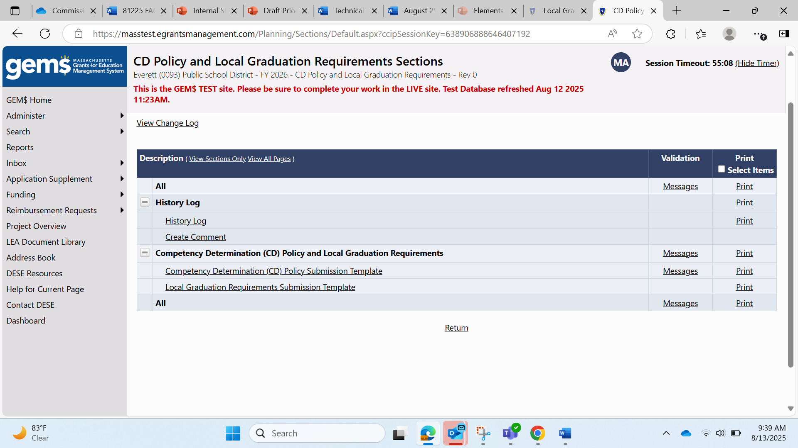

* 1. If the Validation Column is blank, you can change the status to *Application Supplement Completed*.
  2. If the word “Messages” appears in the column, the section(s) has a validation error. All validation errors must be resolved before GEM$ permits the status to be updated to *Application Supplement Completed*.
     1. **Click on *Messages* for a description of any error(s)**. If multiple sections have errors, clicking on Messagesin either of the “All” rows will open a Validation Messages table that describes errors for each section. Clicking on Review will take you to the section of the report that requires attention.
     2. When all validation errors (Messages) have been eliminated and the application supplement is ready for the LEA Superintendent/Chief Executive’s review and approval, return to the **CD Policy and Local Graduation Requirements** Sections page

1. Update the Status from *Application Supplement Started*to*Application Supplement Completed*by clicking *Application Supplement Completed* on the **Change Status To:**line and confirm that you want to update the status. Once the status is updated, GEM$ automatically generates an email that goes to the *LEA Superintendent/Chief Executive* letting them know that the application supplement is ready for review.

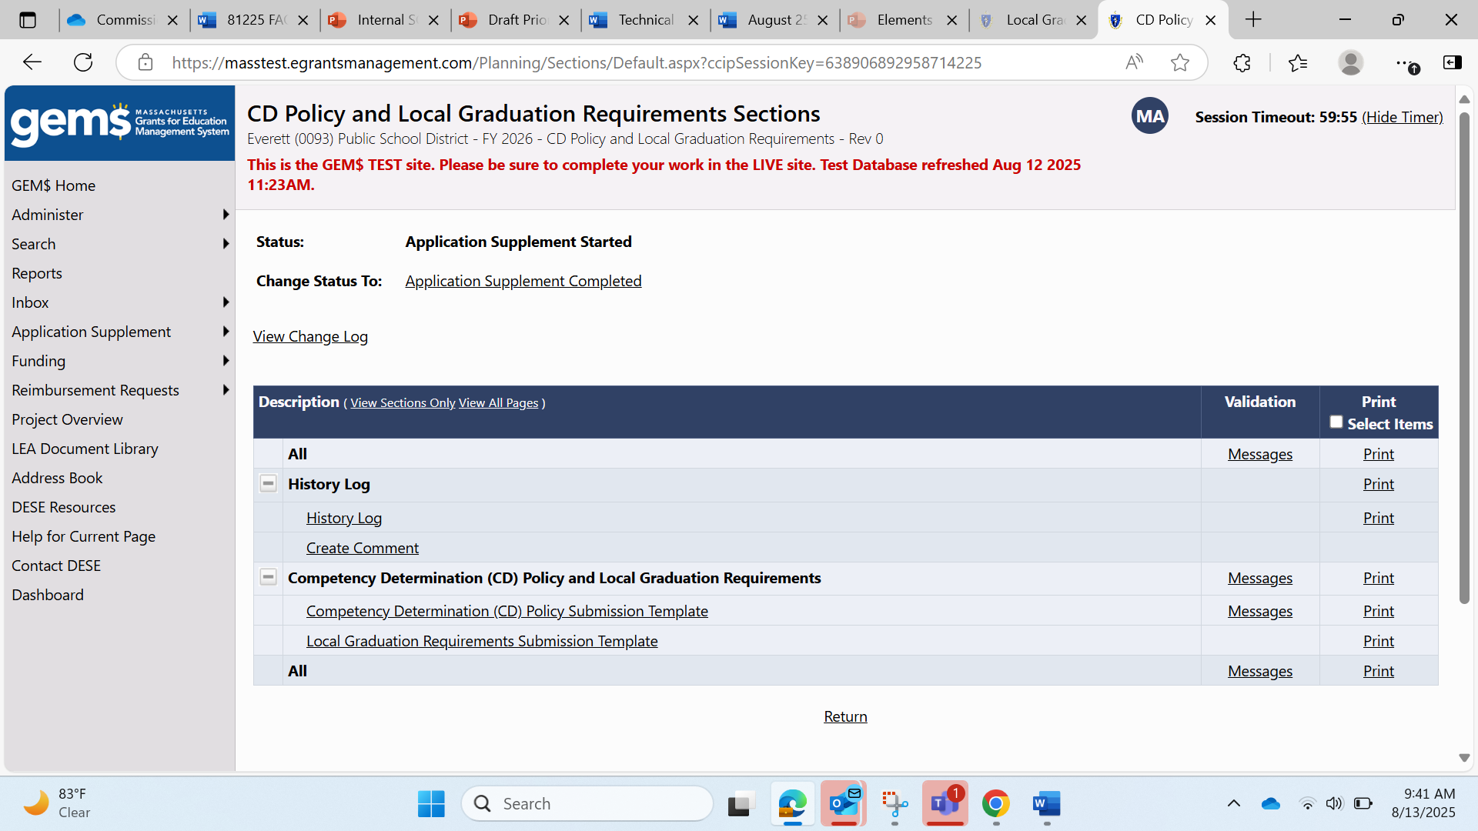

* 1. No further edits can be made once the Status has been updated to *Application Supplement Completed*. If additional edits are required, the *LEA Superintendent/Chief Executive* will need to change the Status to *LEA Superintendent/Chief Executive Returned – Edits Needed.* This will generate an email for the *LEA CD Policy Writer(s)* and restores the application supplement to an editable state for the *LEA CD Policy Writer(s)*.

### Instructions for LEA Superintendent/Chief Executive

The *LEA Superintendent/Chief Executive* will receive a No Reply email from GEM$ indicating that the *LEA CD Policy Writer* has completed the **CD Policy and Local Graduation Requirements** Application Supplement. This is the superintendents’ cue to review the plan and either approve it or return it to the *LEA CD Policy Writer* for edits. A reminder that the *LEA Superintendent/Chief Executive* role does not have permission to make direct edits to the application supplement.

1. Navigate to the **CD Policy and Local Graduation Requirements** Sections page, review the responses, and update the Status from *Application Supplement Completed* to either *LEA Superintendent/Chief Executive Approved* **or** *LEA Superintendent/Chief Executive Returned – Edits Needed* by clicking on the appropriate link on the **Change Status To:** line.

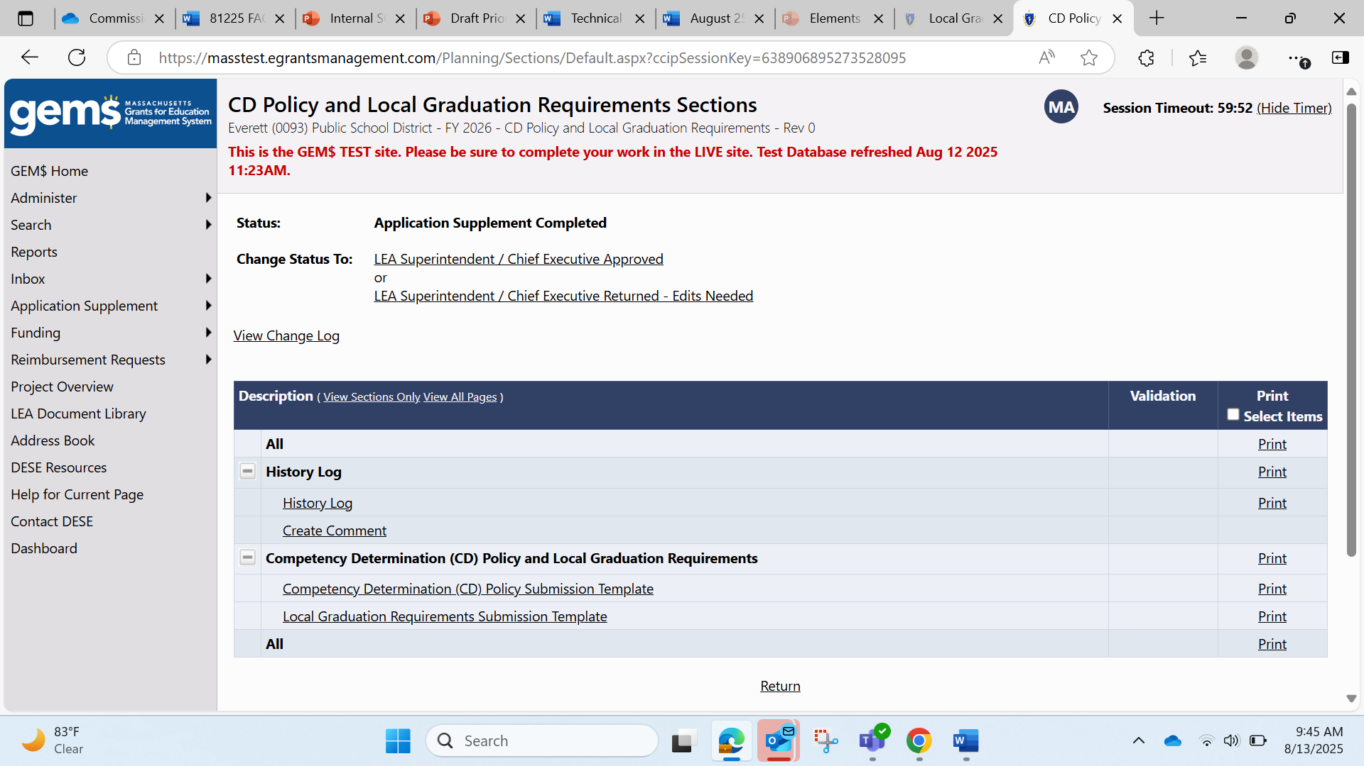

* 1. Changing the Status to *LEA Superintendent/Chief Executive Returned – Edits Needed* generates an email to the *LEA CD Policy Writer(s)* that signals the application supplement needs edits and permits them to make edits to the data entry screens.
  2. Changing the Status to *LEA Superintendent/Chief Executive Approved* generates a GEM$ email to DESE letting us know the application supplement is submitted and ready for review.