Accessing the FY27 Intent to Apply for a
Career Technical Education (CTE) New Program in GEM$
The FY27 designation process for all Massachusetts state-approved pathways (Innovation Career Pathways, Career Technical Education, and Career Technical Education Partnerships) lives in DESE’s Grants for Education Management (GEM$) system.
GEM$ access is assigned by the district. If you do not have access, please contact your LEA User Access Administrator. These resources are available for granting access:
Training Module 4 - User Access Administration
Creating Users and Assigning Roles in GEM$

The Intent to Apply is the first step in each process. All Intents to Apply, for districts seeking designation in FY27 to enroll students for fall 2027, must be submitted by June 30, 2026. An Intent to Apply must be submitted for each pathway the district intends to propose.
Once logged into GEM$, from the navigation pane, select “Application Supplement,” then “Application Supplements”:
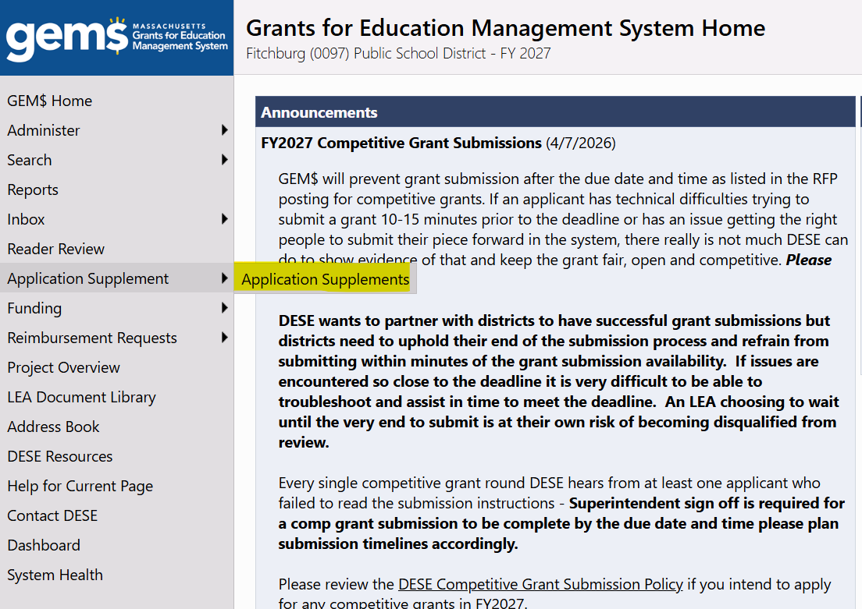
On the Application Supplements page, filter for 2027 on the dropdown with years. The list of available application supplements will populate. Click “CTE New Program Application”:
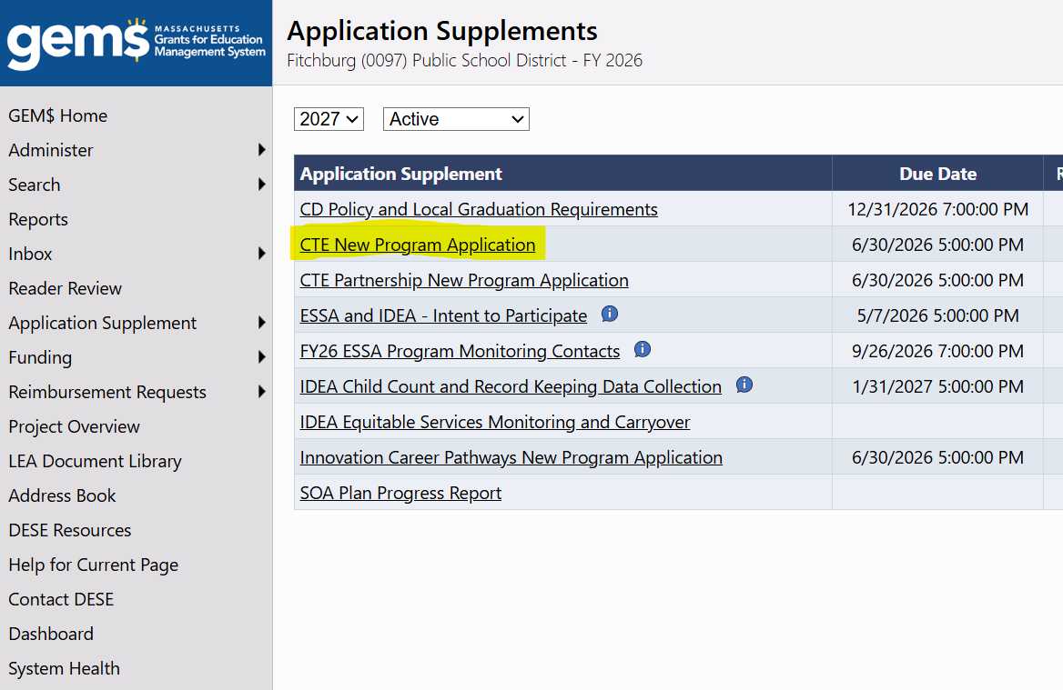
On the next page, you can click on the “Intent to Apply” to preview the questions. Note, you will need to change the status to “Application Supplement Started” to be able to fill in the required fields:
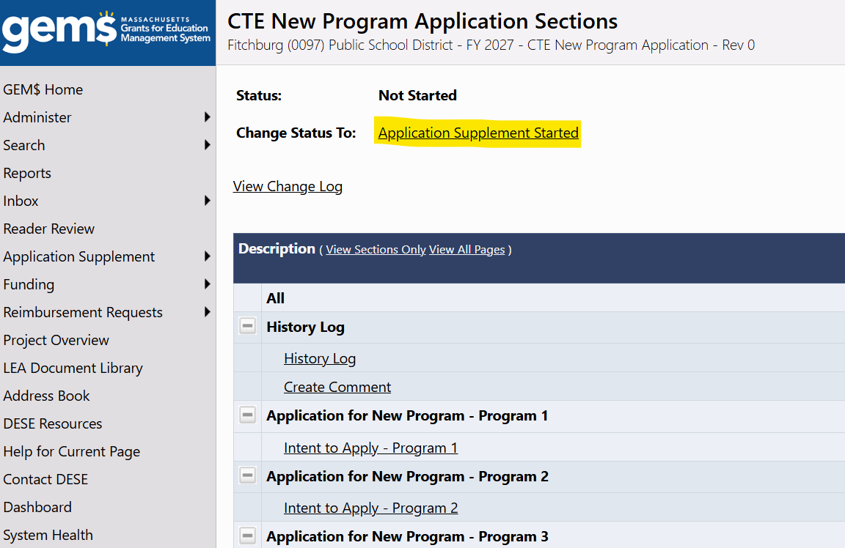
The following GEM$ roles, and individuals assigned to these roles by the district, can change the application status and complete the Intent to Apply questions: LEA Fiscal Representative, CTE New Program Application Writer, and LEA Superintendent/Chief Executive.
Question-Specific Guidance
The Intent to Apply asks the applicant to specify the members of the Design Team:
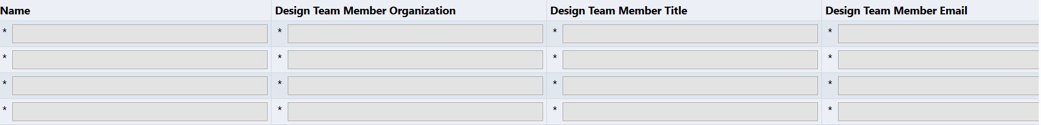
You can add more rows on the Design Team question, but four names are required by the system.
The CTE New Program Intent to Apply Assurances question is a “download/upload”:
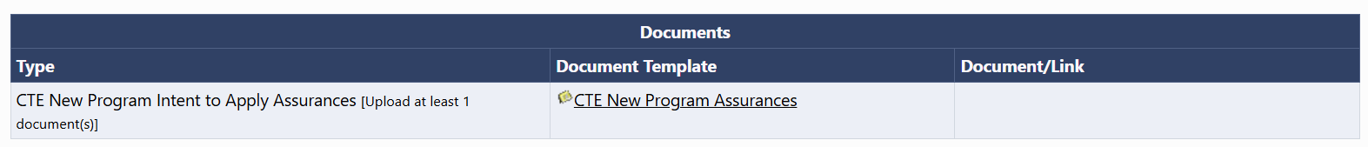
You will download the CTE New Program Assurances (a Word document) from the question in GEM$. As specified in the instructions on the downloaded document, please copy the required language onto district letterhead. Once completed, you will upload the document to the question in GEM$.
If you wish to apply for more than one CTE New Program, after completing the Intent for the first, on the CTE New Program Application Sections page, click Intent to Apply - Program 2 and repeat the process.

