Methods of Administration

Insert Name of School / Institution

This Letter of Finding is based on the review under the
Guidelines for Eliminating Discrimination and Denial of Services on the Basis of Race, Color, National Origin, Sex and Handicap in Vocational Education Programs (34 CFR, Part 100, Appendix B)

Conducted at:

Insert Name of School / Institution
Insert Date Onsite is Conducted

Letter of Finding: Insert Date Letter of Finding is Received

Massachusetts Department of Elementary and Secondary Education
Office for College, Career and Technical Education
135 Santilli Highway, Everett, MA 02149

Safety, Health, and Accessibility Review: Accessibility Feedback Summary

Date:
School:
Program Name:
School Staff Participants:
DESE Staff Completed by: Reviewed By:

This tool is intended to provide feedback regarding the learning environment, facilities, and equipment relevant to student participation in career and technical education. The school and district are responsible for ensuring the health and safety items identified in this report are remedied. Technical assistance is available to provide further explanation if requested.

Accessibility Requirements: Recipient may not exclude students or community members with disabilities from enjoying the benefits of its program or service because its facilities are inaccessible to or unusable by persons with disabilities. Architectural barriers do not prevent students or otherwise qualified persons with disabilities to include parents and/or other community members with disabilities from having ACCESS to vocational, career or academic programs, courses, services, or activities. Section 504:34 CFR § 104.21; Title II: 28 CFR § 35.150(a); Title II: 28 CFR § 35.151(a)(b) Guidelines IV-N

LEA/IHE Section (To be completed by the School or Institution)

Identify Facilities and Construction Dates
In the table below, list all building(s) associated with the secondary school including the date(s) of construction, last renovation and any career and technical program(s) offered therein.
Building | Date of construction and alteration(s) | CTE programs
Insert text here | Insert text here | Insert text here
Insert text here | Insert text here | Insert text here
Insert text here | Insert text here | Insert text here

Local Responsible Agency(ies) / Institution(s)
School/College must provide the local agency(ies) or institution(s) responsible for assuring building compliance with appropriate physical accessibility standards and their most recent review date. Local agencies or institutions could be your local building inspectors.
Agency: Most Recent Review Date:

Do you have documentation of recent review for ADA compliance?
Yes
No
If yes, please provide an electronic copy to your CCTE Liaison.

Accessibility Standards for Students with Disabilities
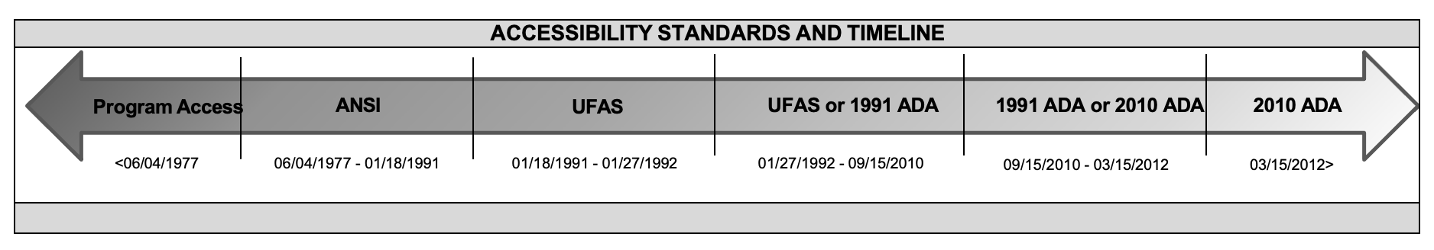
The table below is not an exhaustive list of potential violations. Instead, it highlights common violations found in CTE facilities and provides the standard ADA requirements associated with those violations. To determine what set of standards should be considered for each space within a facility, you must align the date of groundbreaking, or the date of the most recent alteration if alterations have occurred, to the accessibility standards for that period. In instances where facilities are leased and have not been modified, or were constructed prior to June 1977, as stated in 34 C.F.R. § 104.21 and 28 C.F.R. § 35.150, programs and activities must be accessible to and useable by individuals with disabilities. This does not necessarily mean the entirety of an existing facility must be updated to meet federal accessibility standards, but applies to those spaces, and the path-of-travel to those spaces, that are accessed by students. Federal regulations does indicate that entities should consider whether there are areas that may not be accessible to individuals with disabilities and give priority to providing activities and services in the most integrated setting appropriate [34 C.F.R. § 104.22(a)&(e) and 28 C.F.R. § 35.150]. For example, the entity should consider the locations of the restrooms, including those constructed prior to June 1977, and ensure that there are a sufficient number of restrooms meeting accessibility requirements to provide access to students with disabilities.

Prior to 1977, no specific requirements existed relating to placement of specific items such as dispensers, grab bars, or other elements. To determine whether the spaces constructed prior to 1977 were usable by individuals with disabilities, we used the “General Principles and Considerations” section of the ANSI Standards (Section 3). These Standards were the result of a project begun in 1959 by industry representatives to determine minimum requirements for persons with disabilities to be able to function independently. Many of the items identified do not require difficult or costly remedies and would make it easier for a person with a disability to more fully participate in the entity's programs and activities.

If alterations to a space are structural, or if the alteration changes the usability of a space, ADA standards aligning with the date the alteration took place must be followed. This includes in the altered space and in the path-of-travel to the space as stated in Title II 28 C.F.R. § 35.151(b4iii) and includes restrooms and drinking fountains along the path-of-travel.

LEA and SEA Observation Tables
For each common violation, the LEA will review the appropriate standard and enter a check mark if expectation is met, and an X if the expectation needs to be addressed. The SEA will walk the program with the LEA, discuss findings, and make observations as necessary. Both the LEA and SEA findings should be summarized in the Findings table.

Accessible Parking
Common  Violation | ANSI | UFAS | 1991 ADA | 2010 ADA | 2010 ADA Standard  Examples/Images | LEA/IHE | SEA
Space Identified with International Symbol of Accessibility (ISA) | (4.3.1) Identification required | (4.6.4) Required | (4.6.4) Required, and Van accessible spaces should have a sign that reads 'Van Accessible', along with the ISA | (502.6) Required, mounted at least 60" above ground surface (recommended: to  be painted on ground). Van accessible spaces must  have a sign that reads 'Van Accessible' with ISA | No image
Number of Spaces | (4.3.5) No required number, number should be based on frequency of parking need | (4.6.1)  The following information is Total Spaces: Number of ADA required number of spaces  - 1-25: 1  - 26-50: 2  - 51-75: 3  - 76-100: 4  - 101-150: 5  - 151-200: 6  - 201 – 300: 7  - 301-400: 8  - 401-500: 9  - 501-1000: 2%  - 1001+: 20+ 1 per 100 | (4.1.2) Same as UFAS | (208.2) Same as UFAS | 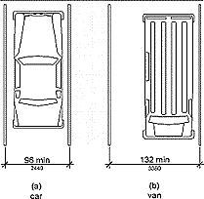  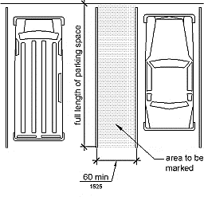  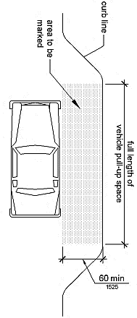
Number of Van Spaces | (4.3.5) No required number, number should be based on frequency of parking needs | (4.6.3) No required number, number should be based on frequency of parking needs | (4.1.2) At least 1 van- accessible space, and 1 van-accessible space for every 8 (or fraction of 8) accessible spaces | (208.2.4) At least 1 van- accessible space, and 1 van-accessible space for every 6 (or fraction of 6) handicap spaces | No image
Dimensions of Spaces | (4.3.3) 12 feet wide | (4.6.3) 8 foot plus 5-foot access, surface slope max of 1:50 (2%), if provided van space  should measure 96in | (4.6.3) Van accessible space should be 16 feet wide (including 'access space', at least 5 feet of  the 16 feet should serve wide and comply with  4.5ground and floor requirements | (502.2) Same as 1991 ADA as 'access space'); other accessible spaces should be 8' wide and have an additional 5' serving as 'access space') | No image
Parking Requirements | (4.3.1-4.3.6) Parking is located closest to accessible entrances, parking surface is smooth, level and there is a clearly defined, safe path from parking spaces to accessible route | (4.6.2) Same as ANSI | (4.6.2) Same as ANSI | (502.4) Same as ANSI | No image

Pathways
Common  Violation | ANSI | UFAS | 1991 ADA | 2010 ADA | 2010 ADA Standard  Examples/Images | LEA/IHE | SEA
Exterior/Interior Accessible Routes | (5.2.1) One primary entrance usable by individuals in wheelchairs and provides access to elevators. Entrances clearly marked with ISA. Non- accessible entrances have sign directing to accessible entrance. | (4.1, 4.3, 4.14) At least  one accessible route within the boundaries of a site shall be provided from public transportation stops, accessible parking, and accessible passenger loading zones and public streets or sidewalks to the accessible building entrance they serve. At least one accessible route must connect all building facilities, amenities, spaces and  dwellings. | (4.3) Same as UFAS | (206, 206.2.2) Same as UFAS | No image
Interior and Exterior Door(s) | (5.3, 5.3.2) Clearance when open 32in minimum, 5ft flat floor  surface shall be present on either side of door with one foot extending beyond each  side of door. | (4.13.5, 4.13.11)  Minimum clearance 32in, applied pressure to open interior doors not considered fire doors 5lbs max, minimum 90 degree  swing | (4.13.5) Same as UFAS | (404.2.3) Same as UFAS | No image
Door Hardware | (5.3) Door must be operable with single effort | (4.13.9) Mounted 34- 38in above floor, shall have hardware easy to grasp with one hand and does not require tight  grasping, pinching or twisting. | (4.13.9) Same as UFAS | (404.2.7) Same as UFAS | 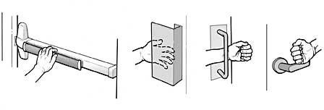
Ground and Floor Surface | (4.5) Path of travel must be stable, firm, slip-resistant, and accessible to entrances. | (4.5.3, 5.5) ground surface must be stable, firm, slip-resistant, and accessible to entrances. Carpet must have a level loop and may not exceed 1.5in height,  edges must be secured | (4.5.1-.3) Same as ANSI | (302.1-.2) Same as ANSI | 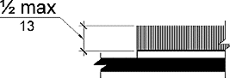
Clear Floor and Ground Space | None | (4.2.4.1, 4.27.2)  Minimum clear floor and ground space required for single wheelchair is 30in x 48in. Either forward or parallel approach at controls, dispensers, receptacles and other operable equipment is reasonable | (4.2.4.1, 4.27.2) Same as UFAS | (305.2-.6) Same as UFAS | 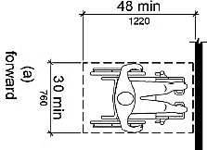  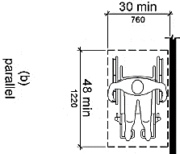
Path of Travel and Walkways | (4.2.1, 4.13.5)  Minimum 4ft. or 48in wide with gradient no more than 5 inches | (3.2.3, 4.3.3-.4)  Minimum width of access points (such as doorways) 32in, 36in wide in continuous pathways. 60in minimum for two individuals in wheelchairs to pass one  another | (4.3.3-.4) Same as UFAS  with passing space of 60in x 60in every 200 feet | (403.5, 403.5.3) Same as  1991 ADA, Exception: can narrow to 32in for 24in max length, narrow stretches must be at least 48in apart | 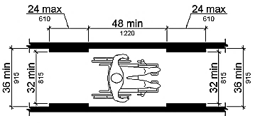
Change in Level | (5.3.2-3, 5.5.2) Floor on  any given story must be level with no sharp changes or must be properly ramped.  Thresholds shall be flush with floor for 5 feet on either side on entrance in the direction of the door swing, and extend a minimum of 1 foot beyond frame | (4.5.2) 1/4in high maximum vertical change in level, between 1/4in and 1/2in a bevel with a slope not steeper than 1:2 is required. Change in level greater than 1/2in must be accompanied by ramp | (4.3.8, 4.5.2) Same as UFAS | (303.2-.3) Same as UFAS |   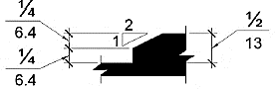
Stairs | (5.4.1-.4) Handrails 32in from tread surface. Risers should not exceed 7in.  Handrails should extend 18in beyond the top and bottom step. Steps required to have non-squared off edges. | (4.9.1-.5) 11in minimum tread width, riser height and tread width should be uniform, handrails should run continuous along stairwell. If not  continuous the rail must extend 12in at top and 12in plus the width of one stair at the bottom. Nosing at the edge of step shall not be abrupt and may protrude no more than 1½ inches and underside of step may slope no more than 60 degrees. | (4.9.1-.4) Same as UFAS | (504.1-.7) 11in minimum tread width, riser height and tread width should be uniform, handrails should be provided on both sides of stairs and ramps (except  for assembly areas - then one rail required), handrails should be between 34-38in from tread surface, handrails should extend 12in at top and bottom of stairs.  Nosing at the edge of step shall not be abrupt and may protrude no more than 1½ inches and under- side of step may slope no  more than 30 degrees. | 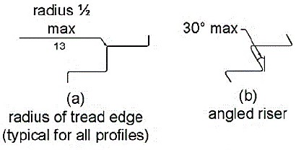  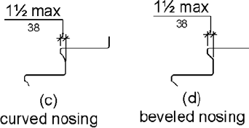
Ramp Slope and Rise | (5.1.1, 5.1.7) Max 1:12  (8.33%) slope with level platforms at 30ft max intervals, 36in width minimum | (4.8.2) Max 1:12 (8.33%)  slope with level platforms at 30ft max intervals, 36in width minimum. Where ramp changes direction a 60in x 60in landing | (4.8.2) Same as ANSI  Also, 1:50 (2%) max for cross-slopes | (405.6) Same as 1991 ADA | 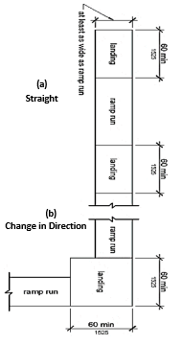
Ramp Handrails | (5.1.2) All ramps must have at least 1 handrail resting 32in from ground and that extends one foot beyond ramp. | (4.8.5) Both sides of ramp should have handrail if rise is greater than 6in or if rise projects more than 72in (6ft), Between 30-34in high from ramp surface., clear space between handrail and wall shall be 1.5in. | (4.8.5) Both sides of ramp should have handrail if rise is greater than 6in or if rise projects more than 72in (6ft), Between 34"-38" from ramp surface to top of handrail gripping surface, Rail extends 12" beyond top and bottom of ramp. | (405.8) Same as 1991 ADA,  unless handrail extension creates hazard- then not required. | No Image
Landing(s) | (5.1.4-.7) 5ft x 5ft  clearance at top and bottom of ramp if door extends into landing. 3ft x 5ft landing required if door does not extend into landing. Landing must extend at least 1 foot beyond all entryways. Landing must extend 6ft at bottom of ramp and be available at 30ft intervals | (4.8.4) Same as ANSI | (4.8.4) Same as ANSI | (405.7) Same as ANSI | No Image
Protruding Objects | (5.13.4) Objects below 84in from floor should protrude no more than 4in into path | (4.4.1-.2) Objects protruding from walls with their leading edge between 27-80in above the floor (e.g., fire extinguishers) should protrude no more than 4in into path. Free standing objects mounted on posted may not exceed 12in overhang. No object shall reduce the  required clear width of an accessible route or maneuvering space. If vertical clearance of an area adjoining an accessible route is reduced to less than 80 inches, a barrier to warn blind or visually- impaired persons shall be provided. | (4.4.1-.2) Same as UFAS | (404.2.5) Same as UFAS | 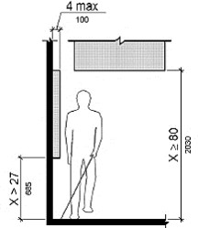  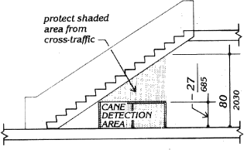
Identification and Signage | (5.11, 1.11.1-.3)  Appropriate identification of specific facilities within a building used by public is essential, raised letters or numbers shall be used to identify rooms or offices, identification should be placed on the wall between 45in and 66in but preferably 60in. | (4.30.1-.6) Character portions for letters and numbers must be width: height ratio between 3:5 and 1:1 and a stroke width: height ratio between 1:5 and 1:10, Interior sign shall be located alongside a door on the latch side at a height between 54in and 66in above finish floor, Letters and numbers must be raised 1/32in minimum and in sans serif characters, raised characters or symbols in pictographs  or signs must be 1/32in high, where permanent identification is provided signs must be mounted on the latch of the door and between 54 and 60in from ground floor | (4.30.1-.6) Same as UFAS  except for: Where permanent identification is provided for rooms and spaces, signs shall be installed on the wall adjacent to the latch side of the door. Where there is no wall space to the latch side of the door, including at double leaf doors, signs shall be placed on the nearest adjacent wall. Mounting height shall be 60 in (1525 mm) above the finish floor to the centerline of the sign.  Mounting location for such signage shall be so that a person may approach within 3in | (703.1-.4) Signs shall have visual and tactile characters, or two separate signs, one with visual, and one with tactile characters must be provided, characters shall be uppercase and raised 1/32 inch (0.8 mm) minimum above their background in San Serif, Character height measured vertically from the baseline of the character shall be 5/8 inch (16 mm) minimum and 2 inches (51 mm) maximum based on the height of the uppercase letter "I", Braille  shall be positioned below the corresponding text. If text is multi-lined, braille shall be placed below the entire text. Braille shall be separated 3/8-inch minimum from any other tactile characters and 3/8inch minimum from raised borders and decorative elements.  Tactile characters on signs shall be located 48 inches minimum above the finish floor or ground surface, measured from the baseline of the lowest tactile character and 60 inches maximum above the finish floor or ground surface, measured from the baseline of the highest tactile character.  Characters and their background shall have a non-glare finish. Characters  shall contrast with their background. | No Image
International Symbols of Accessibility  (ISA) | None | (4.30.5) Must use ISA | (4.30.7) Same as UFAS | (703.7.2) Same as UFAS | 

Classroom Amenities, Lab Accessibility, and Assembly Areas
Common  Violation | ANSI | UFAS | 1991 ADA | 2010 ADA | 2010 ADA Standard  Examples/Images | LEA/IHE | SEA
Fixed Seating | Accessible and Useable | (4.1.17, 4.32.1) Where fixed seating is provided, at least 5% but not less than one space must be accessible and usable. | (4.1, 4.32.1) Same as  UFAS. Additionally, an accessible route shall lead to and through the built-in seating. | (221.2, 226.1) Same as  1991 ADA | No image
Workstations | (3.3.2) 28.5in-33.2in to  top surface of horizontal desk/table | (4.32.1-.4) Top of work surface must measure between 28in and 34in high, Knee clearance is min 27 high, 30in wide and 19in deep. | (4.32.1-.4) Same as UFAS | (306.3, 902.3) Top of work surface must measure between 28in and 34in high, Knee clearance min 27 high with toe clearance of 9in, 30in wide minimum and 11in to 25in deep | 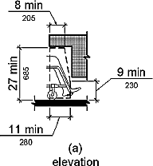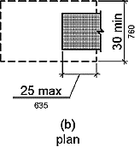
Audio Amplification | Accessible and Usable | (4.33.6) if fixed seating must be within 50’ of stage and have full view of stage | (4.1.19.b) Assembly areas with fixed seating that accommodate at least 50 people or have audio amplification require permanently installed assistive listening systems. The number of  receivers should be 4% of the number of seats but no less than 2 receivers. A sign with the ISA for hearing loss should provide notice of availability of listening system | (2.19.3) Same as 1991 ADA  with the following number requirements:  The following requirements are sectioned by the total number of seats:  - <50: minimum of 2 receivers and 2 that are Receiver Hearing Aid Compatible  - 51-200: minimum of 2 + 1 per 25 seats over 50 receivers and 2 that are Receiver Hearing Aid Compatible  - 201-500: minimum of 20 + 1 per 25 seats over 50 receivers and 1 per 4 receivers that are Receiver Hearing Aid Compatible  - 501-1000: minimum of 20 + 1 per 33 seats over 500 receivers and 1 per 4 receivers that are Receiver Hearing Aid Compatible  - 1001+: minimum of 35 -1 per 50 seats over 1000 receivers and 1 per 4 receivers that are Receiver Hearing Compatible | 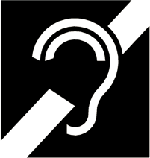
ADA Seating | None | (4.1.18)  Capacity ADA Spaces  1-25 1  26-49 2  50-75 3  76-100 4  101-150 5  151-200 6  201-300 7  301-400 8  401-500 9  501-1000 2%  1000+ 20+1 for each  100> 1000 | (4.1.19)  Capacity ADA Spaces  1-25 1  26-50 2  51-300 4  Over 500 6+1 for  each 100 | (221.2.1) Same as 1991  ADA standards | No image
Access to performing area | None | (4.33.5) An accessible route must connect wheelchair seating with performing area, including: stages, arena floors, dressing rooms,  locker rooms, and other spaces used by performers. | (4.33.5) | (206.2.6) Same as UFAS | No image
Wheelchair Spaces, Companion Seats, and Designated Aisle Seats | None | (Fig 46) 33 inches wide minimum for one space, if two or more adjacent spaces are provided 33 inches wide per space, if front or rear entry to space 48 inches’ deep minimum, if side entry 60 inches’ deep minimum. | (Fig 46) Same as UFAS | (802.1.2) 36 inches wide minimum for one space, if two or more adjacent spaces are provided 33 inches wide per space, if front or rear entry to space 48 inches’ deep minimum, if side entry 60 inches’ deep minimum. | 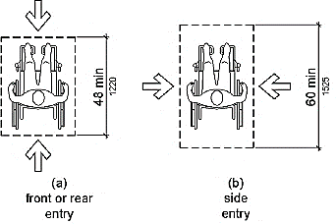  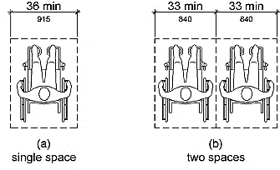
Drinking Fountain | (5.7-5.7.2) Appropriate number must be  accessible the ‘Program Access’ standard (prior to 1977) was: if only one on a floor, it must be accessible. If more than one, 50% are accessible, Spout no higher than 36in from floor, Controls on front or side | (4.15.1-.5) If only one fountain on a floor it must be accessible. More than one fountain 50% must be accessible, 30in x 48in clear floor space for forward approach, spout no higher than 36in from floor and water flow high enough to insert cup. Clear knee space of 27in from floor to apron. Controls on front  or side and operable with closed fist. | (4.15.1-.4) Same as UFAS  except flow of spout positioned so flow of water is at least 4in high and within 3in from front of fountain. | (309.4, 602.1-.6) If there is one fountain only then it must be accessible. More than one fountain 50% must be accessible, 30in x 48in clear floor space for forward approach, Spout max 36in from floor and water flow 4in min height, spout should be at least 15in from the rear of the fountain and 5in max from front edge. If fountain is no deeper than 20in, operable  parts should be no higher than 48in and take no more  than 5lbs of pressure to operate; If fountain is between 20-25in deep, operable parts should be no higher than 44in nor take more than 5lbs of pressure to operate. Units shall have a clear floor space aligning with  required reach ranges. | 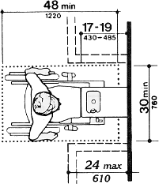  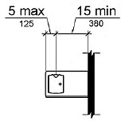  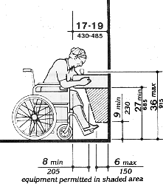

Reach Ranges and Operable Parts
Common  Violation | ANSI | UFAS | 1991 ADA | 2010 ADA | 2010 ADA Standard  Examples/Images | LEA/IHE | SEA
Unobstructed Forward Reach | (3.3.1-.3) Average unilateral vertical reach is 60in. With full reach range being 54in-78in. | (4.2.5) Between 15in to 48in from floor space to object. | (4.2.5) High forward reach shall be 48in maximum and the low forward reach shall be 15in minimum above the  finish floor or ground. | (308.2.1) Same as 1991 ADA. | 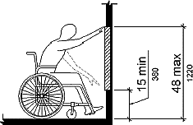
Obstructed Forward Reach | (3.3.1-.3) Average unilateral vertical reach is 60in. With full reach range being 54in-78in. | (Fig 5) Max 24in horizontal reach, and max 46in from floor vertically. | (4.2.5) Same as UFAS. | (308.2.2) Clear floor space shall extend beneath the element for a distance not less than the required reach depth over the obstruction. The high forward reach shall be 48in maximum where the reach depth is 20in maximum.  Where the reach depth exceeds 20in the high forward reach shall be 44in maximum and the reach depth shall be 25in maximum | 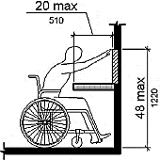  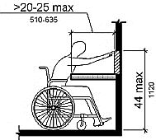
Unobstructed Side Reach | (3.3.4) Average diagonal reach is 48in | (4.2.6) Between 9in to 54in from floor space to object. | (4.2.6) Maximum 44in high when obstruction is 20-25in wide. Maximum 48in high when obstruction is under 20in wide. | (308.3.1) High side reach shall be 48in maximum, low side reach shall be 15in minimum above the finish floor | 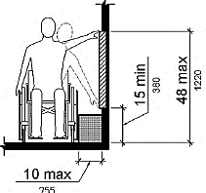
Obstructed Side Reach | (3.3.4) Average diagonal reach is 48in | (Fig 6) Max 24in horizontal reach, and max 46in from floor vertically. | (4.2.6) Maximum 46in high with maximum obstruction 24in wide. | (308.3.2) Obstruction 34in max height by 10-24in width equals max reach height of 46in above finish floor. Obstruction 34in max height by 10in max width equals 48in max reach above finish floor. | 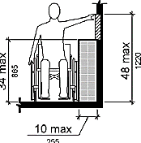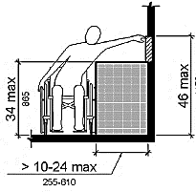
Operable Parts | (3.3.4; 5.10) Wall  mounted operable parts require a maximum 48-inch reach range; Controls and operating mechanisms must fall within reach range | (4.27.2-.4) Clear floor space must be available for approach. Controls and operating mechanisms must fall within reach range.  Controls must be operable with one hand and shall not require tight grasping, pinching or twisting of the wrist. The force required to activate controls shall be no greater than 5lbs. | (4.27.3) Same as UFAS | (309.2-.4) Same as UFAS | No image

Elevators
Common  Violation | ANSI | UFAS | 1991 ADA | 2010 ADA | 2010 ADA Standard  Examples/Images | LEA/IHE | SEA
Elevator Accessibility | (5.9, 5.9.1) Elevators are essential and must be made accessible to, and usable by, individuals in a wheelchair from the level of entry to all floors used by the public. | (4.10) Accessible elevators must be on accessible route | (4.1.3) 1 elevator complying with 4.10 shall serve each level in all multi-story buildings unless exempted as follows: elevators are not required in facilities that are less than 3 stories or less than 3000 per story; ramps complying with  4.8 (e.g., max slope of 8%, max rise of 30" for any run) may be used in lieu of an elevator; platform lifts (wheelchair lifts) can be used in lieu of an elevator if elevator or ramp are technically infeasible | (407.1) Same as 1991 ADA,  also, Elevators must be in good working order. | No image
Elevator Car Size | (3.2, 5.9.2) 54in x 60in  min required measurements, must allow for traffic by wheelchairs | (4.10.9) Centered opening, 51in deep x 80in wide. For off- center opening, 51in deep x 68in wide | (4.10.9) Same as UFAS for new construction. For modifications, when technically infeasible, elevator dimensions can be reduced but in no case, should be less than 48in x 48in or equal or greater square footage (16 square feet) when usability can be demonstrated (Cite 4.1.6) | (407.4) Existing configurations must provide 16 square feet minimum with an inside clear depth of 51in and width of 36in. For new construction, the accompanying diagrams apply. | 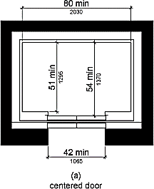  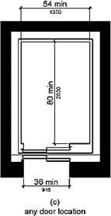
Elevator Doors | (5.3, 5.9) 32 inches wide minimum | (4.10.6, Fig 22) 36in  minimum width, doors must have automatic open and close feature that must stop and reopen should an obstruction present itself at height of 5in to 29in. Door must remain open for 20 seconds before proceeding with close function. | (4.10.6, 4.10.9) same as UFAS | (407.4, 407.3.3) For  Centered door, 42" wide; for off-center door, 36". Doors automatically open and close - doors reopen for obstructions between 5" to 29" from floor and remain open for 20 seconds before closing, no physical contact must be made to initiate response. | 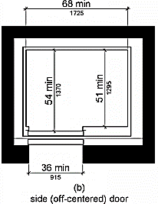
Elevator Car Position Indicator | None | (4.10.13) In car above control panel or door, a visual indicator shows the position of the car, and it illuminates and produces and audible signal when car stops on a floor. Numbers shall be minimum of ½ in tall. | (4.10.13) Same as UFAS | (407.4.8) Same as UFAS | No image
Elevator Audio, Visual Signals | None | None | (4.10.7) (4.10.13) A  special button may be provided that would activate the audible signal within the given elevator only for the desired trip, rather than maintaining the audible  signal in constant operation. | None | 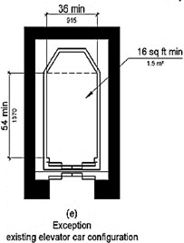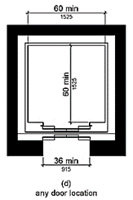
Elevator Call Controls | (3.3, 5.9) Accessible and usable within standard reach range of 48in max height | (4.10.12) 42in to center of 'up button', which must be on top. All call controls should have visual indicator that shows when call has  registered. | (4.10.12) Same as UFAS | (407.4.6) Max of 48in (min of 15in) to center of 'up button', which must be on top. All call controls should have visual indicator that shows when call has  registered. | No image
Elevator Interior Car Controls | (3.3.4, 5.9) Accessible and usable within standard reach range of 48in max height | (4.10.12) Max of 48"  (front approach) to 54" (side approach), with 15" as minimum height from ground surface and measure 3/4in diameter. All control buttons designated by raised characters and symbols to the left of the buttons – Braille characters and tactile symbols are required. Main floor designated with a star. Emergency buttons should have their centerline no less than 35" from floor and they should be grouped at the bottom of the panel. All call controls should have visual indicator that shows when call has registered. | (4.10.12) Same as USAF | (407.2.1) Same as USAF | 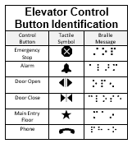
Platform Lifts | None | (4.2.4, 4.5, 4.11.1-.3  4.27) Must have a forward, clear ground approach and accessible controls compliant with 4.27. | (4.2.4, 4.5, 4.11.1-.3 4.27)  Same as UFAS | (410.1-410.6) same as UFAS with the addition of: shall have low-energy power-operated doors or gates complying with  404.3. Doors shall remain open for 20 seconds’ minimum. End doors and gates shall provide a clear width 32-inch minimum. Side doors and gates shall provide a clear width 42-  inch minimum. | 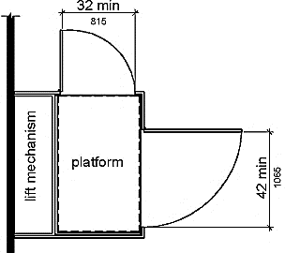

Restrooms, Showers, and Locker Rooms
Common  Violation | ANSI | UFAS | 1991 ADA | 2010 ADA | 2010 ADA Standard  Examples/Images | LEA/IHE | SEA
Number of ADA Compliant Toilets | (5.6) Fitting to the nature and use of the facility | (4.1, 4.22.1, 4.23.1) At  least one accessible ADA toilet for all students, must have accessible route | (4.22.1) Same as UFAS | (213.1, 213.2, 213.2.1, 603)  Where toilet rooms are provided, each toilet room shall comply. Exception: Where it is technically infeasible to comply, altering existing toilet or bathing rooms shall not be required where a single unisex toilet room is provided and located in the same area and on the same floor as existing inaccessible toilet or bathing rooms. | No image
Restroom Pathway | (3.2-.3, 4.2.1-.2, 5.6.1)  Minimum width 48in, where turning is required 63in x 56in or 60in x 60in. Walks shall be a continual common surface not interrupted by steps or abrupt change in levels | (4.1.2-.3, 4.2.4.1, 4.13.5)  Minimum clear floor or ground space 30 x 48in positioned for forward, parallel approach and 60in turning radius; 48in in addition to the projection of any swinging into the space. Door width minimum 38in. | (4.2.1-.2) Same as UFAS | (603.2.1) Clear floor space within the restroom should permit a circle of at least 60in diameter or a T- shaped space within a 60in square. | No image
Toilet Stalls | (5.6.2) minimum 36in wide x 56in deep | (4.17.3, 4.17.4) Size  dependent on door placement and swing, Minimum 56in x 60in, Toe clearance of 9in minimum of partition is required. | (4.17.3) Same as UFAS | (604.3) Clearance around a water closet shall be 60in minimum measured perpendicular from the side wall and 56in minimum measured perpendicular from the rear wall. Toe clearance of 9in minimum on both side and front partition is  required. | 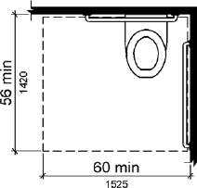
Toilet Stall Door | (5.6.2) 33in width and swings out | (4.17.5) 32" wide; door can swing in or out, if doors are in-swinging they cannot swing into the required clearance/floor space for any fixture; all hardware (e.g., locks, handle) inside and out between 34-48" from floor | (4.17.5) Same as UFAS | (604.8.1.2) Door must swing out and clearance between door side of the compartment and any obstruction shall be 42in minimum. Doors shall be located in the front partition or in the side wall or partition farthest from the water closet. Where located in the front partition, the door opening shall be 4in maximum from the side wall or partition farthest from the water closet. Where located in the side wall or partition, the door opening shall be  4in maximum from the front partition. The door  shall be self-closing. | 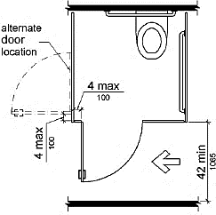  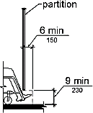
Toilet Seat | (5.6.2) 20in from floor | (4.16.3, 4.16.5) 17-19in  from floor to top of toilet seat. Flush controls no higher than  44in | (4.16.3, 4.16.5) Same as UFAS | (604.4) 17-19in from floor to top of toilet seat. Flush controls no higher than 48in | No image
Urinal | (5.6.2) Open basin 19in max from floor | (4.18.2) Stall-type or wall-hung with rim at max of 17in from floor, flush controls no higher than 44in. Clear space of 30in x 48in in front of urinal | (4.18.2) Same as UFAS | (605.2) Same as UFAS | No image
Grab Bars | (5.6.2) 33in high, parallel to floor, 1.5in in diameter, 1.5in clearance from rail to wall, secured tightly | (4.17.6, 4.26.1-.3) On  one side and rear wall, 33-36in from floor, back length 36in min, side length min 42in with no more than 12 in from wall to start of bar, 1.25-  1.5in diameter, 1.5in clearance rail to wall. The structural strength of grab bars must sufficiently hold 250lbs securely | (4.16.4, 4.26.1-.4) Same  as UFAS | (604.5.1, 609.1- .8) Same as UFAS | 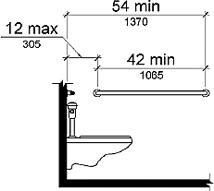  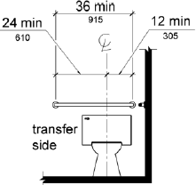
Toilet Paper Dispenser and Sanitary Napkin Disposal Unit | (5.6.6) 40in max above floor | (4.16.6) Toilet paper dispensers within reach and a minimum of 19in above floor | (4.16.6) Same as UFAS | (308.3.2, 604.7) Toilet  paper dispensers between 7-9in from the front of the toilet to the centerline of the dispenser and mounted between 15-48in from floor. Reach shall be 48 inches (1220 mm) maximum for a reach depth of 10 inches (255 mm) maximum. Where the reach depth exceeds 10 inches (255 mm), the high side reach shall be 46 inches (1170 mm) maximum for a reach depth of 24 inches (610 mm) maximum. | 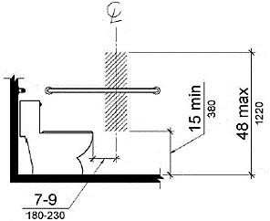
Alternate Stall (Ambulatory) | (5.6.2) Toilet rooms shall be a minimum 3ft wide and 4.8ft deep, with 32in between grab bars for accessibility | (4.17.3) Same as ANSI | (4.17.3) Same as ANSI | (604.8.2, 604.5.1)  Minimum 60in depth and 35-37in width, one side wall mounted grab bar shall be min 42in long and rest 12in minimum from the rear wall. Between 33 and 36in from floor | 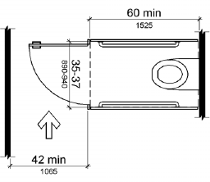
Shower Compartments | None | (4.21.2-.3) Shower stall shall be 36in x 36in. A seat will be provided and mounted on the wall opposite controls 17in to 19in from ground surface. | (4.21.2-4.21.3) Same as UFAS. | (608.1; 608.4) Transfer type shower compartments shall be 36in x 36in clear inside dimensions measured at the center points of opposing sides and shall have a 36-inch- wide minimum entry on the face of the shower compartment. Clearance of 36in wide minimum by 48in long minimum measured from the control wall shall be provided; A folding, or non-folding seat shall be provided in transfer type shower  compartments; | 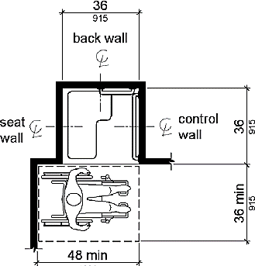
Grab Bars (Transfer Type Shower) | None | (4.21.4) Grab bars will be installed between 33in and 36in from ground surface spanning 18in on control wall and a minimum of halfway  along back wall. | (4.21.4) Same as UFAS. | (608.3) Same as UFAS | 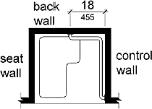
Controls and Shower Units (Transfer Type Shower) | None | (4.21.5; 4.21.6) Controls,  faucets, and shower spray unit shall be installed on the side wall opposite the seat 38 inches minimum and 48 inches maximum above the shower floor and shall be located on the control wall 18 inches maximum from the centerline of the seat toward the shower opening; A shower spray unit with a hose at least 60in long that can be used as a fixed shower head or as a hand-held shower stall will be  provided. | (4.21.5; 4.21.6) Same as UFAS. | (608.5, 608.6) Controls, faucets, and shower spray unit shall be installed on the side wall opposite the seat 38 inches minimum and 48 inches maximum above the shower floor and shall be located on the control wall 15 inches maximum from the centerline of the seat toward the shower opening. A shower spray unit with a hose at least 59in long that can be used as a fixed shower head or as a hand-held shower stall will be provided. | 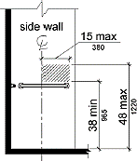
Dispensers | (3.3.4) 48in max above floor | (4.2) Forward  unobstructed reach: 15- 48in, Side unobstructed reach: 9-54in. | (4.2.5-.6) Same as UFAS | (308.2.2, 308.3.2, 309.4)  Forward reach 15-48in unless obstructed then max height 44. Side reach 15- 48in unless obstructed then max height 46. Force required to push/pull  should not exceed 5lb | No image
Mirror | (5.6.4) Reflective area  40in max above floor | (4.19.6) Same as ANSI | (4.19.6) Same as ANSI | (603.3) Same as ANSI | No image
Shelving and Coat Hangers | (5.6.4) 40in max above floor | (4.25.3) Shelves and hangers must be within reach range- max height 48in if forward reach and 54 reach if side  reach | (4.25.3) Same as UFAS | (803.5) Shelves and coat hangers shall be 40in minimum and 48in maximum above the finish floor or ground. | No image
Sink | (5.6.3) Sinks should have narrow aprons and mounted at a height usable by individuals in wheelchairs. | (4.19.2) Mounted with rim or counter surface max of 34in above floor with a clearance of 29in from floor to bottom of the sink basin and a minimum depth of 8in from leading edge of sink to pipe insulation. Also, must be toe clearance of at least 9" high and 6" deep underneath bottom of  pipe insulation | (4.24.2-.5) Sink shall be mounted 34in above finish floor. Knee clearance beneath sinks to be min. 27in high, 30in wide, and 19in deep.  Must have a clear floor space of at least 30in x 48in | (306.3, 606.3) Sink shall be mounted 34in above finish floor. Knee clearance beneath sink to range between 9 and 29in high, 30in wide, and 9in and 11in deep. | No image
Exposed Pipes | (5.6.3) Must be covered with no  exposed metal | (4.19.4) Must be covered with no  exposed metal | (4.19.4) Must be covered with no exposed metal | (606.5) Must be covered with no exposed metal | No image
Restroom Signs | (5.11, 5.11.1, 5.11.2)  Appropriate Identification | (4.30) Signs displaying the ISA should be placed beside the bathroom entrance between 54in and 66in | (4.30, 4.30.6) Signs  displaying the ISA shall be installed on the wall adjacent to the latch side of the room’s exterior  door. Mounting height shall be 60in from the floor to signs centerline. Individually accessible stall units must be identified with the ISA when all units are not physically  accessible. | (216) Same as 1991 ADA, in addition signs must have raised characters and Braille, sign should be at least 18in x18in, it should be on the latch side or push side of door, and the base  of the lowest character on the sign should be at least 48in above the floor and the base of the highest character should be no higher than 60in from floor. | No image

Additional Items
For each, observe and provide feedback regarding whether provided facilities are comparable. Check whether observations suggested Comparable or Not Comparable facilities or indicate not observed. If feedback regarding potentially non-comparable facilities is observed for any, the school must contact their local building authorities to confirm their compliance with requirements.

Comparable Facilities | LEA/IHE - Comparable | LEA/IHE – Not Comparable | SEA - Comparable | SEA – Not Comparable
Changing rooms, showers, and other facilities for students of one sex are comparable to those provided to students of the other sex. | Insert text here | Insert text here | Insert text here | Insert text here
If separate changing rooms, showers, and other facilities exist for students with disabilities, they are comparable to those for students without disabilities. Section 504: 34 CFR §104.34(c); Guidelines VI-A. | Insert text here | Insert text here | Insert text here | Insert text here

Notes and Summary
Criteria | LEA/IHE – Include the Common Violation and Notes that need addressing | SEA – Include the Common Violation and Notes that need addressing
Restrooms, Showers, and Locker Rooms | Findings: | Findings:  Recommendation:
Pathways | Findings: | Findings:  Recommendation:
Reach Ranges and Operable Parts | Findings: | Findings:  Recommendation:
Classroom Amenities, Lab Accessibility, and Assembly Areas | Findings: | Findings:  Recommendation:
Elevators | Findings: | Findings:  Recommendation:
Accessible Parking | Findings: | Findings:  Recommendation:

Provide any additional commentary or notes of findings.

Letter of Findings
Common Violation | Findings
Restrooms, showers, and locker rooms | Findings:  Action Required:
Pathways | Findings:  Action Required:
Reach Ranges and Operable Parts | Findings:  Action Required:
Classroom Amenities, Lab Accessibility, and Assembly Areas | Findings:  Action Required:
Elevators | Findings:  Action Required:
Accessible Parking | Findings:  Action required:

Instructions for the Preparation of Voluntary Compliance Plans
In response to the Letter of Finding on the Review Based on the Guidelines for Eliminating Discrimination and Denial of Services on the Basis of Race, Color, National Origin, Sex and Handicap in Vocational Education Programs (34 C.F.R., Part 100, Appendix B).

In cases where the Letter of Finding (LOF) contains findings that require action, the district/college will submit a Voluntary Compliance Plan (VCP) to the Department of Elementary and Secondary Education’s (the Department) Office of College, Career, and Technical Education.

For each finding that requires action, the district/college would provide:
- a description of the proposed corrective actions the district/college will implement together with:
- proposed completion dates
- anticipated results
- proposed evidence of completion
- proposed person(s) responsible for implementation of actions
- the district’s/college’s proposed internal evaluation process for corrective plan actions which will assure their ongoing compliance

Steps to be taken by the District/College:

The Superintendent/President should take the following steps in developing the VCP:
- Convene an appropriate group of key administrators and other staff (the planning group) to analyze Department findings included in the LOF. For findings that require action, discuss with the planning group all possible strategies of action that will help the district/college to comply with applicable requirements. Discussions during this phase of VCP development should emphasize the opportunity for cross-district/college planning and action.
- Assign a key district/college administrator with cross-district/college responsibilities to develop the VCP to be reviewed by you and the planning group. The VCP shall include:
  - proposed actions, completion dates, and anticipated results;
  - proposed evidence of completion and person(s) responsible for implementation of actions; and
  - internal evaluation process to assure ongoing compliance.
- Review the VCP with the School Committee/Board of Trustees to ensure the members’ understanding of requirements for corrective action, and to secure their commitment to the full implementation of the VCP.
- Forward the proposed VCP to the Office of College, Career, and Technical Education, by the date agreed upon via email by your CCTE liaison.
- Proceed with preliminary steps to implement the proposed VCP pending the Department’s review and approval.

Steps to be taken by the Department:
- The Office of College, Career, and Technical Education will provide technical assistance to the district/college in preparing the VCP.
- The Department will review the VCP within 30 business days of its receipt and will send the Superintendent/President the results.
- The Department’s written review of the VCP will describe whether and to what extent the district/college must provide Progress Reports.
- If the Department cannot approve the VCP as written by the district/college, it will provide a written explanation with its reasons, along with a Department-written VCP for the district to review and implement.

Compliance Plan Approval Criteria
- The district’s/college’s proposed timelines for full implementation of the VCP are reasonable in relation to the actions to be completed.
- The persons responsible for implementing the proposed VCP are reasonable choices in relation to their professional responsibilities and the specific actions to be implemented.
The district’s/college’s plan for internal monitoring of VCP actions is reasonable and, if fully implemented, provides a reasonable likelihood that the district/college will remain in compliance with applicable requirements going forward.

Voluntary Compliance Plan (VCP) Template
District / College Name: _____________________________________________
Dates of Onsite Review: _____________________________________________
VCP Submitted to the Department on: _____________________________________________
Signature of District Superintendent / College President: _____________________________________________

Criteria for VCP | VCP Explanation
Finding | Insert text here
Required Action | Insert text here
Description of the Proposed Action(s) | Insert text here
Proposed Completion Dates | Insert text here
Anticipated Results | Insert text here
Proposed Evidence of Completion | Insert text here
Proposed Persons Responsible | Insert text here
Proposed Evaluation Process | Insert text here

Further Remediation Proof/Evidence for the VCP:

