Accessing the FY27 Middle School Pathway Exploration Policy and Attestation Submission in GEM$
The FY27 process for submitting the Middle School Pathway Exploration Policy and Attestation lives in DESE’s Grants for Education Management (GEM$) system.
GEM$ access is assigned by the district. If you do not have access, please contact your LEA User Access Administrator. These resources are available for granting access:
Training Module 4 - User Access Administration
Creating Users and Assigning Roles in GEM$

The policy, policy link, and attestation must be submitted by November 1.
Once logged into GEM$, from the navigation pane, select “Application Supplement,” then “Application Supplements”:
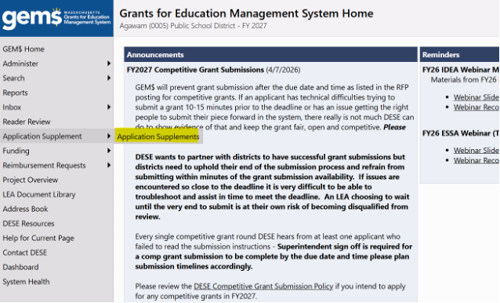
On the Application Supplements page, filter for 2027 on the dropdown with years. The list of available application supplements will populate. Click “Middle School Pathway Exploration Policy and Attestation”:
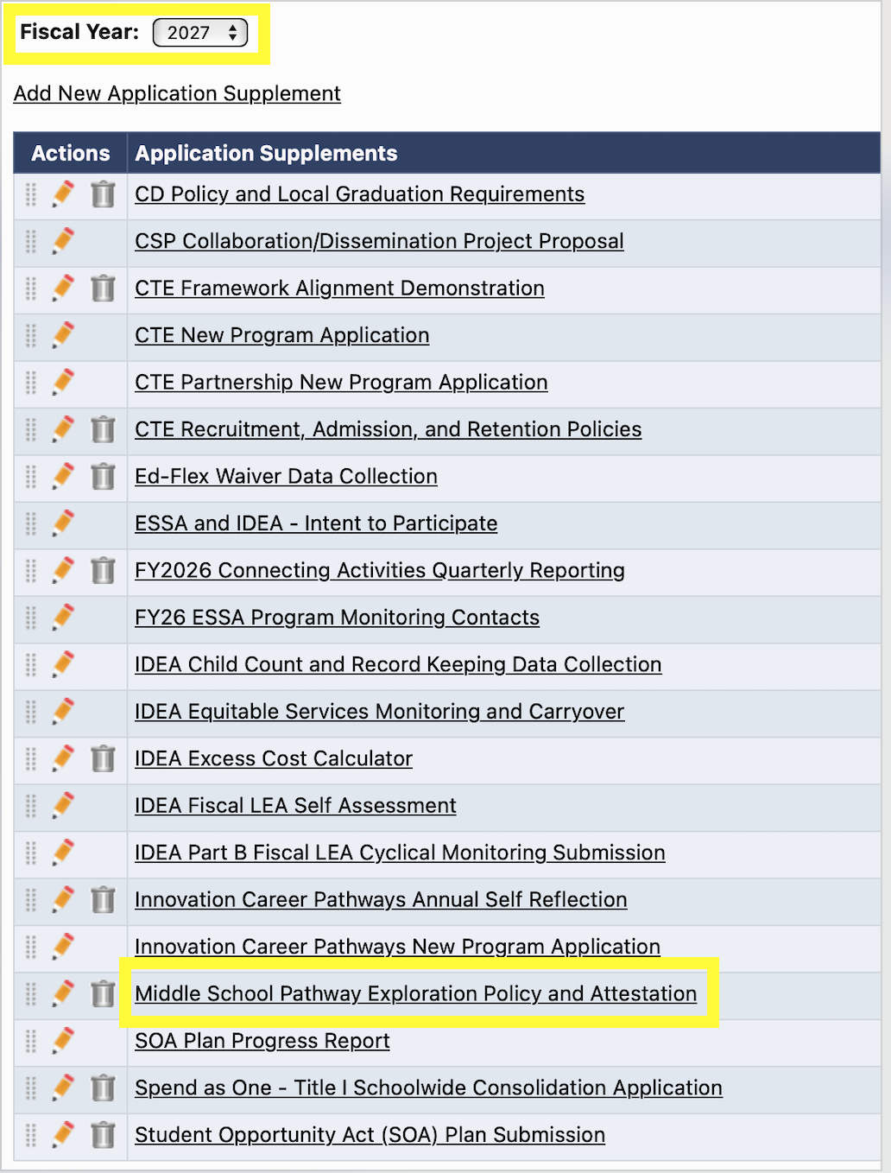
On the next page, you can click on the “Annual Submission Questions” to preview the questions. Note, you will need to change the status to “Application Supplement Started” to be able to fill in the required fields:
Question-Specific Guidance
The Annual Submission Question asks the individual to provide a link to where your districts SY26-27 Middle School Pathway Exploration Policy is available on your district/school website. The policy link is due annually. Paste the link in the textbox.
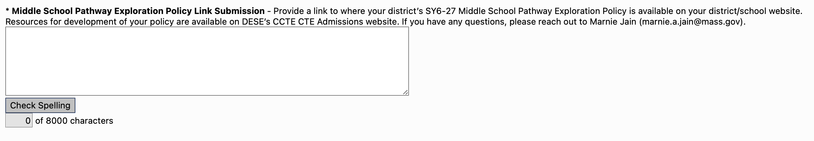
The Annual Submission Required Documents question is for “download/upload” of the Middle School Pathway Exploration Policy. Upload the policy here. A policy template is available on GEM$. Once completed, you will upload the document to the question in GEM$.
The next required document is the Policy Attestation. The attestation is due annually. The attestation form is available for download on GEM$. Once completed, you will upload the document to the question in GEM$.
