# Family Engagement and My Career and Academic Plan (MyCAP)

Family Engagement is an intentional, authentic, respectful and equal partnership between schools and families with a shared vision of positive outcomes for children and youth throughout their PreK-12 education. Grounded [in Massachusetts’ Prenatal through Young Adulthood Family Engagement Framework](https://www.doe.mass.edu/sfs/family-engagement-framework.pdf), this partnership recognizes that each family is unique and brings different strengths and structures to the school community. As the first and best advocates for their children, families are key influencers of their child’s success and essential partners in education.

Decades of research, including findings from National PTA and Harvard’s Family Engagement Lab, show that students whose families are engaged in their education:

* Earn higher grades and test scores
* Have better attendance and are more likely to graduate
* Develop stronger social emotional skills and postsecondary readiness

## School Responsibilities

1. Provide access to DESE’s [Family Portal](https://www.doe.mass.edu/families/) and [School Finder tool](https://profiles.doe.mass.edu/search/get_closest_orgs.aspx) where families can find resources, multilingual supports and career pathway guides
2. Develop materials (in families’ home languages) that explain MyCAP i.e., MyCAP is a process that empowers students to build a path to success after high school. Throughout their educational journey and guided by the MyCAP process students will discover their strengths, skills, talents and passions, identify and explore careers that match those attributes and then better connect their academic program of study with those attributes and careers
3. Create opportunities for students to share their individual MyCAP development such as through student-family-teacher conferences
4. Design a plan for continuous communication about MyCAP i.e., Posters and visuals in the school buildings, monthly newsletters that might include updates, highlights and pictures of students in MyCAP activities, suggested sentence starters to prompt conversations at home
5. Invite families to be part of the planning and implementation processes
6. Create family learning opportunities to provide more details about MyCAP, including virtual meetings, translated resources, and flexible schedules
7. Provide information to help families understand the career development sequence: self-discovery, career awareness, career exploration, and career immersion and the cyclical nature of it. In addition, include families in any

career speaker sessions (maybe a family member would be a speaker), career fairs, or opportunities to engage in understanding the labor market.

## Family Responsibilities

1. Attend learning opportunities to better understand MyCAP and the future planning your child is engaged in
2. Volunteer to be part of planning and implementation teams
3. Participate in career exploration opportunities with your child
4. Engage in regular conversations with your child about their dreams, hopes, goals and future plans.
5. Share your own story
6. Honor the choices and decisions your child shares with you
7. Provide a reflection at the end of every school year about your child and the growth you have seen and your hopes and dreams for them

## Conclusion

Family engagement is not a one-time event but an ongoing partnership that requires schools to create inclusive, welcoming spaces where families feel valued. Family engagement is critical to the MyCAP process. When schools and families develop trusting relationships and support students’ self-exploration and career development, when families take the time at home to discuss evolving future goals and plans, and when both help connect classroom learning to real-world opportunities students will gain the knowledge, skills and experiences to confidently navigate their future pathways. Families play a vital role in their child's preparation to successfully transition to life after high school.

Healthy, respectful, trusting school - family relationships have never been more important!

## Final Note

Family Engagement Resource for whole school development:

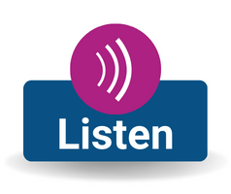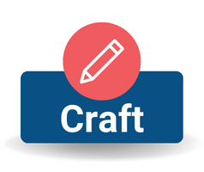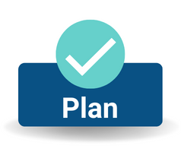

DESE in partnership with the Federation for Children with Special Needs (FCSN) has created a family engagement toolkit that provides resources and materials to support districts as they create systems for authentic family engagement. The Toolkit can be found [here](https://sites.google.com/view/family-communication-toolkit/welcome?authuser=0).