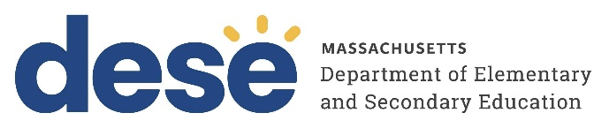
30 Year Best Practice Profile
2024-2025 SY

Atlantis Charter School
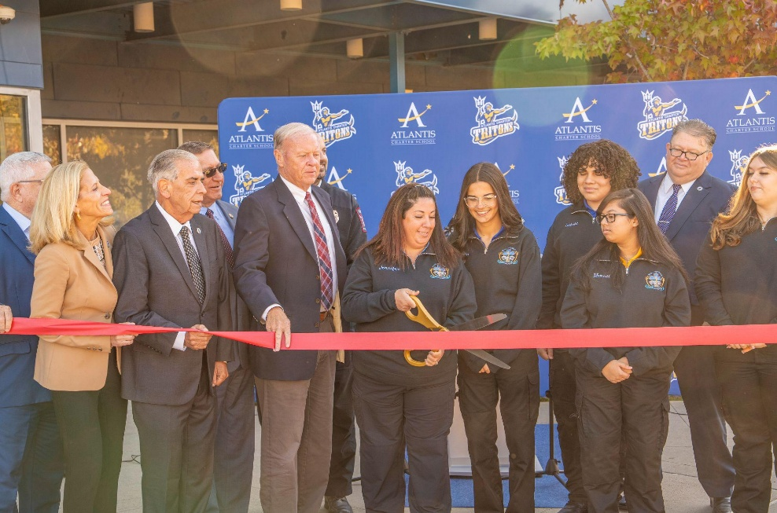
Best Practice: Whole-Child, College & Career Readiness Through SEL and Family Partnership
Applicable Charter School Performance Criteria: Criterion 6: Program Delivery and Criterion 7: School Climate and Family Engagement
History:
- Founded in 1995 to provide a continuous K–12 educational experience for families in Fall River, MA, Atlantis Charter School began with 252 students in grades K–5 and expanded by adding one grade level per year.
- By 1998-99, the school had expanded to serve grades K–8. In 2014, Atlantis received approval to grow its enrollment and launch a high school. The school added one grade each year, reaching full K–12 enrollment by 2018–2019. The school serves 1,246 students.
- The school has received the Innovation Career Pathways designation in four sectors: business and finance (2019), healthcare and social assistance (2019), manufacturing (2019), and information (2021).
- The school was formerly located at three sites in Fall River. In February 2018, the school moved into a new building and merged all three campuses into one.

Mission

“The mission of the Atlantis Charter School is to provide an education second to none, yielding academic excellence and life-long learning skills. Atlantis Charter School, an independent public school, provides an educational choice to the families of Greater Fall
River by offering our students a solid academic foundation on which to build a successful future. We expect an equal partnership among parents, community, faculty, staff and students to create a safe, caring, innovative and progressive learning environment. Atlantis incorporates the best research-based practices in education to meet the needs of our student population. It is our intent to become a model of educational excellence.”

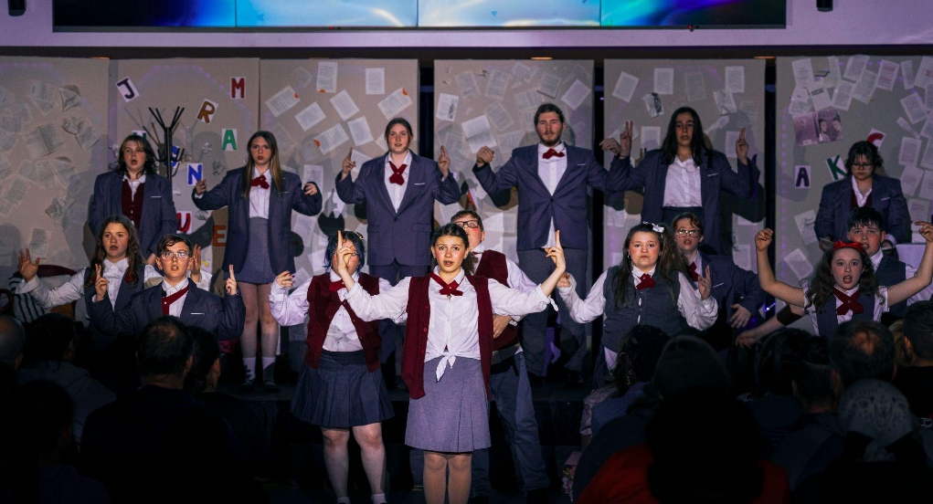
Innovative Methods and Best Practices:

Atlantis Charter School integrates academic rigor, student support, and community partnership through three key practices: a Career Academy Model that combines college preparation with career pathways; a Family Engagement approach anchored by bilingual support and advisory councils; and a comprehensive Social-Emotional Learning system supported by a full team of specialists. Together, these practices promote student growth, inclusion, and readiness for postsecondary success.

- Career Academy Model

Atlantis Charter School’s Career Academy Model is a hallmark of its high school program, integrating college-preparatory academics with hands-on, career-focused learning. All 9th-grade students participate in a structured exploratory program, enabling them to make informed choices before selecting one of five specialized pathways in 10th grade: Arts & Culture, Business, Medical, Teacher Development, and STEM—four of which have received the Department’s Innovation Career Pathways designation. Each pathway includes applied coursework, skill development, and real-world internship opportunities in 12th grade with local partners such as the Fall River Fire Department, St. Anne’s Hospital, and Bay Coast Bank. The program is fully inclusive, with Career Academy staff collaborating with special education and ESL educators to ensure access for students with disabilities and multilingual learners. To support postsecondary readiness, Atlantis provides on-site Preliminary SAT and SAT testing with financial assistance, offers Advanced Placement courses, and coordinates college visits, career fairs, and guest speakers through its full-time guidance counselors.
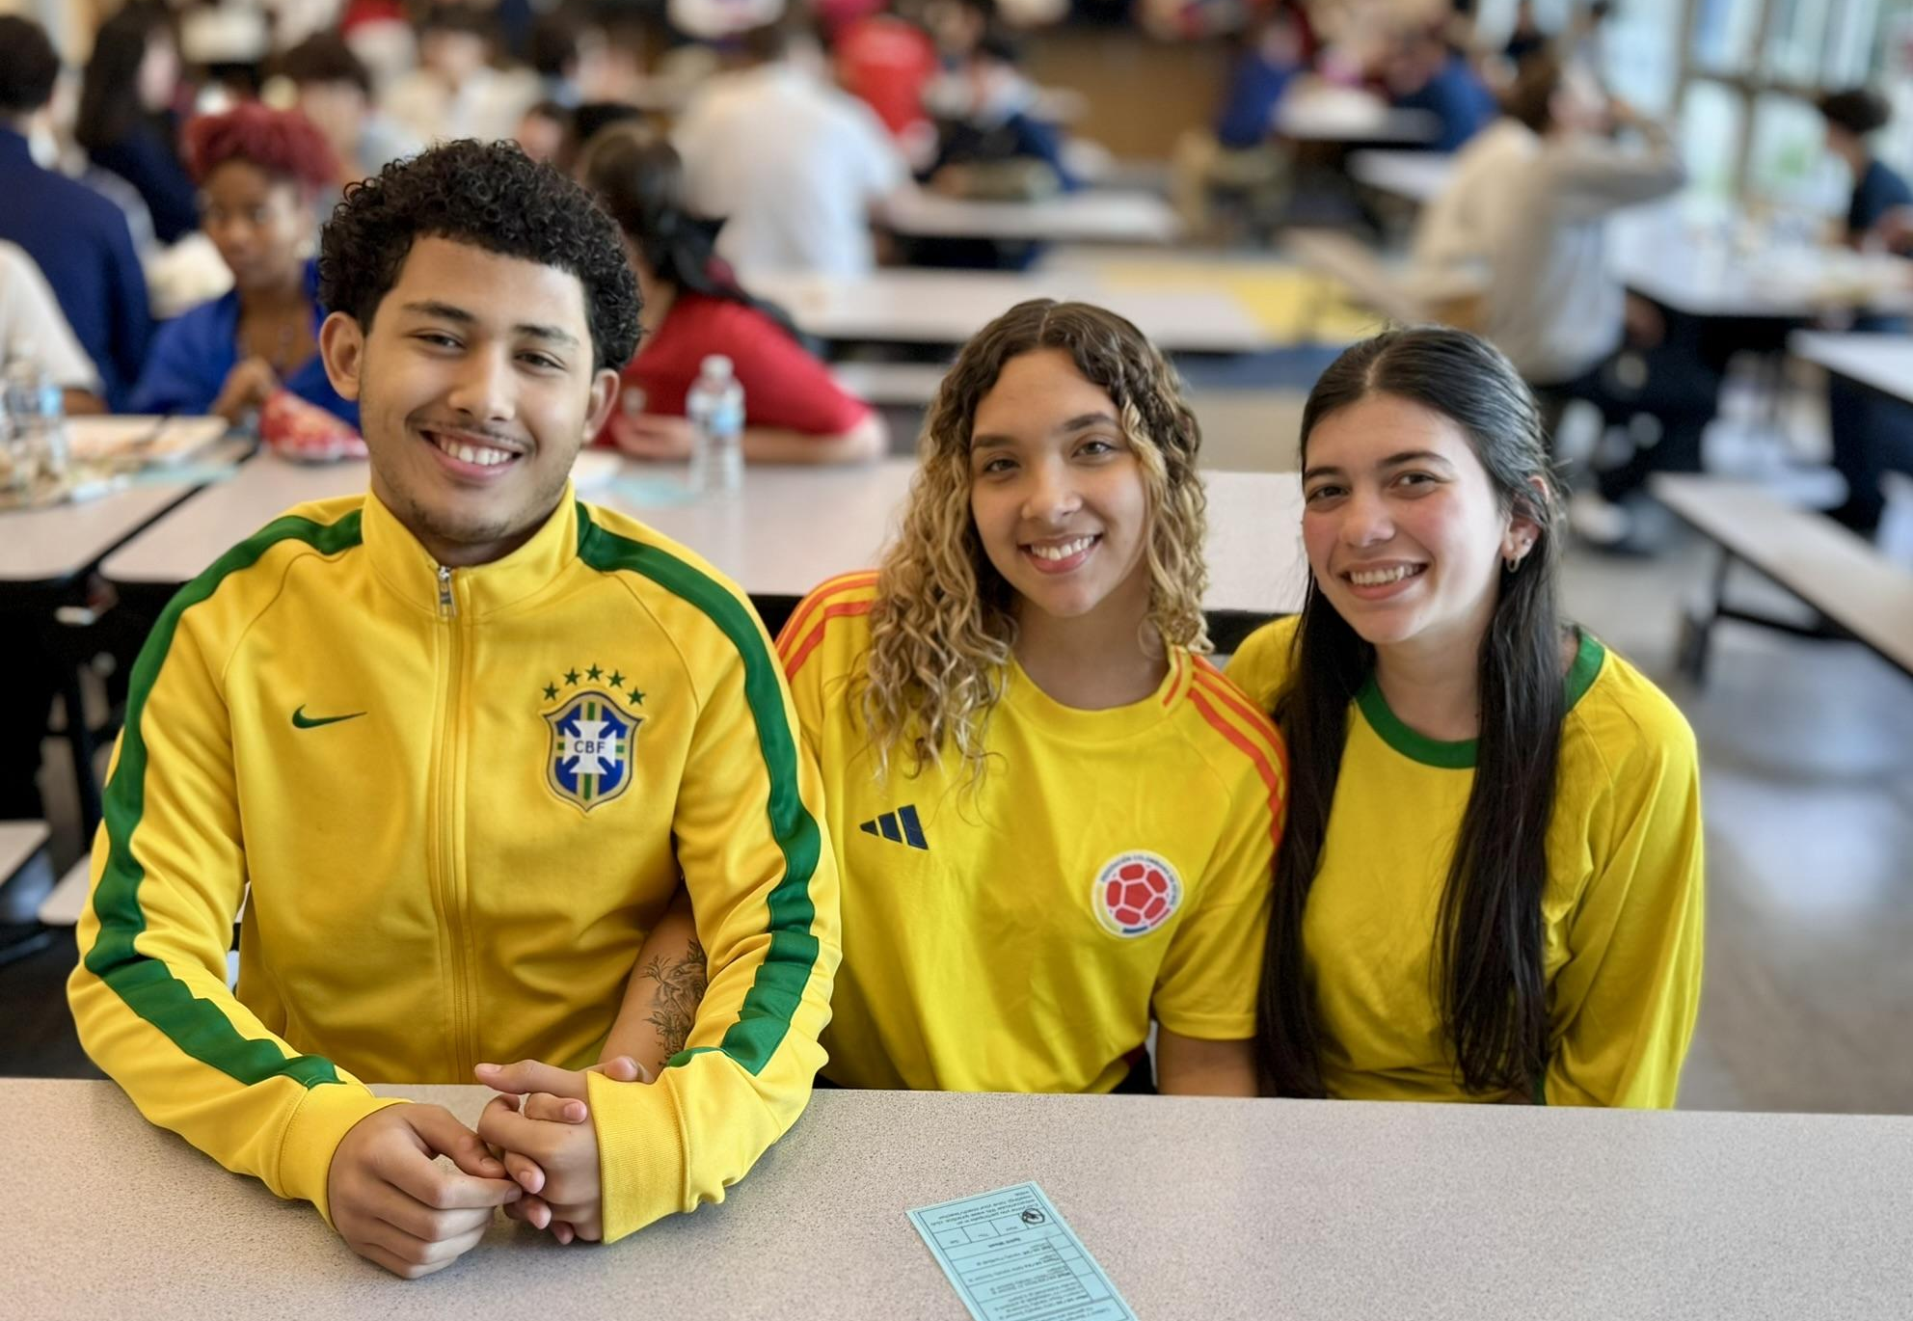

- Family Engagement and Community Partnerships

Atlantis supports family engagement and community partnership through its Family and Community Resource Center (FCRC), which provides bilingual assistance with transportation, financial support, and event coordination. The FCRC plays a vital role in fostering strong home-school relationships, trust, and open communication. The school engages families through programs such as the DESE-sponsored Family Institute for Student Success (FISS), which offers workshops to help families support their children’s education, as well as events like booster runs and fun nights. It collaborates with the Special Education and English Learner Parent Advisory Councils to ensure inclusive support. A dedicated attendance officer conducts home visits and offers re-engagement and counseling referrals to strengthen family-school connections.
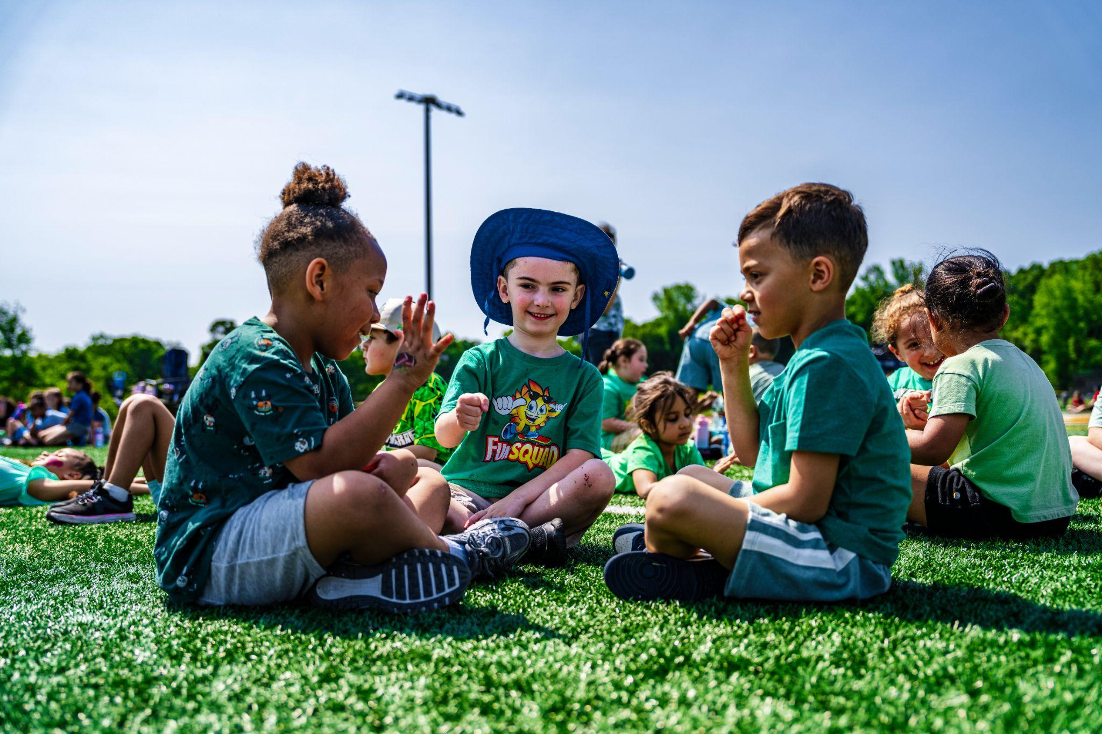
- Social-Emotional Learning and Support Services

The school supports student wellness and academic success through a multi-tiered system that integrates social-emotional learning (SEL) and academic interventions. The school employs a full complement of support staff, including two full-time school psychologists, seven school adjustment counselors (SACs), paraprofessionals in most academic classes, and specialists in speech, PT, OT, BCBA, and RBT services. SEL is embedded through daily morning meetings in grades K–6 and weekly 35-minute advisory sessions in grades 7–12, using a curriculum aligned with Conscious Discipline—a whole-school approach that supports students with behavior and emotional regulation—along with restorative practices. In 2024–25, the school adopted Wayfinder, an SEL program aligned with CASEL competencies. Student Support Teams (SST) meet biweekly during common planning time to review academic, behavioral, and SEL data, implement tiered interventions, and assess their effectiveness. Additional academic supports include literacy and math interventionists in grades K–6, lunch and after-school tutoring, and embedded professional development, mentoring, and coaching for teachers. Participation in DESE’s Social, Emotional, and Behavior (SEB) Academy strengthens the school’s systemic focus on whole-child development.

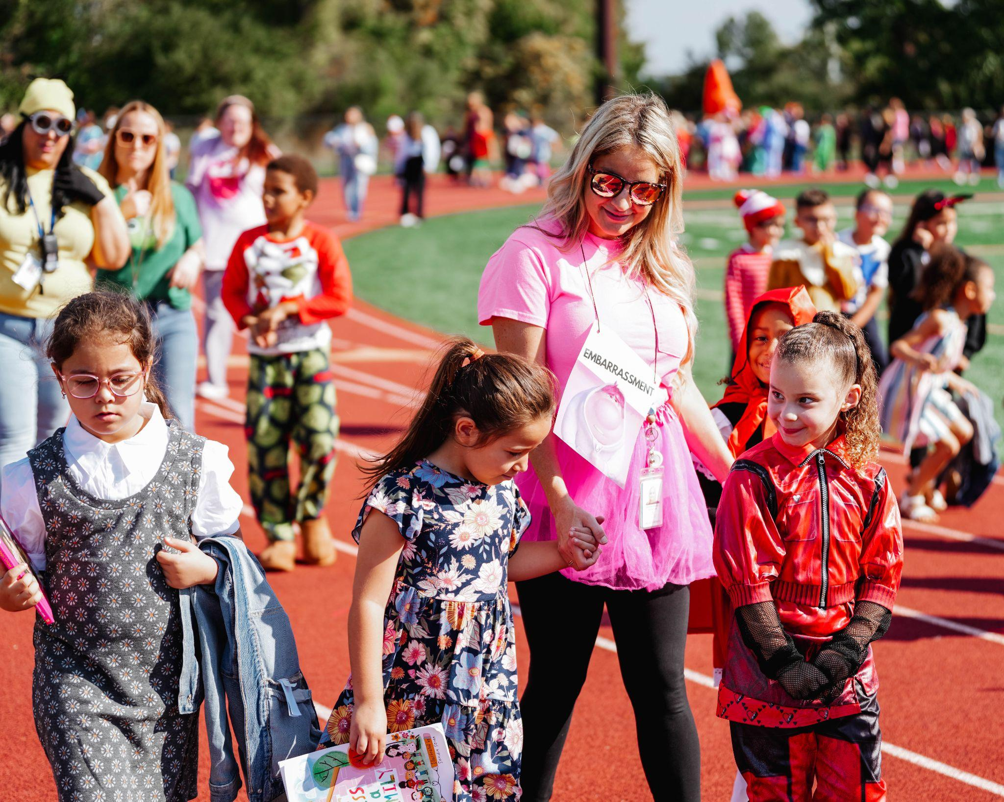
Results of Implementation:
- More than 75 percent of Atlantis graduates achieved passing grades (70 or above) in all Career Academy coursework, including an internship at a partner organization or comparable capstone project in 2021-2024 years.
- In the past five years, between 75 percent and 95 percent of graduates were accepted to a two- or four-year college or university.
- The school’s data show improved social, emotional, and behavioral outcomes among students, along with an upward trend in academic proficiency.



