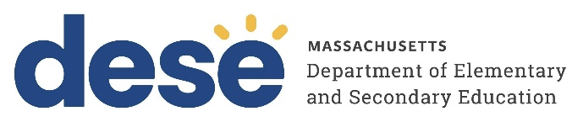
30 Year Best Practice Profile
2024-2025 SY

Benjamin Franklin Classical Charter Public School

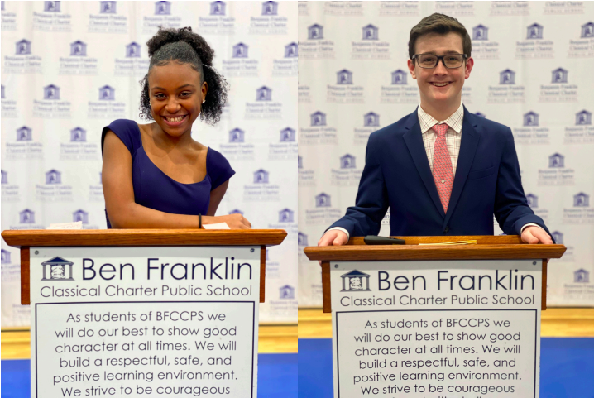

Best Practice: Integrated K–8 Model of Character Development, Literacy, and Service Learning Culminating in the Capstone Project
Applicable Charter School Performance Criteria: Criterion 6: Program Delivery and Criterion 7: School Climate and Family Engagement
History:
- Benjamin Franklin Classical Charter Public School (BFCCPS) received its charter in 1995 to serve 450 students in grades K through 8. The school opened in 1995, serving 150 students in grades K through 4. The school added one grade each year, reaching its maximum grade span in 1999.
- In March 2014, the school was granted an amendment to increase the school’s enrollment cap from 450 to 900 students. The amendment also made BFCCPS as a regional charter school, expanding its catchment area to include 12 surrounding districts in addition to Franklin.
- BFCCPS moved into a newly constructed building in 2019–2020. The facility includes a STEAM lab, flexible classrooms, and dedicated spaces for music, art, and library programs—designed to support a classical education and whole-child approach. The school reached full enrollment of 900 students in the 2024–2025 academic year.

Mission:

“The mission of BFCCPS is to assist parents in their role as primary educators of their children by providing the children with a classical academic education coupled with sound character development and community
service.”
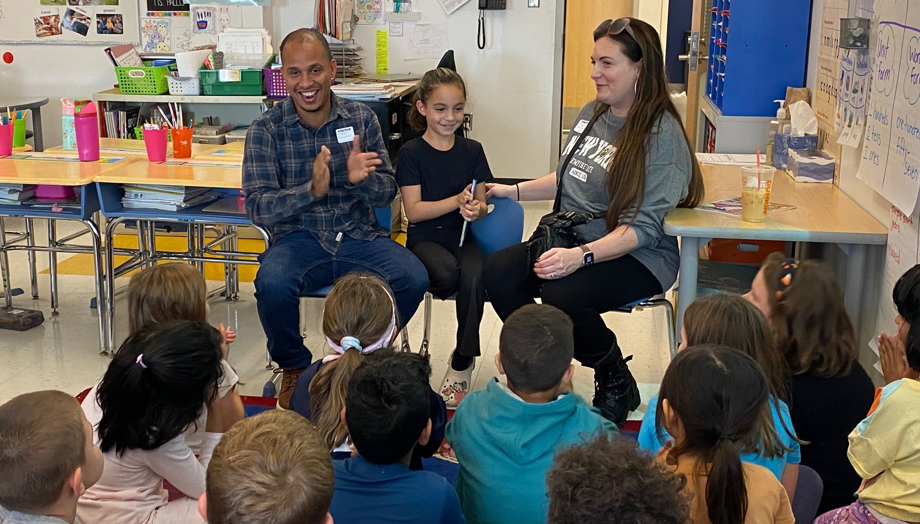
Innovative Methods and Best Practices:

Benjamin Franklin Classical Charter Public School (BFCCPS) exemplifies a comprehensive and intentional approach to character development, literacy, and community engagement across grades K–8. Central to this framework are structured programs that foster cross-grade relationships, integrate service learning into the curriculum, and culminate in a student-driven Capstone Project. Through the Intergrade Buddy Program, students participate in mentoring and collaborative academic activities that reinforce social-emotional growth and literacy skills. Community service is embedded as a core element of the student experience, with age-appropriate projects promoting empathy and civic responsibility from early grades onward. Together, these best practices form a cohesive model that prepares students to become responsible, reflective citizens equipped for lifelong learning and leadership.

- “Grade Buddies” Program for Character and Literacy Development:

BFCCPS’ character education is a foundational practice and is woven into the K–8 curriculum through a school-developed vocabulary and structured cross-grade partnerships. A key feature of this model is the “grade buddies” program: every other week, eighth and fifth graders mentor kindergartners, fourth graders pair with second graders, and third graders partner with first graders to engage in literacy, character development, and service activities. These connections are reinforced during schoolwide events such as the Kindergarten Author Celebration, where fifth graders cheer on young students presenting their first books and projects like the Volume Zoo, in which fifth graders and kindergarten students engage in math and science multidisciplinary projects together. This hands-on, collaborative approach strengthens both academic and social-emotional development.
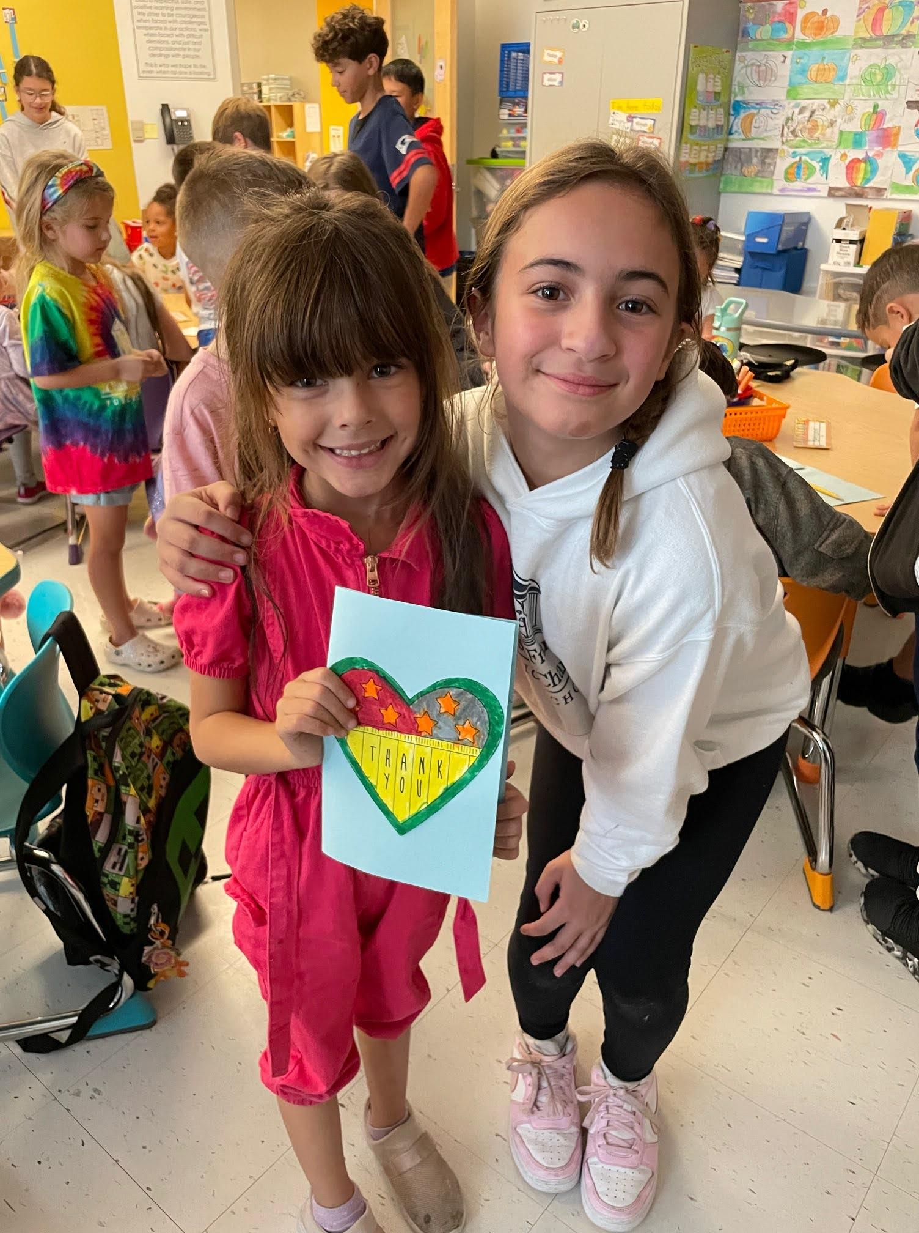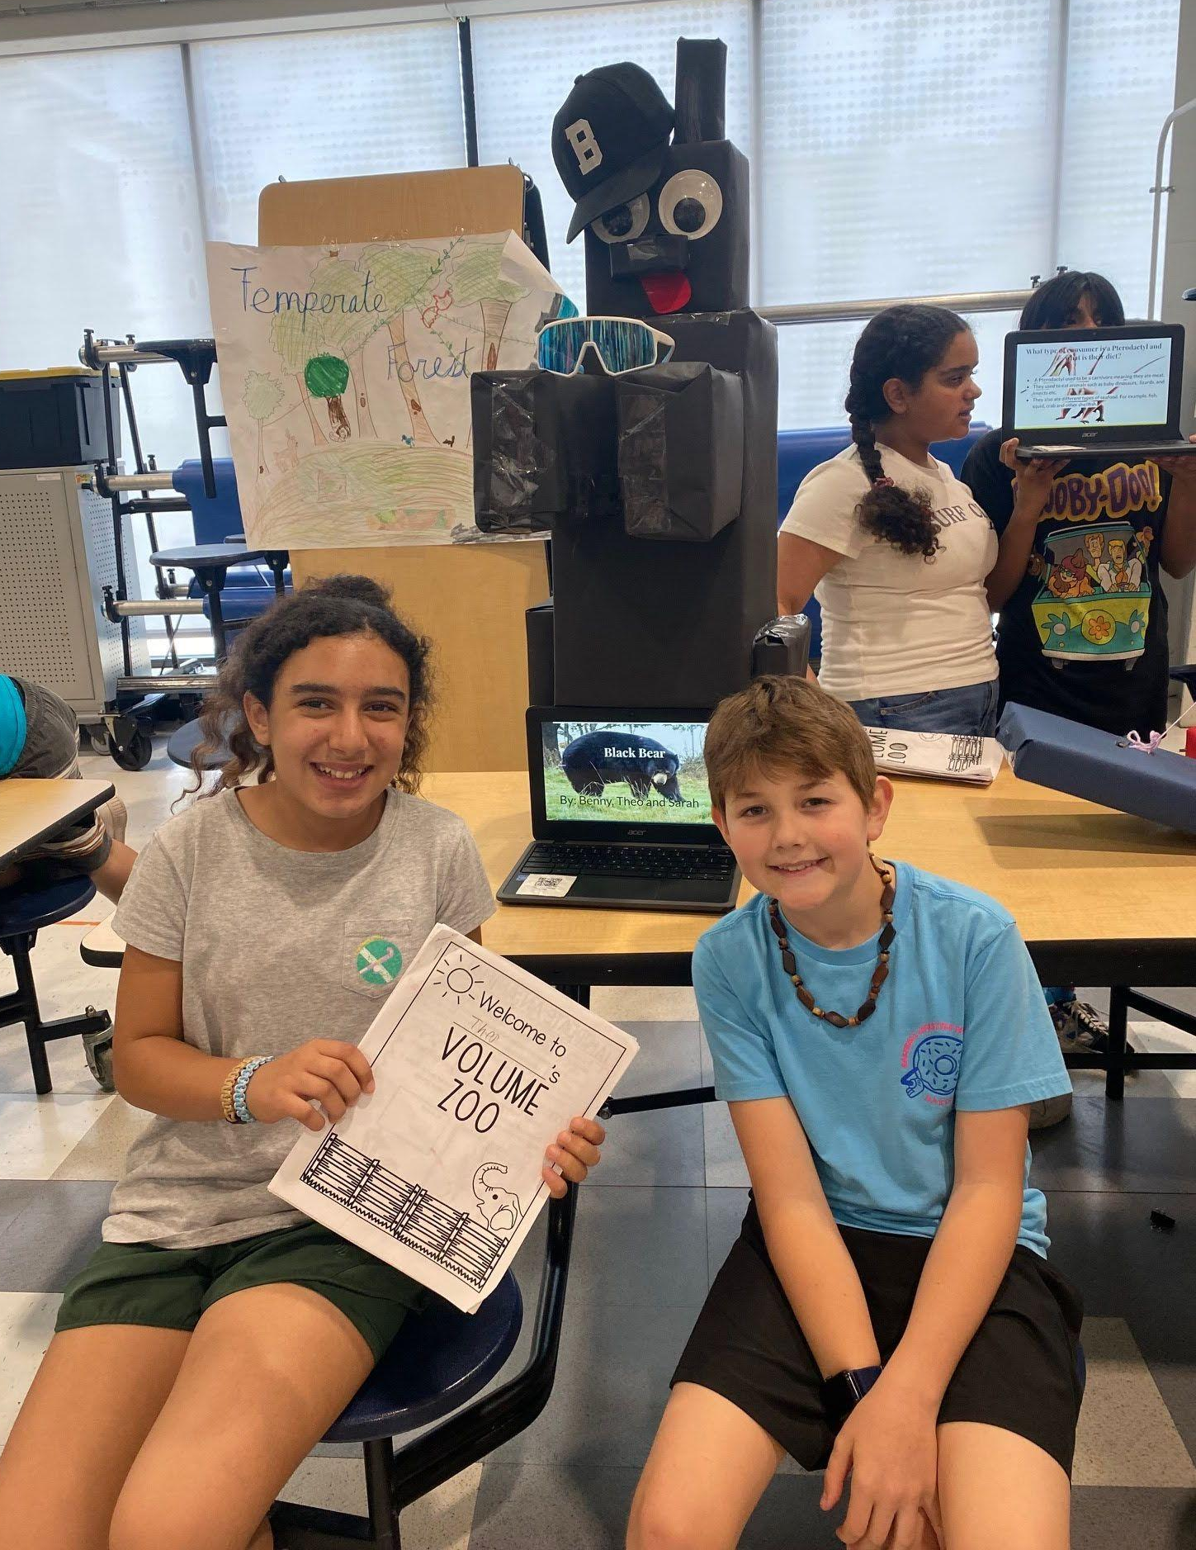
- Community Service Across Grades K–8:
BFCCPS implements a structured and developmentally appropriate approach to community service, engaging all students from kindergarten through grade 8 in meaningful service projects at least three times each year. Community service is integrated into the academic calendar through clear benchmarks, ensuring it is not an extracurricular activity but a core part of the student experience. Service learning begins at the early grades: kindergartners engage in activities like leaf raking on school grounds, while second graders build year-long relationships with local seniors by engaging in multiple activities, such as making cards before concluding the year with an in-person visit. This model helps students understand that they can make a difference at any age, fostering empathy, civic responsibility, and a lifelong commitment to service.
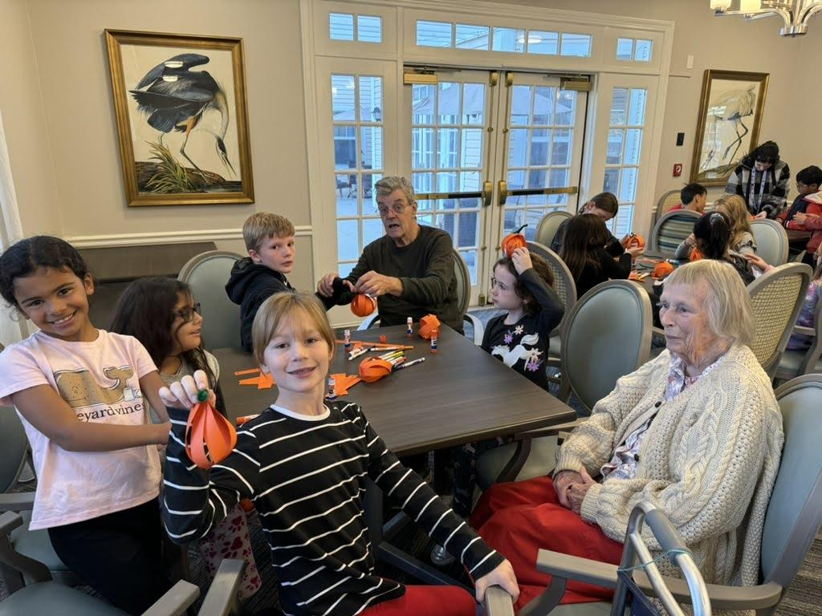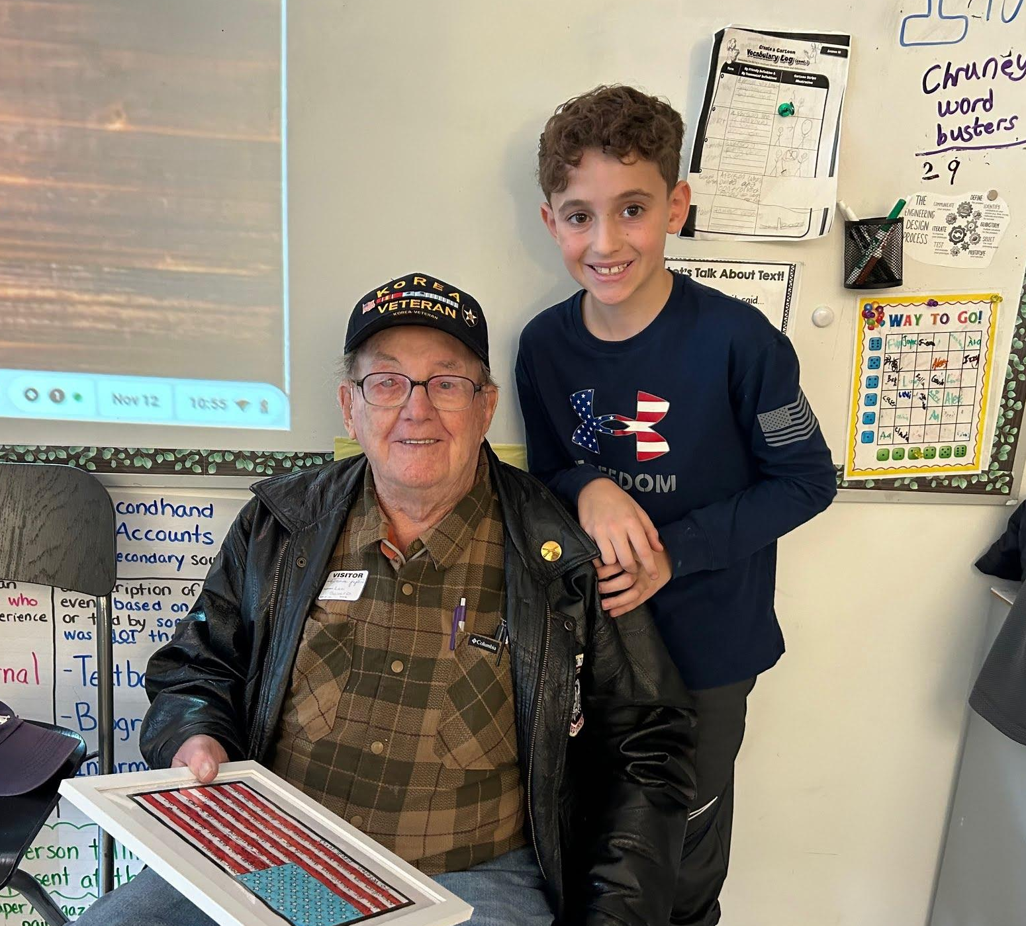
- Capstone Project:
The Capstone Project supports the school’s mission to develop responsible, reflective citizens through service and scholarship by integrating its four foundational pillars: parents as primary educators, classical education, community service, and character education. Beginning in seventh grade, students design and implement an individual community service project based on their prior experiences and personal passions, conducting research and collaborating with community organizations over two years. Each grade 8 student presents to an audience of several hundred, and reflects on their capstone project goals, challenges, outcomes, and personal growth. BFCCPS academic assemblies where students showcase their learning, character education practices, as well as the community service programming prepare grade 8 students for the capstone experience.
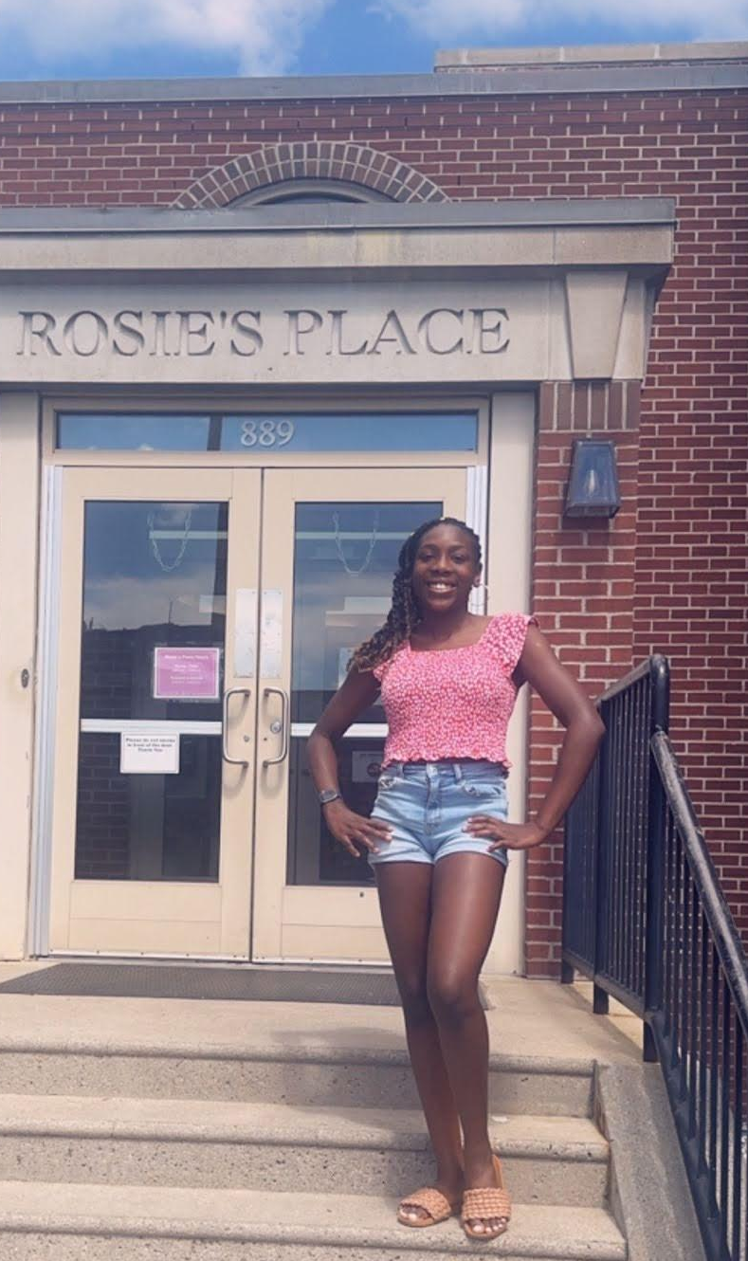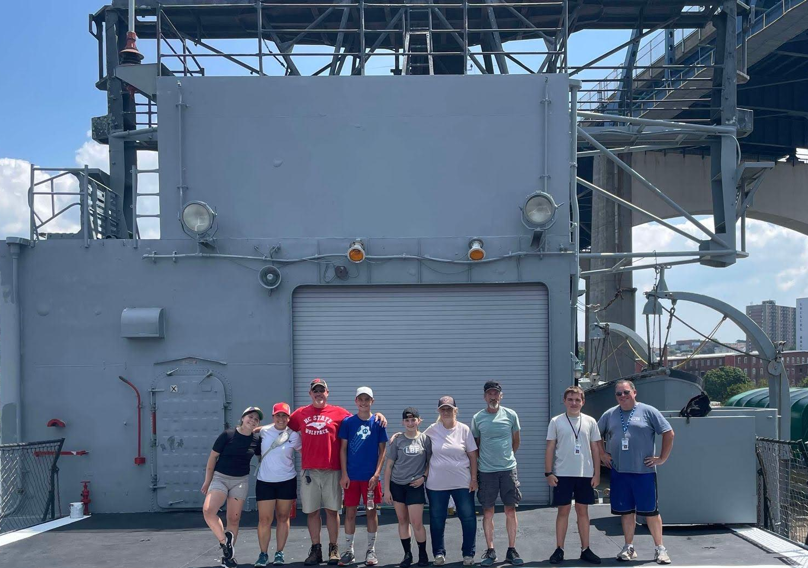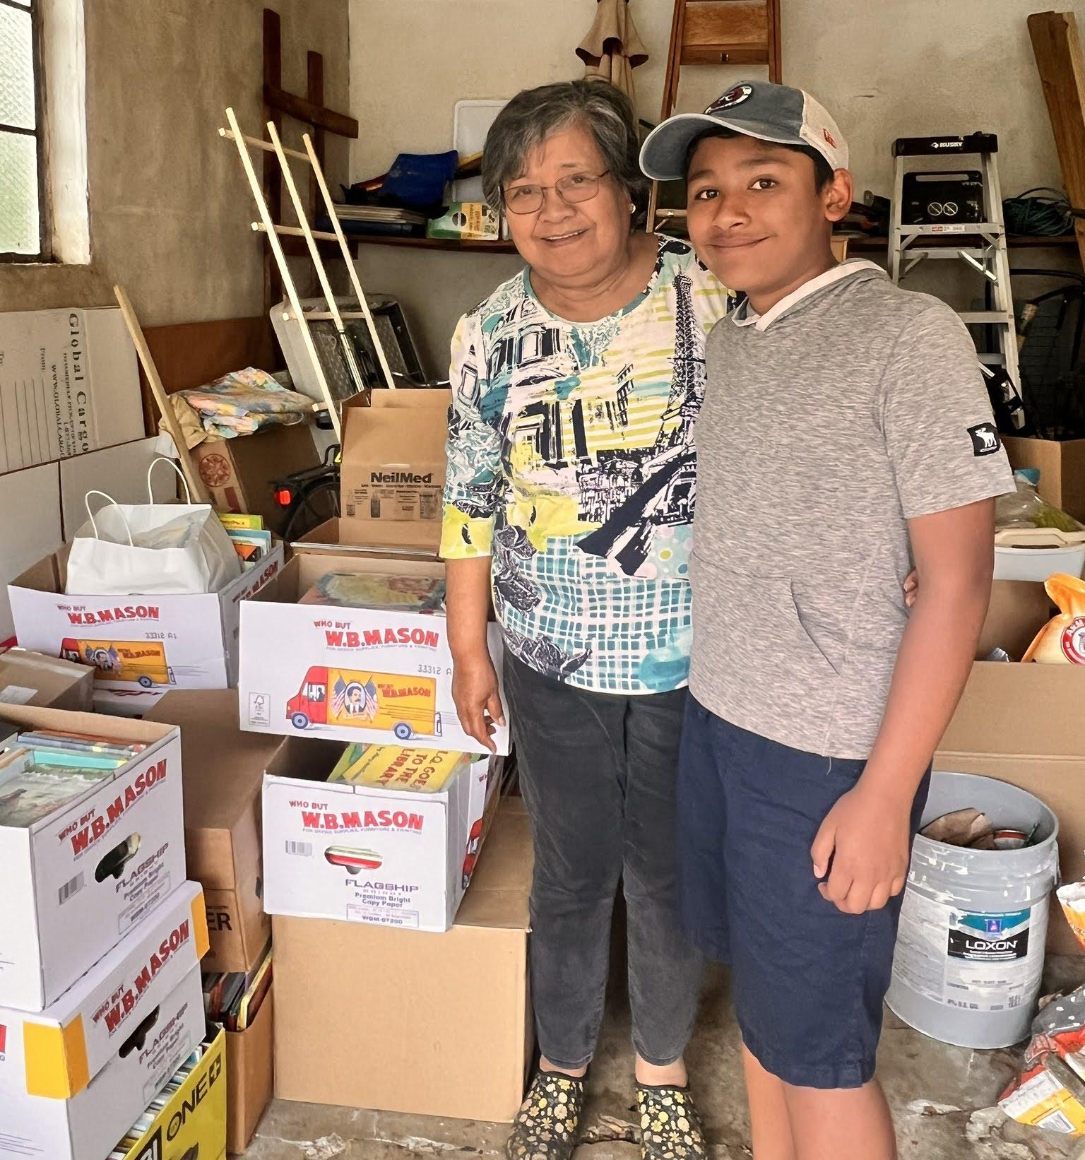
Results of Implementation:
- From 2020–21 through 2023–24, 100 percent of BFCCPS 8th-grade students successfully completed and presented their Capstone projects, each year earning a score of 85 percent or higher on the final rubric.
- Parents report that BFCCPS graduates are more excited about learning and actively seek opportunities to help others, demonstrating strong character and community engagement compared to students from traditional education.
- Numerous students extend their Capstone Projects beyond graduation, leveraging personal experiences to generate significant community impact. Examples include a student who coordinated the development of a local dog park, another who identified the needs of cancer patients and mobilized peers to produce and donate 150 recovery pillows to Johns Hopkins Hospital, and a student who instructed classmates in crocheting hats for NICU infants, subsequently donating these to a children’s hospital. These initiatives exemplify the students’ enduring dedication to community service and the cultivation of leadership skills.

