
30 Year Best Practice Profile
2024-2025 SY

Boston Renaissance Charter Public School
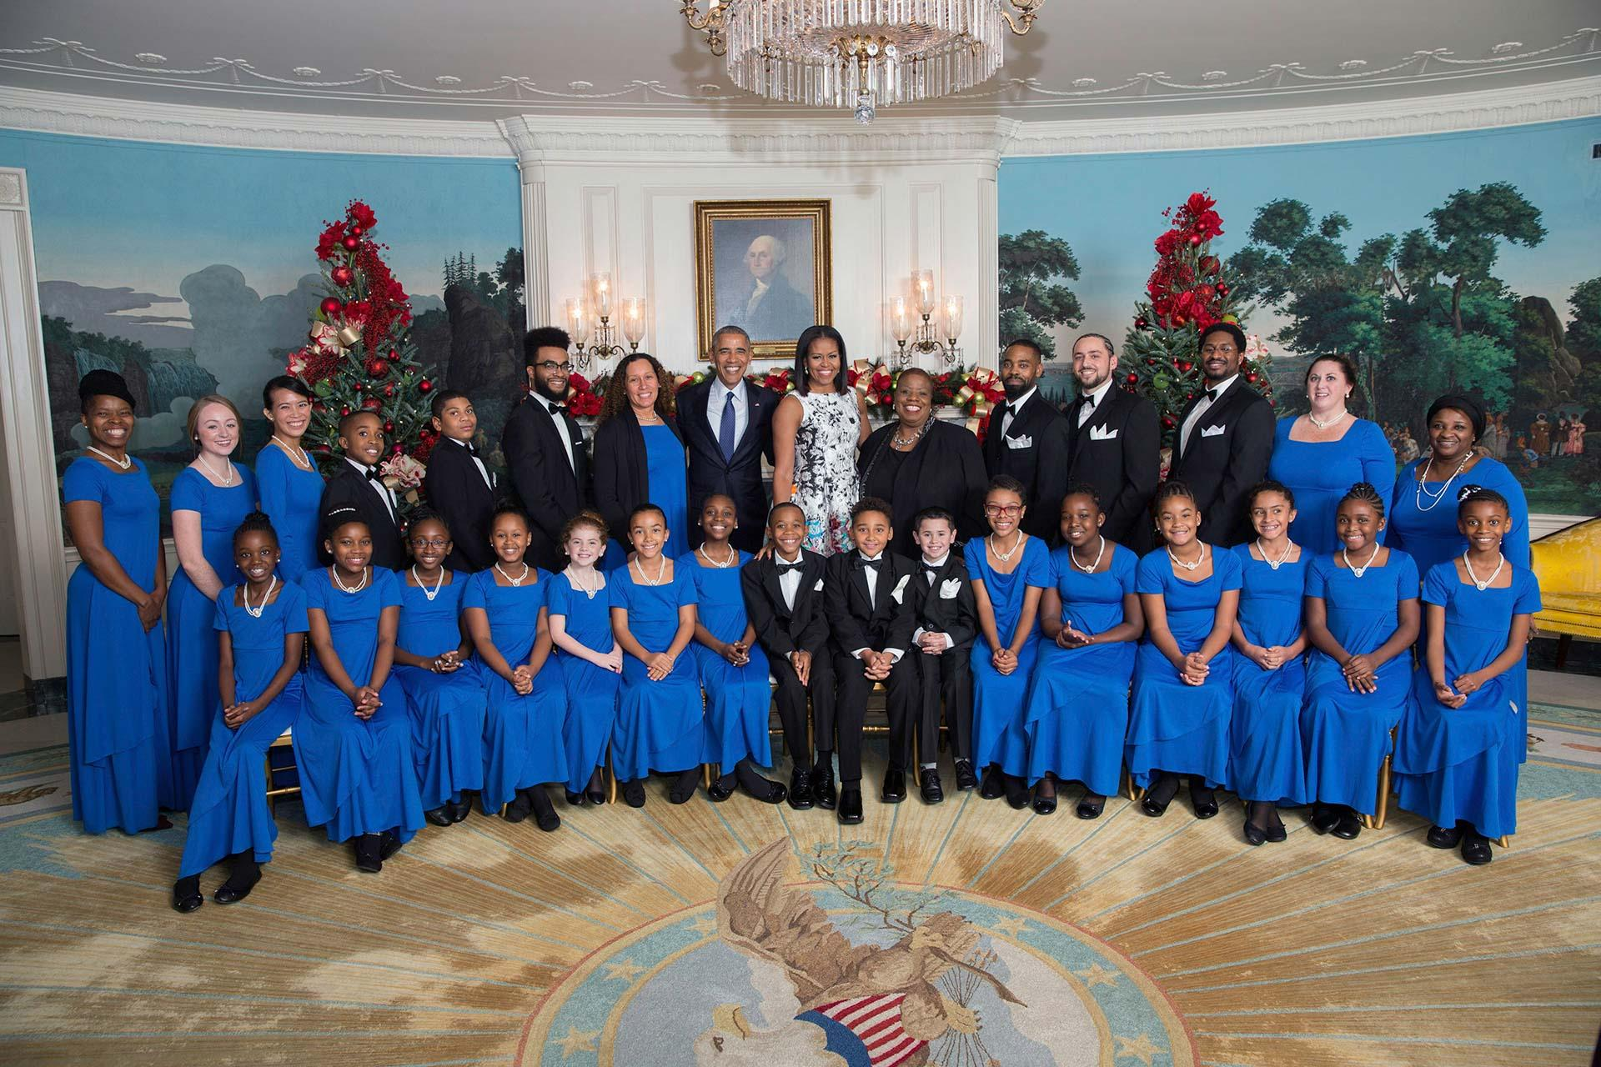
Best Practice: Whole-Child Growth Through Integrated Academic and Social-Emotional Systems of Support
Applicable Charter School Performance Criteria: 7: School Climate and Family Engagement
History:
- Boston Renaissance Charter Public School (BRCPS) received its charter in 1994 to serve 1,479 students in grades PK through 12. The school opened in 1995 with a mission to provide a high-quality education to Boston’s children, initially serving 615 students in grades K–5. BRCPS currently has a maximum enrollment of 938 students in grades PK through 6.
- In its early years, BRCPS partnered with Edison Schools, Inc. to support its academic and operational development. Since 2002, the school has operated independently under the guidance of its board of trustees.
- In August 2010, the school relocated from 250 Stuart Street in Boston to 1415 Hyde Park Avenue.

Mission

“The mission of the Boston Renaissance Charter Public School is to nurture and develop academic, social, and emotional competence while building confidence, character, and citizenship among its students.”
Innovative Methods and Best Practices:

Boston Renaissance Charter Public School (BRCPS) takes a holistic, inclusive approach to education that supports students’ academic, social, emotional, and mental health needs. Through integrated practices like daily WIN (What I Need) blocks and arts integration, BRCPS nurtures the whole child. Its long-standing co-teaching model embeds specialized instruction ensuring all students receive individualized support. These strategies reflect the school’s mission to prepare confident, capable, and compassionate learners.
- WIN (What I Need) Time and Academic Enrichment in ELA and Math
BRCPS implements a daily WIN block in grades K–6 to provide targeted, data-driven instruction in both English Language Arts (ELA) and mathematics. Based on assessment data from Aimsweb, i-Ready, and curriculum-based tools like Fundations, Wonders, and Bridges, students are placed in small, ability-alike groups supported by general education, special education, and specialist staff. Groups are adjusted every 3–6 weeks using benchmark data, unit exit tickets, and platforms such as Illuminate. WIN instruction includes interventions, small-group strategy lessons, and enrichment opportunities through programs like Lexia and i-Ready. This consistent structure supports the school’s commitment to equitable academic growth and personalized learning.
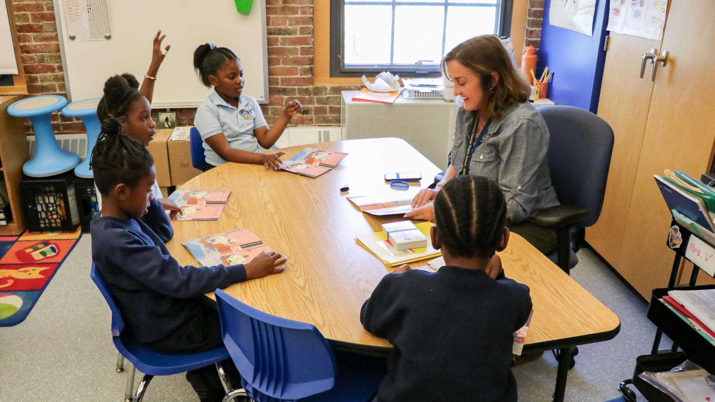
- Arts Integration and Student Expression as a Core Instructional Practice
For over 25 years, BRCPS has prioritized arts education as a critical dimension of whole-child development. Students participate in up to two specialty blocks per day—choosing from dance, visual arts, music, theater, Mandarin, and more—allowing them to explore, refine, and showcase their talents. Signature programs such as “Stars in the Arts” and the school’s choir, which performs in three-part harmony, give students platforms to build confidence and express themselves. These opportunities are fundamental to the curriculum and support a growth mindset, as students rehearse, receive feedback, and build resilience through creative practice.
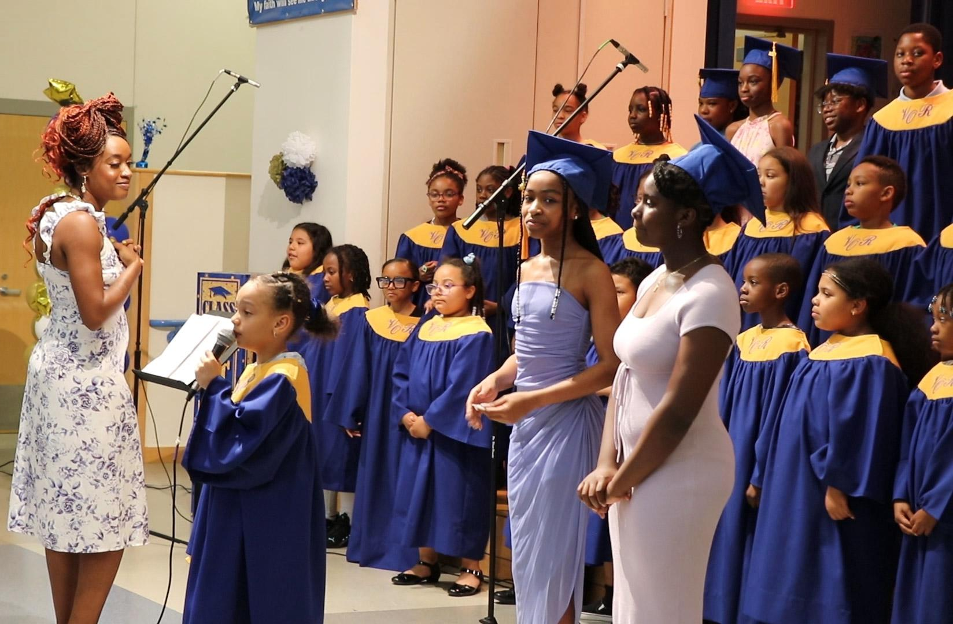
- Co-Teaching Special Education Model
Boston Renaissance Charter Public School’s co-teaching special education model, in place for over 20 years, integrates general and special education teachers in full-day classrooms (excluding kindergarten). This inclusive approach supports diverse learners within the general education setting, enabling differentiated instruction, targeted small-group support, and individualized accommodations. By fostering collaboration and shared responsibility between two certified educators, the model enhances instructional flexibility and benefits all students through continuous scaffolding, varied teaching methods, and increased adult-student interaction.
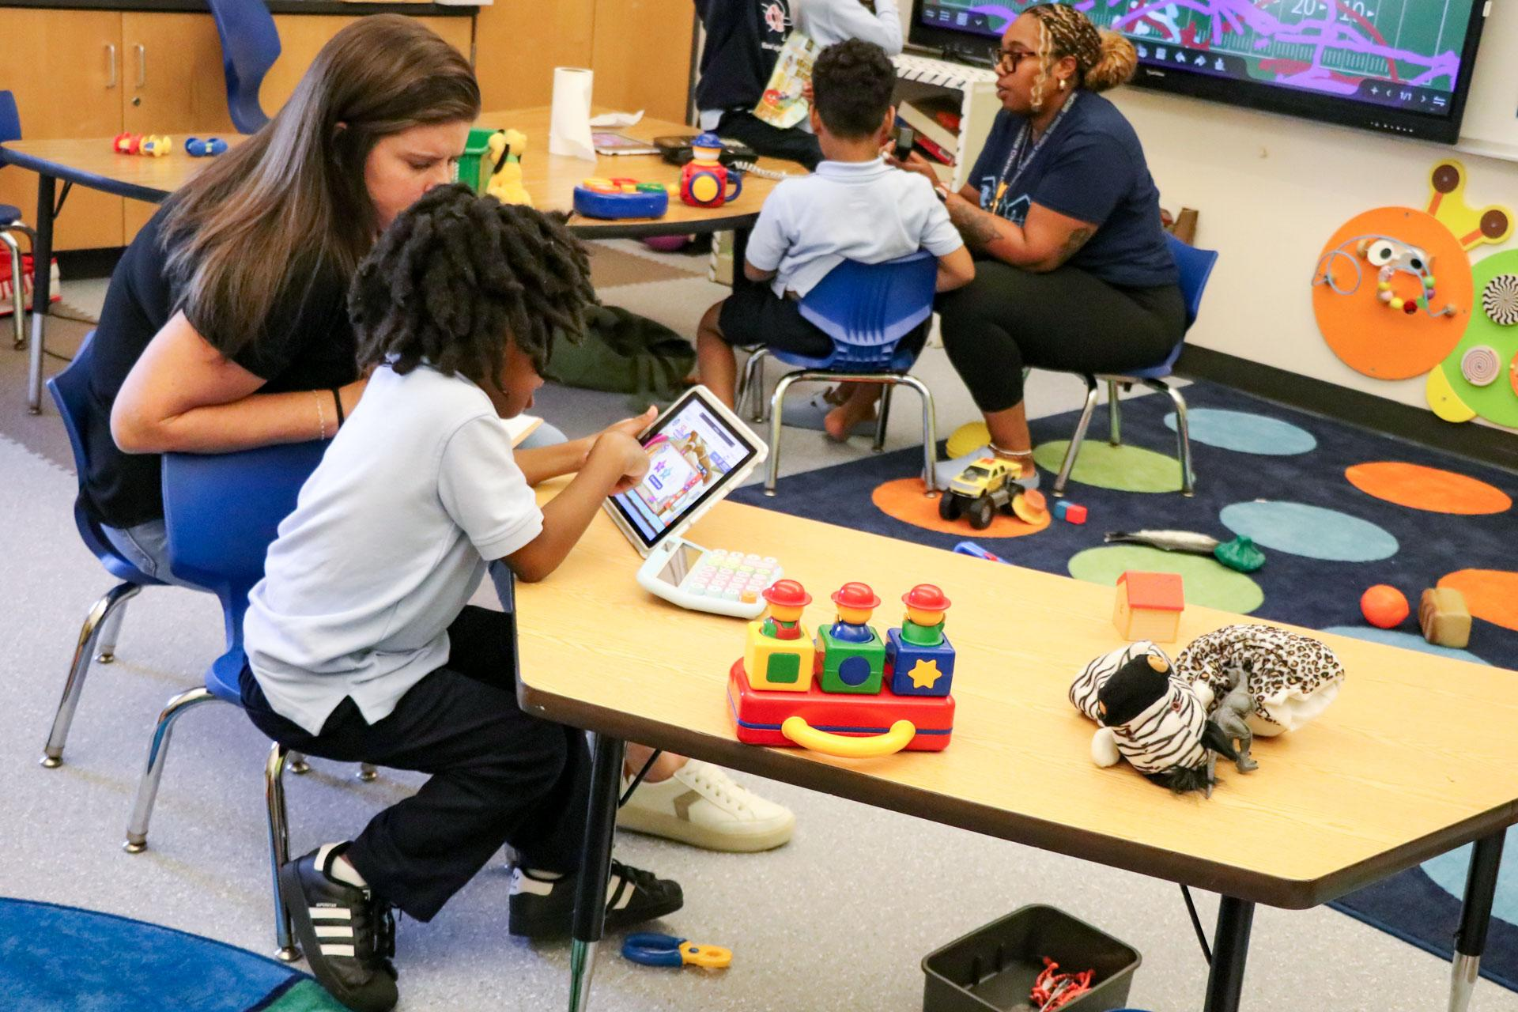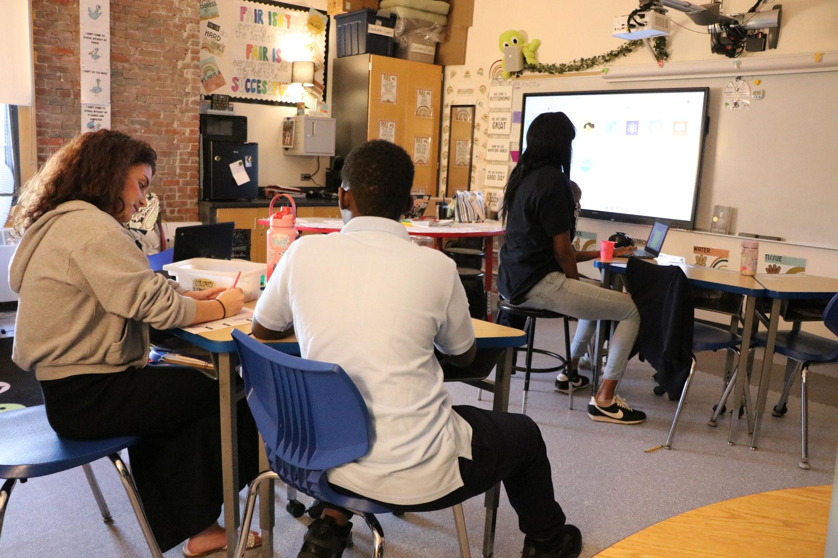

Results of Implementation:
- In the 2022–2023 school year, 53 percent of students in kindergarten through grade 6 met their annual typical growth target in reading, while 50 percent of students in grades K 2 through 6 achieved their annual growth target in mathematics.
- From 2020 to 2024, 100% of BRCPS general and special education teachers, along with coaches and facilitators, consistently participated in 40 hours of collaborative planning time and bi-weekly meetings focused on data-driven, differentiated instruction.
