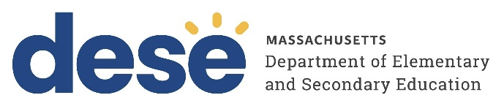
30 Year Best Practice Profile
2024-2025 SY

Cape Cod Lighthouse Charter School
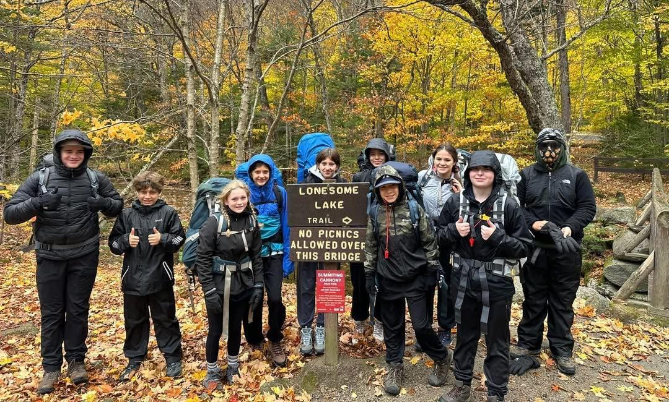
Best Practice: Empowering Middle School Learners Through Choice, Challenge, and Deep Engagement
Applicable Charter School Performance Criteria: Criterion 6: Program Delivery and Criterion 7: School Climate and Family Engagement
History:
- Cape Cod Lighthouse Charter School (CCLCS) received its charter in 1994 to serve 400 students in grades 6 through 12. The school opened in 1995, serving 130 students in grades 6 through 8.
- In November 2010, the Board of Elementary and Secondary Education (Board) approved an amendment to relocate the school’s facilities from Orleans to East Harwich. The school moved to East Harwich in September 2012.
- During the 2010-11 school year, teachers at the school unionized. Teachers are represented by the American Federation of Teachers and negotiate a contract annually.
- In December 2015, the Board approved an amendment to decrease the grades served from 6 through 12 to 6 through 8 and to decrease the maximum enrollment from 400 to 260 students.
Mission

“Cape Cod Lighthouse Charter School seeks to provide a supportive and challenging learning environment for middle school students, where teachers foster intellectual development and academic achievement in an atmosphere that celebrates learning as a lifelong pleasure.

We appreciate and understand middle school-aged students. We enjoy the often undervalued creativity and intellectual potential of this age group. We strive to provide an emotionally safe and supportive community, encouraging students to develop their strengths and risk new growth, while pursuing an academically rigorous
curriculum. Wherever possible, students learn through experience, allowing them to be engaged in the process of discovery and to see the practical applications of classroom lessons.

Looking beyond the walls of the classroom, we collaborate with local partners to utilize the unique natural and creative resources on Cape Cod and reach out to global partners to broaden our cultural understanding and knowledge. Our graduates take with them the values of personal responsibility, consideration for others, respect for the environment, academic integrity, creative expression, and perseverance.”
Innovative Methods and Best Practices:

CCLCS fosters student autonomy, confidence, and deep engagement through an integrated approach that combines academic rigor, real-world experiences, and student-driven learning. Three long-standing practices—an elective Seminar Program, Challenging and Adaptive Field Trip Experiences, and a Project-Rich Instructional Model—serve as cornerstones of the school’s educational philosophy. These structures are designed to support whole-child development, honor diverse strengths, and cultivate both academic and personal growth. Across disciplines and grade levels, students are given opportunities to explore their interests, tackle complex problems, and engage in learning that prepares them not only for high school but for life.

- Elective Seminar Program

At CCLCS, the Elective Seminar Program exemplifies the school’s mission to cultivate independent, engaged learners by fostering autonomy, choice, and depth in learning. Established in 1995 as one of the school’s founding innovations, the Seminar Program was designed to expand learning beyond conventional academic standards. Teachers and students co-create elective courses that may fall outside the traditional curriculum, intentionally drawing on Howard Gardner’s theory of multiple intelligences—a framework the school continues to value for its ability to engage students across a broad spectrum of cognitive strengths. Offered weekly for an hour and a half for an entire term, seminars allow students to select from a wide range of topics—such as quantum physics, food science, the science of COVID-19, or service learning with preschoolers—based on their interests and talents. For instance, in a Quantum Physics seminar, students might explore theoretical concepts through simulations, guided experiments, and collaborative discussions.

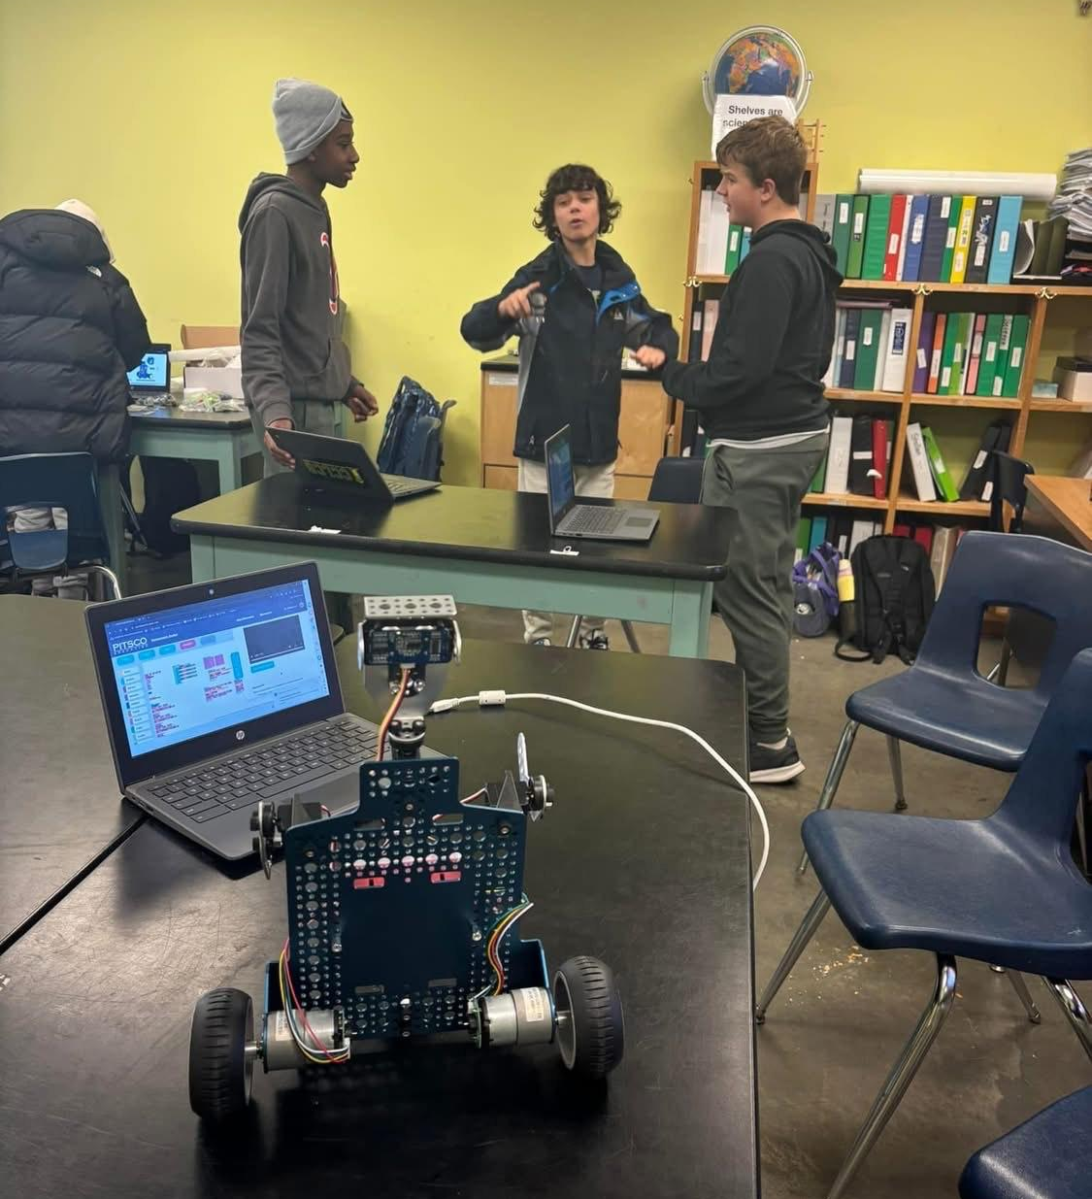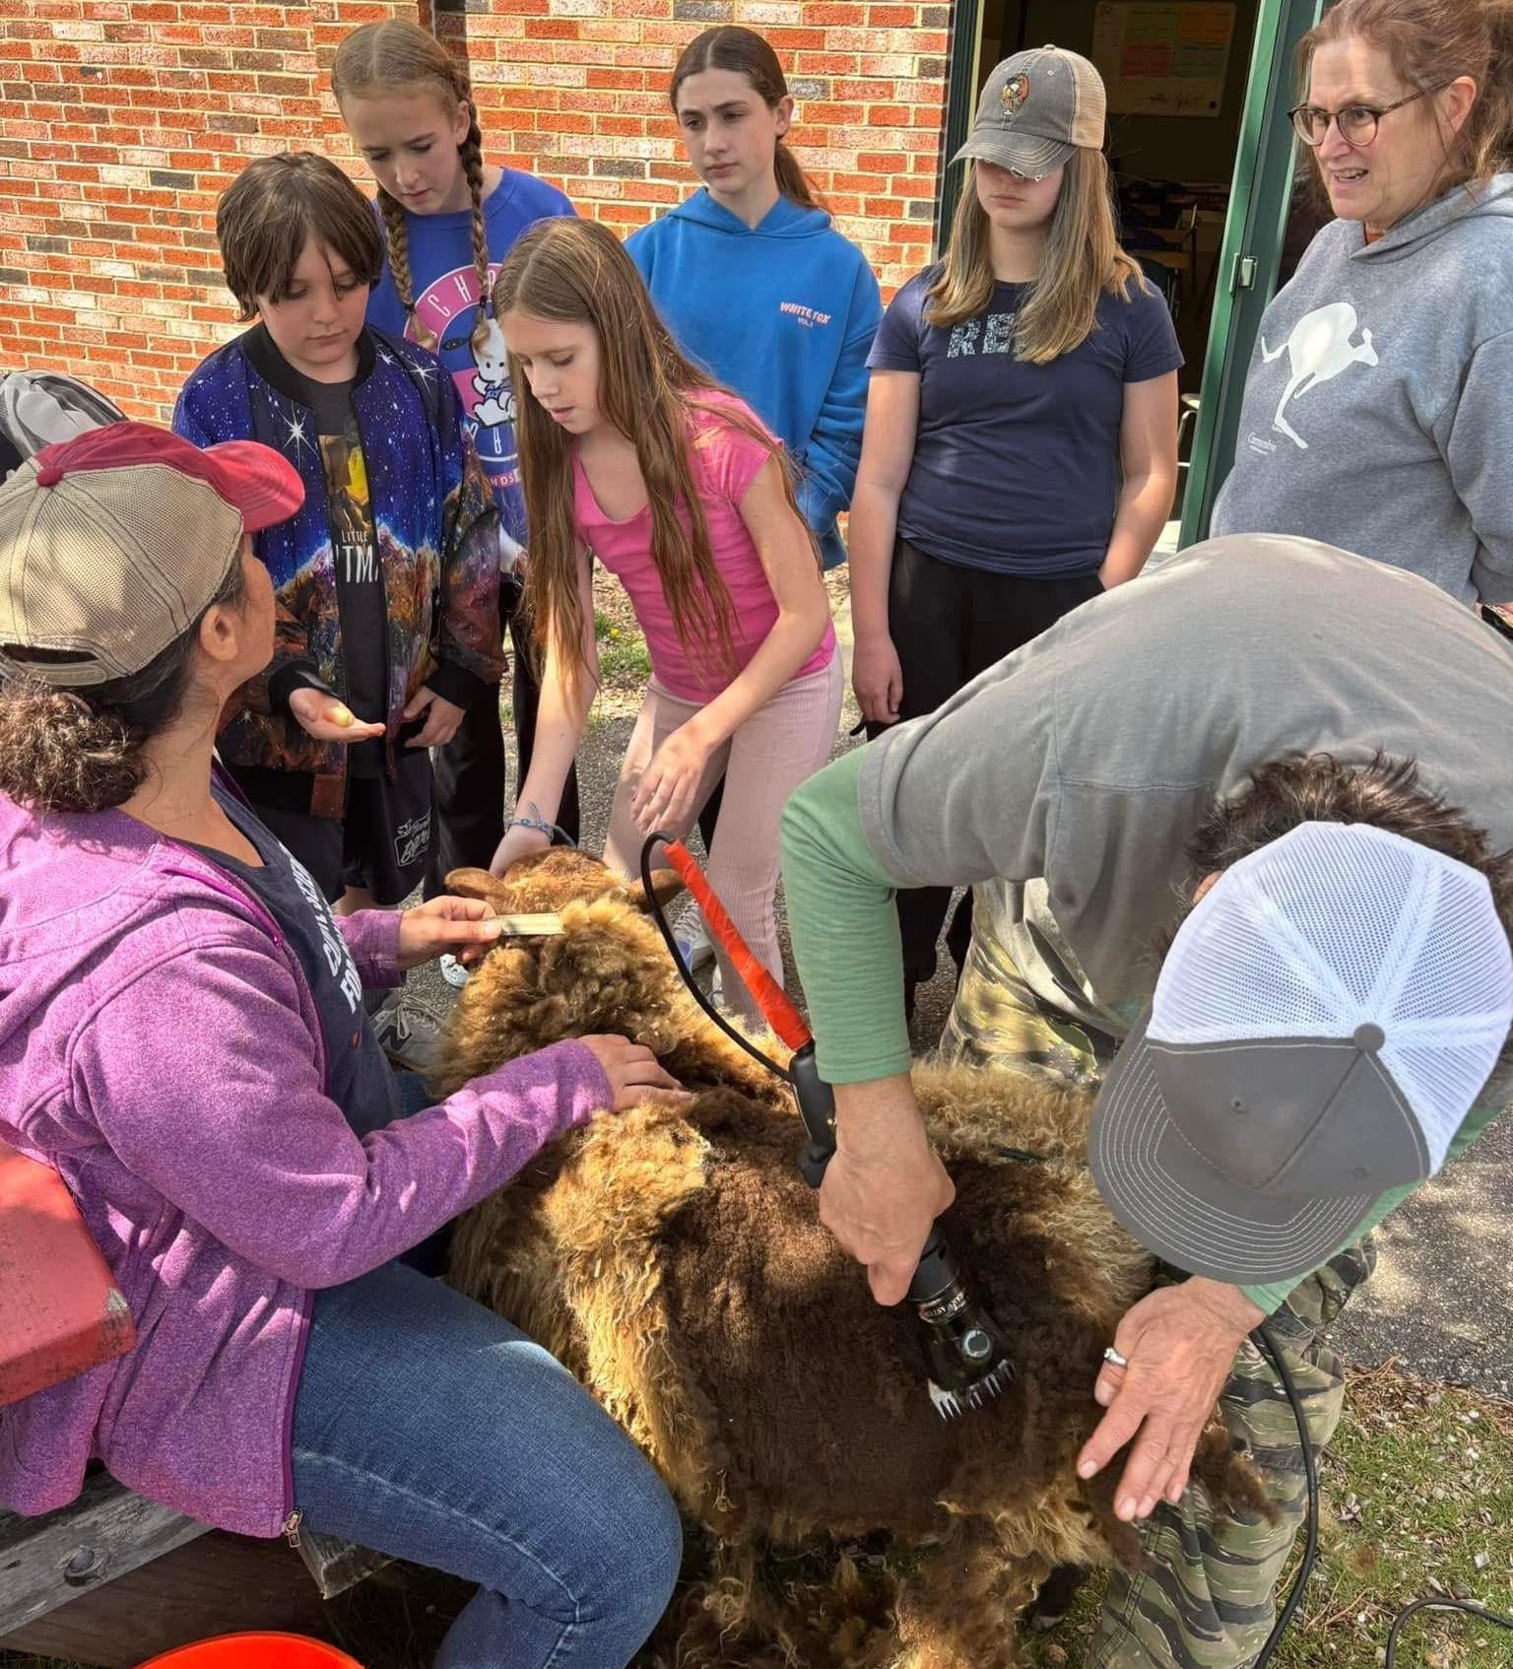
- Challenging and Adaptive Field Trip Experiences
CCLCS has designed field experiences as a foundational practice to foster resilience, independence, and social-emotional growth. These experiences begin with local excursions in sixth and seventh grades and culminate in eighth-grade expeditions to the White Mountains, in partnership with the Appalachian Mountain Club. The field trips are designed to be progressively challenging, both physically and emotionally, and are scaffolded across grade levels to build students’ confidence and capacity. The eighth-grade hiking experience, a longstanding tradition, includes three distinct levels of physical challenge, allowing educators to place students in hiking groups that align with their abilities. For students with disabilities or specific needs, individualized or small group adaptations ensure full inclusion and success. Eighth-grade students also participate in a full-week trip to Washington, D.C., Gettysburg, and other historic American sites, deepening civic learning through shared experiences. These trips are organized by educators, allowing for thoughtful scaffolding, cost-efficiency, and community ownership. The impact of these field experiences often resonates long after graduation, equipping students with confidence and collaborative skills that extend into adulthood.
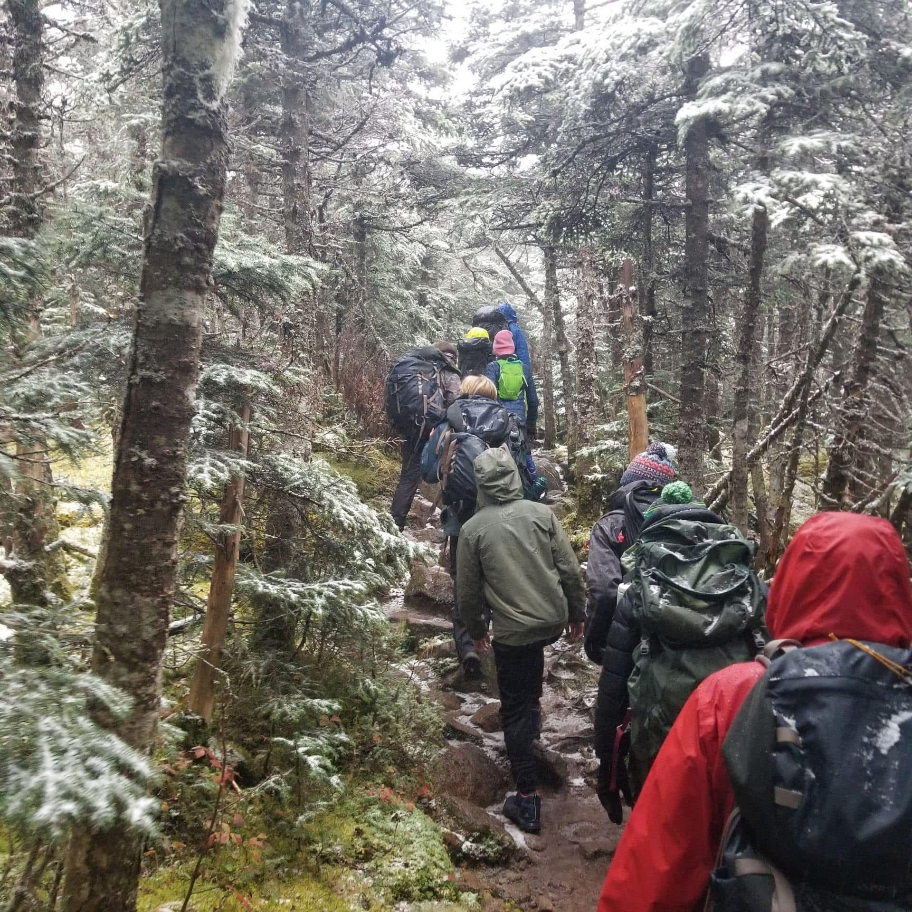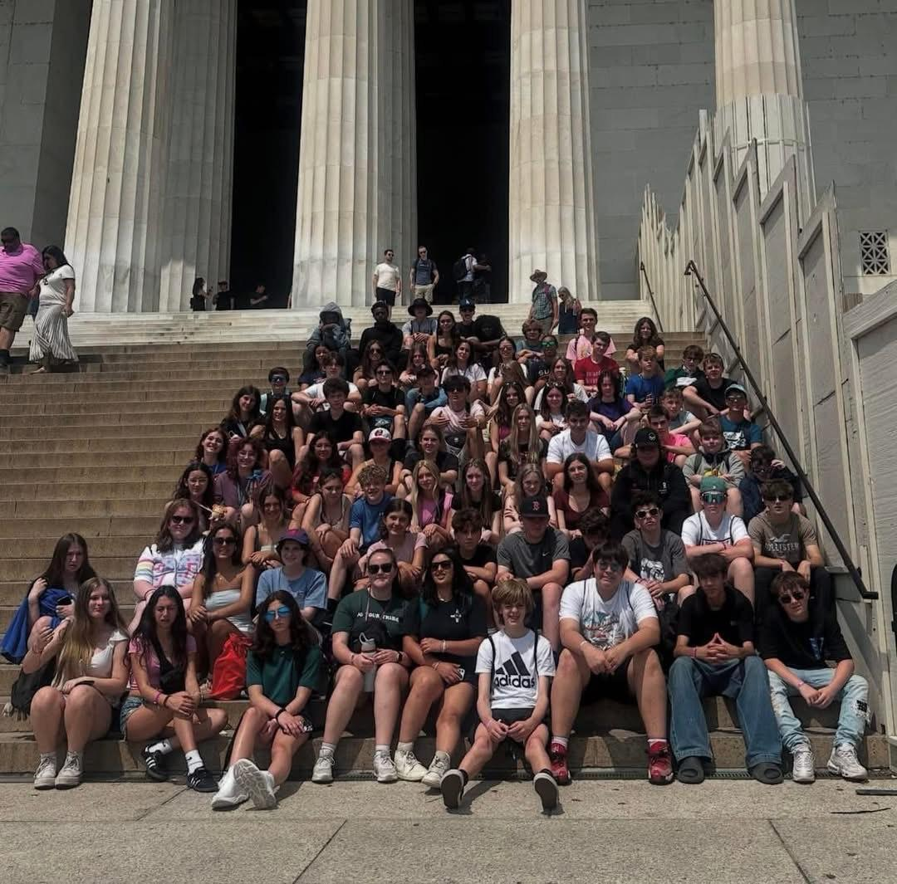
- Project-Rich Instructional Model
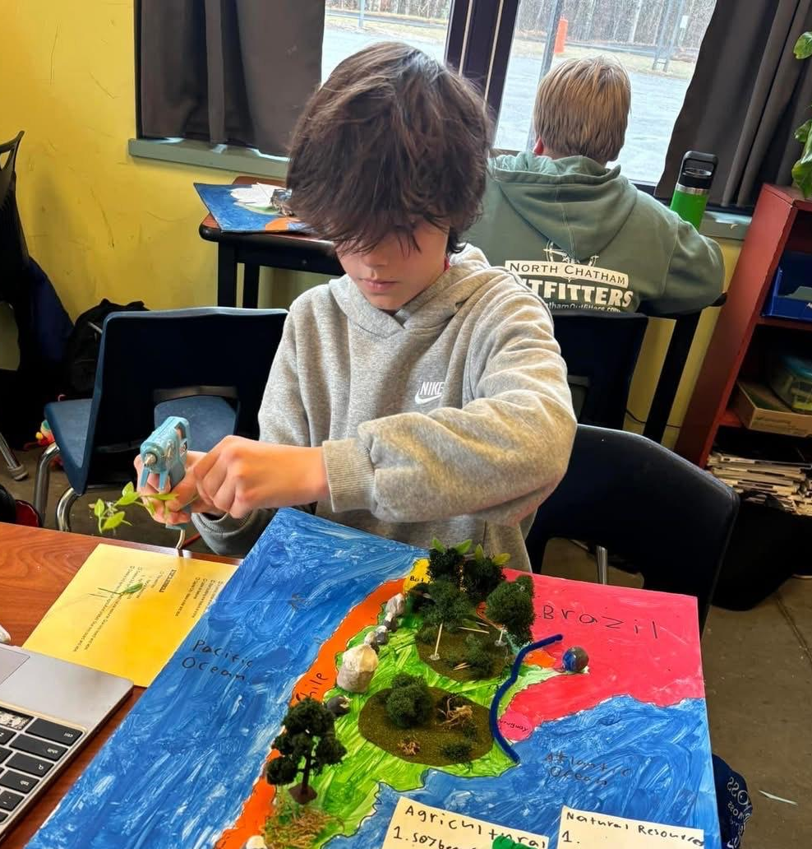
At CCLCS, project-based learning has evolved into a Project-Rich Instructional Model embedded across all disciplines and grade levels. Meaningful project work is integrated into every subject, enabling students to actively engage with content and apply real-world project management skills. Students take ownership of their learning by posing questions, managing timelines, collaborating with peers, and selecting how to demonstrate understanding. In a recent biology unit, for example, eighth-grade students explored the human body through the lens of their own health histories. Teachers use a blend of formative and summative assessments, such as quizzes, exit tickets, and differentiated project-based tasks, including group work, video recordings, and arts-integrated models and posters. Even in traditionally non-project-based subjects like mathematics, students approach complex, multi-step problems with persistence and strategic thinking. This instructional model fosters autonomy, creativity, and critical thinking while helping students discover and apply their individual strengths.
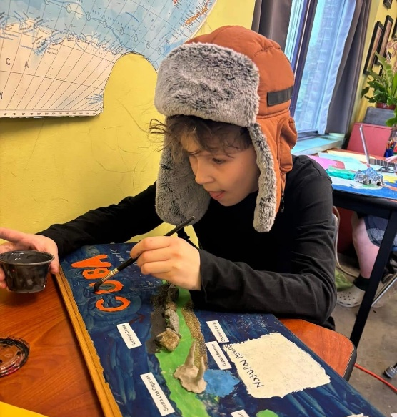

Results of Implementation:
- A high percentage of students are accepted to their first-choice high schools, including vocational-technical schools and Sturgis Charter School, an International Baccalaureate charter high school located in Hyannis.
- Educators report that local high schools actively recruit CCLCS graduates due to their reputation for civic involvement, leadership, and collaborative learning.
- Several former students have returned to CCLCS as educators or mentors, further reflecting the strength of the school’s community and the enduring relevance of its mission.

