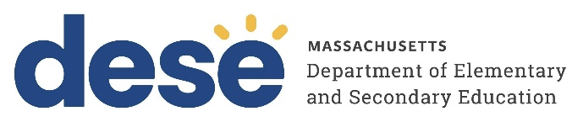
30 Year Best Practice Profile
2024-2025 SY

Community Day Charter Public School
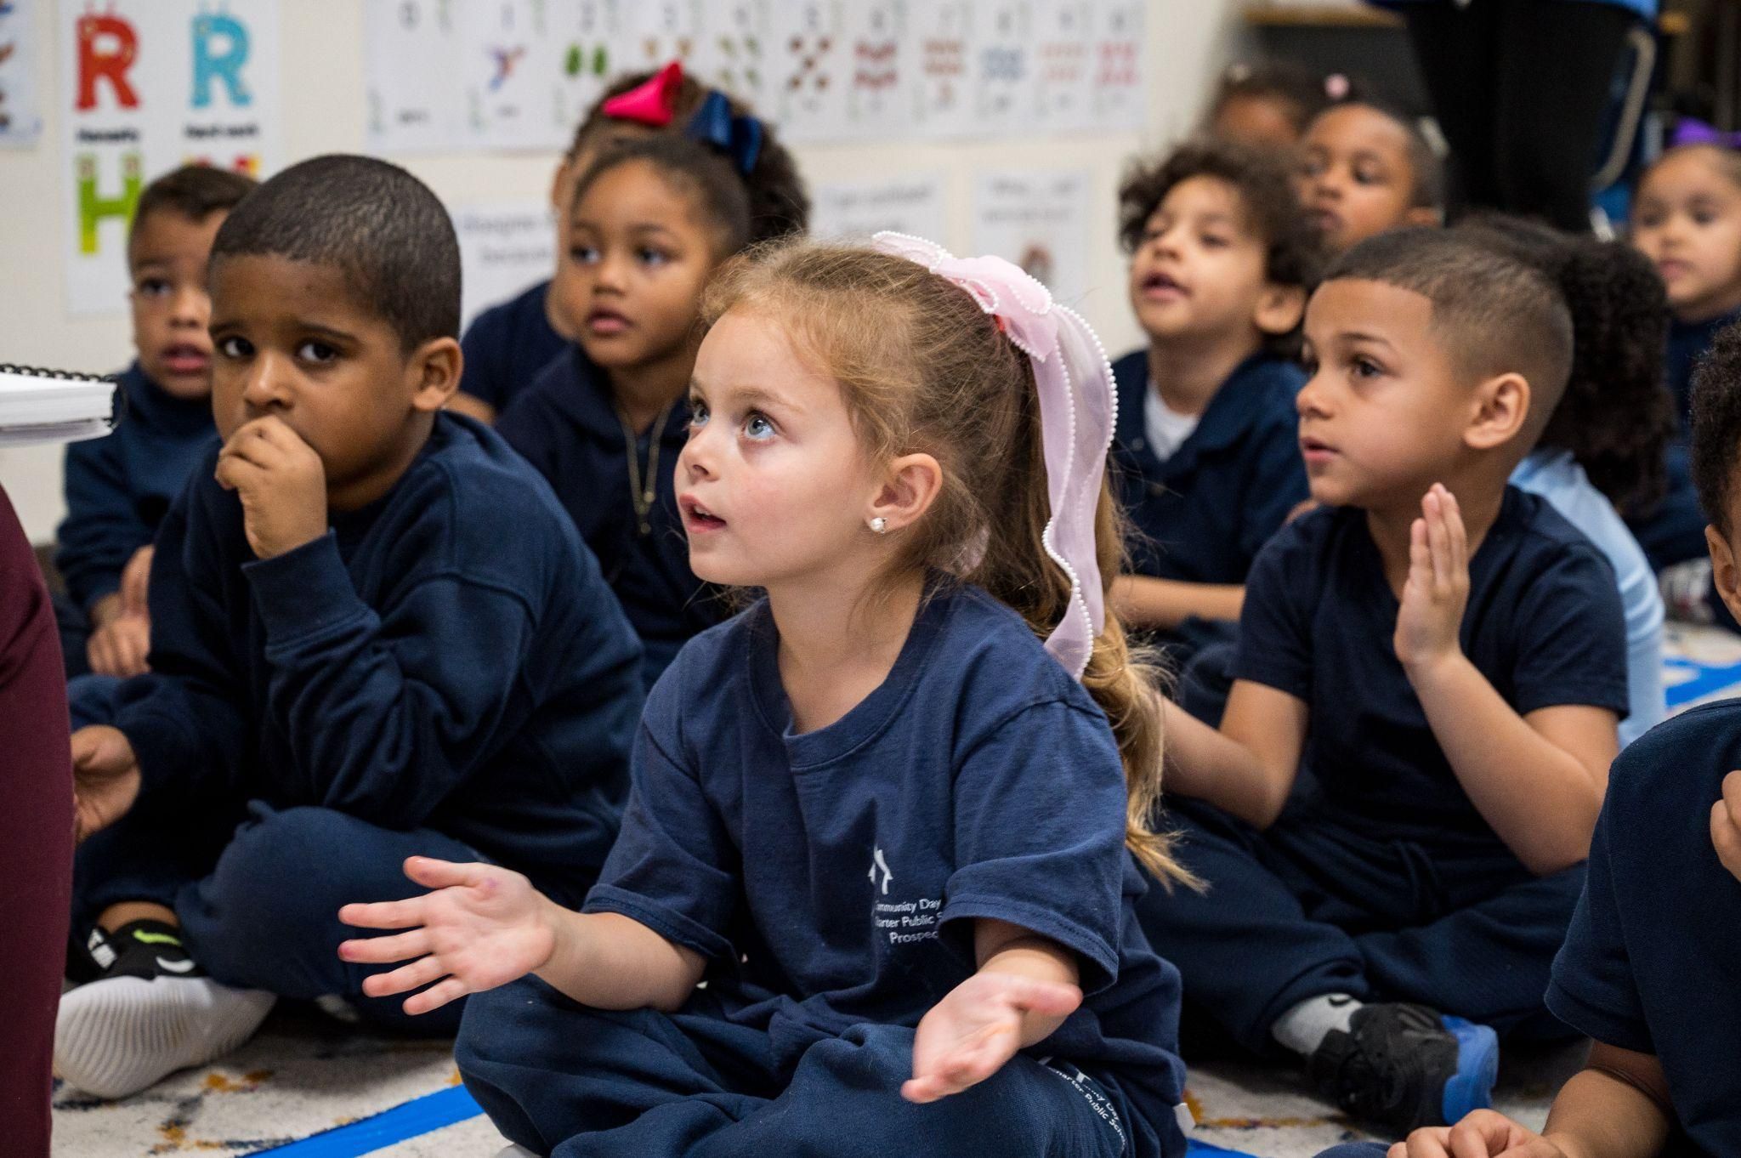
Best Practice: Strengthening Student Success Through Family Partnership, Data, and Transition Support
Applicable Charter School Performance Criteria: Criterion 7: School Climate and Family Engagement
History:
- The school opened in 1995 as Community Day Charter School, serving 110 students in grades K through 4. It added one grade each year, reaching the original chartered grade span of K through 8 during the 1999–2000 school year. The school received its charter in 1995 to serve 306 students in grades K through 8. It adopted its current name, Community Day Charter Public School, in September 2004, was later renamed Community Day Charter Public School–Prospect (CDCPS–Prospect) in January 2012, and reverted to its current name in 2022.
- Since 2006, the Board of Elementary and Secondary Education (Board) approved amendments that increased the school’s maximum enrollment and grade span. Currently, CDCPS serves grades PK through 8 with a maximum enrollment of 1.200 students.
- CDCPS partners with The Community Group (TCG), an education management organization that has supported the school since its founding.
- The school has multiple campuses in Lawrence, organized by grade level.
Mission:

“The mission of Community Day Charter Public School is to provide a Kindergarten through grade eight school that will draw upon our considerable experience in working together as a community to develop and implement a curriculum that discovers and supports the special characteristics and unique learning styles of each student. We will engage that student in meaningful learning experiences for the purposes of clearly stated goals in the areas of understandings, knowledge, skills, habits and social competencies. The school will reinforce the positive aspects of our city: its culture, art and economy, its working-class history and strong work ethic. Our educational philosophy, curriculum and teaching methods are informed by an understanding that learning takes place in the context of family and that family must be supported in ways that make learning for the child possible.”
Innovative Methods and Best Practices:

CDCPS has developed a set of interrelated best practices that reflect its commitment to student achievement, equity, and community partnership. These practices are grounded in a holistic approach that views families as essential collaborators, uses data to drive responsive instruction, and ensures that students are well-prepared for high school and beyond. By fostering strong family engagement, leveraging structured data cycles for continuous improvement, and guiding students through comprehensive high school placement, CDCPS creates a cohesive and supportive learning environment that promotes long-term success for all learners.
- Family Partnership as a Foundational Practice:
At CDCPS, family partnership is a foundational practice rooted in collaboration, shared decision-making, and continuous feedback. From its inception, the school has engaged families in shaping policies and programming based on their needs and voices. This commitment continues through regular surveys, coffee hours, and advisory structures such as the Parent Advocacy Board (PAB), which organizes community events and supports staff appreciation; the English Learner Parent Advisory Council (ELPAC), which hosts events and discussions primarily in Spanish; and the Special Education Parent Advisory Council (PAC), which offers workshops on homework support and special education rights. Each campus holds fall and spring events such as potlucks, book fairs, and cultural festivals co-designed with families to reflect community interests and build connections.
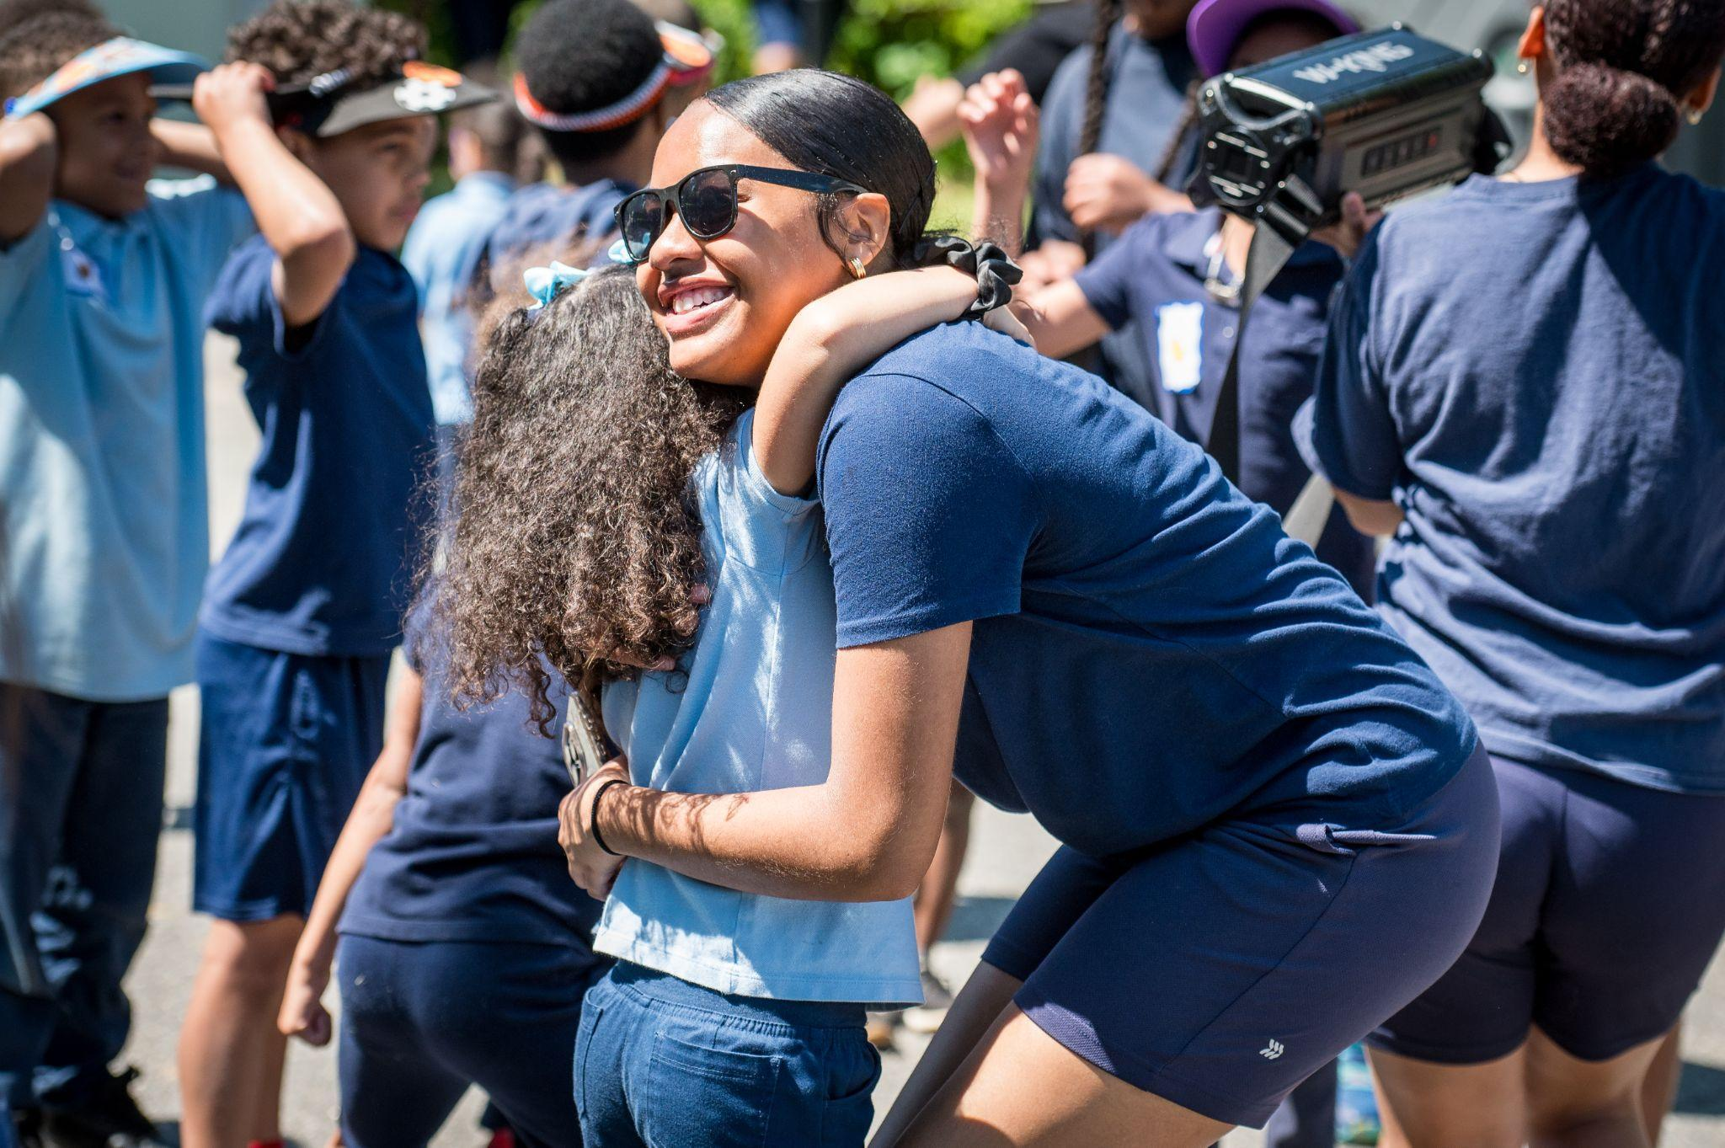
- Data-Driven Instruction and Personalized Support:

At CDCPS, data cycles are central to instructional planning and student growth. Teachers and leaders engage in structured analysis of assessment data—such as DIBELS (Dynamic Indicators of Basic Early Literacy Skills), MAP (Measures of Academic Progress), and MCAS (Massachusetts Comprehensive Assessment System) - aligned benchmarks—to identify trends, track individual progress, and inform instructional adjustments. DIBELS assesses foundational literacy skills in early grades through quick, one-on-one measures of phonemic awareness, decoding, and fluency. MAP provides adaptive, norm-referenced assessments in math and reading for grades 3–8, tracking individual student growth over time. MCAS-aligned benchmarks are administered two to three times per year using released state test items to measure mastery of Massachusetts’ curriculum standards. These cycles include goal setting, progress monitoring, and collaborative data reviews that guide both classroom practice and professional development.
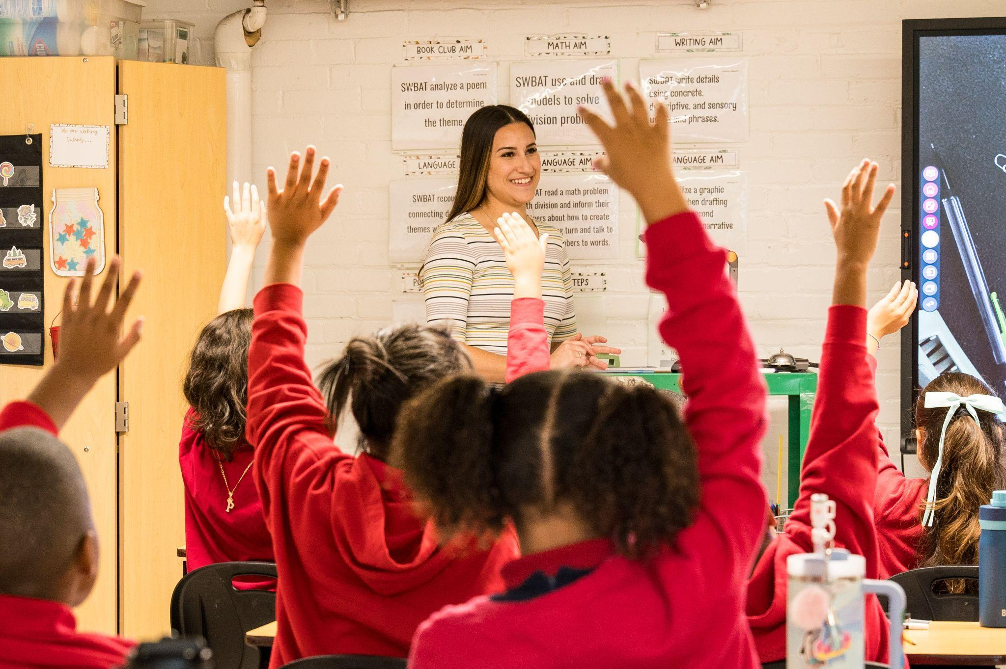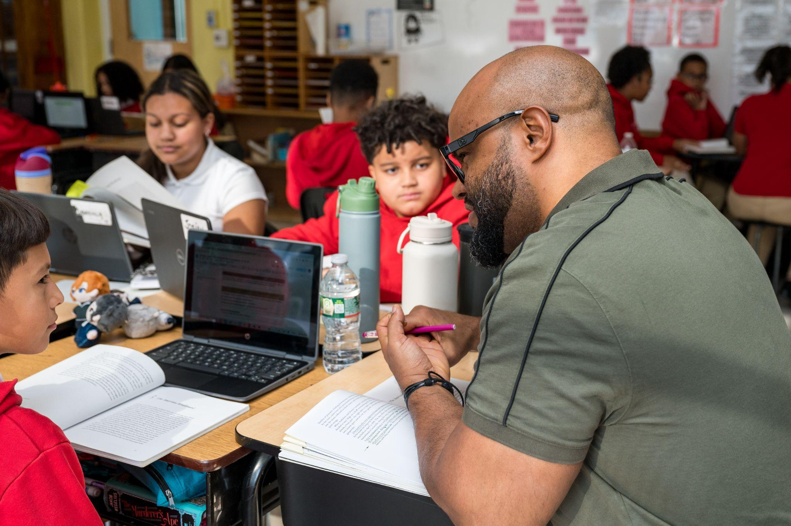
- Comprehensive High School Placement and Student Transition Support:
The school provides a comprehensive high school placement program to ensure every student is well-prepared and supported in their transition beyond 8th grade. The placement team guides students and families through the entire process—from exploring school options to completing applications, preparing for entrance exams, and navigating financial aid. Individualized support includes interview preparation and assistance with financial aid forms, ensuring access, choice, and long-term success. Students apply to a diverse range of public, private, charter, and technical high schools, with additional scholarship opportunities offered through private donors.
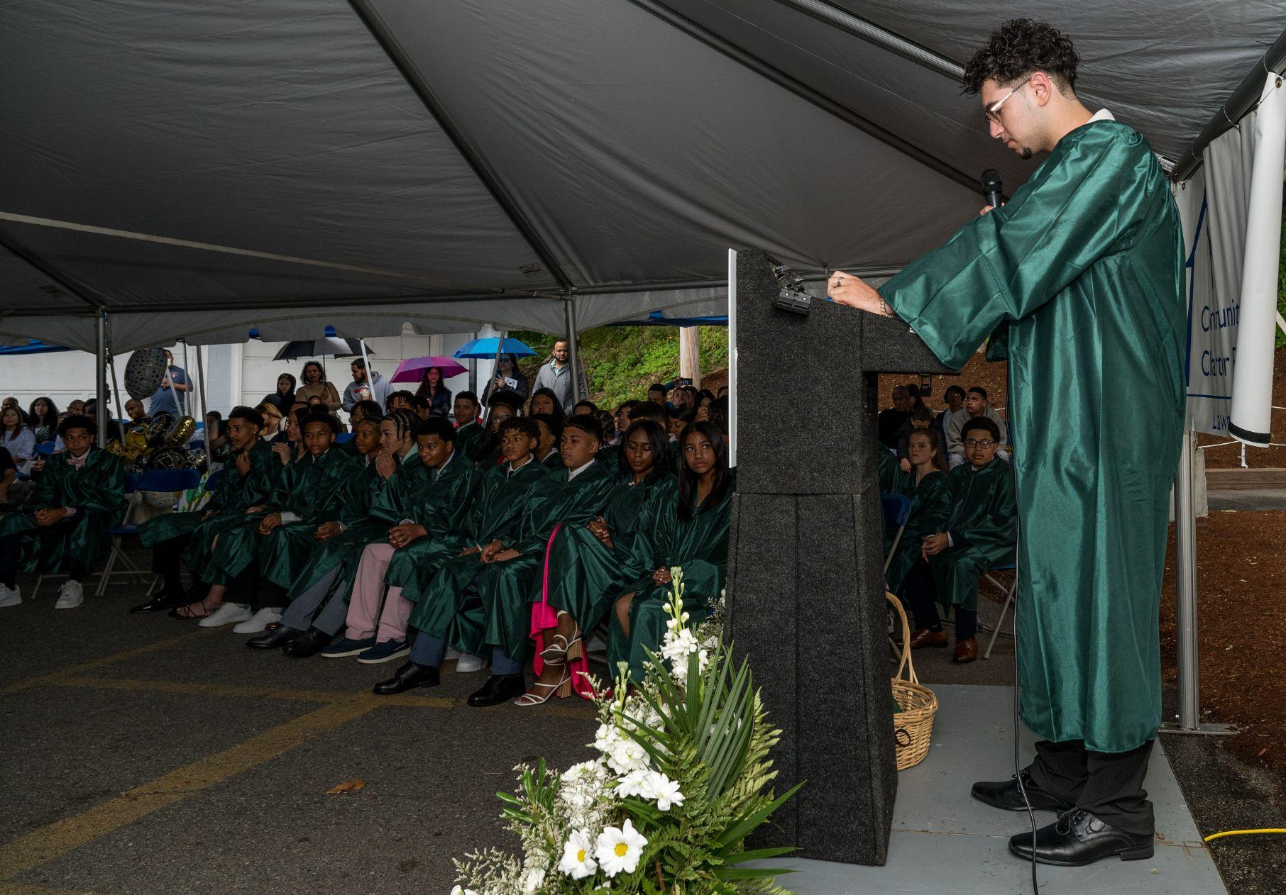
Results of Implementation:
- The school saw a 20 percent increase in applications for the 2025–26 school year, underscoring growing community interest and trust in the school's mission.
- CDCPS maintains a high student retention rate, with most students remaining through 8th grade. Approximately 1 percent of students have withdrawn for the upcoming school year, with nearly all departures due to relocation.
- The annual school survey data from 2020–21 to 2023–24 indicate consistently strong parent satisfaction across multiple areas:
  - 81 to 89.6 percent of parents agreed or strongly agreed that CDCPS consistently used a variety of teaching methods to support individual learning styles.
  - 81 to 91 percent of parents agreed or strongly agreed that the school provided multiple opportunities to partner and share in their child’s school experience.
  - 90 to 95.2 percent of parents agreed or strongly agreed that the school consistently used a variety of teaching methods to promote high scholastic achievement in English language arts, mathematics, science, social studies, and the use of technology.
- During this same timeframe, 100 percent of parents participated in the first parent-teacher conference each year.
- By 2025, 76 percent of 2024-25 8th grade graduates will attend private, public college-preparatory, or technical schools, with the class receiving a total of $1.2 million in financial aid awards.
