
30 Year Best Practice Profile
2024-2025 SY

Francis W. Parker Charter Essential School
Best Practice: Personalized Learning and Inclusive Community Model
Applicable Charter School Performance Criteria: Criterion 6: Program Delivery and Criterion 7: School Climate and Family Engagement
History:

- Francis W. Parker Charter Essential School (Parker) received its charter in 1994 to serve students in grades 7 through 12. Established by local parents, teachers, and community members to embody the principles of the Coalition of Essential Schools, Parker opened in 1995 with 122 students in grades 7 and 8. Parker added one grade per year, reaching the full grade span during the 1999-2000 school year.
- Theodore R. Sizer, an educator and reformer, played a foundational role in the creation of Parker. His vision of a democratic and student-centered education, embodied in the 10 Common Principles of the Coalition of Essential Schools, shaped the school's mission and continues to guide its practices.
- The school is organized into three divisions rather than traditional grade levels: Division 1 (grades 7-8), Division 2 (grades 9-10), and Division 3 (grades 11-12).
- Instruction is provided as four interconnected domains: arts and humanities; mathematics, science, and technology; Spanish; and wellness.

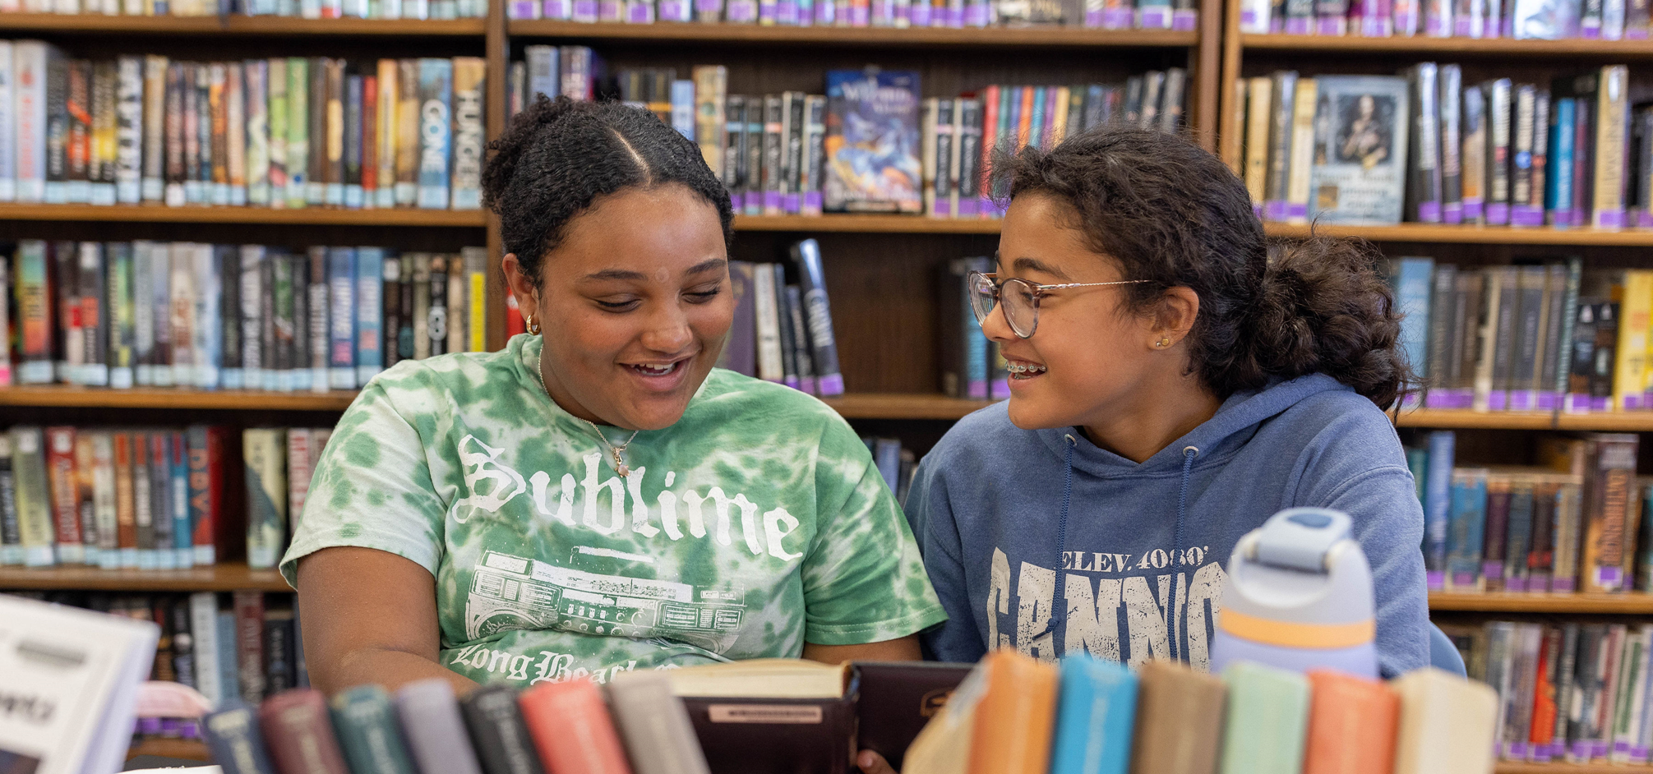

Mission

“The Parker School's mission is ‘to move the child to the center of the education process and to interrelate the several subjects of the curriculum in such a way as to enhance their meaning for the child’ (Charter, October 1994). As a member of the Coalition of Essential Schools, the Parker School will realize this mission through educational practice guided by the Ten Common Principles of Essential Schools.”

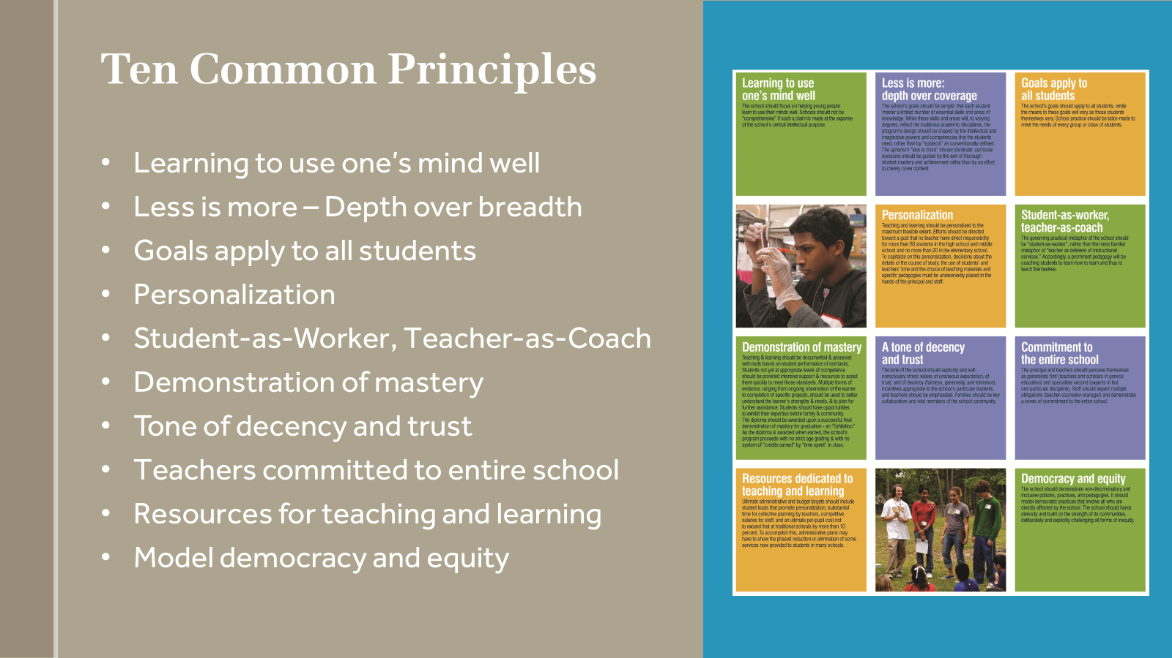
Innovative Methods and Best Practices:

Parker embraces its role as a laboratory for innovative practices, actively sharing its approaches with the broader educational community. The Sizer Teacher Center plays a central role in this mission, offering teacher-centered workshops designed to share and develop effective educational methods. Through these workshops, educators from both charter and traditional public schools learn about Parker’s unique approaches, fostering collaboration and the broader adoption of best practices. Among the key practices shared are Parker’s mastery-based assessment with public exhibitions, senior projects, advisory systems with personalized learning plans (PLPs), and inclusive practices. Each of these practices reflects the school’s commitment to personalized, meaningful learning experiences and building a safe, inclusive community, serving as a model for educational innovation.

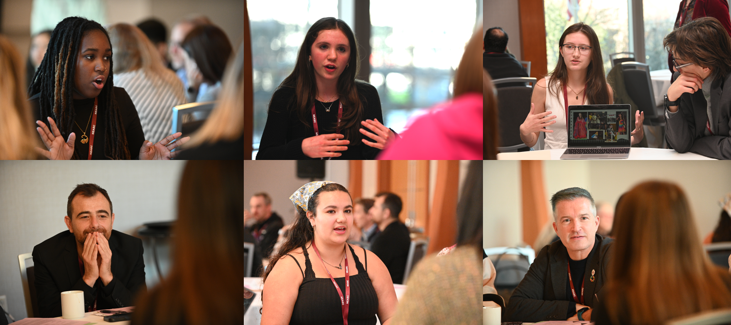

- Mastery-Based Assessment

At Parker, assessment emphasizes students' progress toward meeting standards rather than traditional letter grades. Instead of assigning A-F grades, the school uses a continuum of "Beginning" (Be), "Approaching" (Ap), and "Meeting" (Me), symbolized as climbing a mountain to represent continuous growth. This standards-based approach includes detailed feedback, guiding students to proficiency through practice and reflection. Academic mastery is demonstrated through public exhibitions, with students completing seven formal exhibitions from grades 7 to 12, including a senior juried presentation. A flexible pacing system allows students to progress according to readiness, fostering personal growth while maintaining high expectations for all. Students are grouped by cohort and mastery rather than grade level, promoting an inclusive, supportive learning environment.
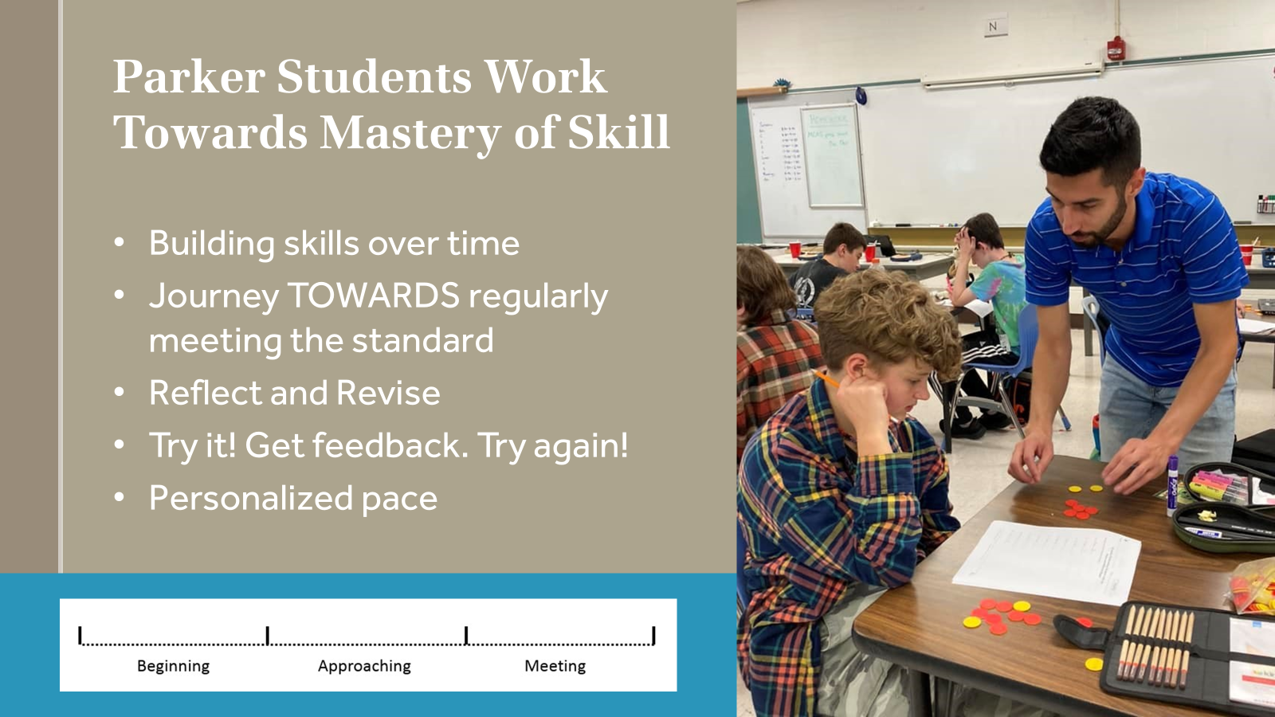
- Senior Projects:
Senior Projects offer a year-long capstone experience where students investigate essential questions, engage in hands-on learning, and collaborate with mentors to produce a final demonstration of their work. This process empowers students to pursue their passions while honing critical thinking and research skills. The model’s success has inspired adoption by other schools, illustrating its impact on fostering deep, independent learning.
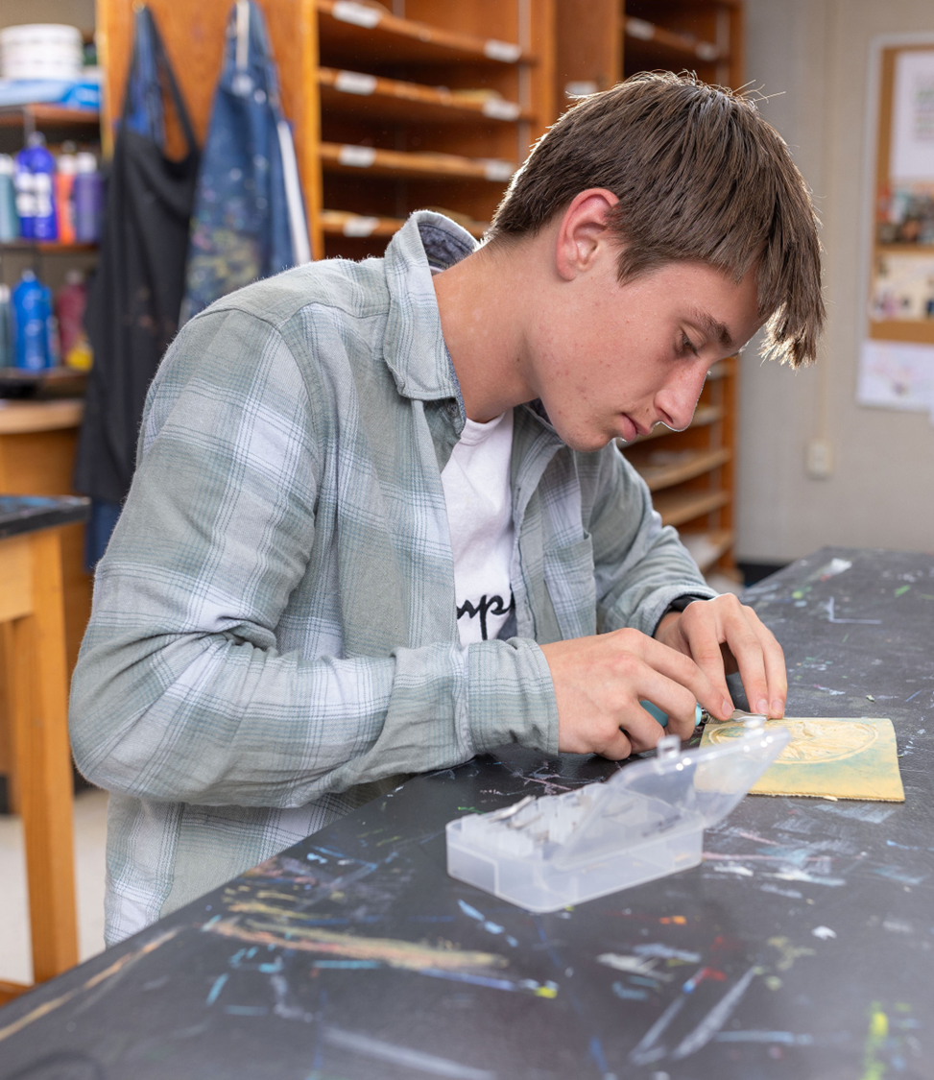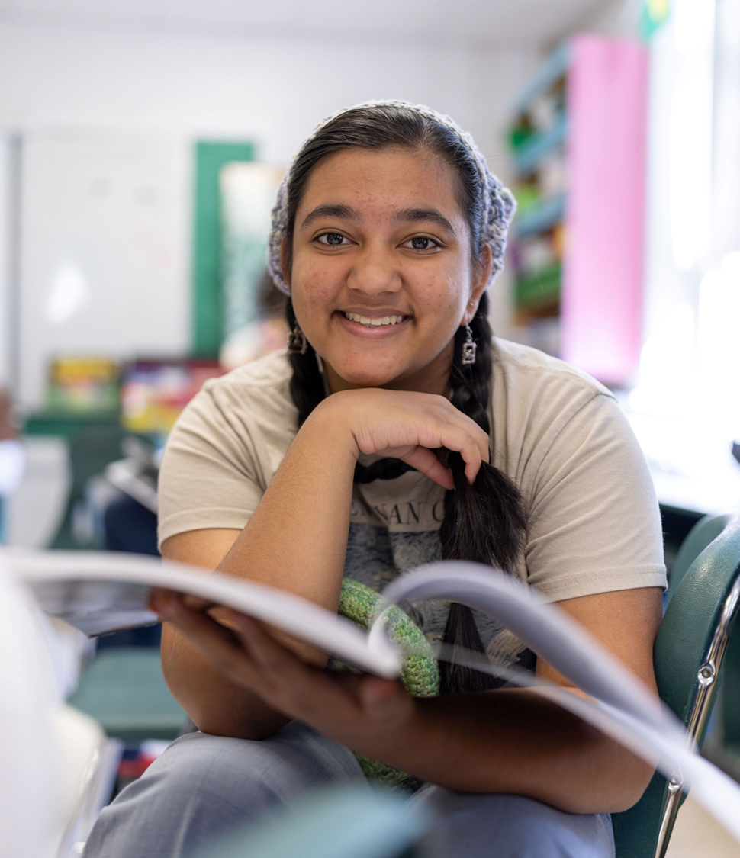
- Advisory System and Personalized Learning Plans (PLPs):
The Advisory and PLPs are key components of fostering student growth through individualized goal setting and reflective practice. Each student develops a PLP in collaboration with their families and teachers, setting goals for the academic year. These plans are regularly monitored to track progress, encouraging students to think metacognitively about their learning journey. The advisory program also prioritizes building strong student-teacher relationships to support learning.
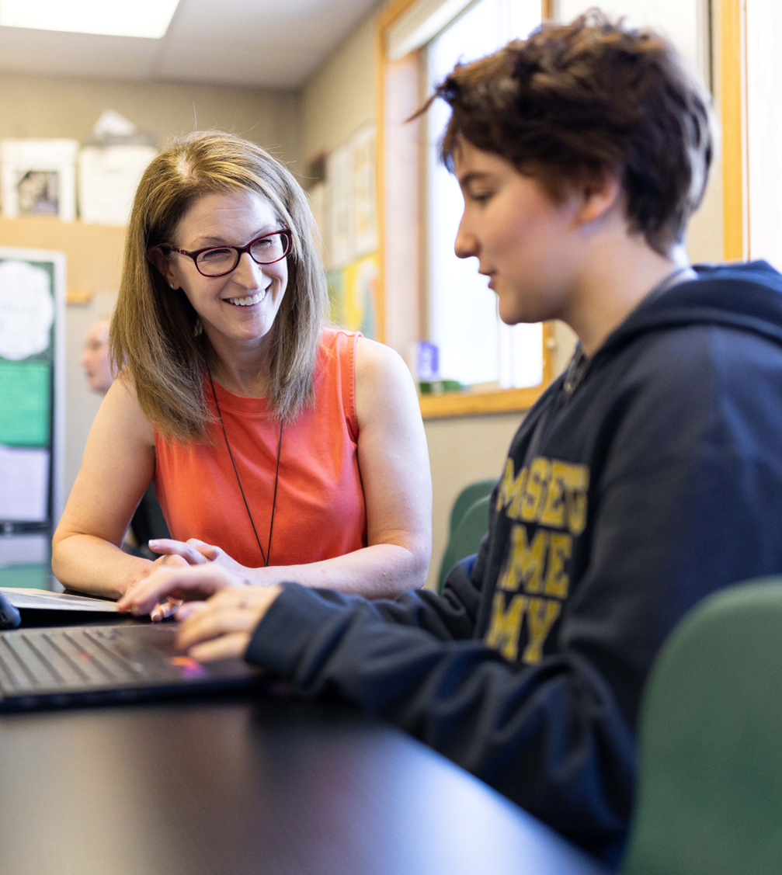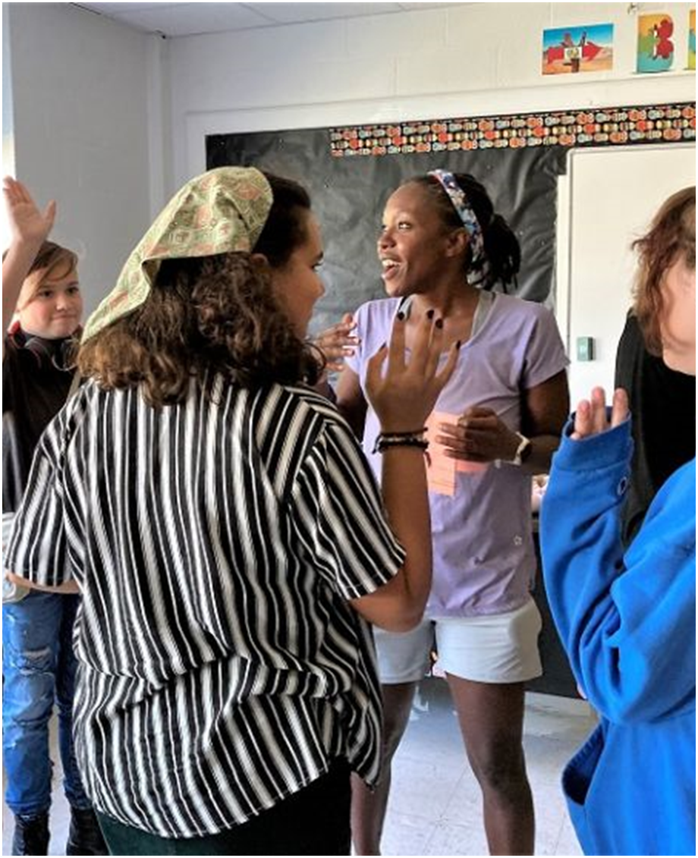
- Inclusive Practices:
Committed to creating a safe and welcoming community, Parker has a longstanding focus on LGBTQ+ inclusion, including hosting the first Gender and Sexuality Alliance (GSA) club. For 25 consecutive years, the school has commemorated the Day of Silence, an event dedicated to raising awareness about the silencing effects of anti-LGBTQ+ harassment and discrimination, fostering awareness and solidarity.
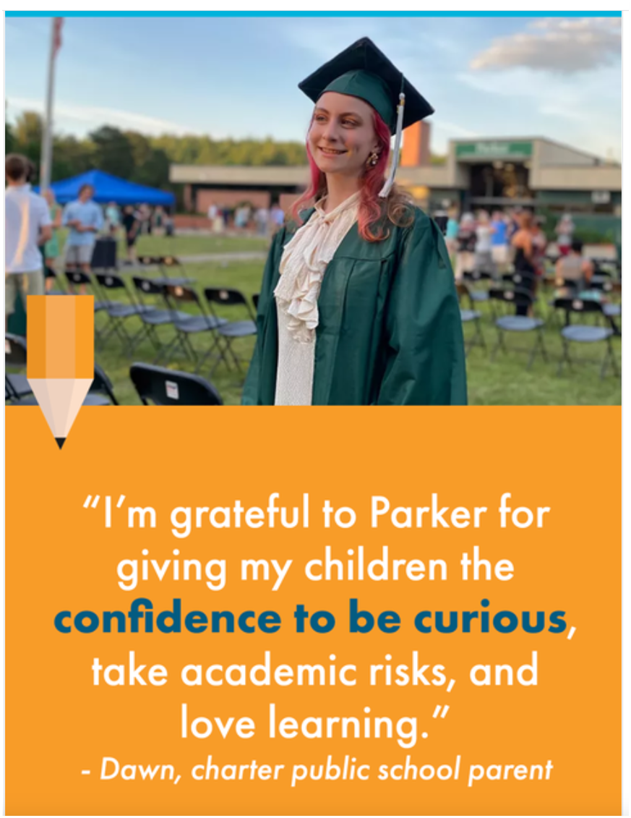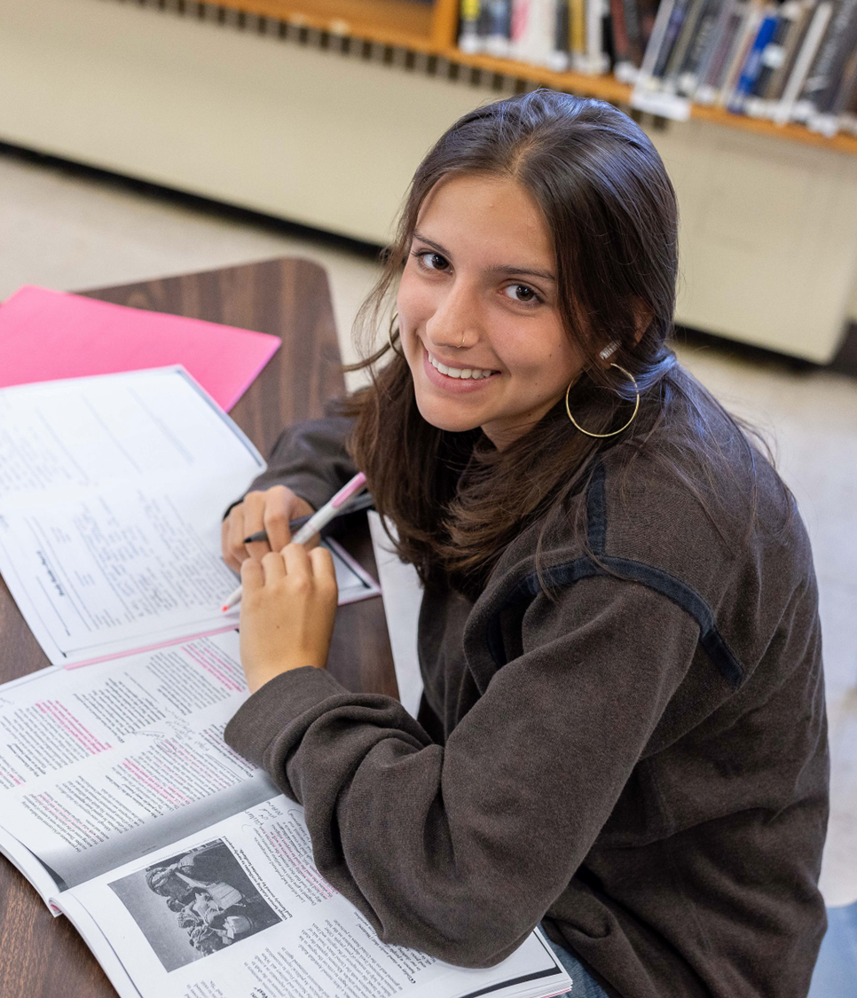

Results of Implementation:
- Internal surveys reveal that students rate their happiness above 7 out of 10 on average—a notably high level for teenagers, reflecting a positive climate where students feel supported and valued.
- More than 90% of students at Parker report that they receive meaningful feedback on their progress.
- At Parker, all juniors and seniors fulfill a community service requirement, with over 50 percent choosing to serve as teaching assistants, peer mentors, or in leadership roles—demonstrating their commitment to giving back and embodying the school’s mission as role models within the community.
- Alumni report that the school’s focus on goal setting and resilience builds lasting flexibility and confidence. Students develop a growth mindset, learning to overcome challenges and navigate life with persistence and adaptability.
- Over 90% of Parker graduates go to college compared to 67% statewide.
- Only 5% of Parker graduates take remedial classes in college compared to 24% statewide. Additionally, 94% of Parker graduates return to college for a second year compared to 85% statewide.
- Parker’s leadership in inclusivity has led other schools to seek guidance on developing similar supportive environments for diverse student identities.

