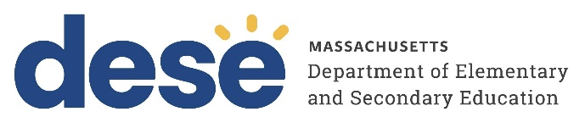
30 Year Best Practice Profile
2024-2025 SY

Hilltown Cooperative Charter Public School

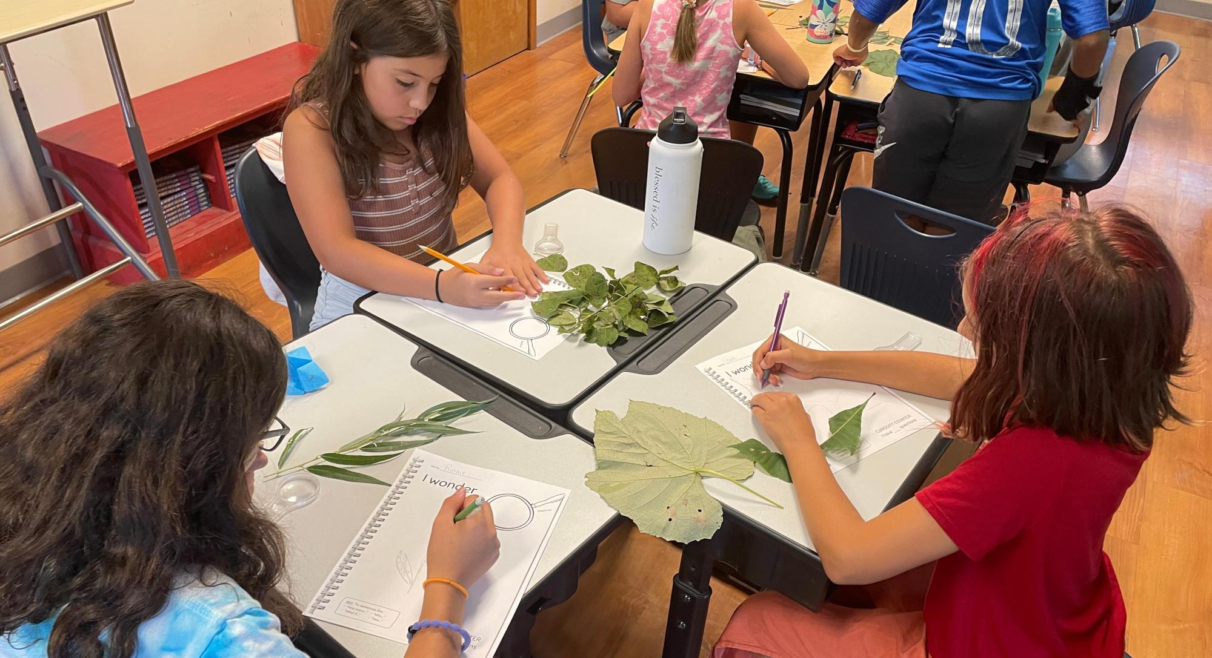
Best Practice: Fostering Student Voice and Community Through Arts Integration and Gatherings in a Multi-Age Model
Applicable Charter School Performance Criteria: Criterion 6: Program Delivery and Criterion 7: School Climate and Family Engagement
History:
- Hilltown Cooperative Charter Public School (Hilltown) received its charter in 1995 to serve 146 students in grades K through 6. The school opened in Haydenville in 1995, serving 42 students in grades K through 4. The school added a grade each of the next two years, reaching the school’s original chartered grade span during the 1997-98 school year.
- Hilltown was originally founded on the principles of the Reggio Emilia approach—an early childhood education model from Italy that centers student voice and allows students to help shape the curriculum.
- In 2000, the Board of Elementary and Secondary Education approved the school’s request to expand its chartered grade span from K–6 to K–8. Over the following years, the Board approved several amendment requests submitted by the school to raise its maximum enrollment: from 146 to 154 students in 2004, from 154 to 180 students in 2008, and from 180 to 218 students in 2012.
- In October 2013, the Board approved an amendment to relocate the school from Haydenville to Easthampton beginning with the 2014-15 school year.
Mission

“To involve young people in a school which uses experiential, hands-on activities, the arts, and
interdisciplinary studies, to foster critical thinking skills and a joy of learning. To sustain a cooperative, intimate community of students, staff, families and local community members, which guides and supports the school and its educational programs. To cultivate children’s individual voices and a shared respect for each other, our community, and the world around us.”
Innovative Methods and Best Practices:

Hilltown fosters student voice, leadership, and a strong sense of community through two interrelated practices: weekly assemblies and interdisciplinary art integration within a multi-age framework. These structures are intentionally designed to support social-emotional growth, collaborative learning, and student agency. Through opportunities to express themselves, whether by leading school-wide gatherings or shaping creative, cross-disciplinary projects, students develop confidence, advocacy skills, and connections with peers, teachers, and families.

- Community-Building Through Weekly Assemblies

Every Friday, Hilltown holds a 45-minute all-school assembly featuring common practices that foster connection, inclusion, and student voice. The assembly's structure includes songs, student presentations, public appreciations, and announcements. Students across grade levels have the opportunity to share their learning, perform, or lead parts of the gathering, building confidence and advocacy skills in a multi-age setting. Regular attendance by families during weekly assemblies contribute to a sense of shared community and making school experiences visible to parents and caregivers.
- Art Integration Through Collaborative Multi-Age Structures
At Hilltown, art integration is a central instructional practice strengthened by the school’s multi-age classroom model and structured collaboration time. Early release days every Wednesday allow classroom and arts teachers to co-plan interdisciplinary units that blend academic content with artistic expression. For example, in a science unit on ecosystems, students explored the life cycle of salmon, then extended their understanding by writing and performing original music about streams or expressing water flow through movement in a physical expression class. A key element retained from the Reggio Emilia approach is the emphasis on student agency, as students help shape the direction of arts integration projects, which may take different forms each year. This approach is supported by Hilltown’s two-year looping structure, where students in grades 2–5 and 7–8 learn in multi-age classrooms spanning two grades. Additionally, all students engage with peers and staff from every grade during mini-courses—non-academic sessions held three times per year, once a week for four weeks. These sessions foster trusting relationships, ensure students feel heard, and promote leadership and mentorship as learners alternate between roles of mentees and mentors within a stable classroom community.
Results of Implementation:
- The school reported that 81 percent of families responded to the annual satisfaction survey in 2023-24. Survey responses showed that at least 80 percent of these responses matched school demographics, and 96 percent of families reported students feeling connected to the school.
- At least 90 percent of families participated in school events in 2022–23 and 2023–24.
- The school reported that 100 percent of students in grades K through 8 participated in mixed-age programs, including weekly all-school meetings, year-long cross-grade buddies, and three sessions of mixed-age mini-courses in 2023-24.
- The school reported that 100 percent of students in grades K through 8 participated in hands-on units of study. Presentations and artifacts from arts-integrated units and featured studies were shared on Hilltown’s website from 2020 to 2024.
- Hilltown alumni return to the school in roles such as teaching assistants, substitute teachers, or contributors to the annual spring musical, with some seeking internships during their graduate studies.

