
30 Year Best Practice Profile
2024-2025 SY

Lawrence Family Development Charter School
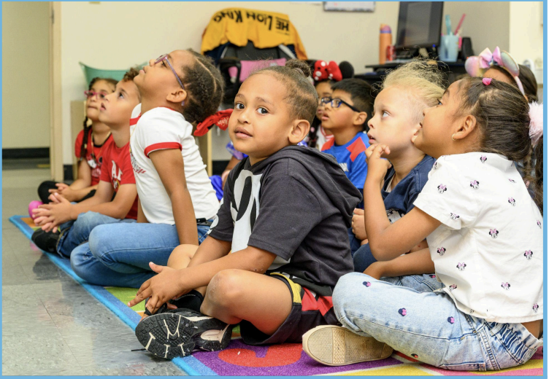
Best Practice: Culturally Responsive Family Engagement
Applicable Charter School Performance Criteria: Criterion 7: School Climate and Family Engagement
History:
- Founded in 1995 by a coalition of Hispanic/Latino parents and community leaders to address the academic, language, cultural, and developmental needs of the local immigrant community.
- Initially served 180 students in grades 1–3 and has since expanded to serve grades PK–8, now enrolling 899 students, with plans to reach a capacity of 1,000 by SY2029–2030.
- Operates across three campuses: Early grades (PK–2); Lower school (grades 3–4); Upper school (grades 5–8)
- Established to provide a culturally and linguistically responsive education for the children of Lawrence, MA, primarily serving immigrant families. Parents are engaged as “advocates for their children” as an essential element of our history.
- Expanded over the years through strong community partnerships, campus development, and a focus on both academic and social-emotional growth.

Mission:
“Strong families, working in partnership with the school as advocates for academic achievement, will create an environment where every child has the opportunity to acquire the foundation skills and habits of mind that foster life-long learning, citizenship participation and personal fulfillment.”
Innovative Methods and Best Practices:
LFDCS fosters student success through intentional family engagement and unique practices, including bilingual home visits, conferences, interactive events, and ongoing community outreach that build trust and strengthen school–family partnerships. Heritage language instruction in English and Spanish supports language development and cultural identity, with progress monitored through MAP assessments and Grade 8 portfolios. Families actively participate in governance, serving on the School Board and advisory councils to guide school decisions and programming. Additionally, affordable after-school programs provide tutoring and enrichment, supporting families and ensuring all students have opportunities to thrive. This holistic approach creates a welcoming, inclusive environment where students flourish through active family involvement.
Key Practices and Strategies:
- Home Visits
For over 30 years, LFDCS has maintained the practice of home visits by parent liaisons, particularly for families with children in the K-1 (pre-K) program, including those on the waitlist. These visits build early connections with families and foster familiarity and trust from the start. During each visit, parent liaisons meet with students and parents to review the student and parent handbooks, address specific questions, and provide information in a comfortable setting. This approach ensures clear communication while also allowing liaisons to better understand the unique needs of each family. Importantly, since many families speak Spanish as their first language, the liaisons, who are native Spanish speakers, ensure effective communication and a stronger, more inclusive relationship with the community.
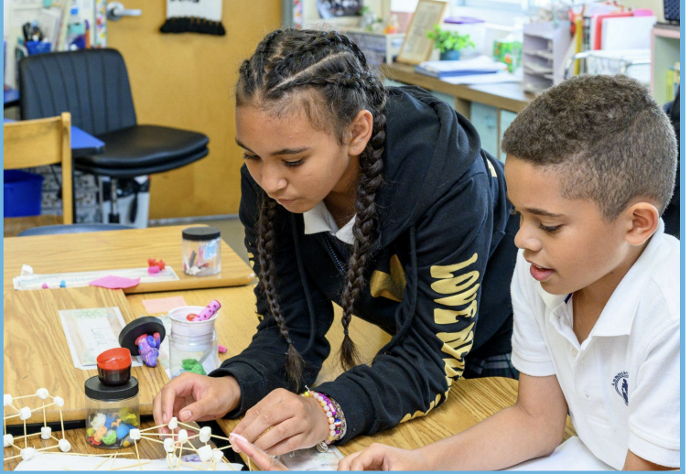
- Family Participation in School Events
LFDCS fosters active family participation in the educational process through bilingual communication, ensuring families are fully engaged in their child’s learning and aware of school events. Parents are encouraged to attend three conferences per year to discuss their child’s(ren’s) academic and social development and strengthen their involvement. This model emphasizes culturally relevant communication and fosters engagement through bilingual interactions, family-centered events, and active participation in school meetings, ensuring that all families feel valued, heard, and connected to the school community. To strengthen community ties, LFDCS organizes events such as Open Houses, Parent Coffees, Grade-Specific Family Nights, Opening Doors Orientations (middle school to high school transition) and “Right from the Start” (workshops on family support and engagement) sessions for preschool parents. These events create opportunities for families to connect with the school and each other, fostering a strong sense of belonging and reinforcing the school’s commitment to inclusive, family-centered engagement.
- Heritage Language Education
LFDCS provides a “heritage language” curriculum, offering instruction in both English and Spanish. This language-rich environment not only supports English language acquisition but also preserves students' cultural and linguistic identities, reinforcing the importance of cultural relevance in education. LFDCS tracks language progress in both English and Spanish using the MAP assessment. Additionally, students in Grade 8 must develop and present a portfolio in English and Spanish as a part of their graduation requirements.

- Families as part of Governance
LFDCS provides families multiple opportunities to be decision makers in the school. Seven members (more than 50%) of the LFDCS School Board are Parent Representatives. There are also several parent representatives on the Special Education Parent Advisory Council, English Learner Parent Advisory Council, and School Site Council. These councils provide parents formal opportunities to provide feedback to the school on programming and services. This type of governance supports the vision and mission of LFDCS.
Results of Implementation
The implementation of best practices at LFDCS has yielded positive outcomes across multiple areas for family engagement.
- Consistent 100% attendance at parent conferences and strong participation in family events.
- From 2020-2024, the Special Education and ESL Parent Advisory Councils consistently offered four annual parent workshops, guided by topics identified through fall surveys. During the same period, teacher and parent members of the Special Education and ESL Parent Advisory Councils (PACs) and the School Site Council consistently met or exceeded the 75 percent attendance goal, with participation ranging from 75 to 91 percent.
