
30 Year Best Practice Profile
2024-2025 SY

Lowell Middlesex Academy Charter School
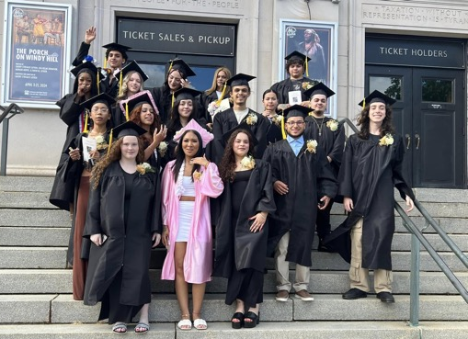
Best Practice: Reconnecting Youth: Student-Centered Advisory Program
Applicable Charter School Performance Criteria: Criterion 7: School Climate and Family Engagement
History:

- Lowell Middlesex Academy Charter School (LMACS) was established in 1995 in partnership with Middlesex Community College (MCC) to provide an alternative educational program for students in grades 9–12.
- Originally designed to serve up to 150 students, the school opened with an enrollment of 100. LMACS was founded in partnership with Middlesex Community College (MCC) and has maintained a contractual relationship with MCC for administrative and financial services since its founding.
- The school was created to offer a supportive, flexible learning environment for students seeking an alternative to traditional high school education.

Mission:
“The mission of Lowell Middlesex Academy Charter School (LMACS) is to enable its students to achieve academic, social, and career success. This supportive school community identifies, encourages and develops interests and abilities, while acknowledging and respecting each student’s personal and cultural identity.”

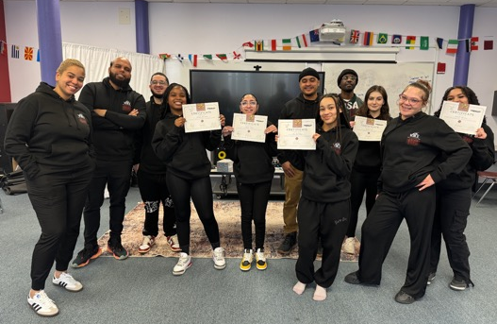
Innovative Methods and Best Practices:
LMACS fulfills its mission by implementing innovative practices that foster academic, social, and career success. Through its personalized advisory program and the hands-on Learning Through Interests/Internship (LTI) curriculum, students build connections with adults, develop practical skills, and gain real-world experience. Monthly community meetings encourage open communication and active participation, creating a supportive environment. These practices not only help students build meaningful connections with adults and peers but also prepare them for postsecondary success, as evidenced by alumni who have pursued higher education and leadership roles and return to contribute to the school community.
Key Practices and Strategies:
- Daily Advisory Meetings:
The cornerstone of LMACS's support system is its advisory program, a foundational element of the school culture. In this program, students meet daily with a dedicated advisor who serves as their advocate, mentor, and community builder. Through consistent interactions, advisors build relationships with students, gaining an understanding of their backgrounds, situations, and goals. This personalized approach prioritizes students' social-emotional well-being before addressing academic objectives, fostering a sense of connection, belonging, and value. The goal of advisory is to ensure every student feels supported, welcomed, and valued within the learning environment.
At LMACS, students participate in advisory meetings twice daily from Monday to Thursday, with a 38-minute morning session and a 60-minute afternoon session. Advisors have the flexibility to tailor these meetings, especially in the morning, to address students' social-emotional needs. The program also emphasizes developing ethical values and life skills through discussions on moderation, responsibility, and decision-making.
The afternoon session focuses on the Learning Through Interests/Internship (LTI) curriculum, developed in collaboration with Big Picture Learning (BPL), which blends experiential learning with academic development. This program includes three key components: skills for success, passion projects, and leaving to learn. In the skills for success component, students develop essential professional abilities, including goalsetting, resume writing, and job interview techniques. Advisors further support this growth by guiding students in creating Individual Learning Plans (ILPs) to document progress, establish goals, and compile portfolios. Passion projects encourage them to explore areas of personal interest, leading to creative or community-centered initiatives like researching public health issues, organizing service projects, crafting, or writing. The leaving to learn component immerses students in real-world career exploration through internships and job shadowing at various local sites.

- Monthly community meetings:
The school has implemented community meetings where students are encouraged to openly discuss any issues they face, with the goal of fostering a safe and supportive environment for sharing and collective problem-solving. These regular meetings promote open communication and active listening, which are especially important for teenagers. The school strives to empower students to actively participate in the community and build confidence in expressing their perspectives.

Results of Implementation:
- Survey data consistently show that 100% of students feel connected to at least one adult in the building, and often to most adults, highlighting the strength of supportive relationships.
- Alumni success stories from LMACS highlight graduates who have earned master's degrees and taken on leadership roles in education and other fields.
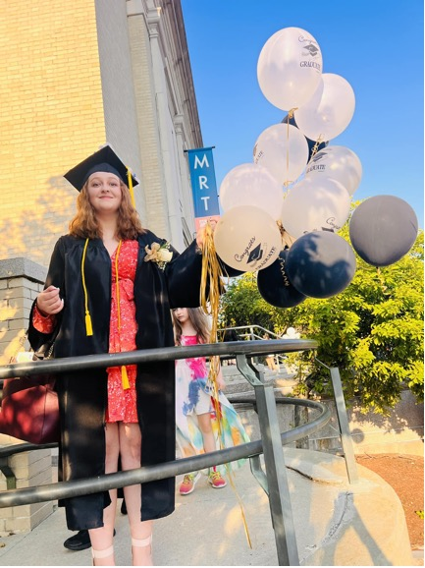
- Many alumni return to work at the school, showing the impact of these formative relationships; currently, two alumni are members of the staff, and one serves on the Board of Trustees.

