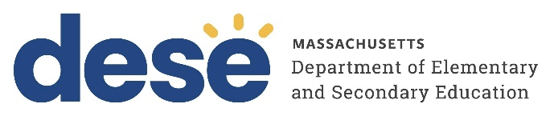
30 Year Best Practice Profile
2024-2025 SY

Marblehead Community Charter Public School
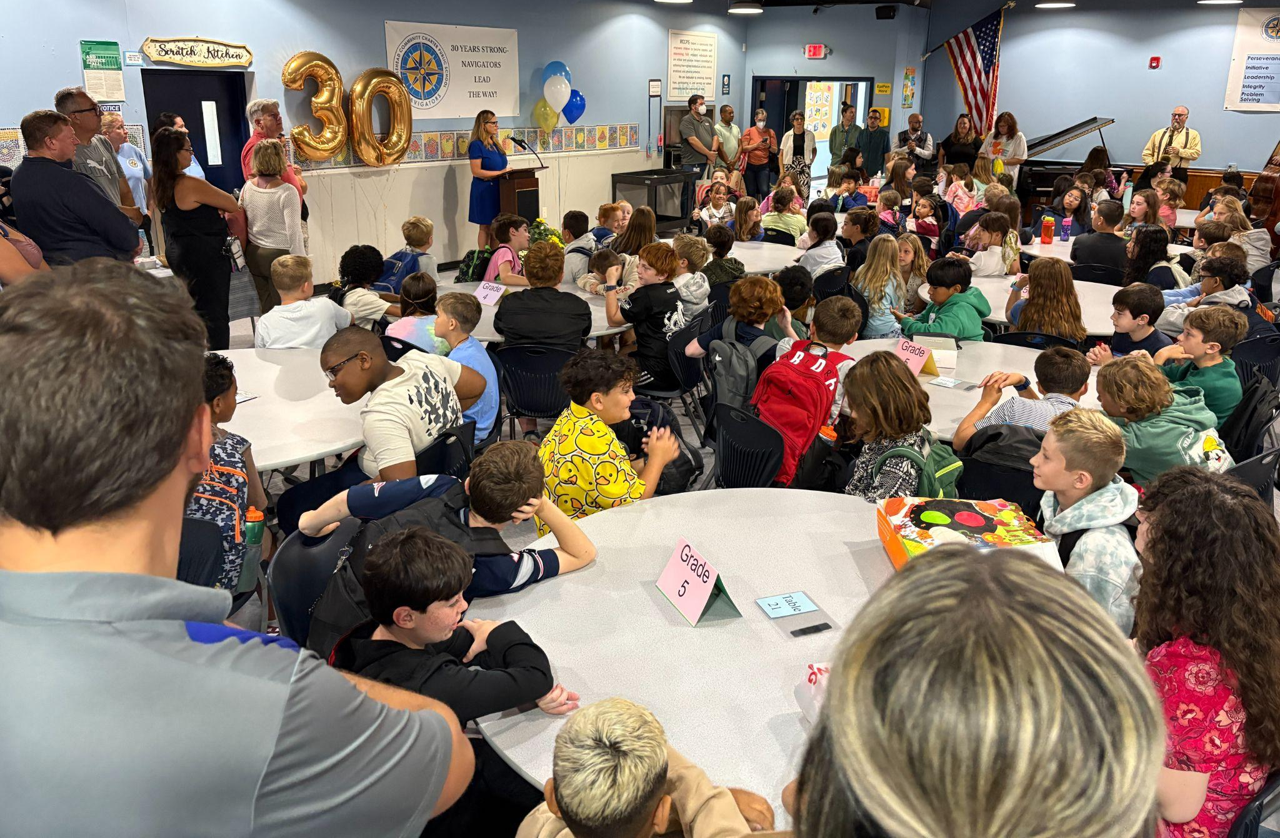

Best Practice: Holistic Student-Centered, and Personalized Learning through Community Engagement, Student Ownership, and Project-Based Learning with a Strong Focus on Arts Integration
Applicable Charter School Performance Criteria: Criterion 6: Program Delivery and Criterion 7: School Climate and Family Engagement
History:
- Marblehead Community Charter Public School (MCCPS) received its charter in 1995 to serve 176 students in grades 5–8. The school opened that year with 137 students in grades 5–7 and added grade 8 the following year.
- Two times (2001 and 2005), the school sought and was granted expansions by the Board of Elementary and Secondary Education. The school currently has a maximum enrollment of 230 students in grades 4 through 8.
- Additionally, to better align with enrollment trends, in 2021, MCCPS requested the addition of Nahant and Swampscott to its enrollment region and became a regional school.

Mission:

“MCCPS fosters a community that empowers children to become capable, self-determining, fully engaged individuals who are critical and creative thinkers committed to achieving their highest intellectual, artistic, social, emotional, and physical potential. We are dedicated to involving, learning from, participating in, and serving our school community and the community at large.”
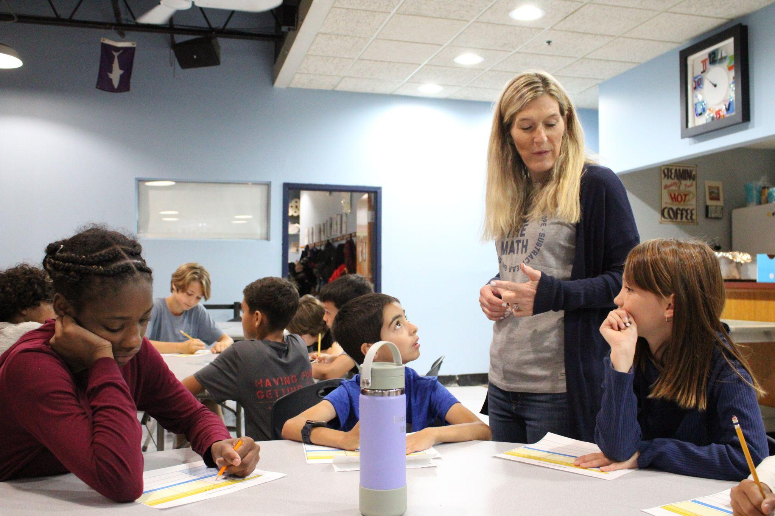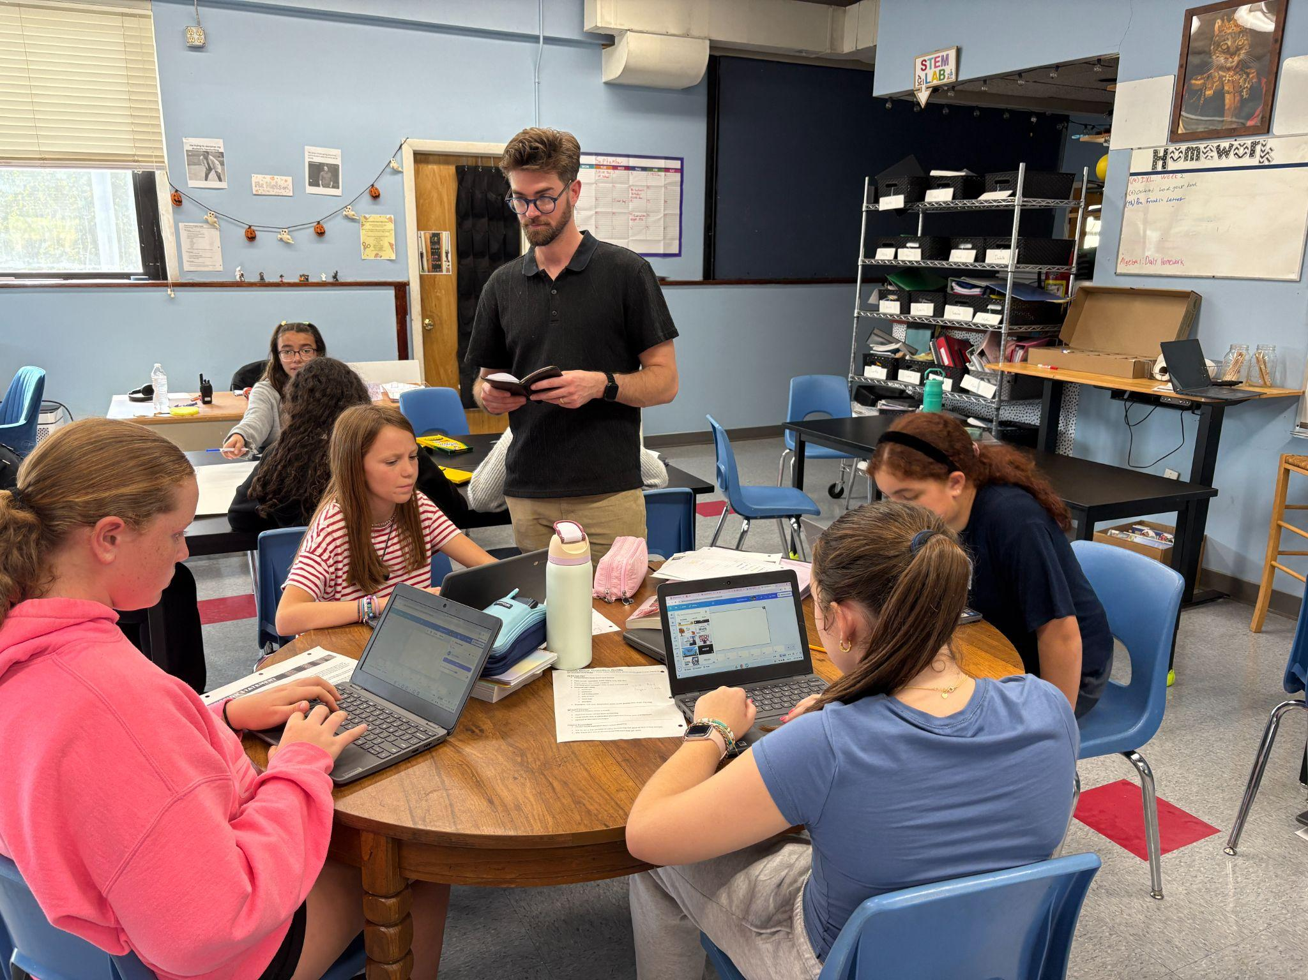
Innovative Methods and Best Practices:

Marblehead Community Charter Public School provides a holistic, student-centered education through a set of best practices that engage learners in meaningful, real-world experiences. Central to this approach are Community Service Learning, Student-Led Conferences, and Project-Based and Integrated Learning. Each practice is designed to foster student ownership, reflection, and collaboration while connecting academic content to authentic contexts. Together, these practices not only support academic achievement aligned with state standards but also cultivate essential life skills such as leadership, communication, perseverance, and creativity—reflecting MCCPS’s dedication to nurturing the whole child within a project-based learning environment.
- Community Service Learning:
Community Service Learning (CSL) is a signature practice at MCCPS that reflects the school’s mission to foster student ownership, engagement, and civic responsibility. Most prominently featured in the 8th grade, students identify real community needs, design solutions, and implement year-long projects as part of a graduation requirement. Students begin the year with service activities and a classwide project that models the CSL process, gaining practice with planning tools and receiving weekly guidance that balances structure, accountability, and independent ownership of their individual projects. Final projects, shaped by students’ own designs, typically take the form of a community service event, program, or campaign, reflecting both their individual interests and the needs they’ve identified. This practice, rooted in the school’s original charter, integrates academic content with real-world application and supports the development of essential life habits such as perseverance, leadership, and problem-solving—reinforcing MCCPS’s whole-child, project-based learning model.
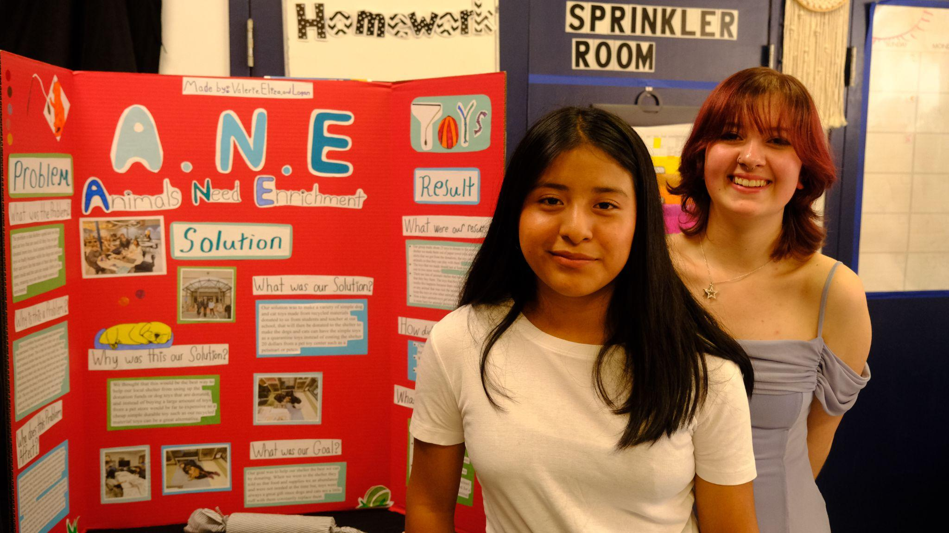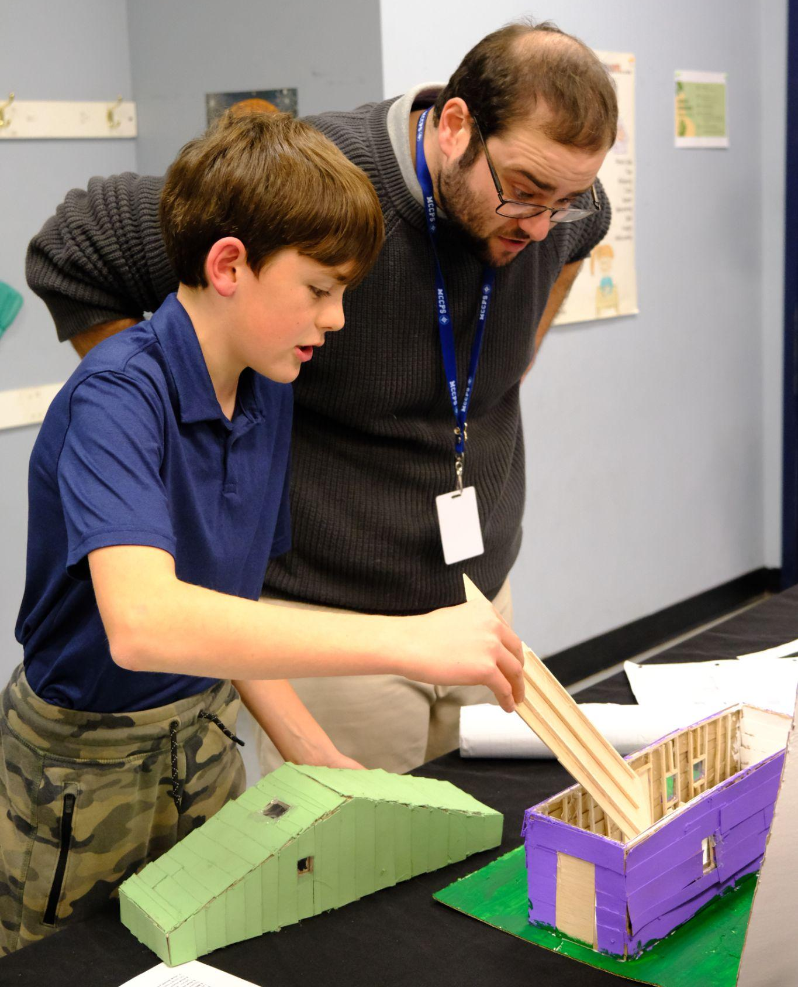
- Student-Led Conferences
Student-Led Conferences are a central element of MCCPS’s personalized learning model, promoting student ownership, reflection, and family engagement across all grade levels. In the fall, families participate in a traditional parent-teacher conference, followed by a student-led goal-setting session. In the spring, students independently facilitate a second conference, presenting their academic growth, reflections, and progress toward goals to their families and a staff member. These conferences are required for all students, parents may participate remotely, and the school tracks participation and collects parent feedback through end-of-year surveys. This model cultivates metacognitive, communication, and self-advocacy skills, reinforces the school’s whole-child philosophy, and has been shared with other schools through formal dissemination efforts.
- Project-Based and Integrated Learning
At Marblehead Community Charter Public School, integrated and project-based learning are core components of the curriculum, supported by a commitment to the integrated arts. Students in grades 4 through 8 participate in music, art, physical education, digital seminar, and Spanish twice a week, ensuring frequent and consistent engagement in each area. Teachers at every grade level are provided with regular planning time to collaborate across disciplines. This collaboration enables them to design interdisciplinary projects aligned with grade-level standards in multiple subjects. For example, in Spring 2025, 5th graders in Music and Science listened to Gustav Holst’s The Planets, learned a piano piece, composed and notated their own original composition about a planet, and performed it during the Exhibition evening. 7th grade Art, Music, and ELA students performed scenes from Romeo and Juliet, wrote essays analyzing character motivation and identifying key quotes, and created stained-glass-style drawings of their scenes. 8th graders concluded their Art and History unit with Claes Oldenburg–inspired sculptures made from recycled materials. This approach ensures that integrated arts are consistently woven into project-based learning, enriching students’ academic experience and deepening their understanding through cross-curricular connections.
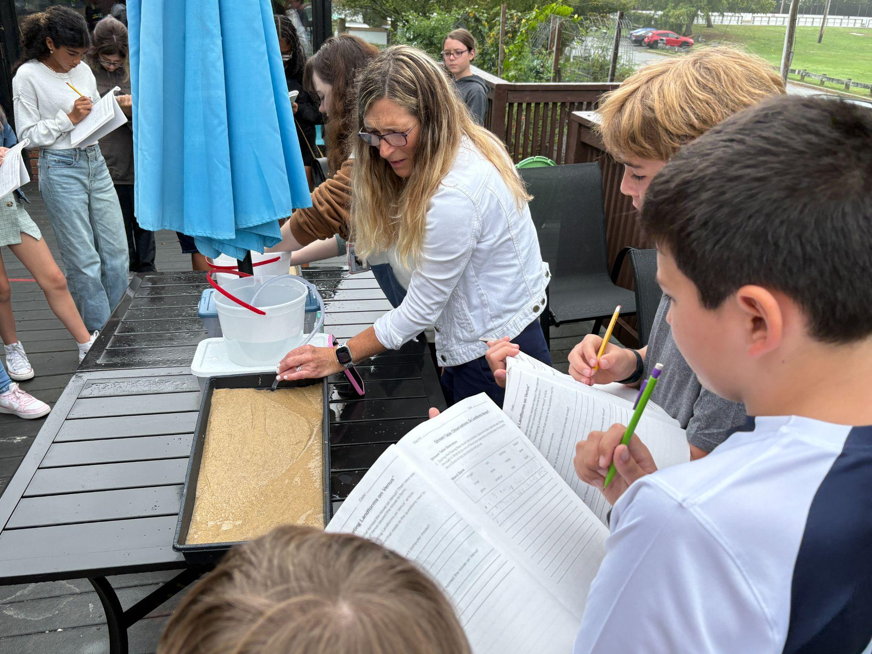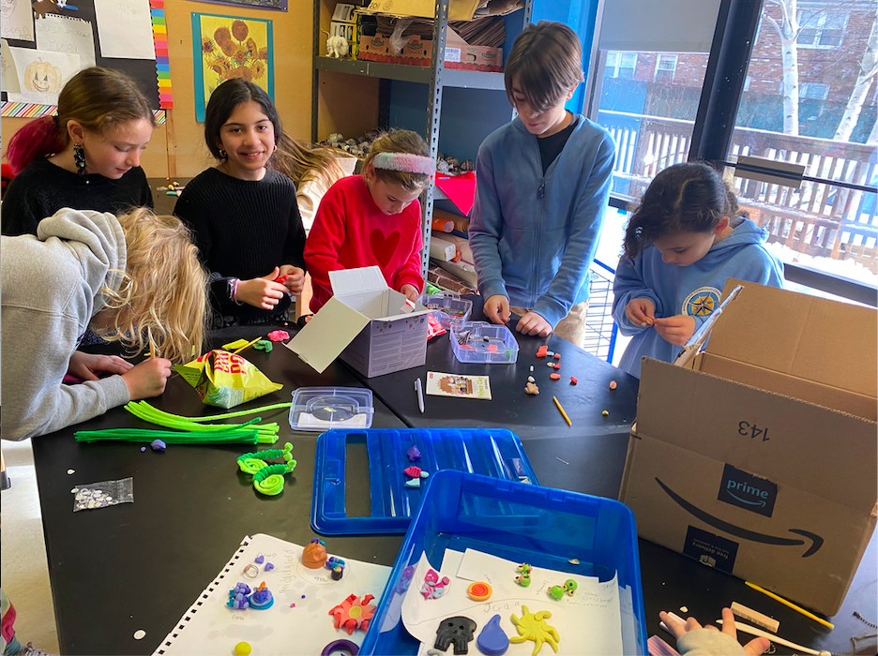
Results of Implementation:
- MCCPS has consistently demonstrated a student retention rate exceeding 90 percent, indicating sustained family satisfaction with the school’s academic approach and inclusive educational environment.
- Parent surveys and ongoing feedback demonstrate satisfaction with the school’s inclusion practices, co-taught classrooms, and integrated learning.
- During the 2023–24 academic year, students across all grade levels developed digital portfolios for each core subject area on a trimester basis, providing a structured platform for documenting and reflecting on their academic progress.
