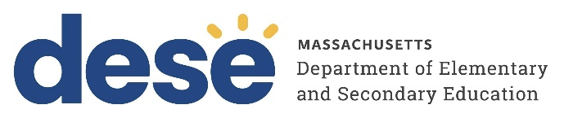
30 Year Best Practice Profile
2024-2025 SY

Neighborhood House Charter School
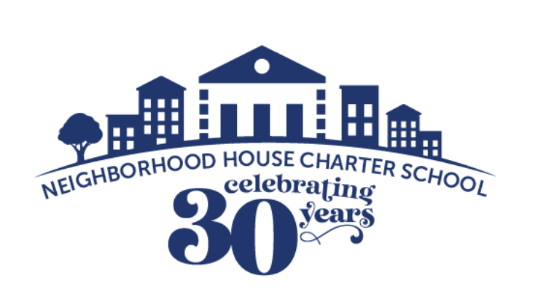
Best Practice: Implementing Rich and Structured Learning Experiences (RISL) to Support Inclusive, Culturally Responsive PK–12 Education
Applicable Charter School Performance Criteria: Criterion 6: Program Delivery and Criterion 7: School Climate and Family Engagement
History:
- Neighborhood House Charter School (NHCS) was founded in 1995 with a mission to provide a high-quality public education to students in Boston. Initially serving 50 students in grades K–2, the school expanded gradually, reaching its full K–8 enrollment by the 1999–2000 school year.
- NHCS has steadily increased its enrollment through charter amendments, most recently growing to a maximum enrollment of 828 in 2016. That same year, the Massachusetts Board of Elementary and Secondary Education approved an expansion of the grade span to PK–12. The school reached its full PK–12 enrollment during the 2020–2021 school year.
- In 2006, the school moved into a new facility owned by the Neighborhood House Charter School Foundation. Today, NHCS operates on two campuses: grades PK–7 are located at 21 Queen Street, and grades 8–12 at 197 Centre Street, both in Dorchester.
- In February 2024, teachers at the school voted to form a union backed by the Boston Teachers Union (BTU).

Mission:
“The NHCS combines rich and structured learning with extensive social/emotional programming to help all children succeed in school and in life. We strive to develop scholars who seek knowledge, embrace effort, act thoughtfully, and commit to the common good. Many children come to us with significant challenges. We don’t give up on them. Our goal is that all of our students thrive at Neighborhood House, graduate from high school, and pursue post-secondary education on the path to life success.”

Innovative Methods and Best Practices:
Neighborhood House Charter School (NHCS) is guided by a commitment to whole-child development, culturally responsive teaching, and inclusive educational practices. The school’s approach to program delivery is grounded in both innovation and equity, ensuring that all scholars are supported academically, socially, and emotionally. From dynamic classroom instruction to specialized student support services and reflective staff development, NHCS has developed a set of interconnected best practices that exemplify its mission. The following three practices—Rich and Structured Learning Experiences (RISL), inclusive therapeutic support, and Ubuntu Circles for professional learning—demonstrate how the school brings its vision to life in practical and impactful ways.
Key Practices and Strategies:
- Rich and Structured Learning Experiences (RISL)
The school implements “RISL”—Rich and Structured Learning Experiences—as a core instructional practice that brings learning to life for scholars. Through the RISL model, NHCS teachers design lessons that are culturally relevant, academically rigorous, interdisciplinary, hands-on, and emotionally engaging. These experiences are woven into daily instruction to ensure that every lesson offers meaningful, immersive engagement. Educators are given the autonomy to adapt curriculum creatively, turning potentially dry content into immersive experiences that resonate with scholars and reflect their lived experiences. For example, during a kindergarten literacy unit on the “World of Color,” teachers transformed the classroom into a vibrant Caribbean cultural experience—complete with music, costumes, traditional snacks, and storytelling—drawing on their own cultural backgrounds to make the lesson engaging. Similarly, in grade 6, an English teacher taught the biography of Malcolm X by Walter Dean Myers, using the local historical context to help scholars engage deeply with the material through personal, reflective writing. These experiences foster academic curiosity, cultural pride, and emotional investment in learning, all within a thoughtfully structured framework that supports both academic and social-emotional growth.
- Inclusive Supports through a Therapeutic Model
To support scholars with emotional impairments, Neighborhood House developed a Therapeutic Support Program rooted in inclusion and individualized care. Designed by a licensed special educator, the program uses data and functional behavior assessments to create tailored support plans. Importantly, scholars remain in inclusive classrooms and receive therapeutic interventions as needed, rather than being placed in separate settings. This open-door model promotes emotional regulation, academic continuity, and equity in learning environments.
- Ubuntu Circles – Staff Professional Development on Equity and Belonging
Launched in 2020, Ubuntu Circles is a professional development initiative at Neighborhood House Charter School focused on diversity, equity, inclusion, and belonging (DEIB). All staff are engaged in structured, small-group conversations around culturally relevant pedagogy, identity, and the broader social contexts affecting scholars. This initiative builds the cultural competence of educators while strengthening the relational and inclusive foundation of the school community.
Results of Implementation:
- Recent outcomes demonstrate the effectiveness of targeted academic supports for high-needs scholars. In grades 3–8, the percentage of possible points earned on the 2024 MCAS by students identified as high-needs rose dramatically from 25 percent to 71 percent in one year. Similarly, eight scholars exited multilingual learner status following the implementation of a high-quality, tailored curriculum—underscoring the impact of responsive instruction and evidence-based materials.
- 86.5 percent of staff members rated their experience in the Ubuntu Circles—a community-building and diversity-focused professional development initiative—as highly positive (4 or 5 on a 5-point scale), underscoring the program’s success in fostering staff well-being and inclusion.
- An increasing number of alumni and family members maintain active roles within the school community, including formal governance positions such as membership on the Board of Trustees. At present, three alumni serve on the board, and a former staff member has been identified as a prospective vice chair.

