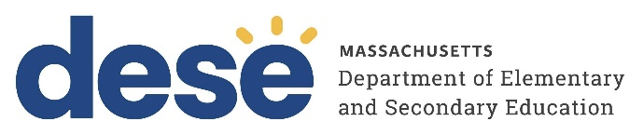
30 Year Best Practice Profile
2024-2025 SY

South Shore Charter Public School
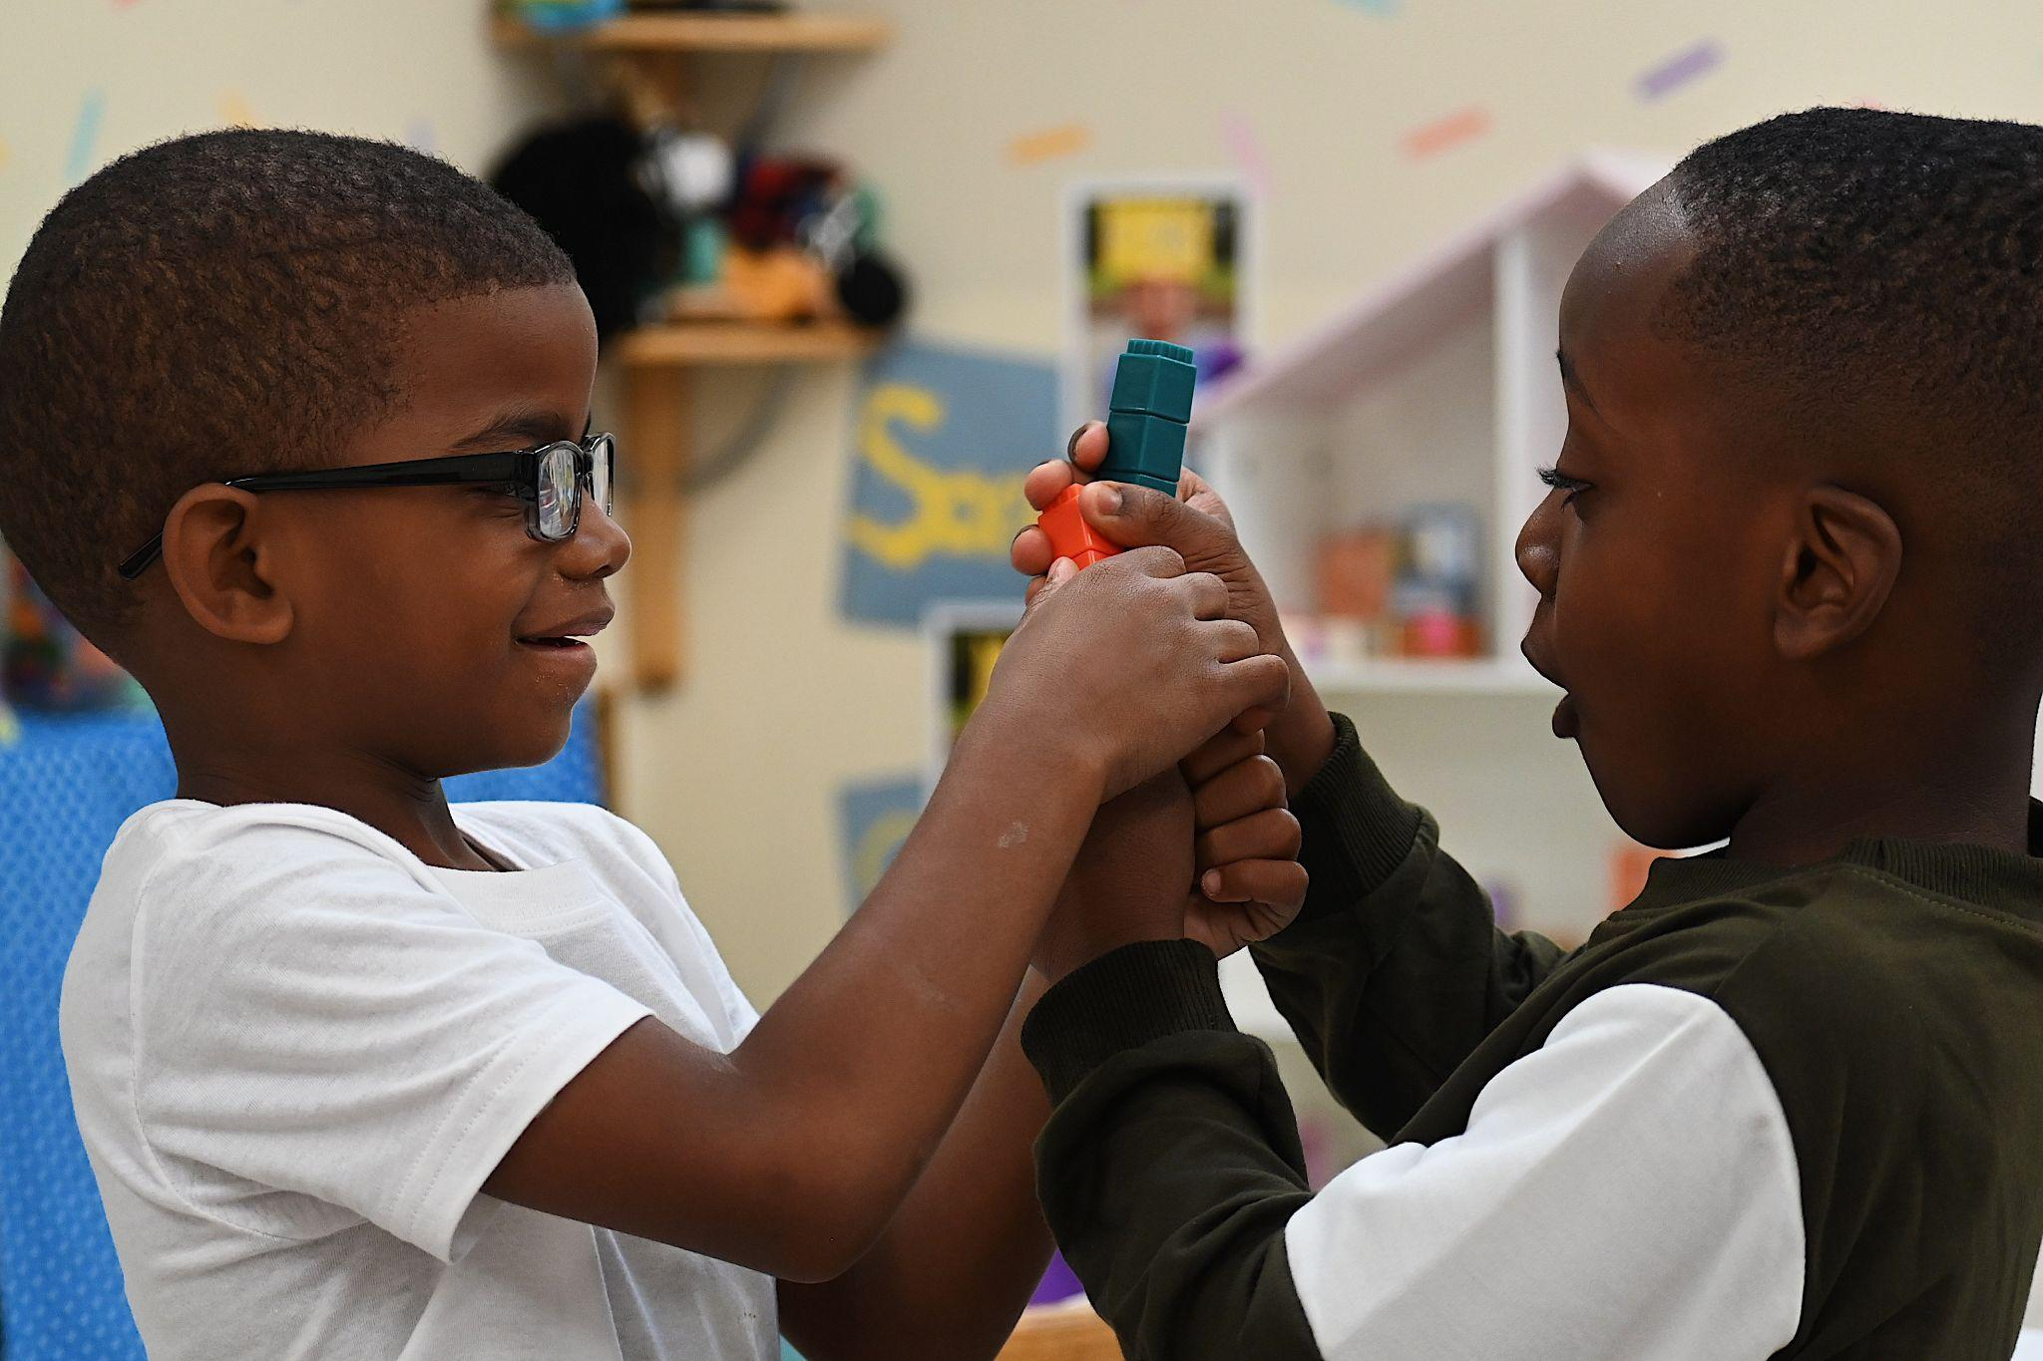
Best Practice: Integrated Structures for Inclusive and Equitable Academic Success
Applicable Charter School Performance Criteria: Criterion 6: Program Delivery and Criterion 7: School Climate and Family Engagement
History:

- South Shore Charter Public School (South Shore) opened in 1995 in Hull, serving 150 students in grades K through 2 and 6 through 12. The school reached the chartered grade span during the 1996-97 school year. The school relocated to Norwell in 2004.
- Since its opening, the Board of Elementary and Secondary Education (Board) approved three amendments to increase the school’s maximum enrollment. Currently, the school has a maximum enrollment of 1,300 students.
- Students in grades K through 8 are organized into learning communities called levels. Level I includes grades K through 2; Level II includes grades 3 and 4; Level III includes grades 5 and 6; and Level IV includes grades 7 and 8.
Mission

“Inspiring every student to excel in academics, service, and life.”
Innovative Methods and Best Practices:

South Shore promotes equity, inclusion, and academic readiness through three interrelated practices: collaborative level teams, an inclusive special education model, and a summer English Learner (EL) program. These structures are intentionally designed to support differentiated instruction, collective responsibility, and access to rigorous learning experiences for all students. By fostering educator collaboration, embedding supports within the general education setting, and extending learning opportunities beyond the school year, South Shore ensures that all students, including ELs, students with disabilities, and high-needs students, experience a unified and inclusive K–12 system.

- Collaborative Level Teams and Curriculum Alignment for Inclusive Academic Excellence
At South Shore, structured collaboration time through grade-based “Level Teams” is a foundational practice. Each level team: K through 2, 3 and 4, 5 and 6, 7 and 8, and high school meets weekly for approximately 50 minutes to co-plan instruction, share classroom strategies, reflect on classroom experiences, and align expectations across levels. Faculty engage in cross-grade curriculum work throughout the year to ensure horizontal and vertical alignment with the Massachusetts Curriculum Frameworks. This collaborative approach supports differentiated instruction for diverse learners, including ELs and students with disabilities, while promoting coherence across the K–12 continuum. Through backward design from Advanced Placement, Practice SAT, and SAT benchmarks, and coordinated planning across grade levels, the school has built a coherent K–12 instructional system. Regular use of diagnostic tools such as i-Ready and DIBELS (Dynamic Indicators of Basic Early Literacy Skills) enables educators to monitor student progress, identify learning gaps, and provide targeted support. Curriculum coordinators support this alignment by working directly with teachers to ensure consistency, rigor, and inclusion. As a result, while overall MCAS scores align with state averages, South Shore students in key subgroups, particularly ELs, consistently outperform their statewide peers, reflecting the school’s commitment to equity, readiness, and meaningful outcomes for all learners.
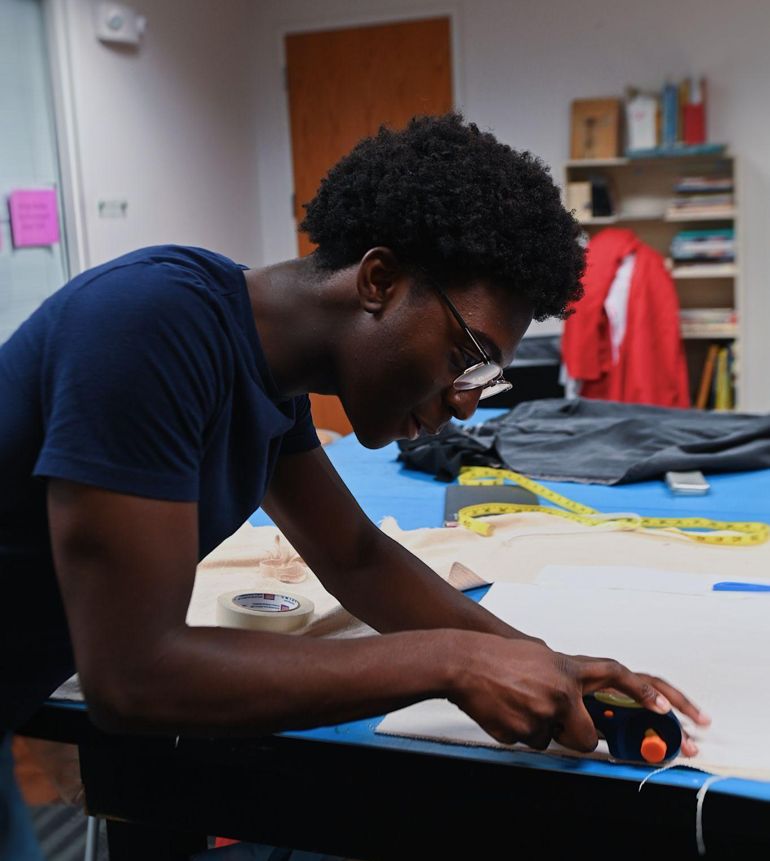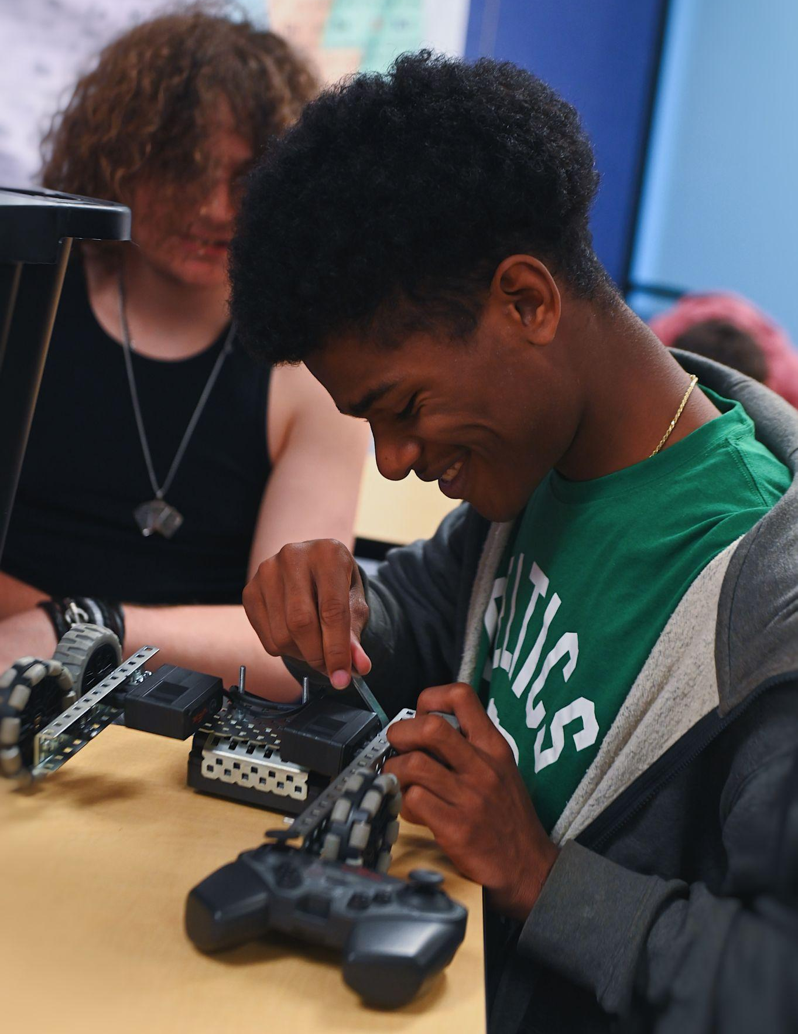
- Inclusive Special Education Model with Liaison-Based Coordination
The school operates a fully inclusive K–8 program with no substantially separate classrooms, ensuring that students with disabilities learn alongside their peers. A dedicated daily block, Focused Instructional Time (FIT), allows all students to receive small-group interventions in literacy, math, or EL support, or participate in enrichment, without missing core instruction. Special education staff, referred to as "liaisons," serve as central coordinators of student services, family communication, and data collection. They conduct educational assessments, lead IEP meetings, and design individualized support plans responsive to students’ academic and developmental needs.
- Summer English Learner Program for Language Development and Academic Readiness
South Shore has sustained and expanded its Summer EL Program over the past six years to support language development and academic readiness. Funded through the school’s operational budget and offered annually as a four-week program, it serves EL students in grades 1 through 4 who require additional language instruction. The program provides targeted support in reading, writing, speaking, and listening, organized around a new academic theme each summer, such as the “Language of Science” in the previous year. Instruction is enriched with experiential field trips to local museums, nature centers, and historic sites, reinforcing vocabulary and academic concepts in real-world contexts. In the most recent school year, 100 percent of 5th-grade EL students exited EL services after demonstrating proficiency on the ACCESS assessment. By fostering consistent language growth in an inclusive and engaging environment, the program has become a cornerstone of the school’s EL success strategy.
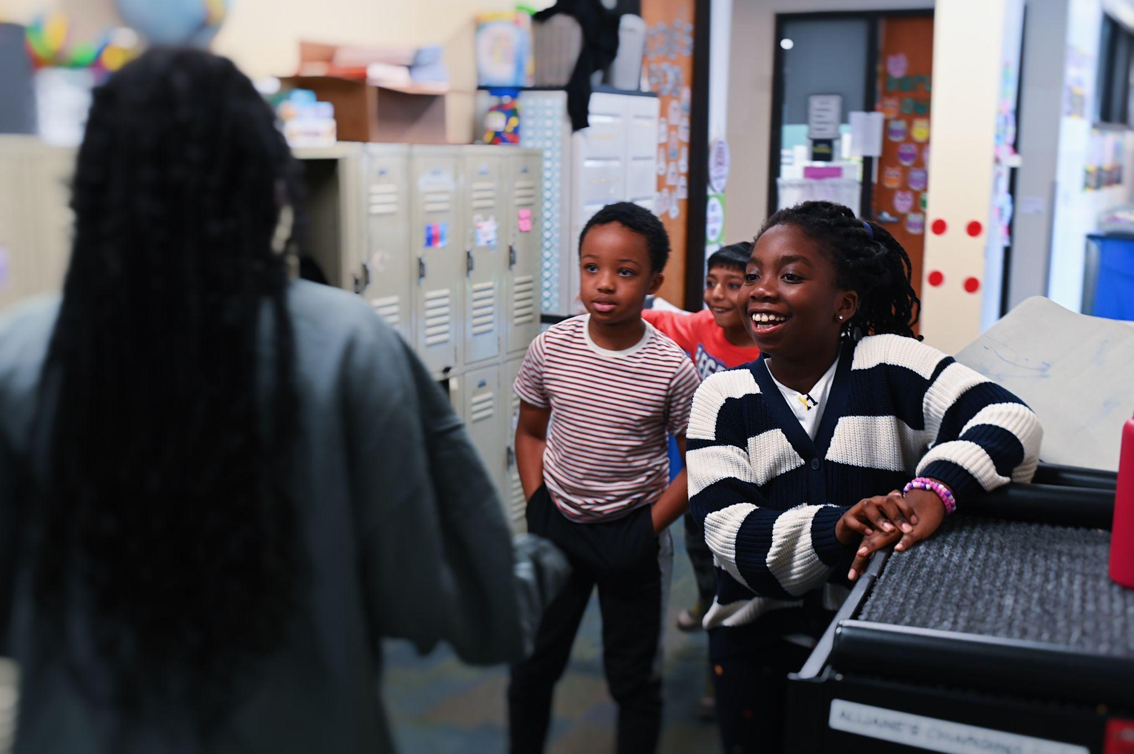
Results of Implementation:
- As a full-inclusion school, South Shore reflects its commitment to diversity with over 40 languages spoken in the school community and a track record of EL and high-needs student success.
- All 11th-grade students participate in SAT testing during school hours at no cost to families, ensuring equitable access to college admissions pathways.
- From 2020-21 to 2023-24, the percentage of high needs students in grades 9 through 12 who successfully completed honors and/or advanced placement coursework increased from 38 percent to 52 percent.

