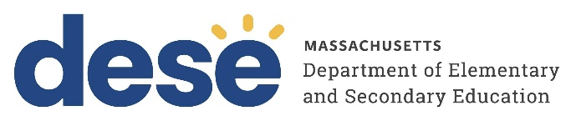
30 Year Best Practice Profile
2024-2025 SY

Springfield International Charter School
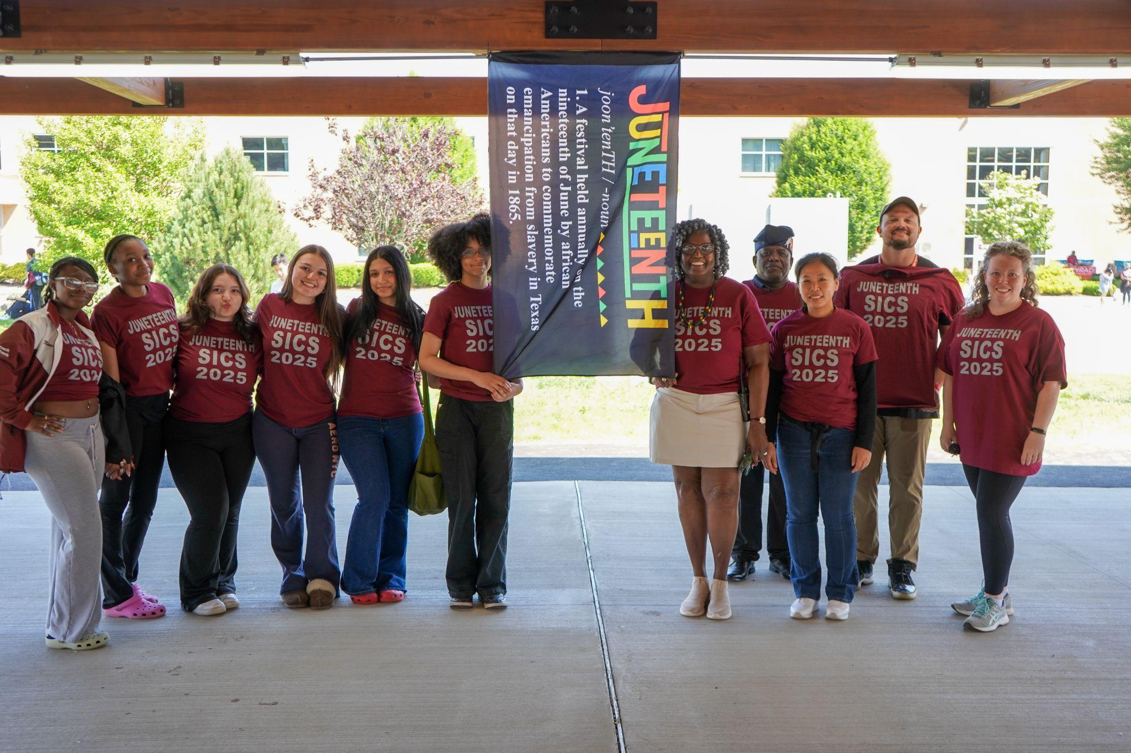
Best Practice: Comprehensive K-12 College and Career Readiness through a transition to Project-Based Learning for High School.
Applicable Charter School Performance Criteria: Criterion 7: School Climate and Family Engagement
History:
- Springfield International Charter School (SICS) was established in 1995 as SABIS International Charter School, serving grades K through 7 with an initial enrollment of 450 students. It expanded by one grade each year, reaching its full K-12 span in the 2000-01 school year.
- In 2021, the school’s board of trustees ended its partnership with Springfield Education Management LLC, moving away from the SABIS model and becoming self-managed.
- The school's governance structure includes the board of trustees overseeing the school director and a structured administrative team managing academics, student services, and operations.
Mission

“The Springfield International Charter School (SICS) is a college preparatory school that provides top-quality education on a non-selective basis to children of different races, religions, nationalities and backgrounds. It teaches these children to perform to the best of their ability, to achieve academic excellence in a global context, and prepares graduates to attend colleges and universities. The school develops and strengthens students’ ethical, moral, and civic values thus molding men and women with the knowledge, skills, and social judgment they will need to face the challenges of the times. The school believes those students with a SICS education, especially in a multicultural setting, will be able to provide leadership throughout the world.”
Innovative Methods and Best Practices:
SICS is committed to providing a consistent, inclusive, and academically rigorous environment for a diverse, urban student population. One of the school’s core strategies is its project-based, college and career-aligned instruction, designed to equip students with the skills needed for success beyond high school. From grades K through 12, the school introduces college pathways early and uses backward-designed instruction that mirrors real-world and postsecondary expectations. Through public speaking, collaborative projects, and leadership opportunities, students develop the confidence and competencies necessary for college and the workplace, ensuring they graduate well-prepared and future-ready.
- College and Career Readiness through Real-World Project-Based Learning:
The school prepares students for college and careers through a project-based model aligned with real-world expectations. Starting in kindergarten, students visit colleges. Since becoming self-managed in 2021, SICS has implemented a project-based instructional model designed to reflect the expectations of college and the modern workplace. The curriculum is designed backwards from college standards. High school students complete public speaking assignments, lab reports, and collaborative projects in assigned groups to reflect workplace dynamics. Classrooms prioritize student-led discussion, and teachers serve as facilitators. Dual enrollment allows students to earn college credits and present academic work. The school provides financial support, such as free tutoring and coverage of AP exams and college applications, to ensure all students can access these opportunities. Dual Enrollment offerings included courses such as Sociology, Introduction to Nursing, and Feminism and Gender Studies, broadening curriculum access and enabling students to earn college credits starting in the 9th grade.
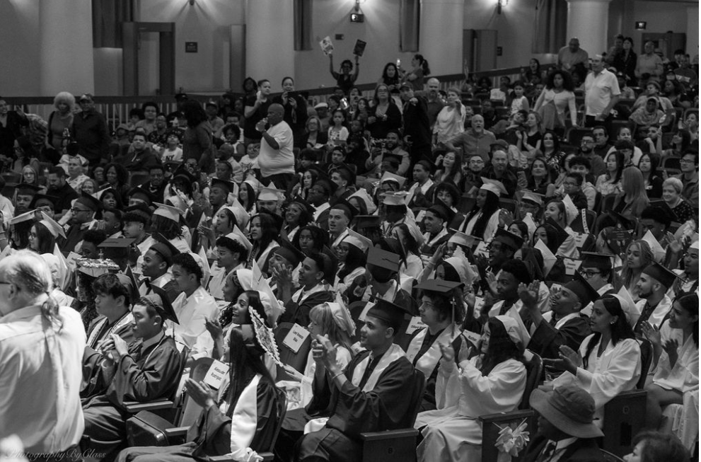

Results of Implementation:
- SICS offered 13 Advanced Placement (AP) courses during the 2023–24 school year, with 163 student course enrollments, providing students with exposure to college-level academic expectations.
- In 2023-24, 72 of 73 students (98.6 percent) participating in Dual Enrollment earned college credit, totaling 216 credits earned.
- Beginning in 2024-25, SICS is expanding the Dual Enrollment Program to operate year-round, including during the summer.
- Students at SICS have a high college acceptance rate, receive substantial financial aid, and gain access to a wide range of college options.
- The school has seen increased college and career readiness, with students showing greater confidence in presentations and a more seamless transition to higher education. Opportunities for dual enrollment and access to advanced coursework have grown substantially, further preparing students for postsecondary success.

