Massachusetts Department of

Elementary and Secondary Education

75 Pleasant Street, Malden, Massachusetts 02148-4906 Telephone: (781) 338-3000 TTY: N.E.T. Relay 1-800-439-2370

Jeffrey C. Riley
Commissioner

MEMORANDUM

To: | Charter School Leaders, Business Managers, Charter School Admissions and Enrollment Coordinators, and District Data Coordinators
From: | Brenton Stewart, Coordinator of School Redesign and Impact, Office of Charter Schools and School Redesign
Date: | February 15, 2023
Subject: | 2023-2024 Pre-Enrollment, Sibling Pre-Enrollment, and Waitlist Data Submission Memorandum and Instructions  Submission Deadline Wednesday, March 15, 2023 at 5:00 p.m.

The Charter School Pre-Enrollment Report is used by the Department of Elementary and Secondary Education (Department) to collect projected enrollment data for the determination of each Commonwealth charter school's first five monthly tuition payments for the upcoming fiscal year. The projected enrollment submitted by Commonwealth charter schools sets the maximum number of students upon which each school's tuition calculation will be based for the upcoming fiscal year. It is also used to notify sending school districts by April 1, as required by law, of the number of students enrolled in charter schools for the upcoming school year and to calculate estimated FY2024 charter school tuition that will be posted by the end of April. All charter schools are required to submit pre-enrollment data by the deadline.
The Sibling Pre-Enrollment Report is a new report element and will be used by the Department to collect projected sibling enrollment data from Commonwealth charter schools. Projected sibling enrollment data is used to estimate sibling tuition payments for sending districts projected to exceed the relevant net school spending (NSS) cap. As more districts reach NSS caps, Commonwealth charter schools face the possibility of proration of charter school tuition. The Commonwealth pays tuition for siblings when enrollment causes a district to exceed its NSS cap, subject to state appropriation. If tuition payments from a district to Commonwealth charter schools do not exceed its NSS cap in any year, the district will resume paying tuition for siblings. Only Commonwealth charter schools are required to submit the total number of pre-enrolled siblings by town.
Please note: The pre-enrollment numbers submitted must be based on actual enrollment data including, but not limited to, applications for admission, admission lottery results, accepted offers of admission, and students expected to return in the upcoming school year. The total number of pre-enrolled students in this upcoming March submission and the actual enrollment reported on the October 1 SIMS should be very similar.
As noted above, the first five charter tuition payments are based on the pre-enrollment number submitted by each Commonwealth charter school. If actual enrollment numbers, as collected by the October 1, 2023 SIMS submission, are lower than a school’s pre-enrollment projection, tuition payments will be adjusted over the course of the winter months to reflect the lower actual enrollment and to recoup the overpayment for the first five months.
Please note that the Department informs all Commonwealth charter schools of sending districts that are subject to “skip over” requirements or recommendations based on NSS caps by February 15 each year. The Department provides notice of all at-cap and near-cap sending districts for Commonwealth charter schools in its annual Pre-Enroll NSS Cap Guidance for Districts memorandum to inform the upcoming fiscal year’s enrollment. The NSS cap memorandum and this memorandum should be read and reviewed in tandem.

Information and Instructions for FY2024 Charter School Pre-Enrollment data and Sibling Pre-Enrollment data submission
FY2024 pre-enrollment data must be submitted to the Department by 5:00 pm on Wednesday, March 15, 2023. The pre-enrollment data will be submitted via the ‘Charter and Virtual School Pre-Enrollment’ application within the Security Portal. Instructions to assist charter schools in completing both submissions are found on the ‘Charter and Virtual School Pre-Enrollment’ home page.
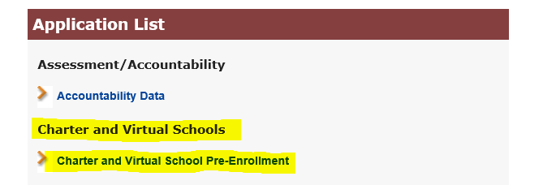
Charter schools must select the upcoming fiscal year, the ‘Pre-Enrollment’ module, and the school name from each dropdown menu prior to clicking the ‘next’ button. After completing the Pre-Enrollment report, Commonwealth charter schools must also complete the Sibling Pre-Enrollment report, which may be selected from the menu featured on the left-hand side of the screen. Instructions to assist charter schools in completing both submissions are found on the ‘Charter and Virtual School Pre-Enrollment’ home page.
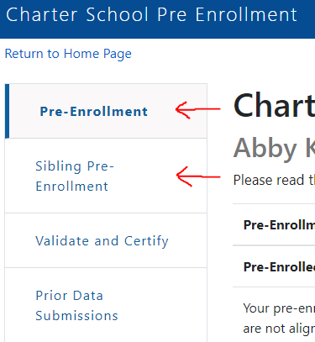
After the pre-enrollment data has been collected and reviewed, the Department will determine if a charter school's enrollment qualifies as a significant expansion. Charter schools who qualify as significantly expanding will be required to submit additional enrollment data for select student populations. This additional data collection only applies to a few schools that are newly chartered, adding grades, or increasing enrollment by more than 10 percent when compared to the previous year. If applicable, the schools will be informed and given instructions to complete this report by the June submission deadline.
- Please contact Brenton Stewart at Brenton.Stewart@mass.gov with any questions regarding the pre-enrollment data submission, the sibling pre-enrollment data submission, or the significant expansion submission.

Information and Instructions for FY2024 Initial Waitlist submission
Each charter school is required to submit a waitlist to the Department by 5:00 pm on Wednesday, March 15, 2023. This submission will provide student level waitlist data established after the most recent lottery and should reflect an accurate student waitlist, as of March 15, 2023, for the upcoming school year. The FY2024 Initial Charter School Student-Level Waitlist Report should be completed using the Excel template named FY24_waitlist_March_[your school’s LEA Code] that was uploaded to your school's Charter School File Exchange dropbox within the Security Portal.
There are detailed instructions in the Instructions tab found within the uploaded FY2024 waitlist Excel template. Please review these instructions and fill out the contact information tab before completing your FY2024 initial waitlist report. Please note, the Department continues to collect additional information pertaining to the sibling status of waitlisted students. There is an additional column requesting schools to identify these students in its waitlist report. Sibling status is only applicable for waitlisted students that are siblings of currently enrolled students. Please identify each student’s sibling status with either a ‘Y’ or a ‘N’.
Embedded within the waitlist collection template (‘initial’ tab) are several data flags and error checks (i.e., duplicate records, unsupported characters within a student name, student age, etc.). The Department relies on complete and accurate waitlist submissions and these embedded tools are included to support accuracy. These data flags and error checks work properly with Microsoft Excel. The Department has added a field to the contact information page for schools to identify which spreadsheet program was used to complete the waitlist report (e.g., Google Sheets). Please be sure to provide this information.
The Department requests that each charter school provide the following data elements for each student included in their current waitlist:
FIRSTNAME | LASTNAME | MIDDLENAME | DOB (MM/DD/YYYY) | TOWNCODE | GRADE | SIBLING OF CURRENTLY ATTENDING STUDENT (Y/N)?
There are additional instructions that have been tailored for the one school that continues to maintain roll-over waitlists established prior to March 31, 2014. Also note, that in addition to the embedded tools highlighted above, there is another data flag that should identify students who are found on both the initial waitlist and on the rollover list, which would be considered a duplicate record. Please confirm that the student record added to the initial tab is not a duplicate of a student identified on a roll-over waitlist. If it is determined to be a duplicate record, then remove the student's information from the initial tab.
- Please contact Brenton Stewart (Brenton.Stewart@mass.gov) or Lee DeLorenzo (Lee.DeLorenzo@mass.gov) if you have any questions or have difficulty accessing your FY2024 waitlist Excel template.

MGL Chapter 71 §89(o): Each charter school shall annually, not later than April 1, notify each public school district in writing of the number and grade levels of students who will be attending the charter school from that district the following September as well as the number of new students who will be transferring from that district to the charter school in the following September. Tuition for charter school students shall only be paid for the number of students for whom notification has been reported by April 1. Tuition for charter school students shall be paid only for students actually enrolled in the school. 603 CMR 1.08(5): Enrollment Reports: Every charter school shall file a pre-enrollment report annually in accordance with deadlines established by the Department. Every charter school must keep accurate records related to enrollment including, but not limited to, applications for admission, the lottery process, and wait lists. The Department will report to districts the aggregate number of students who are selected for admission for the upcoming school year from their districts and the total enrollment for each charter school. No charter school shall receive tuition payments that exceed the total enrollment for that charter school as it was reported to the Department in the school's pre-enrollment report. In their pre-enrollment reports, charter schools must notify the Department of: (a) the school's total enrollment for the subsequent academic year; and (b) the projected number of students selected for admission, by grade and district of residence, for the subsequent academic year.
The charter school statute specifies that the Commonwealth pays tuition for "siblings attending commonwealth charter schools to the extent that their attendance would otherwise cause the school district's charter school tuition payments to exceed 9 per cent of the school district's net school spending." G.L. c. 71, § 89(i)(2). The charter school regulations further explain that non-siblings should be skipped over but kept on the school’s waitlist if their enrollment would cause the NSS cap to be exceeded and that payment for sibling enrollment from the state is subject to appropriation. 603 CMR 1.05(10)b.

