

Memorandum

To: Charter School Leaders, Business Managers, Charter School Admissions and Enrollment Coordinators, and District Data Coordinators
From: Brenton Stewart, Coordinator of School Redesign and Impact, Office of Charter Schools and School Redesign
Date: February 23, 2026
Subject: 2026-2027 Pre-Enrollment, Sibling Pre-Enrollment, and Waitlist Data Submission Memorandum and Instructions
Submission Deadline Thursday, March 12, 2026 at 5:00 PM

The Charter School Pre-Enrollment Report is used by the Department of Elementary and Secondary Education (Department) to collect projected enrollment data for the determination of each Commonwealth charter school's first five monthly tuition payments for the upcoming fiscal year. The projected enrollment submitted by Commonwealth charter schools sets the maximum number of students upon which each school's tuition calculation will be based for the upcoming fiscal year. It is also used to notify sending school districts by April 1, as required by law, of the number of students enrolled in charter schools during the next school year and to calculate the estimated charter school tuition for the next fiscal year. All charter schools are required to submit pre-enrollment data.
The Sibling Pre-Enrollment Report is used by the Department to collect projected sibling enrollment data from Commonwealth charter schools. Projected sibling enrollment data is used to determine estimated sibling tuition payments for sending districts projected to exceed the relevant net school spending (NSS) cap. As more districts reach NSS caps, Commonwealth charter schools face the possibility of proration of charter school tuition. The Commonwealth pays tuition for siblings when enrollment causes a district to exceed its NSS cap, subject to state appropriation. If tuition payments from a district to Commonwealth charter schools do not exceed its NSS cap in any year, the district will resume paying tuition for siblings. Only Commonwealth charter schools are required to submit sibling pre-enrollment data.
Please note: The enrollment numbers submitted must be based on actual enrollment data including, but not limited to, applications for admission, admission lottery results, accepted offers of admission, and students expected to return the following school year. The total number of pre-enrolled students in this upcoming March submission and the actual enrollment reported on the October 1 SIMS should be very similar.
As noted above, the first five charter tuition payments are based on the pre-enrollment number submitted by each Commonwealth charter school. If actual enrollment numbers, as collected by the October 1, 2026 SIMS submission, are lower than a school’s pre-enrollment projection, tuition payments will be adjusted over the course of the winter months to reflect the lower actual enrollment and to recoup the overpayment for the first five months.
Please note that the Department informs all Commonwealth charter schools of sending districts that are subject to “skip over” requirements or recommendations based on NSS caps by February 15 each year. The Department provides notice of all at-cap and near-cap sending districts for Commonwealth charter schools in its annual Pre-Enroll NSS Cap Guidance for Districts memorandum to inform the upcoming fiscal year’s enrollment. The NSS cap memorandum and this memorandum should be read and reviewed in tandem.
Please review the instructions below before beginning your submission. If the correct grade span is not available or the minimum and maximum enrollment do not align with your school’s approved growth plan, please contact Brenton Stewart at Brenton.Stewart@mass.gov to adjust it. Please feel free to contact Brenton with any questions.

Information and Instructions for FY2027 Charter School
Pre-Enrollment Data and Sibling Pre-Enrollment Data Submission
FY2027 pre-enrollment data must be submitted to the Department by 5:00 PM on Thursday, March 12, 2026. All pre-enrollment data will be submitted via the Charter and Virtual School Pre-Enrollment application within the Security Portal. The school leader is required to certify and submit the data, even if someone else enters it into the application. Please plan for a careful check of the data because it will impact tuition payments for the upcoming fiscal year and cannot be changed once submitted.
The Department recommends that schools take the following steps prior to inputting pre-enrollment and sibling pre-enrollment data:
- Identify all students that will be enrolled in your charter school during the next school year, including current students who will return and students who are newly admitted.
  - Organize student information by town and grade level.
  - Identify the total number of students by town and grade level.
- Identify students, both newly admitted and currently attending students, who will be reported as a sibling in your student information system. The student may have been admitted through sibling preference after a lottery or if no lottery was required, they have a sibling who attended the school at the time the offer of admission was made. This may also include siblings who have been admitted from the waitlist. Please remember siblings are children who share a common biological or legal parent.
  - Organize sibling student information by town only.
  - Identify the total number of sibling students by town only.

Accessing the Pre-Enrollment Application
The pre-enrollment module can be accessed from within the Security Portal. Once at the main security portal landing page, select ‘Charter and Virtual School Pre-Enrollment’ application.
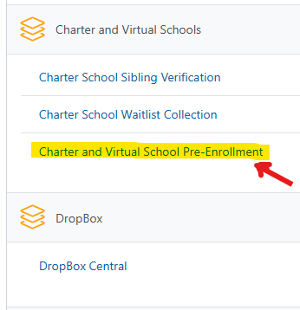

Inputting Pre-Enrollment Data
- Select the upcoming fiscal year, the Pre-Enrollment module, and school name from each drop-down menu. Once all drop-downs are selected, click Next. You will be brought to the Pre-Enrollment landing page. The Pre-Enrollment landing page can also be accessed from the menu featured on the left-hand side of the screen.
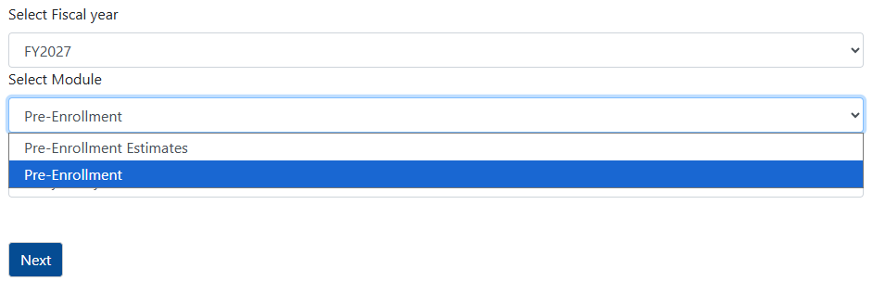
- Column 1: Select the first Town from the drop-down menu for which the school has pre-enrolled students. The town names will be listed in an order based on the school’s enrollment trends.
- Column 2: Select the applicable grade level from the Grade drop-down menu for the town. Please note the additional ‘Grade SP’ for select students.
- Column 3: Enter the Total Pre-Enrollment Number for the applicable town and grade level.
- Click Add at the end of the row when finished.
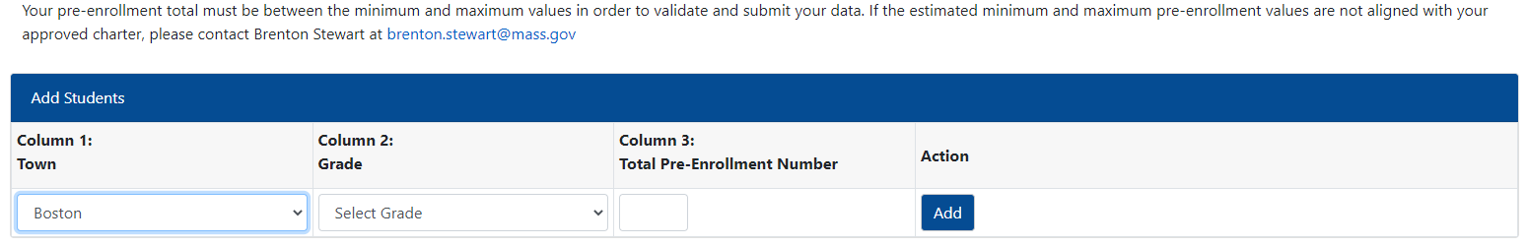
- Continue entering data for each town and grade, in the manner described above, until all pre-enrolled students have been entered.
- The final total enrollment must not exceed the estimated maximum, nor fall below the estimated minimum (Est. Min/Est. Max). If the final total enrollment falls outside of the min and max provided, your submission will receive an error at the validation stage.

Inputting Sibling Pre-Enrollment Data
- Select Sibling Pre-Enrollment from the menu featured on the left-hand side of the screen.
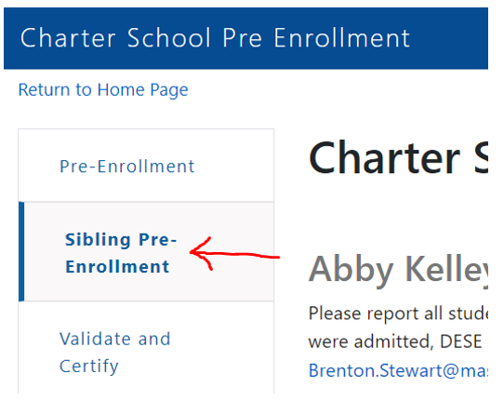
- No Siblings or Horace Mann:
Complete the No Sibling Pre-Enrollment Counts to Report if there are no students admitted through sibling preference or your school is a Horace Mann charter school. Check the available box and then click Save. You may proceed to Validate and Review from the menu featured on the left-hand side of the screen.
- Siblings to Report:
Column 1: Select the first Town from the drop-down menu for which the school has pre-enrolled students. The town names will be listed in an order based on the school’s enrollment trends.
- Column 2: Select the applicable grade level from the Grade drop-down menu for the town. Please note the additional ‘Grade SP’ for select students.
- Column 3: Enter the Total Number of Students Admitted with Sibling Preference, including new and currently attending students. The student may have been admitted through sibling preference after a lottery. If no lottery was required, they have a sibling who attended the school at the time the offer of admission was made. This may also include siblings who have been admitted from the waitlist.
- Click Add at the end of the row when finished.
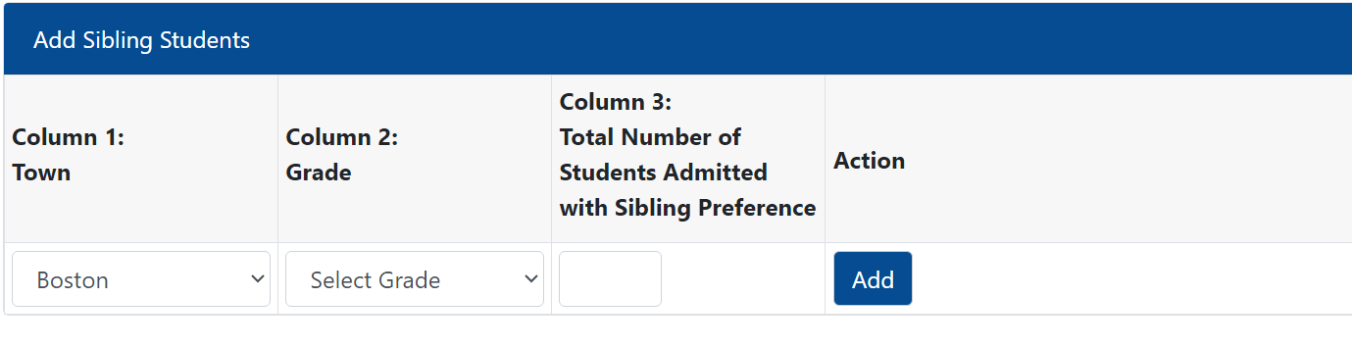
- Continue entering data for each applicable town where a sibling resides, in the manner described above, until all pre-enrolled siblings have been entered.
- The total number of siblings identified for each town cannot exceed the number of students reported for the same town in Pre-Enrollment Report. If the number of siblings exceeds the number of pre-enrolled students reported, your submission will receive an error at the validation stage.

Validate and Certify Pre-Enrollment Data and Sibling Data
- Select Validate and Review from the menu featured on the left-hand side of the screen.
- Click the Validate and Review button to review your pre-enrollment and sibling submissions for errors.
*No Errors: If there are no errors in your data, you will receive a message stating that no errors were identified. Click Certify to complete your submission.

*Errors: If error(s) are present in your data, you will receive a message that identifies the number of validation errors found. Use the link labeled ‘click here’ to view and download the error(s). See image below. A new tab will appear; your current tab will not close.

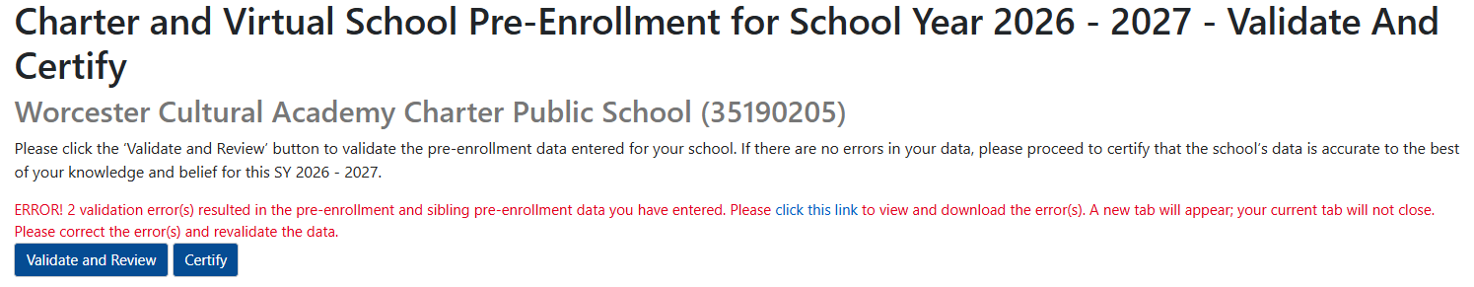
- Review the type of error(s) and the identified module where error(s) are present. Correct the error(s) by navigating back to that module’s subpage and editing the identified data error(s). After correcting the error(s), click Validate and Review again. If error(s) are rectified, you will receive a message that identified no errors. Click Certify to complete your submission.
- After certifying, you must take a screenshot of your submission to provide to your auditor.
After the pre-enrollment data has been collected and reviewed, the Department will determine if a charter school's enrollment qualifies as a significant expansion. Charter schools who qualify as significantly expanding will be required to submit additional enrollment data for select student populations. This additional data collection only applies to a few schools that are newly chartered, adding grades, or increasing enrollment by more than 10 percent when compared to the previous year. If applicable, the schools will be informed and given instructions to complete this report by the June submission deadline.
- Please contact Brenton Stewart at Brenton.Stewart@mass.gov with any questions regarding the pre-enrollment data submission, the sibling pre-enrollment data submission, or the significant expansion submission.

Information and Instructions for FY2027 Initial Waitlist Submission
Each charter school is required to submit a waitlist to the Department by 5:00 PM on Thursday, March 12, 2026. This submission will provide student-level waitlist data established after the most recent lottery and should reflect an accurate student waitlist, as of March 12, 2026, for the upcoming school year. For previous waitlist collections, charter schools submitted their waitlist reports using an Excel template provided by the Department and uploaded through the Charter School File Exchange within the Security Portal. The Department has created a new application within the Security Portal called the ‘Charter School Waitlist Collection’. Starting with this upcoming FY2027 collection, all charter schools will submit their Initial and Updated Charter School Student-Level Waitlist Reports through this new collection application, also found within the Security Portal.

Accessing the Charter School Waitlist Collection Application
The waitlist collection module can be accessed within the Security Portal. At the main security portal landing page, select the ‘Charter School Waitlist Collection’ application. If you do not see the application listed, please reach out to your Directory Administrator and ensure you have the appropriate permissions, and your role within the Directory Administration is correctly identified as the Charter School Admissions and Enrollment Coordinator.
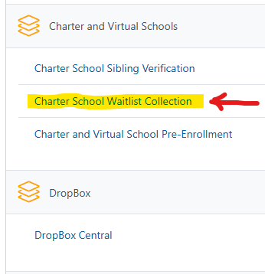

Preparing the Waitlist Collection Data Spreadsheet for Upload
- Charter schools will upload their waitlist collection data through the application as a file. The waitlist file must be saved as a .csv or .xlsx file prior to attempting to upload.
- To facilitate extraction of the required waitlist information from the uploaded file, required information must be provided in an unlocked file with the required information located on the first tab of the file. You will encounter upload errors if instructions are not followed.
  - Charter schools may save various tabs of information within their waitlist collection worksheets. Only the first tab within the worksheet will be extracted.
  - Do not lock any cells or worksheets prior to submitting. Be sure to check prior to uploading.
- Waitlist spreadsheets must contain seven required column headers in the first row. Column headers must be labeled exactly as instructed below to avoid errors.
  - Please note that the waitlist spreadsheets you maintain may contain additional columns that are not required, and the columns may be ordered in any order. Only the data from the seven (7) columns identified below will be extracted and uploaded into the Charter School Waitlist Collection report within the application.

Required columns are:
- FIRSTNAME
- LASTNAME
- MIDDLENAME
- DOB
    - DOB must be formatted as a date, which is supported in any short form. For example, a student born on July 8, 2020 can be represented as 7/8/20.
- TOWNCODE
    - TOWNCODE must be formatted with 3-digits. It is best to save the column as text, but you may also use custom formatting.
- GRADE
- SIBLING
    - SIBLING must include a ‘Y’ or ‘N’ for each student record. Students identified with a ‘Y’ are siblings of currently attending students and are waitlisted with sibling preference.

Uploading the Waitlist Collection Data Spreadsheet
- First, select the Upload button (labeled in blue) on the main page of the Charter School Waitlist Collection application. When the pop-up window opens, choose the ‘+ Browse’ button to select the file. 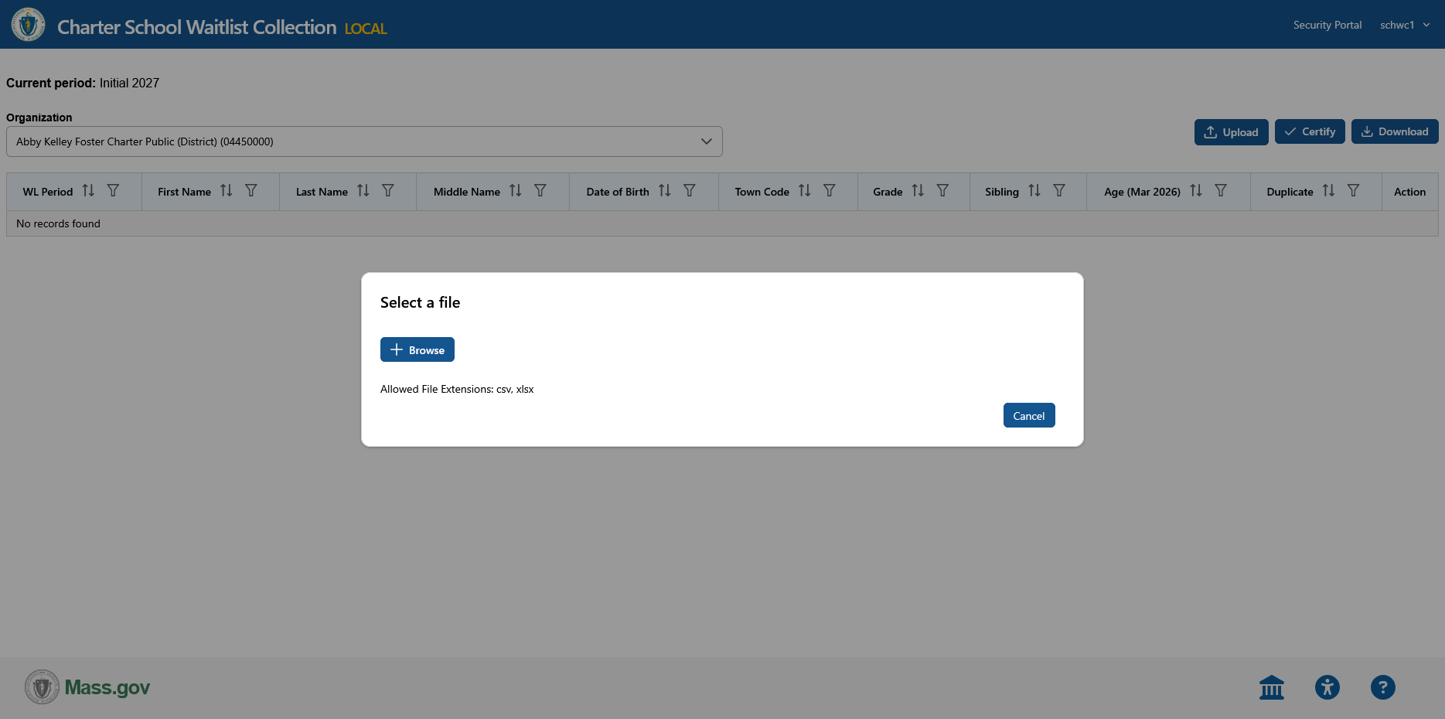
- Navigate your computer’s file explorer to locate the waitlist file that you intend to upload. Click the ‘Submit’ button (labeled in blue).
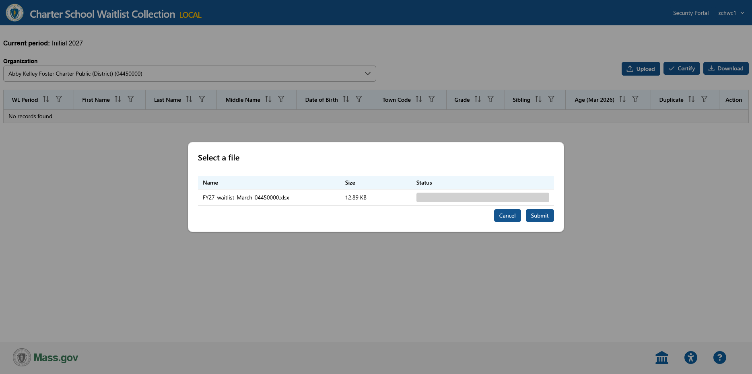
- If your upload is free of errors, then your school’s waitlist data will be extracted and uploaded to your charter school report. A pop-up (with a green background) will appear, indicating a successful upload.
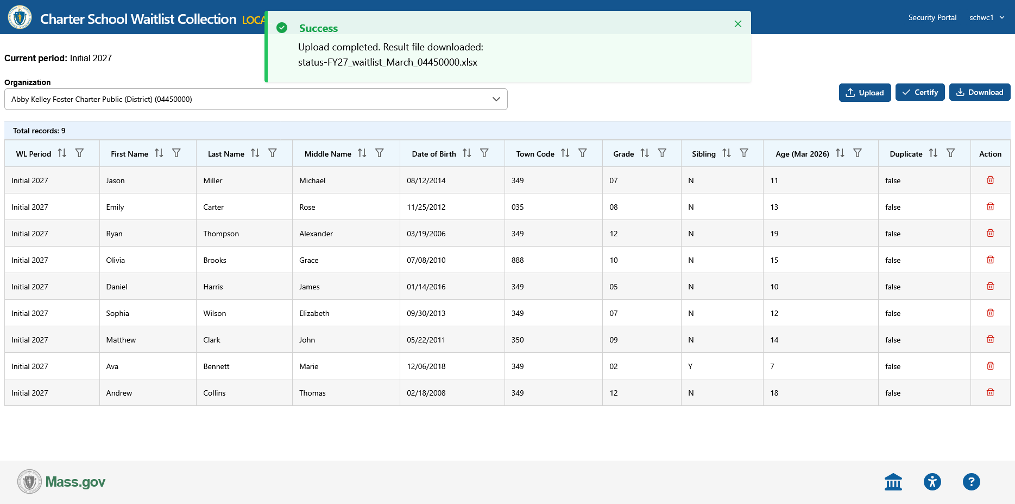
- If your waitlist spreadsheet contains errors, then no data will be uploaded into your charter school waitlist report. A pop-up screen (with a red background) will appear, with an error message stating that ‘No records were inserted due to validation errors’. An extract of the errors will automatically be downloaded to your computer as a spreadsheet file. Review the downloaded spreadsheet file for the specific errors for individual student records.
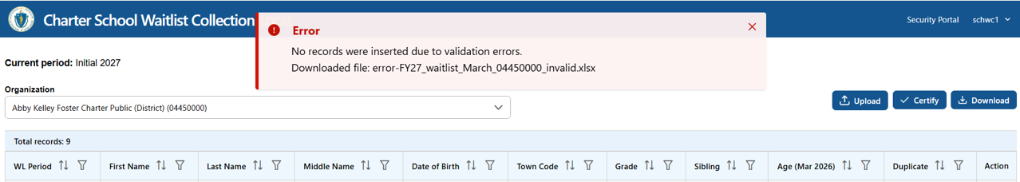
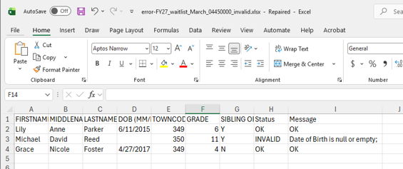
- After you resolve the identified errors, resave your waitlist spreadsheet and reupload your file. If your waitlist spreadsheet is free of errors, your waitlist data will be uploaded successfully. See screenshot from step 3.

- After you upload your waitlist, perform a final review of the populated report within the application for accuracy and completeness.

  - Removal of student record(s) from report: If a student is determined to be incorrectly placed on the waitlist and should not appear in the charter school waitlist collection upload, you are able to remove the record from the report by clicking on the trashcan icon (labeled red) on the far right of the screen for the individual record. A pop-up screen will appear asking for confirmation of the removal of the student. If this is the student you wish to remove, click on the ‘Yes, remove’ on the pop-up screen.
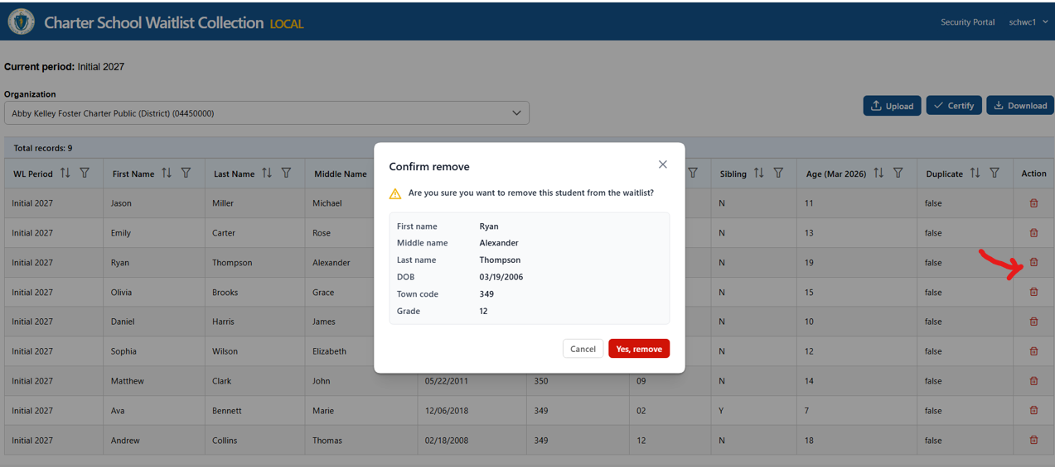
  - Accidental removal of student record(s) from the report: If the wrong student was removed from the charter school collection upload, you are able to add the deleted record into the waitlist report. Follow steps 1 and 2 to reupload your original waitlist file containing the removed record(s). The student record that was accidentally removed will be re-inserted into the waitlist report. All previously uploaded student records will not be impacted. Note that if your reupload is free of errors, a pop-up (with a blue background) will appear, indicating that the upload was completed and duplicates were skipped over during the extract. The removed record(s) are added into the waitlist report and will appear at the end of your waitlist.

  - Addition of student record(s) to the report: Follow steps 1 and 2 to re-upload your waitlist file with additional student records. Note that if your reupload is free of errors, a pop-up (with a blue background) will appear, indicating that the upload was completed and duplicates were skipped over during the extract. The additional rows of waitlist data will appear at the end of your waitlist.
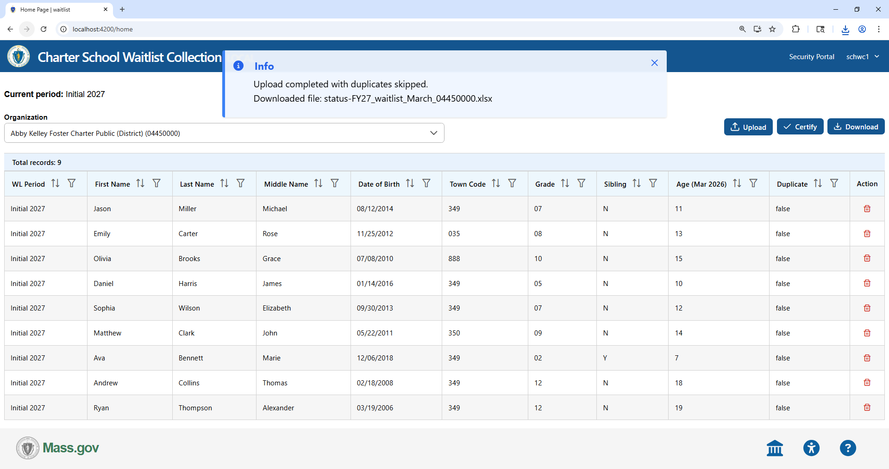
A download of your reuploaded file will automatically initiate, and you can review the status of your resubmission for each student waitlist record.
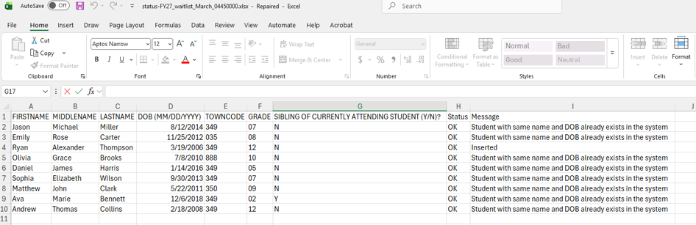

- When you are ready to officially submit your charter school waitlist report, click the ‘✓ Certify’ button (labeled blue) on the top right of the screen and a pop-up screen will appear. You must select the box indicating that you ‘understand and want to certify’ in order to select the ‘Confirm’ button (labeled in green) located near the bottom right of the pop-up screen.
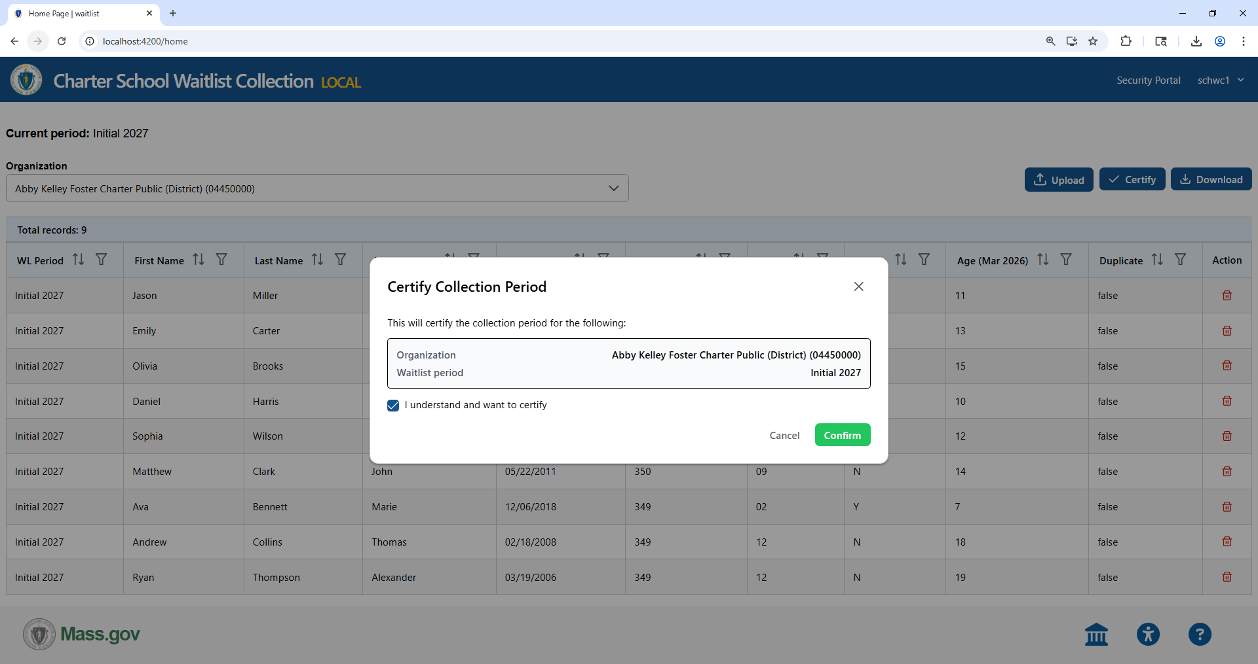
Please contact Brenton Stewart (Brenton.Stewart@mass.gov) if you have any difficulty completing or submitting your charter school waitlist or Lee DeLorenzo (Lee.DeLorenzo@mass.gov) if you have any difficulty accessing the Charter School Waitlist Collection application within the Security Portal.

