

Memorandum

To: Charter School Admissions and Enrollment Coordinators
From: Brenton Stewart, Coordinator of School Redesign and Impact, Office of Charter Schools and School Redesign
Date: September 28, 2026
Subject: 2026-2027 Updated Waitlist Data Submission Memorandum and Instructions
Submission Deadline: Thursday, October 8, 2026 at 5:00 PM

Information and Instructions for FY2027 Updated Waitlist Submission
Each spring, charter schools submit to the Department of Elementary and Secondary Education (Department) the projected number of students enrolled for the upcoming school year as well as the number of students placed on the schools’ waitlists. The most recent initial waitlist submission provided student-level waitlist data established as of March 12, 2026, for the 2026-2027 school year.
Last spring, the Department launched a new application within the Security Portal called the “Charter School Waitlist Collection.” All charter schools submitted their Initial Charter School Student-Level Waitlist report through this new collection application, found within the Security Portal, and will also use this collection application to submit their Updated Charter School Student-Level Waitlist Reports.

Accessing the Charter School Waitlist Collection Application
The waitlist collection module can be accessed within the Security Portal. At the main Security Portal landing page, select the “Charter School Waitlist Collection” application. If you do not see the application listed, please reach out to your Directory Administrator and ensure you have the appropriate permissions and your role within the Directory Administration is correctly identified as the Charter School Admissions and Enrollment Coordinator.
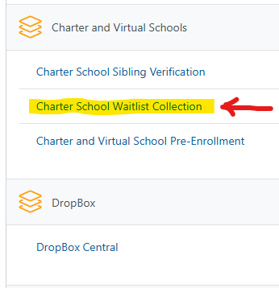

Removing Students from the Initial Collection Period
- Charter schools that submitted their initial waitlist collection data last spring through the application will find this data already uploaded into the collection application. For schools that did not submit a waitlist during the initial collection and still do not have a waitlist, just click the certify button. For those schools that have since created and maintain a waitlist, please scroll down and follow the instructions on how to prepare and upload your waitlist data.
- The Department recommends that you have a list of the students who were removed from your initial waitlist ready for reference.
Helpful hints: You can sort the column headers displayed within the “Waitlist students” tab on the landing page (see below). Additionally, you can also increase the number of visible records by changing the view from 10 students to 300 students at the bottom of the webpage from the visible drop-down.
You are able to select multiple students to be removed from your waitlist at the same time by selecting the box located to the left of the students’ first name. Once student(s) are selected, a red “ Delete Selected” button will appear on the top right-hand side of the waitlist table.
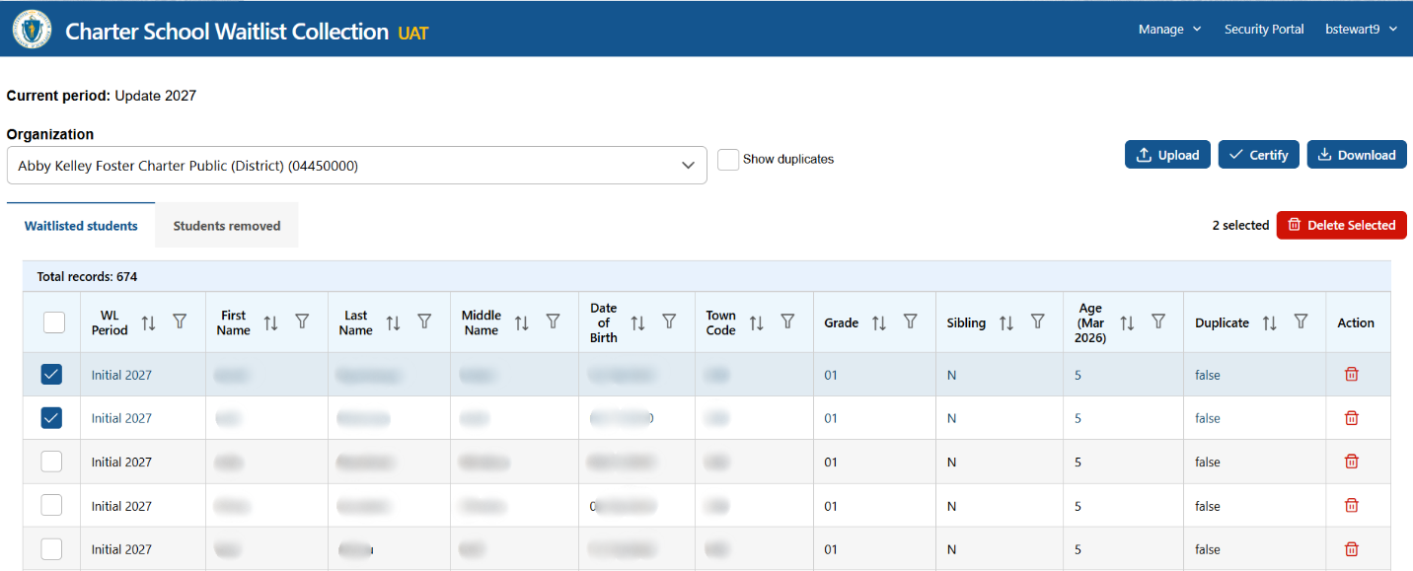
- If you click on the red delete button, a pop-up will appear asking you to confirm (bulk) removal.
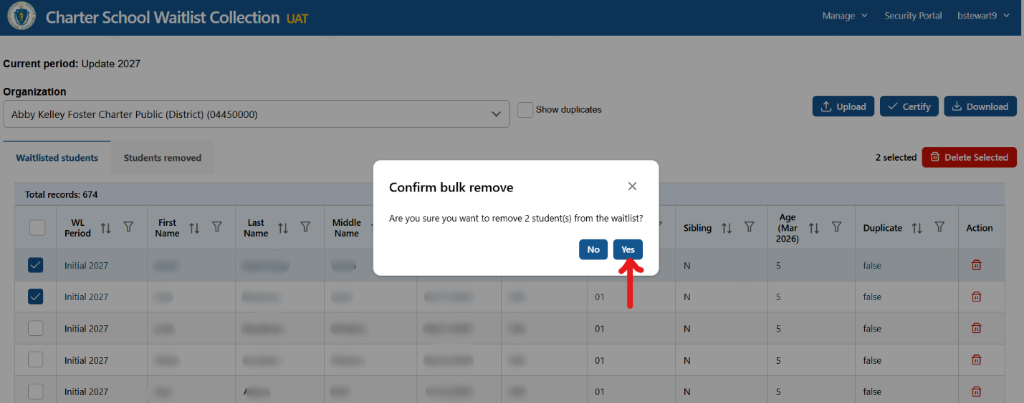
If you select “Yes”, the students will be removed from your main “Waitlisted students” tab and be placed in the “Students removed” tab. A green pop-up will appear confirming the removal of student(s) from your waitlist.
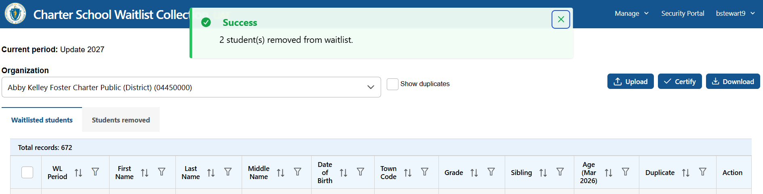
- You can still view the students you removed from your waitlist by selecting the “Students removed” tab. If you believe you accidentally removed the wrong student, you can reinstate them by clicking on the green circular arrow within their row under the “Action” column.
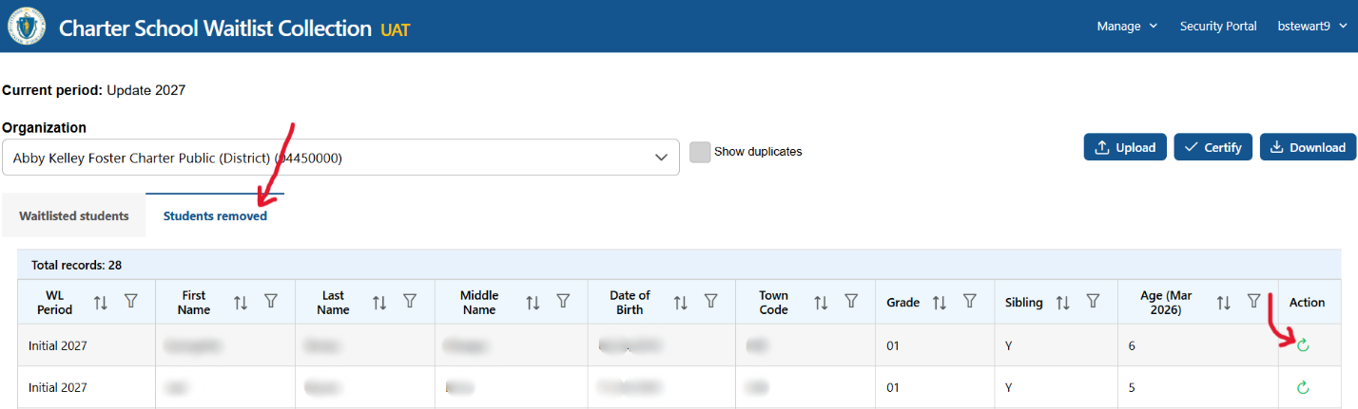
If selected, a pop-up will appear asking you to confirm reinstatement. Once you select the green “Yes, reinstate” button, the student will reappear in the main “Waitlisted students” page.
- Please remove all the students who are no longer found on your current waitlist. Once this step is completed, you can either upload additional students (who were added to the waitlist after the submission of the school’s initial waitlist in March 2026 and are still waiting to receive an offer of admission) or certify your updated waitlist report. To upload additional students, see the instructions provided in the following sections. To certify, please review the certification section found on the last page of this document.

Preparing the Waitlist Collection Data Spreadsheet of Recently Waitlisted Students for Upload
- Charter schools will upload any additional waitlist collection data through the application as a file. Additional waitlist collection data is waitlist data that was not provided in the initial waitlist report in March 2026. The waitlist file must be saved as a .csv or .xlsx file prior to attempting to upload.
- To facilitate extraction of the required waitlist information from the uploaded file, required information must be provided in an unlocked file with the required information located on the first tab of the file. You will encounter upload errors if instructions are not followed.
  - Charter schools may save various tabs of information within their waitlist collection worksheets. Only the first tab within the worksheet will be extracted.
  - Do not lock any cells or worksheets prior to submitting. Be sure to check the file prior to uploading.
- Waitlist spreadsheets must contain seven required column headers in the first row. Column headers must be labeled exactly as shown below to avoid errors.
  - Please note that the waitlist spreadsheets you maintain may contain additional columns that are not required, and the columns may be ordered in any order. Only the data from the seven (7) columns identified below will be extracted and uploaded into the Charter School Waitlist Collection report within the application.

Required columns are:
- FIRSTNAME
- LASTNAME
- MIDDLENAME
- DOB
    - DOB must be formatted as a date, which is supported in any short form. For example, a student born on July 8, 2020 can be represented as 7/8/20.
- TOWNCODE
- TOWNCODE must be formatted with 3 digits. It is best to save the column as text, but you may also use custom formatting.
- GRADE
    - GRADE must be formatted as text and include one of the following: PK, K, 01, 02, 03, 04, 05, 06, 07, 08, 09, 10, 11, or 12.
- SIBLING
- SIBLING must be formatted as text and include a “Y” or “N” for each student record. Students identified with a “Y” are siblings of currently attending students and are waitlisted with sibling preference.

Uploading the Additional Waitlist Collection Data Spreadsheet
- If you have students who were added to your waitlist and are still waiting to receive an offer of admission, select the Upload button (labeled in blue) on the main page of the Charter School Waitlist Collection application. When the pop-up window opens, choose the “+ Browse” button to select the file. 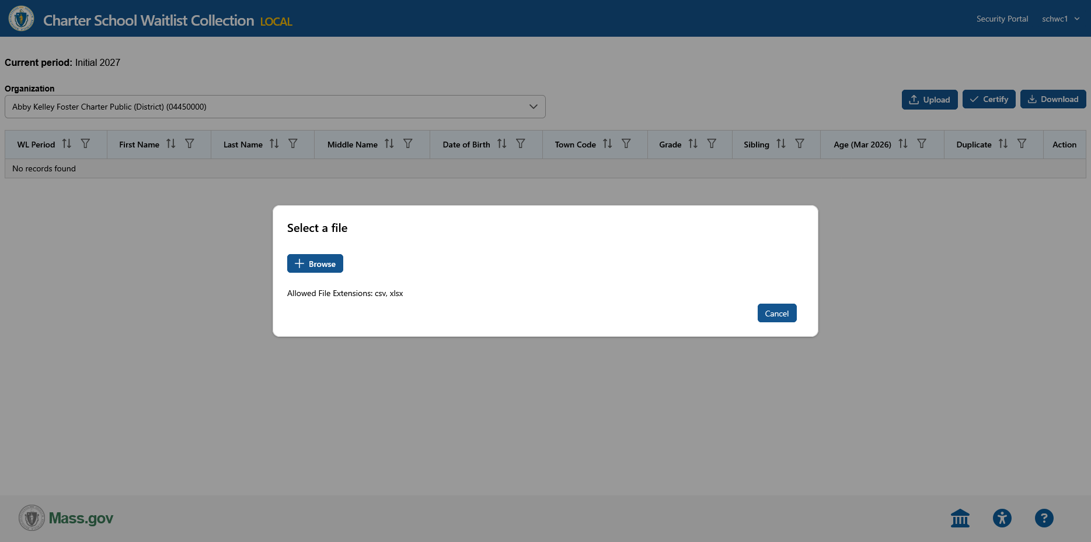
- Navigate your computer’s file explorer to locate the waitlist file that you intend to upload. Click the “Submit” button (labeled in blue).
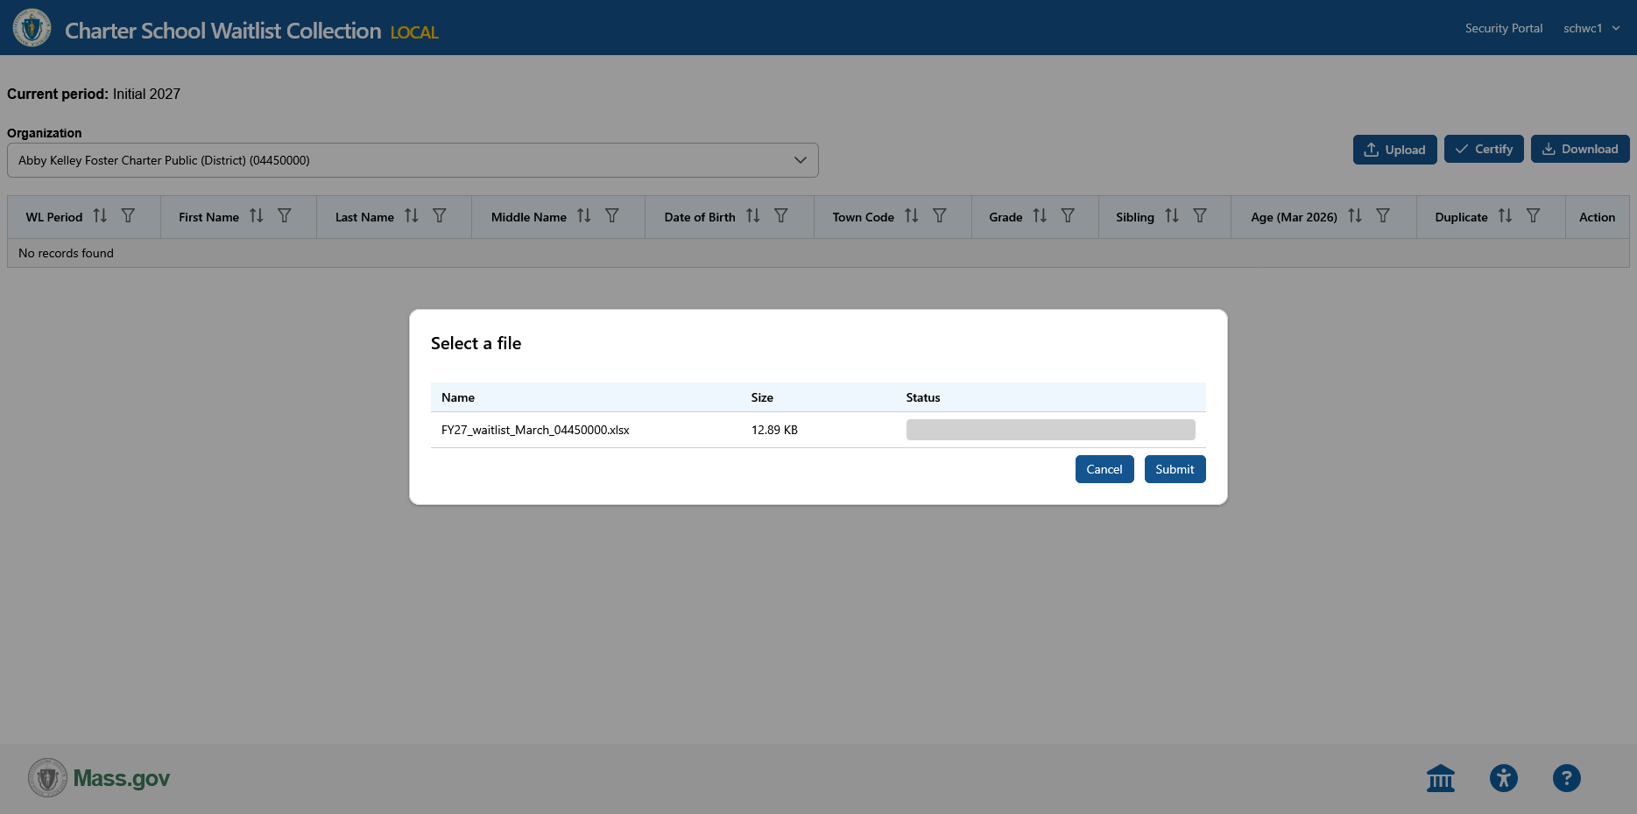
- If your upload is free of errors, then your school’s waitlist data will be extracted and uploaded to your charter school report. A pop-up (with a green background) will appear, indicating a successful upload. These uploaded students will appear at the end of your waitlist report. You can easily identify them by sorting the “WL Period” column header, and all new waitlisted student records will have “Update 2027” associated with their record.
- If your waitlist spreadsheet contains errors, then no data will be uploaded into your charter school waitlist report. A pop-up screen (with a red background) will appear, with an error message stating that “No records were inserted due to validation errors.” An extract of the errors will automatically be downloaded to your computer as a spreadsheet file. Review the downloaded spreadsheet file for the specific errors for individual student records.
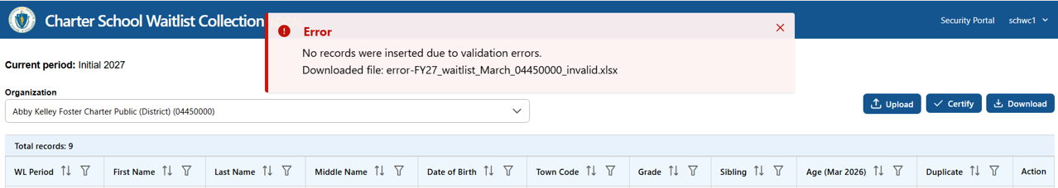
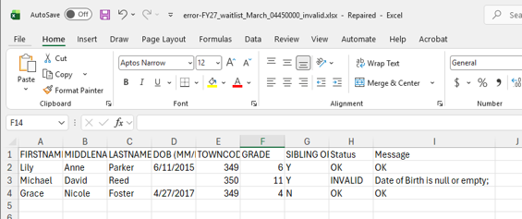
- After you resolve the identified errors, resave your waitlist spreadsheet and reupload your file. If your waitlist spreadsheet is free of errors, your waitlist data will be uploaded successfully, and a green confirmation pop-up will appear at the top of your screen.
- After you upload your waitlist, perform a final review of the populated report within the application for accuracy and completeness.

  - Removal of student record(s) from report: If a student is determined to be incorrectly placed on the waitlist and should not appear in the charter school waitlist collection upload, you are able to remove the record from the report by clicking on the trashcan icon (labeled red) on the far right of the screen for the individual record. A pop-up screen will appear asking for confirmation of the removal of the student. If this is the student you wish to remove, click on “Yes, remove” on the pop-up screen.
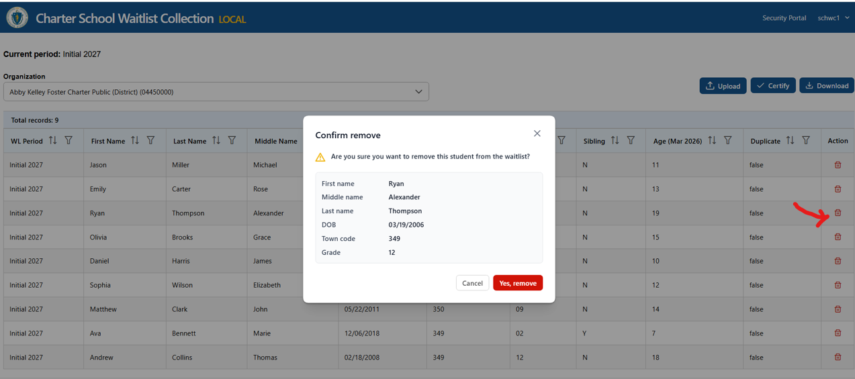
  - Accidental removal of student record(s) from the report: If the wrong student was removed from the charter school collection upload, you are able to add the deleted record to the waitlist report. Follow steps 1 and 2 to reupload your original waitlist file containing the removed record(s). The student record that was accidentally removed will be reinserted into the waitlist report. Previously uploaded student records will not be impacted during the re-upload process. Note that if your re-upload is free of errors, a pop-up (with a blue background) will appear, indicating that the upload was completed and duplicates were skipped over during the extract. The removed record(s) are added to the waitlist report and will appear at the end of your waitlist.

  - Addition of student record(s) to the report: Follow steps 1 and 2 to re-upload your waitlist file with additional student records. Note that if your re-upload is free of errors, a pop-up (with a blue background) will appear, indicating that the upload was completed and duplicates were skipped over during the extract. The additional rows of waitlist data will appear at the end of your waitlist.
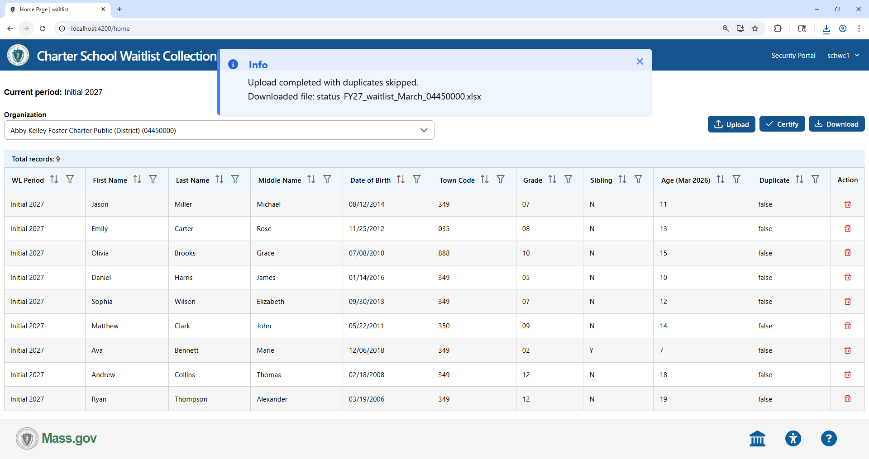
A download of your reuploaded file will automatically initiate, and you can review the status of your resubmission for each student waitlist record.
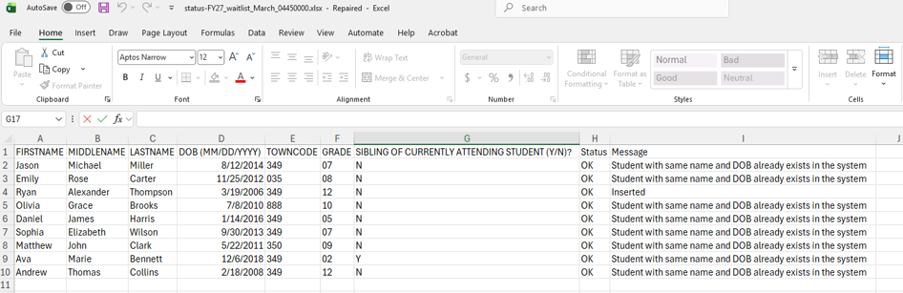

Certifying Your Updated Waitlist Report
When you are ready to officially submit your updated charter school waitlist report, click the “✓ Certify” button (labeled blue) on the top right of the screen and a pop-up screen will appear. You must select the box indicating that “I understand and want to certify” in order to select the “Confirm” button (labeled in green) located near the bottom right of the pop-up screen.
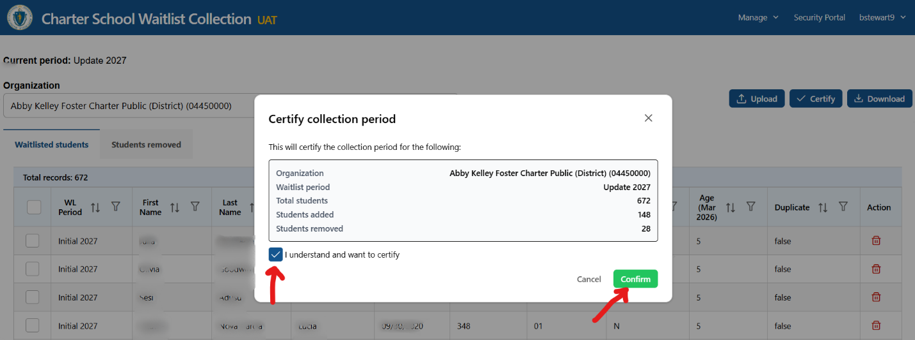

Please contact Brenton Stewart (Brenton.Stewart@mass.gov) if you have any difficulty completing or submitting your charter school waitlist, or Lee DeLorenzo (Lee.DeLorenzo@mass.gov) if you have any difficulty accessing the Charter School Waitlist Collection application within the Security Portal.

