Guide to Charter School Accountability
September 2014

Massachusetts Department of Elementary and Secondary Education
75 Pleasant Street
Malden, MA 02148
Phone: (781) 338-3227
Fax: (781) 338-3220

This guide aims to provide schools and other interested parties with information on the accountability system that is unique to charter schools in Massachusetts. Each component of the Guide provides specific information regarding a particular aspect of the accountability process. The accountability process was conceived when charter schools first opened in the Commonwealth and has been added to and improved upon through years of implementation.

Introduction
Authorized by the Commonwealth of Massachusetts’ Education Reform Act of 1993, charter schools are independent public schools that operate under five-year charters granted by the Commonwealth’s Board of Elementary and Secondary Education (Board).

The Board is required by Massachusetts General Law, Chapter 71, Section 89, and regulations under 603 CMR 1.00 to conduct an ongoing review of charter schools and, by the fifth year of each school’s operation, decide whether those charters should be renewed. Throughout the charter term and during renewal, charter schools are held accountable to the Charter School Performance Criteria (Criteria). The Criteria are presented in the three guiding areas of charter school accountability defined in the current regulations (603 CMR 1.00):
Faithfulness to the Charter

Academic Program Success

Organizational Viability

In exchange for a high level of autonomy, charter schools are held accountable for results on an ongoing basis by the Department of Elementary and Secondary Education (Department). The increased freedom coupled with increased accountability infuses all aspects of the Department’s oversight of charter schools. Evaluation of the school’s success in the three guiding areas is based on a variety of information that is provided by the school and gathered by the Department.

Charter School Accountability Cycle
Once the Board has awarded a charter on the basis of a successful application, the charter school enters the cycle of accountability. In addition to the responsibility of producing high academic results throughout the term, the school has various accountability requirements during each year of the term. The graphic below displays the components of the accountability cycle of a school during its five-year term.

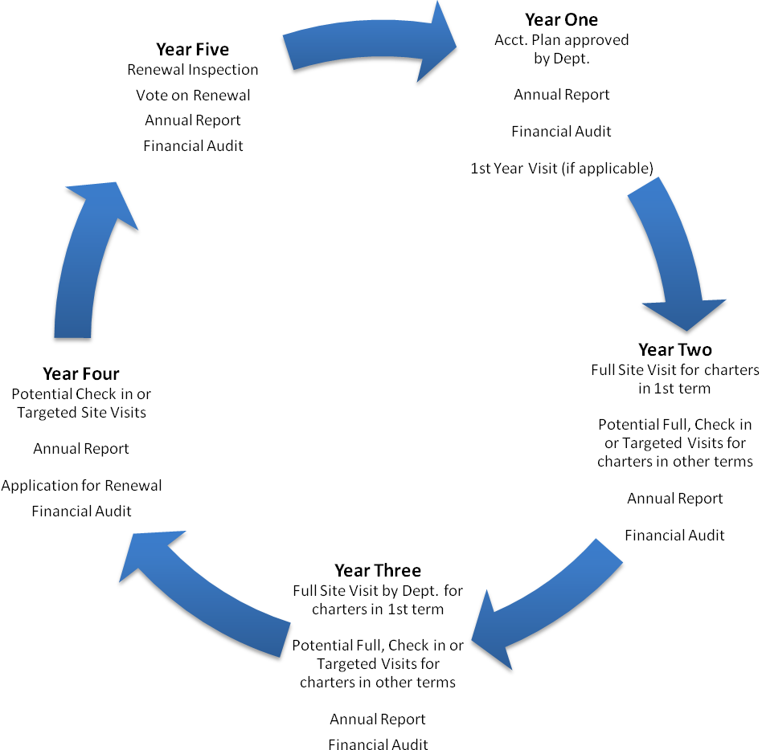
Charter School Accountability Cycle

Key Components of the Accountability Cycle

Below are brief descriptions of the key components of the accountability cycle. Each description is accompanied by the general timeline/deadline and links to online resources to successfully navigate each requirement.

Application for a Charter | Timeline: Pre-opening
Description:
The Board awards charters only to applicants who have met the criteria published by the Department. The questions that guide each application, and the criteria against which applications are judged, are found in the Application for a Public School Charter.

The applicant group writes the prospectus in order to communicate plans for a potential charter school and demonstrate that they have the potential to create a high quality public charter school. At the prospectus phase, Office of Charter Schools and School Redesign staff present a synopsis of the information to the Commissioner and, based upon the information presented, the Commissioner determines which applicant groups will be invited to move into the final application stage.

The applicant group writes the final application in order to communicate plans for a potential charter school and demonstrate that they have a strong probability of creating a high quality public charter school. If an applicant group’s board of trustees is granted a charter, the final application serves to define the material terms of the charter to which the school is held accountable, along with any approved amendments.

During the 2014-2015 application cycle, the Department introduced a required one stage process for current charter school boards of trustees who intend to apply for a new charter and operate a charter school network. In the one stage process, current charter school boards of trustees are exempt from submitting a prospectus but must still meet Proven Provider requirements, if applicable, and submit a complete final application addressing the criteria that is set forth in the charter statute.

The Commissioner presents his recommendation for chartering to the Board, along with a comprehensive written summary of all materials prepared by the Department evaluating or recommending approval or disapproval of the final application. The Board makes the final decision on the award of charters.
Resources:
Charter Developer Information: http://www.doe.mass.edu/charter/new/?section=app
Opening Procedures Handbook: http://www.doe.mass.edu/charter/guides/ophandbook.pdf
Charter Application 2014-15: http://www.doe.mass.edu/charter/app/NewOperators.pdf

Annual Report | Timeline: Due Every Year by August 1st
Description:
In accordance with charter school laws and regulations, a charter school must submit an annual report to the Department on or before August 1st of each school year and post annual reports to their school’s website(s). The Annual Report will be used by the Department to review the school's performance and progress for the past academic year and will be corroborated and augmented by site visits. The Annual Report Guidelines provide a thorough description of the information that schools must include in an annual report. The Charter School Regulations, 603 CMR 1.08(1)(c)(d) require all charter schools to include the following in the Annual Report: a report on the school's implementation of its current recruitment and retention plan and an updated recruitment and retention plan for the upcoming school year.
Resources:
Annual Report Website: http://www.doe.mass.edu/charter/acct.html?section=annual

Accountability Plan | Timeline: End of Year 1 (during first term), End of Year 5 (after first term)
Description:
The Accountability Plan defines the school’s internally set performance objectives and how progress toward these objectives will be measured. A charter school creates an Accountability Plan at the end of year one of their first charter term to articulate to the community and the state what goals the school will use to measure its success during following years. Schools in their second term and beyond must submit a new accountability plan to the Department at the end of the fifth year of the charter term. The Guidelines for Writing Charter School Accountability Plans are intended to give schools guidance on the type of data that provide compelling evidence, the desirable structure for goals and objectives, and how to most clearly present results. With these tools in mind, schools can write rigorous and measurable accountability plans that will serve them well as they participate in the charter school accountability process, especially at the time of renewal. The Accountability Plan must receive approval from the Department before a school can begin implementing. If a charter school plans to alter its Accountability Plan, the school's board of trustees must vote on and submit a minor amendment request to do so. Changes to a school’s Accountability Plan require approval from the Commissioner.
Resources:
Accountability Plan Guidelines: http://www.doe.mass.edu/charter/acct.html?section=guidelines
Accountability Plan Website: http://www.doe.mass.edu/charter/acct.html?section=guidelines
Amendment Guidelines: http://www.doe.mass.edu/charter/governance/AmendmentGuidelines.pdf

Site Visits | Timeline: Typically 2 – 3 times during a charter term
Description:
The primary purpose of a site visit is to corroborate and augment the information contained in a school’s annual report and to gather evidence on progress the school is making toward meeting the standards articulated in the Charter School Performance Criteria (Criteria). During a site visit, the team conducts classroom observations, conducts focus groups with various stakeholders, and reviews school documents. Site visits are organized and executed according to the Charter School Site Visit Protocol. Following the site visit, the team will compose a report on the evidence gathered under each criterion. Each criterion addressed during the visit will receive a rating based on evidence gathered. The report will become part of the body of evidence used by the Commissioner when making a renewal decision at the end of the charter term. Each school will be given the opportunity to factually correct the report before it is finalized. Additionally, if the school substantially disagrees with the findings or ratings in the report, it may issue a response which will be appended to the final site visit report.
Resources:
Site Visit Protocol: http://www.doe.mass.edu/charter/acct.html?section=visit

Application for Renewal | Timeline: Before August 1st of Year 5
Description:
Every charter school undergoes a rigorous renewal process during the final year of its charter term to determine whether or not the school can continue to operate. The renewal process includes the submission of a renewal application, a renewal inspection visit, and an analysis of all evidence related to the charter school's performance, including quantitative and qualitative evidence collected through the Department's charter school accountability process. The application for renewal of a charter is the school's opportunity to present evidence that demonstrates success in the three areas of charter school accountability: faithfulness to the charter, academic program success, and organizational viability. The school’s Application presents evidence of the school’s performance during the current charter period relative to the Charter School Performance Criteria (Criteria). The application process also allows the school to examine its practices and decisions over the current charter term, offer explanations for any performance or operational issues, identify actions taken to correct past problems, and provide information regarding the school’s plans for improvement in the future.

Resources:
Renewal Information Website: http://www.doe.mass.edu/charter/acct.html?section=renew

Renewal Reports | Timeline: Fall - Winter of Year 5
Description:
Renewal Inspection Report: After submitting an application for renewal, each school undergoes a two to three-day Renewal Inspection conducted by a non-Department vendor. The visit is designed to corroborate and augment the school’s Application for Renewal and identify the school’s progress toward meeting the Criteria. The renewal inspection team’s final report provides independent and objective judgment regarding the school’s performance and serves as another component of the body of evidence used for renewal determinations.

Summary of Review: The Renewal Inspection Report, Application for Renewal, Annual Reports, Site Visit Reports, performance on state assessments, financial records, and other information present in the school’s file provide the evidentiary basis for the Commissioner’s review and recommendation regarding the renewal of each school’s charter. This material is reviewed by the Department and a Summary of Review is written summarizing the evidence from the entire charter term.

Memorandum Regarding Renewal: The Commissioner reviews the Summary of Review and based on the data contained in the report makes a renewal determination or recommendation. A memo is written containing the Commissioner’s recommendation or determination and it is presented to the Board of Elementary and Secondary Education. During renewal, schools may receive an unconditional renewal, a renewal with conditions, a renewal with probation, or a non-renewal of the charter. See the Commissioner’s Considerations for Charter School Renewal below.
Resources:
Renewal Inspection Protocol: http://www.doe.mass.edu/charter/guides/RenewInspect.pdf
Commissioner’s Memo on Renewal: http://www.doe.mass.edu/news/news.aspx?id=7802

Financial Audit | Timeline: Due Every Year by November 1st
Description:
In accordance with M.G.L. c. 71, § 89, every charter school shall have an independent audit conducted of its accounts, consistent with generally accepted government auditing standards and any guidelines issued by the Department. Audits must be submitted to the Department by November 1st of each school year in alignment with the Charter School Audit Guide.
Resources:
Finance Website: http://www.doe.mass.edu/charter/finance/auditing/
Charter School Audit Guide: http://www.doe.mass.edu/charter/finance/auditing/2015AuditGuide.pdf

