How to Use the Charter School Dashboard to Insert Recruitment and Retention Plan Data into the Annual Report
These visual directions outline how to gather enrollment and attrition data from the Charter School Dashboard and where to input the data into the school’s Recruitment and Retention Plan. It is helpful to have the following documents open, which are linked on the Annual Report Guidelines website.
- 2025-26 Annual Report Guidelines (ARG)
- The Charter School Dashboard (Dashboard)

How to Find the School’s Data in the Dashboard
- Open up the dashboard and the 2025-26 ARG.
- In the upper left hand corner, scroll down to select your school from the dropdown menu or you can begin to type the school’s name and select your school when it appears.
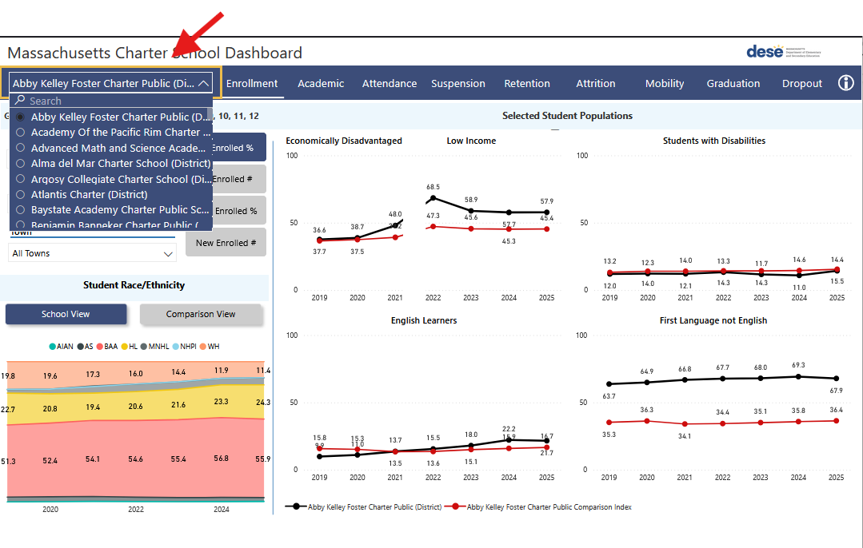

How to Find the School’s Enrollment Data for Groups of Students
- Select the Enrollment Tab next to the school’s name.
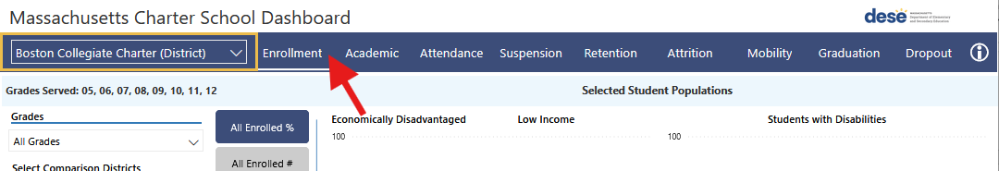
- The display shows all the data for the three student groups you will need to complete the Recruitment Plan data sections. These student groups are students who are low income (LI), students with disabilities (SWD), and English learners (EL). There is information here for students whose first language is not English, but that data is not included in Recruitment and Retention Plans.
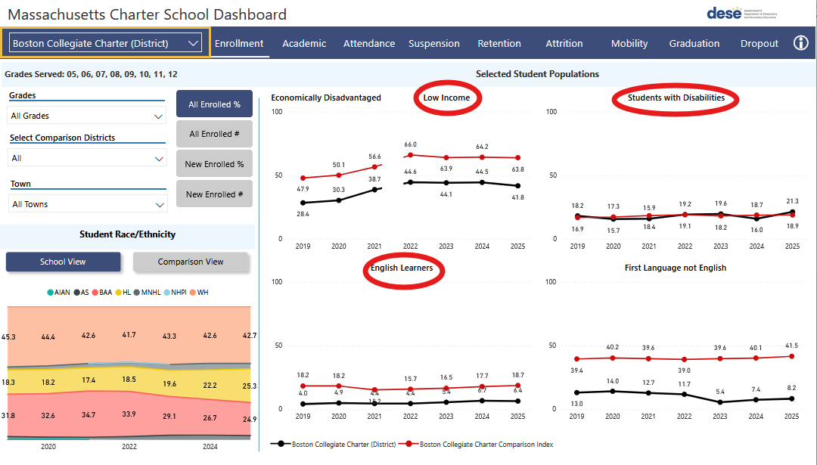
- Hover over the 2025 red and black data points for LI. A box will appear with the school’s data and the Comparison Index. The black data point is the school’s data and the red data point is the Comparison Index.
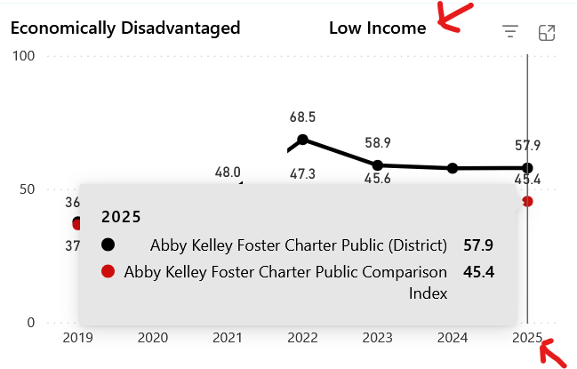
- Hover over the 2025 red and black data points for SWD. A box will appear with the school’s data and the Comparison Index data. The black data point is the school’s data and the red data point is the Comparison Index.
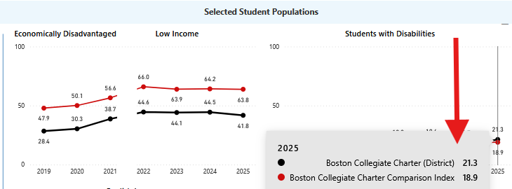
- Hover over the 2025 red and black data points for ELs. A box will appear with the school’s data and the Comparison Index. The black data point is the school’s data and the red data point is the Comparison Index.

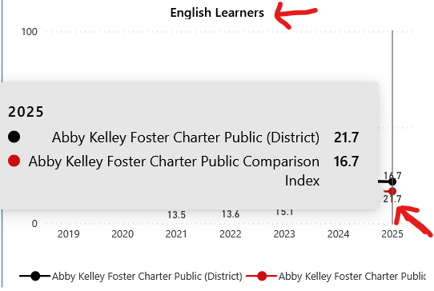

Where to Insert the Dashboard Data into the Recruitment Plan
- Open your copy of the ARG and scroll down to Appendix B: Recruitment and Retention Plan. Scroll down to the “Recruitment Plan Strategies for 2026 – 27 for Specific Student Groups” heading. Under this heading, each student group (SWD, EL, and LI) is listed separately.
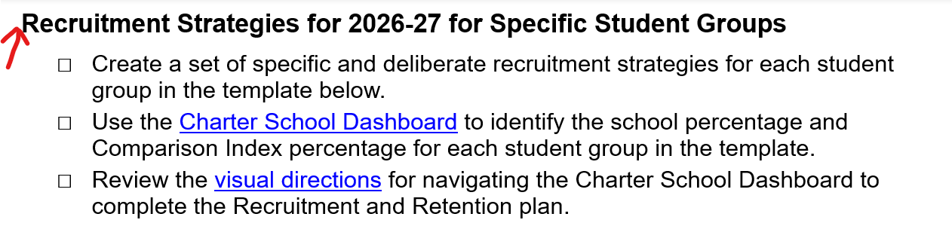
- Fill in the information for each student group with data
  - Under the SWD section, fill in the 2025 dashboard data for SWD, the Comparison Index percentage, and choose the appropriate word to complete the last sentence based on the data.
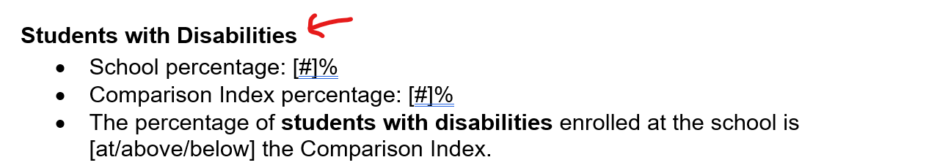
  - Under the EL section, fill in the most recent dashboard data for ELs and choose the appropriate word to complete the last sentence based on the data.
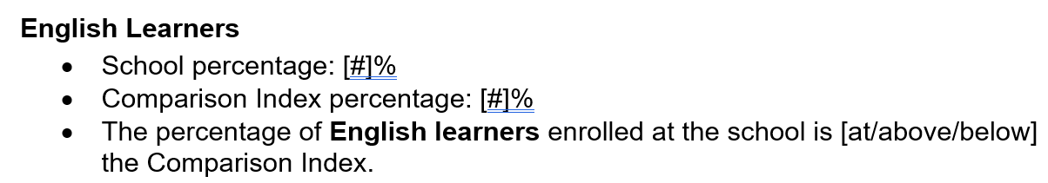
  - Under the LI section, fill in the 2025 dashboard data for LI and choose the appropriate word to complete the last sentence based on the data.
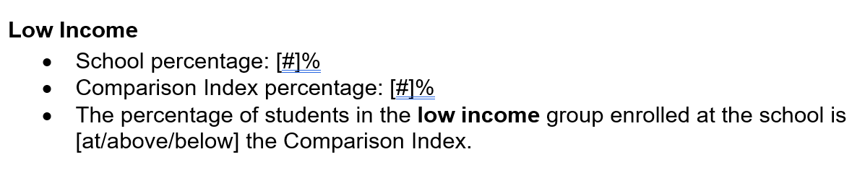

How to Calculate the Overall Student Retention Goal
- Open the Dashboard and the 2026-26 ARG.
- In the upper left hand corner, select your school from the dropdown menu or you can begin to type in the school’s name, then select the school when you see it.
- Select the Attrition tab.
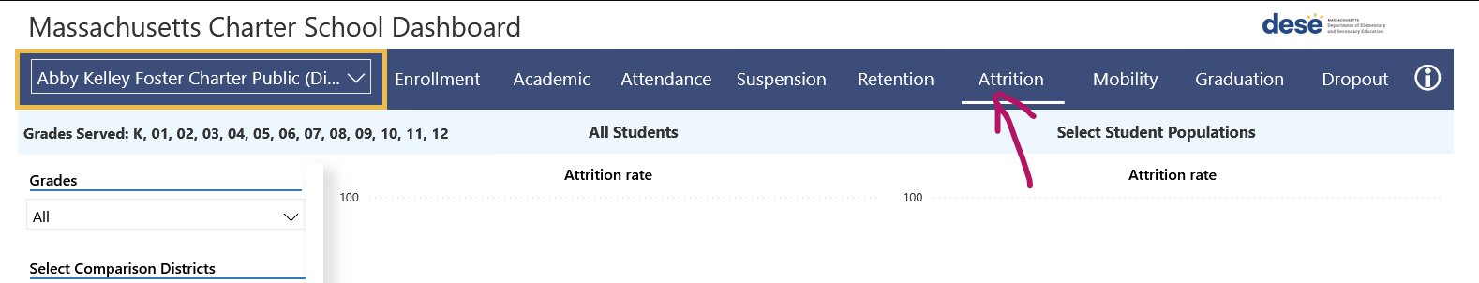
- The default screen shows the data for all students. To ensure you are viewing the correct data:
  - Under Grades, select “All”
  - Under Select Comparison Districts, select “All”
  - Under Student Group Type, select “Selected Population”
  - Under Student Group Name, select “All Students”.
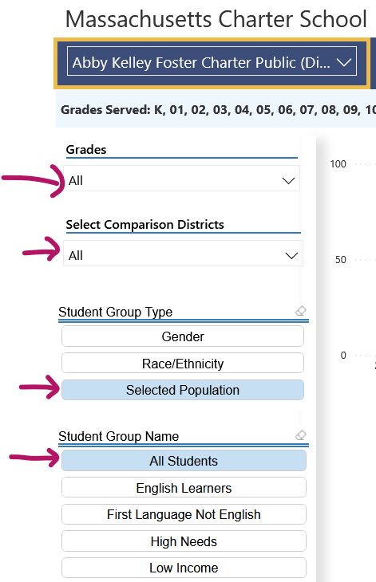
- Hover over the 2025 red and black data point dots under the “All Students” and “Attrition Rate” graph. A box will appear with data. The black data point is the school’s data.
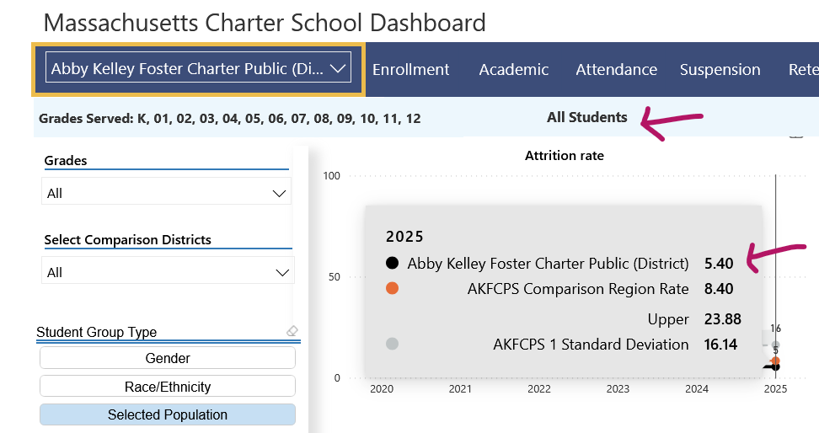
- Next, calculate your school’s 2025 retention rate.
  - Subtract the “all students” attrition rate (black data point) from 100%.
  - For example, if SCHOOL’s attrition rate for 2025 is 5.4%, the retention rate is calculated as 100%-5.4%, which is 94.6%.
- The school needs to update the overall student retention goal percentage for the 2026-27 school year. This may be determined based on trends for the school’s retention rates, trends for the sending district(s) retention rates, and the supports the school implements to increase student retention.
- Open the ARG and scroll down to “Overall Student Retention Goal" section. Insert the school’s updated overall student retention goal percentage in the “Annual goal for student retention” bullet.
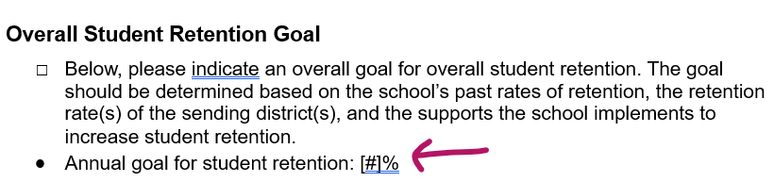

How to Find the School’s Attrition Data for Student Groups in the Dashboard
- Follow directions in steps 1-3 in the How to Calculate the Overall Student Retention Goal in the section above.
- The default screen shows the data for all students. To ensure you are viewing the correct data:
  - Under Grades, select “All”
  - Under Select Comparison Districts, select “All”
  - Under Student Group Type, select “Selected Population”
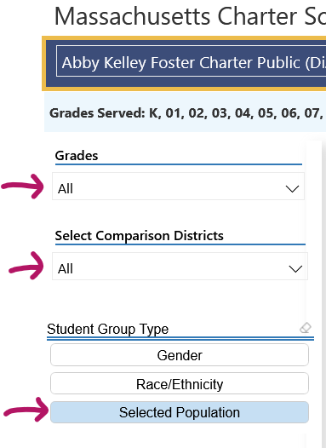

- Find the Data for Student Groups.
  - SWD
    - Select the “SWD” button under student group name. The table will keep the “All Students” attrition rate on the graph on the left and populate the attrition graph for SWD on the right.
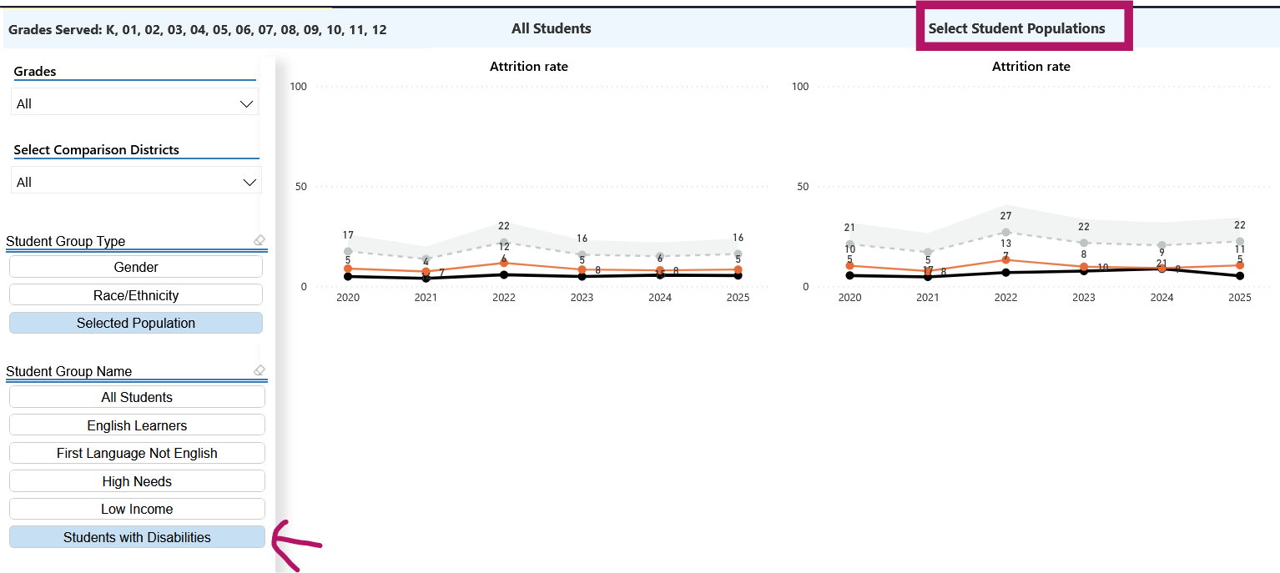
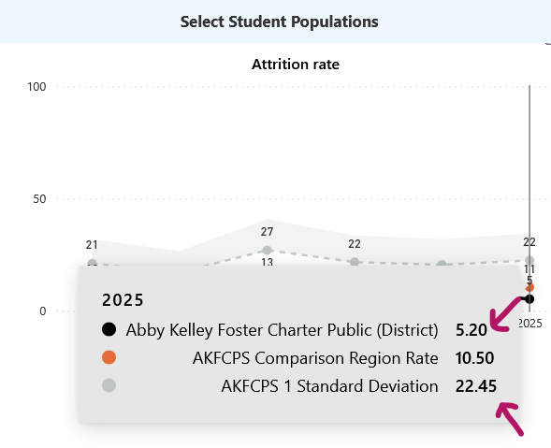
    - Hover over the 2025 data point dots for SWD. A box will appear with the school’s data and the comparison data. The black data point is the school’s data and the gray dot is 1 Standard Deviation.

  - EL
    - In the Dashboard, select the “English Learners” button under “Student Group Name”. The table will keep the all student attrition rate on the left and populate the attrition visual for ELs on the right.
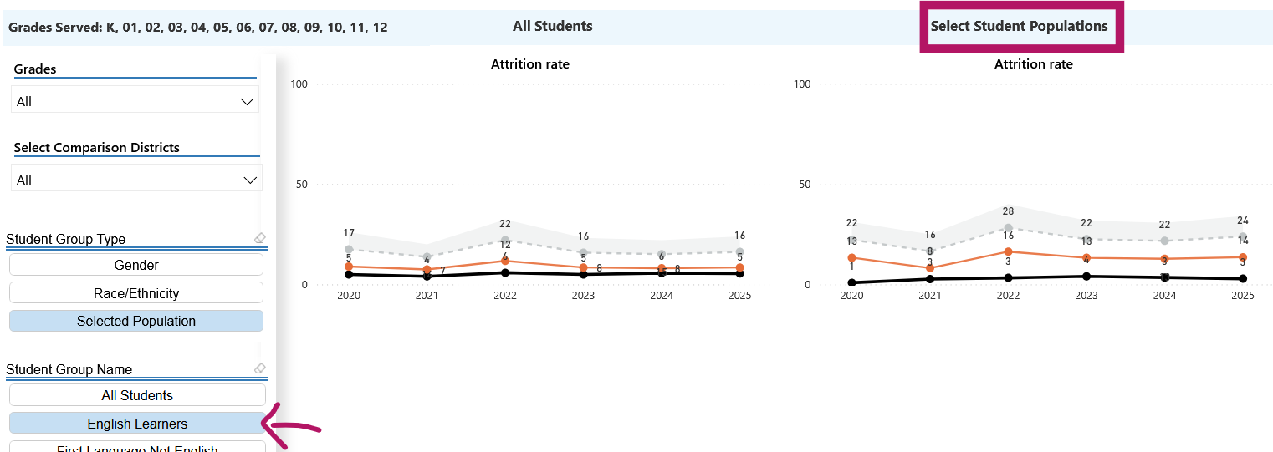

    - Hover over the 2025 data point dots for ELs (under the selected populations section on the right). A box will appear with the school’s data and the comparison data. The black data point is the school’s data and the gray dot is the 1 Standard Deviation.
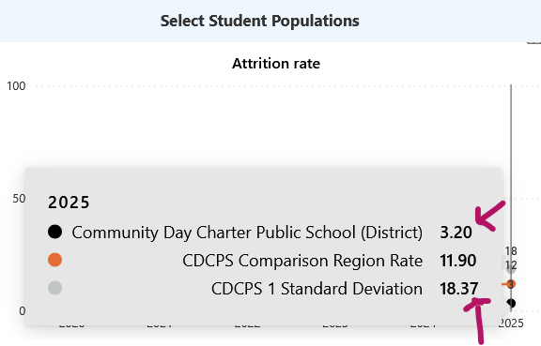

- Low Income:
    - In the Dashboard, select the “Low Income” button under “Student Group Name”. The table will keep the all student attrition rate on the left and populate the attrition visual for Low Income on the right.
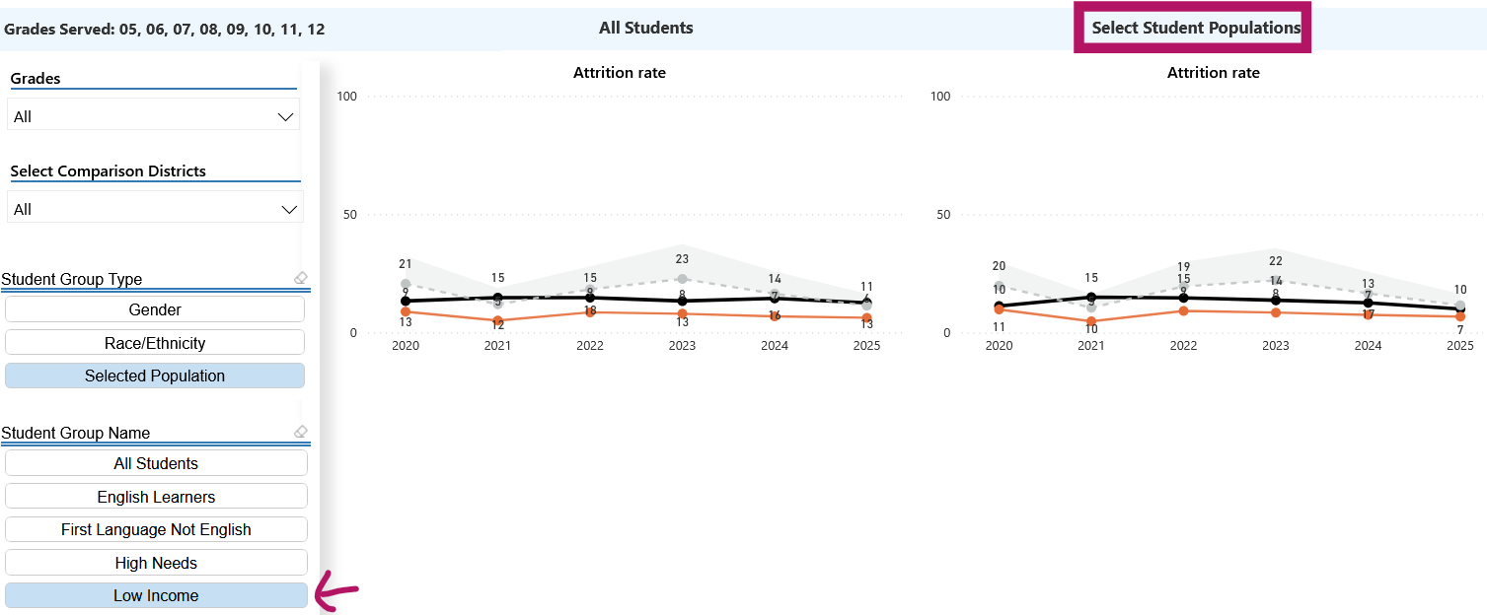
    - Hover over the 2025 data point dots for LI. A box will appear with the school’s data and the comparison data. The black data point is the school’s data and the gray dot is 1 Standard Deviation.
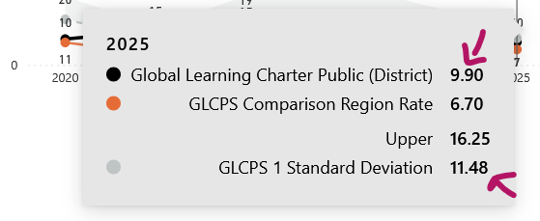

How to Insert the School’s Attrition Data into the Retention Plan
- Open the ARG and scroll down to Appendix B: Recruitment and Retention Plan. Find the “Retention Strategies for 2026-27 for Specific Student Groups” section. Under this heading, each student group (SWD, EL, and LI) is listed separately.
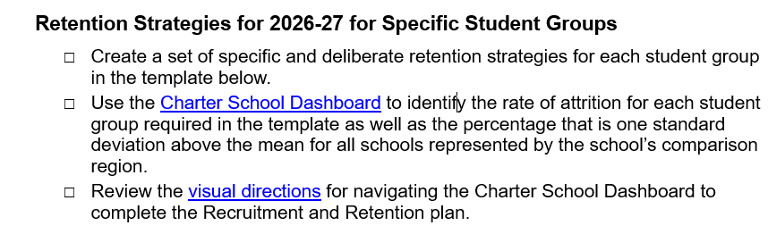
- Fill in Information for Groups of Students
- Under the SWD section, fill in the 2025 school percentage and 1 Standard Deviation percentage from the CSD data for SWD. Then, choose the appropriate word to complete the last bulleted sentence based on the data.
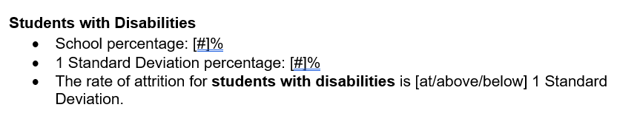
- Under the EL section, fill in the 2025 school percentage and 1 Standard Deviation percentage from the CSD data for ELs. Then, choose the appropriate word to complete the last bulleted sentence based on the data.
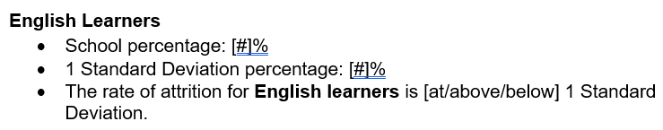
- Open the ARG and scroll down to Appendix B: Recruitment and Retention Plan. Find the “Retention Strategies for 2026-27 for Specific Student Groups” section. Under this heading, each student group (SWD, EL, and LI) is listed separately.
- Under the LI section, fill in the 2025 school percentage and 1 Standard Deviation percentage from the CSD data for LI. Then, choose the appropriate word to complete the last bulleted sentence based on the data.
