Drop Box Instructions

The charter school claim form is available for download in the Claim Form Drop Box on DESE’s secure web portal https://gateway.edu.state.ma.us. To assist charter schools with this process, a step-by-step walkthrough is provided below.

Accessing the Drop Box

- Open your web browser.
- In the address area of the browser, type in https://gateway.edu.state.ma.us. The DESE Security Portal window will load and the user will be forwarded to the login screen. Login.
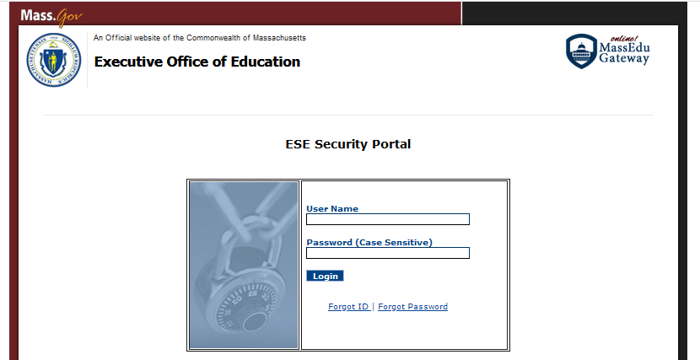

- Once logged in you will be forwarded to the Gateway. Select the Application List from the Featured Services menu:

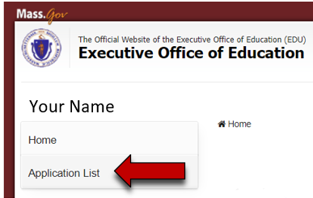

- You will be directed to a web page that lists the available applications; select “Drop Box Central;”
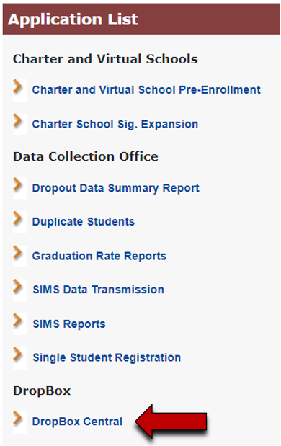

- Select the “Charter School Claim Form” item and press the “Next” button;
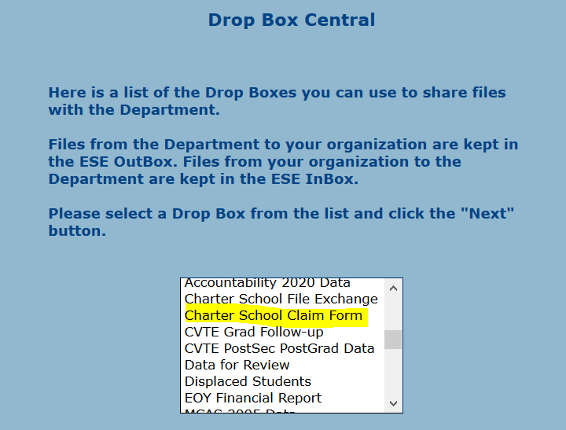
- Select your organization type and name, then click on the “Next” button to enter the drop box;
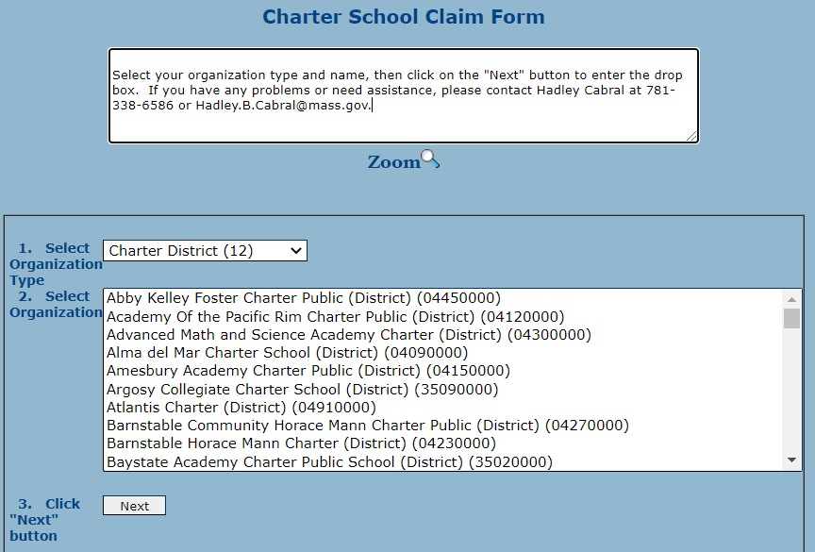

- You are now inside the drop box. This page has three sections. The top section contains a text box explaining the upload and download processes. Use the scroll bar to see the entire contents of the text box. The middle section, below the text box, contains the features needed for uploading the completed claim form. The bottom section is where the files are located for you to download. If this section is expanded, you should see the file listed in the outbox: 23febxxxx.xlsx (where “xxxx” equals the charter school’s LEA);
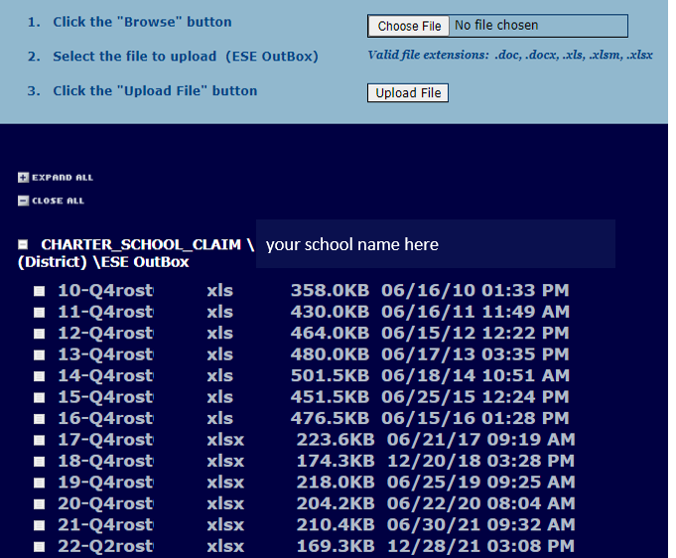

- To begin the download process, place your mouse cursor over a file name until it changes color. Right-click your mouse. A small dialog box should appear. Select the option “Save link as.” Another dialog box should open that prompts you to save your file. Please make note of the name of the folder where you have chosen to save your file.
DO NOT work on your claim form on the web. If the internet connection or server access on either the charter school or DESE’s end fails, you will LOSE all the work completed since the last save.
- To upload the completed claim form, click the “Browse” button directly below the text box, in the blue section of the page. A dialog box will open and prompt you to locate the file you wish to upload. Once you have selected the file, press the “Open” button and you will be returned to the web page. The location of your file should now be listed in the box to the left of the “Browse” button. You may now press the “Upload” button.

Once the file has been received in the Drop Box, a small dialog box will pop up which states “File Uploaded Successfully!” If you do not see your file listed in the In-Box, refresh your browser. DESE will be notified via email that a file has been uploaded and is ready for review.

- Instructions for completing the claim form are provided inside the MS Excel claim form file.

