MEMORANDUM

To: | Commonwealth of Massachusetts Virtual School Leaders, Business Managers, and Data Coordinators
From: | Brenton Stewart, Coordinator of School Redesign and Impact
Date: | April 3, 2024
Subject: | 2024-2025 Pre-Enrollment Data Submission Memorandum and Instructions  Submission Deadline Wednesday, May 1, 2024 by 12:00 p.m.

Commonwealth of Massachusetts Virtual Schools (CMVS) are required to file an annual pre-enrollment report that includes the school's projected total enrollment for the upcoming academic year and the projected number of students, by grade, selected for admission from each sending district for the upcoming academic year. The CMVS Pre-Enrollment Report is used by the Department of Elementary and Secondary Education (Department) to estimate each virtual school's monthly tuition payments for the upcoming fiscal year.
The first five monthly tuition payments in each fiscal year are based on the pre-enrollment report; monthly tuition payments from December through May are based on the October student information management system (SIMS) collection with adjustments made in the final tuition payment in June based on the school choice claim form and special education increment form submissions that are submitted at the end of April. Although each monthly tuition payment is intended to equal approximately one twelfth of the projected annual amount, tuition payments in the later months of each fiscal year (from December through June) include adjustments to correct any over-or under-payments in earlier months, including adjustments for special education increments.
This guidance should be read in tandem with the CMVS Regulatory Notification of 2024-2025 Sending Districts 1% Vote At-Cap (Regulatory Notification) distributed to schools on March 12, 2024. The Regulatory Notification specifies enrollment restrictions for certain districts that the CMVS must follow during their primary enrollment processes for the 2024-2025 school year, the 2024-2025 pre-enrollment data submission, and for all subsequent enrollment decisions for the 2024-2025 school year. CMVS must carefully track enrollment numbers and applications from restricted districts. If a CMVS enrolls new students for the 2024-2025 school year beyond the caps found in the Regulatory Notification, the CMVS will not receive tuition for such students.
The CMVS Pre-Enrollment Report collection will be completed via an application located in the Security Portal. CMVS 2024-2025 pre-enrollment data must be submitted to the Department by 12:00 pm noon on Wednesday, May 1, 2024.
Please note: The enrollment numbers submitted must be based on actual enrollment data including, but not limited to, applications for admission, admission lottery results, accepted offers of admission, and students expected to return in the upcoming school year. The total number of pre-enrolled students in this pre-enrollment submission and the actual enrollment reported on the October 1 SIMS should be very similar.
Please review the instructions below before beginning your submission. Please contact Brenton Stewart at Brenton.Stewart@mass.gov with any questions.

Instructions for 2024-2025 CMVS Pre-Enrollment Data Submission
All CMVS pre-enrollment data will be submitted via the Charter and Virtual School Pre-Enrollment application within the Security Portal by 12:00 pm noon on Wednesday, May 1, 2024. The school leader is required to certify and submit the data, even if someone else enters it into the application. Please plan for a careful check of the data because it will impact tuition payments for FY2025 and cannot be changed once submitted.
The Department recommends that schools take the following steps prior to inputting pre-enrollment data:
- Identify all students enrolled for the upcoming 2024-2025 school year, including current students who will return and students who are newly admitted.
  - Organize student information by town and grade level.
  - Identify the total number of students by town and grade level.
Accessing the Pre-enrollment Application
The pre-enrollment module can be accessed from within the Security Portal. Once at the main security portal landing page, select ‘Charter and Virtual School Pre-Enrollment’ application. See screenshot for reference:
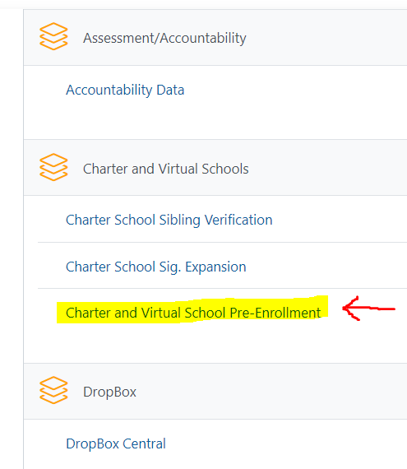
Inputting Pre-Enrollment Data
- Select the upcoming fiscal year, the Pre-Enrollment module, and the school’s name from each dropdown menu. Once all dropdowns are selected, click Next. You will be brought to the Pre-Enrollment landing page. The Pre-Enrollment landing page can also be accessed from the menu featured on the left-hand side of the screen.
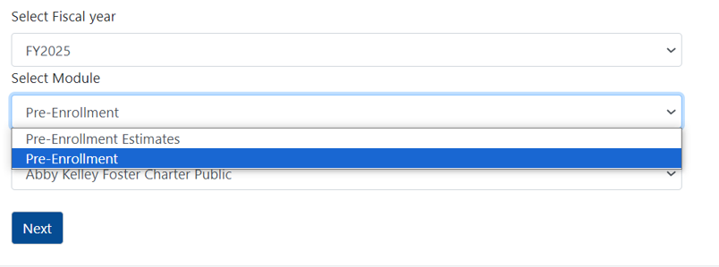
- Column 1: Select the first Town from the dropdown menu for which the school has pre-enrolled students. The town names will be listed in an order based on the school’s enrollment trends.
- Column 2: Select the applicable grade level from the Grade drop down menu for the town.
- Column 3: Enter the Total Pre-Enrollment Number for the applicable town and grade level.
- Click Add at the end of the row when finished.
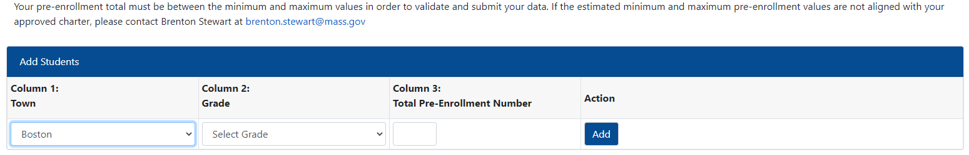
- Continue entering data for each town and grade, in the manner described above, until all pre-enrolled students have been entered.
- The final total enrollment must not exceed the estimated maximum, nor fall below the estimated minimum (Est. Min/Est. Max). If the final total enrollment falls outside of the min and max provided, your submission will receive an error at the validation stage. Sibling Pre-Enrollment Report, NOT APPLICABLE
Please note that the Sibling Pre-Enrollment Report, which is used by the Department to collect projected sibling enrollment data from charter schools, does not apply to CMVS.
Validate and Certify Pre-Enrollment Data
- Select Validate and Review from the menu featured on the left-hand side of the screen.
- Click the Validate and Review button to review your pre-enrollment submissions for errors (and that the No Sibling Pre-Enrollment Counts to Report box was checked).
- *No Errors: If there are no errors in your data, you will receive a message that identified no errors. Click Certify to complete your submission.

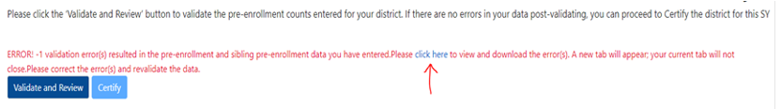
*Errors: If error(s) are present in your data, you will receive a message that identifies the number of validation errors found. Click on the click here link to view and download the error(s). See image below. A new tab will appear; your current tab will not close.
- Review the type(s) of error(s) and the identified module where error(s) are present. Correct the error(s) by navigating back to that module’s subpage and editing the identified data error(s). After correcting the error(s), click Validate and Review again. If error(s) are rectified, you will receive a message that identified no errors. Click Certify to complete your submission.
- After certifying, you must take a screenshot of your submission to provide to your auditor.

Please contact Brenton Stewart at Brenton.Stewart@mass.gov with any questions regarding the pre-enrollment data submission or for technical assistance, as needed.

603 CMR 52.08(5): Pre-enrollment Report. A Commonwealth of Massachusetts virtual school shall file a pre-enrollment report annually with the Department in accordance with established deadlines. Pre-enrollment reports must include the virtual school's projected total enrollment for the subsequent academic year and the projected number of students, by grade, selected for admission from each sending district for the subsequent academic year.
603 CMR 52.07(4): Monthly Payments. The first five monthly payments in each fiscal year will be based on the Commonwealth of Massachusetts virtual school's pre-enrollment report. Remaining monthly payments for the fiscal year will be based on the October SIMS collection from the Commonwealth of Massachusetts virtual school. Although each monthly payment is intended to equal approximately one twelve of the projected annual amount, payments in the later months of each fiscal year (from December through June) shall include adjustments to correct any over- or under-payments in earlier months, including adjustments for special education increments.

