

TEC Connections academy commonwealth of massachusetts virtual school

Year 7 accountability review Report

Date of visit: January 20-21, 2021

Date of this report: March 26, 2021

**Massachusetts Department of Elementary and Secondary Education**

75 Pleasant Street

Malden, MA 02138

Phone: (781) 338-3227

Fax: (781) 338-3220



This document was prepared by the   
Massachusetts Department of Elementary and Secondary Education

Jeffrey C. Riley

Commissioner

The Massachusetts Department of Elementary and Secondary Education, an affirmative action employer, is committed to ensuring that all of its programs and facilities are accessible to all members of the public.

We do not discriminate on the basis of age, color, disability, national origin, race, religion, sex, gender identity, or sexual orientation.

Inquiries regarding the Department’s compliance with Title IX and other civil rights laws may be directed to the

Human Resources Director, 75 Pleasant St., Malden, MA 02148-4906. Phone: 781-338-6105.

© 2021 Massachusetts Department of Elementary and Secondary Education

Permission is hereby granted to copy any or all parts of this document for non-commercial educational purposes. Please credit the “Massachusetts Department of Elementary and Secondary Education.”

This document printed on recycled paper

Massachusetts Department of Elementary and Secondary Education

75 Pleasant Street, Malden, MA 02148-4906

Phone 781-338-3000 TTY: N.E.T. Relay 800-439-2370

[www.doe.mass.edu](http://www.doe.mass.edu)



Table of Contents

About Accountability Reviews 2

Executive Summary 3

Introduction 1

School Profile 1

School History 1

Demographics 6

Methodology 6

Ratings, Findings, and Evidence 9

Faithfulness to Certificate 9

Criterion 2: Access and Equity 9

Academic Program Success 1

Criterion 5: Program Delivery 14

Organizational Viability 1

Criterion 7: Capacity 1

Criterion 8: Governance 29

Appendix A: Student Performance 1

Overall Results 1

Results for Students in the High Needs Subgroup 1

Detailed Data for Each Indicator 1

Appendix B: Finance 41

Appendix C: School's Response to Accountability Review Report…………………………………………………………..44

# About accountability reviews

Virtual school accountability reviews are conducted in accordance with CMR 52.08(2): “(2) Accountability Reviews. The Department may send evaluation teams to visit each Commonwealth of Massachusetts virtual school on an annual or as-needed basis to corroborate and augment the information provided in the annual report. The Department may conduct other accountability reviews, as necessary. Accountability review teams will gather any other evidence relevant to the virtual school's performance. The written reports from these reviews shall become part of the Commonwealth of Massachusetts virtual school's record, along with any written comments that the school wishes to submit.”

In conducting accountability reviews (reviews), the Department of Elementary and Secondary Education (Department) is carrying out the requirements of the Commonwealth of Massachusetts Virtual Schools (CMVS) regulations (CMR 52.00). Reviews may occur annually or at times when deemed necessary by the Department. Reviews vary in length depending on the size, age, and/or specific conditions of a particular school.

The CMVS Performance Criteria (Criteria) form the foundation of the review process. The Criteria expand upon and give definition to the three areas of CMVS accountability defined in CMR 52.00: faithfulness to certificate, academic program success, and organizational viability. During the review, the school is assessed on all or a subset of the performance indicators contained in the Criteria. The types of site visits conducted by the Department and the methods used to assess a school’s performance are described in the CMVS Accountability Review Protocol.

The product of each review is a report such as this one. Review reports are one of the means by which the Department documents each CMVS’ performance and progress over time, corroborating and augmenting the information reported each year in the CMVS’ annual report. Review reports generated by the Department are important components of the body of evidence used by the commissioner and Board of Elementary and Secondary Education (Board) to make a renewal determination or inform other authorizing actions pertaining to the school.

# Executive Summary

|  |  |  |
| --- | --- | --- |
| Commonwealth of Massachusetts Virtual School Performance Criteria | | |
| Faithfulness to Certificate | | Rating[1] |
| **Criterion 2: Access and Equity**  The school ensures program access and equity for all students eligible to attend the school and for all students who attend the school. | | ** Partially Meets** |
| Academic Program Success | |  |
| **Criterion 5: Program Delivery**  The school delivers a high-quality academic program that meets the academic needs of all students. | Key Indicator 5.1: Curriculum and Course Design | ** Partially Meets** |
| Key Indicator 5.3: Assessment and Program Evaluation | ** Meets** |
| Key Indicator 5.4 Support for All Learners | ** Meets** |
| **Criterion 7: Capacity**  The school sustains a well-functioning organizational structure and creates a professional working climate for all staff. | Key Indicator 7.1: School Leadership | ** Meets** |
| Key Indicator 7.2: Professional Climate | ** Meets** |
| Organizational Viability | |  |
| **Criterion 8: Governance**  Members of the board of trustees uphold their responsibilities under Massachusetts law and regulations to act as public agents authorized by the state and provide competent and appropriate governance to ensure the success and sustainability of the school. | | ** Partially Meets** |

# Introduction

## School Profile

|  |  |  |  |
| --- | --- | --- | --- |
| TEC Connections Academy Commonwealth Virtual School (TECCA) | | | |
| **Year Opened** | July 1, 2014 | **Current Age of School** | 7 |
| **Maximum Enrollment** | 2,700 | **Current Grade Span** | K-12 |
| **Current Enrollment** | 2,514[2] | **Year(s) Renewed** | 2017 |
| **Students on Waitlist** | 74[3] | **Location of Administrative Offices** | 141 Mansion Drive  Suite 300  East Walpole, MA 02032 |
| **Mission Statement:**  TEC Connections Academy will provide Massachusetts students a quality public school experience. | | | |

## School History

* The Education Cooperative (TEC) as the “founder entity” submitted an application for a virtual certificate to the Department of Elementary and Secondary Education (Department) in the spring of 2013; on February 25, 2014, the Board of Elementary and Secondary Education (Board) approved a 3-year operating certificate for TEC Connections Academy Commonwealth Virtual School (TECCA) under the state's virtual school legislation ([Chapter 379 of the Acts of 2012](https://malegislature.gov/Laws/SessionLaws/Acts/2012/Chapter379)).
* TECCA opened on July 1, 2014 serving 1,000 students in grades K-12. The school expanded to its original maximum enrollment of 2,000 by the third year of its operation.
* In February 2017, the Board renewed the school’s certificate for a five-year term (until June 20, 2022) with conditions requiring the school to: submit a detailed plan for ensuring that not less than 95 percent of students participate in the Spring 2017 MCAS tests by March 2017, and submit a detailed plan for serving students who are English language learners by April 2017. TECCA met both conditions by the corresponding deadlines.
* In June and August 2014, the commissioner approved two amendment requests allowing the school to add three new board members to TECCA’s board of trustees.
* In November 2015, the commissioner approved an amendment for the school to amend the financial and operational arrangement between TECCA and Connections Education (CE), the entity that provides the school with its LMS, curriculum, and additional services as specified in the contract.
* In May 2016, the commissioner approved an amendment for the school to amend its board of trustees’ bylaws.
* In September 2016, the commissioner approved an amendment for the school to amend its contract with CE regarding human resources management.
* In August 2018, the commissioner approved an amendment to increase the school’s maximum enrollment by an additional 300 seats, for a new maximum enrollment of 2,300.
* In August 2018, the commissioner approved four additional amendment requests: to amend TECCA’s contract with CE, to amend TECCA’s mission statement and add two additional pathways (i.e., accelerated, extended programs), and to add a new board member to TECCA’s board of trustees.
* In November 2019, the commissioner approved an amendment for the school to amend its contract with CE to include accounting (expense reporting, tracking, receivables, facilitating accounts payable excluding any payment to CE), audit support, and provision of Human Resources support during a time of administrative transition.
* In August 2020, the Commissioner approved the school’s request to increase its maximum enrollment by an additional 400 seats, for a new maximum of 2,700 in order to meet elevated demand for virtual programming due to the COVID-19 pandemic.
* In March 2020, TECCA teachers started negotiations to become an affiliate of the Massachusetts Teacher’s Association (MTA).
* The school has implemented leadership changes during the certificate term. In January 2020, the interim superintendent created the district leadership team including new leadership positions of director and assistant director of elementary school, director and assistant director of middle and high schools, dean of students, 504 coordinator, and registrar. In July 2020, the interim superintendent transitioned to TECCA’s new superintendent, replacing the former superintendent who had served in the role since July 2015.
* The school’s board of trustees oversees the superintendent, who oversees the district leadership team. The school district leadership team includes the business manager, human resources, the executive assistant to administration, the director of assessment, instruction, and professional development, the director and assistant director of counseling services, the director of special education, the director and assistant director of middle and high schools, and the director and assistant director of elementary school. The superintendent, the director and assistant director of middle and high schools, and the director and assistant director of elementary school share oversight of the general education teachers. The director and assistant director of counseling services share oversight of the school’s guidance counselors, family engagement coordinators, social workers, and 504 coordinators. The director of special education oversees special education teachers.

## Demographics

| Enrollment by Race/Ethnicity (2020-21)[4] | |
| --- | --- |
| **Race/Ethnicity** | **Percentage of Student Body** |
| African-American | 8.0 |
| Asian | 2.7 |
| Hispanic | 17.9 |
| Native American | 0.2 |
| White | 64.0 |
| Native Hawaiian, Pacific Islander | 0.3 |
| Multi-Race, Non-Hispanic | 6.8 |

| Selected Populations (2020-21)[5] | |
| --- | --- |
| **Title** | **Percentage of Student Body** |
| First Language not English | 4.7 |
| English Language Learner | 1.1 |
| Students with Disabilities | 17.9 |
| High Needs | 53.0 |
| Economically Disadvantaged | 43.7 |

## methodology

As stated above, the Criteria form the foundation of the accountability review process. During the review, the CMVS is assessed on all or a subset of the performance indicators contained in the Criteria. The *Executive Summary* indicates the criteria and key indicators included within the scope of this review.

The following participants conducted the site visit:

* Alison Bagg, Department of Elementary and Secondary Education (DESE), Office of Charter Schools and School Redesign (OCSSR)
* Jacqueline Chavez, DESE, OCSSR
* Ruth Hersh, DESE, OCSSR
* Amy Michalowski, The Virtual High School
* Janice Pamphile, DESE, OCSSR

The two-day visit was conducted on January 20 and 21, 2021. This accountability review was conducted remotely.

Team members used the [CMVS Accountability Review Protocol](https://www.doe.mass.edu/cmvs/) to plan for and conduct the review. Prior to the review, team members reviewed documents and other information related to each of the criteria and key indicators listed in the *Executive Summary*. On the day of the review, team members held focus group interviews, reviewed documents, and discussed evidence.

*Key documents and other information reviewed by the team:*

* The school’s most recent annual report
* The school’s website
* The school’s most recent accountability review report
* The school’s most recent Summary of Review
* The school’s learning management system
* Recruitment and student/family orientation materials
* Curriculum materials
* Student enrollment data and attendance policy
* A written description of the school’s system of supports for all learners provided by the school
* The school’s special education policies and procedures manual
* The school’s ESL policies and procedures manual
* The school’s District Curriculum Accommodation Plan
* The school’s most recent special education and English learner education program self-evaluations
* The school’s student/family handbook
* Aggregated teacher and student survey data
* Samples of educator and administrator evaluation tools
* Samples of the school’s professional development sessions
* The school’s staff roster
* The school’s organizational chart
* Board of trustees meeting minutes and other board materials

*Focus group interviews held by the team:*

* Board of trustees: The team interviewed three board members, including the board chair, the board treasurer, and a trustee.
* School leaders: The team interviewed the superintendent, the director of assessment, instruction, and professional development, the director of special education, the assistant director of special education, the director of school counseling services, the middle and high school assistant director, the elementary school director, and the elementary school assistance director.
* General education teachers: The team interviewed the English as a second language coordinator, the grade 6 through 12 success coach, and eight teachers, including teachers representing grades K through 12 and the following content areas: special education, social studies, History, English language arts, science, and mathematics.
* Students: The team interviewed ten students, including students in grades 4 through 12.
* Families: The team interviewed seven family members, representing students in grades K through 12.
* Contractual Partner Representatives: The team interviewed five contractual partner representatives including the director of state account relations, the director of school leadership team, a board relations representative, and two curriculum representatives.

The team’s analysis of the evidence related to each of the criteria and key indicators included in the scope of the review is presented below.

# Ratings, Findings, and Evidence

## Faithfulness to Charter

|  |  |
| --- | --- |
| Criterion 2: Access and Equity | |
| The school ensures program access and equity for all students eligible to attend the school and for all students who attend the school. | ** Partially Meets** |

*Finding: TECCA provides information to the public regarding non-discriminatory enrollment practices and the availability of special education and English learner programs at the school. TECCA provides few translated recruitment and orientation materials for families whose first language is not English. The school ensures that all students have technological and material access to the educational program.*

* The school provides sufficient information to the public regarding non-discriminatory enrollment practices and the availability of specialized programs and services at the school to meet the needs of students with disabilities and English learners (ELs). The school’s website and student handbook provide information regarding the school’s non-discriminatory enrollment practices. The school’s website provides a description of special education and English learner programs, resources, and supports available for students. Members of the public can also find the school’s English Learner Program handbook for students and families on the website. This handbook provides information to students and families about TECCA’s English as a Second Language (ESL) program, the procedures to identify and support ELs, and additional ESL resources and supports. The handbook can be found in English, Spanish, and Portuguese, the most prevalent languages in the districts from which TECCA enrolls students.
* The school provides few translated recruitment and orientation materials for families whose first language is not English. The school’s website has the option to translate content into multiple languages. However, school leaders reported, and the school’s submitted documents confirm, that recruitment materials are not translated into a language other than English. The school provides a translated orientation packet to families and students. However, the packet is only translated into Spanish, and it does not include all the information and resources provided in the general English orientation materials nor does it provide support in multiple modalities. The Spanish orientation packet includes visuals outlining step by step instructions on how to navigate Connexus, TECCA’s learning management system (LMS). It also includes information regarding the learning coach’s responsibilities, additional resources for support, and expectations for a typical day in virtual learning; the learning coach is the parent or guardian of the student enrolled at TECCA. All stakeholders reported that the school provides MAPA Translation and Language Solution (MAPA) services to the public and to families upon request. After the accountability review, the school shared that the enrollment department uses Language Line Solutions On-demand Interpreter Services for recruitment and enrollment support in over 240 languages. Through the use of these services, a translator will work with a TECCA enrollment advisor to provide information to families about TECCA’s program, answer questions, and walk families through the enrollment process in families’ preferred language, and fill out enrollment forms on families’ behalf. These services are provided after a family has expressed interest in enrolling.
* The school ensures that all students have technological and material access to the educational program. All stakeholders reported that the school provides the necessary materials for all students to be successful in online learning including laptops[6], internet hotspots, information for discounted internet providers, partial internet reimbursement credit cards, hard copies of textbooks, and additional printed course materials and supplies. Digital content is accessible for all learners as required by law. The school’s orientation for the review team confirmed that Connexus includes translation tools and other accessibility applications for students. *See 5.1: Curriculum and Course Design for more information regarding LMS accessibility and intervention and acceleration supports.*
* The school provides sufficient and accurate information to the public related to its online program. The school’s website includes an overview of online learning elements such as the LMS, required technological materials for virtual learning, and the school’s virtual curriculum. School leaders reported that TECCA staff host virtual informational sessions throughout the school year to inform the public about the school’s mission, online learning platform, support services, and enrollment policies, and to answer any questions that arise.
* The school provides information to students and families, before students begin significant coursework, that explains the environment required to support and enhance success in online learning. The school’s onboarding and orientation materials confirm that this information is provided in multiple modalities including written materials, videos, interactive activities, and one-on-one calls with teachers and school staff. The school’s orientation materials cover multiple topics including time management; how to create daily schedules; tips for establishing daily routines; virtual learning norms and expectations; processes for making up work; how to take screenshots and navigate the LMS; how to access accessibility and intervention tools in the LMS; communication tips; and information on counseling services. These topics are differentiated for each grade level. For example, at the elementary level, students and learning coaches are provided with an Elementary SmartStart presentation and packet. The Elementary SmartStart packet includes a list of action items and information for students and learning coaches to complete and read together. The description of counseling services is also organized by elementary, middle, and high school as each school covers different social-emotional learning (SEL) topics throughout the year and offers different services to students depending on the grade level. In addition, the onboarding and orientation materials for students in grade 9 include a description of how students can experience success in the Freshman Academy. After the accountability review, the school shared that starting in the 2020-21 school year, TECCA offered late-enrolling families the opportunity to attend “101workshops” as part of the onboarding process.
* In addition to the orientation materials, all stakeholders reported that homeroom teachers provide students and learning coaches with a “welcome call” before the school year starts or within seven days of enrollment if a student enrolls after the start of the school year. During the welcome calls teachers guide students and learning coaches through the orientation materials and action items. Teachers then track the completion of action items in a formalized system and follow up as needed to ensure students and learning coaches are fully prepared for success on the first day of classes. Students reported that students feel prepared to be successful at TECCA because of the onboarding and orientation support provided.
* Board members, school leaders, teachers, and families reported that TECCA provides learning coaches with further onboarding resources to support students in online learning. For example, TECCA staff provide learning coaches with a data orientation at the beginning of each school year. The review team observed that the data orientation includes information about the tests students will take, how that data is used by teachers to guide instruction, and how learning coaches can access scores and reports. Board members, school leaders, teachers, and families also reported that learning coaches are connected to a learning coach specialist and provided with a Connexus Learning Coach Central platform. When students first enroll, the learning coach specialist provides a separate orientation to learning coaches and a walkthrough of the Learning Coach Central. Families reported that the Learning Coach Central is a valuable resource that provides multiple resources throughout the school year. Families reported that learning coaches feel prepared to support students because of the learning coach specialist’s support.

*Finding: TECCA defines and monitors student attendance, participation, and truancy. The school has been successful in recruiting, enrolling, and retaining a population that is demographically comparable to the state for all student groups except for English learners.*

* School documents outline, and board members and school leaders confirmed, that TECCA defines student attendance as participating in TECCA’s curriculum (documented via completed asynchronous assignments), Live Lessons (synchronous weekly lessons), and other school-related activities 25 hours per week at the elementary level and 28 hours per week at the middle and high school level. Students have the flexibility to complete these hours at any time between Sunday at 12:01 a.m. and Saturday at 11:59 p.m. each week. In addition, learning coaches are required to enter student attendance in Connexus at a minimum of every-other day. Then the homeroom teacher verifies that the attendance records are accurate by comparison to Live Lesson attendance, lesson and assessment completion, attendance at regularly scheduled meetings, and through conversations with the student during bi-weekly check-in calls. If the attendance hours entered are not substantiated by the student’s lesson completion or verified through conversations between the homeroom teacher and the learning coach, then the homeroom teacher retroactively changes the attendance log.
* School leaders and teachers reported that TECCA monitors student attendance through the school’s escalation system. School leaders reported that the escalation system is neither a reward nor a punishment system, but instead a systematized method to hold students and learning coaches accountable for student learning. The school’s 2020-21 student handbook states that the escalation system consists of a combination of measures (i.e. academic performance, attendance records, student-teacher contact log) that indicate if a student is On Track, Approaching Alarm, or In Alarm. A student who is On Track is meeting or exceeding TECCA’s attendance requirements. A student who is Approaching Alarm is very close to not meeting TECCA’s attendance expectations and improvement in attendance is required. A student who is In Alarm has dropped below or well below TECCA’s attendance expectations and immediate improvement in attendance is required. Students who do not move out of In Alarm status will be placed on an engagement/truancy plan for re-engagement with the goal to improve attendance and student success.
* The school’s 2020-21 student handbook defines truancy as the following, three or more consecutive days of unexcused absences with no parent contact and/or days in which no work has been completed; or, five or more days in which no work has been completed within a six-month period; or, not meeting the state-mandated minimum number of hours per week on a regular basis; or, low participation or lesson completion. School leaders reported that limited student participation and engagement is seen as a truancy issue and for that reason the school’s truancy team was renamed as the family engagement team in the 2019-20 school year. TECCA addresses truancy in a four-step procedure. First, the family engagement team will notify the learning coach that there is a truancy issue and schedule a formal truancy meeting. Participants in this meeting will include the homeroom teacher, attendance coordinator, caretaker/learning coach, student, family engagement coordinator, and other relevant stakeholders, such as the special education teacher if the student has an individualized education program (IEP) or 504 plan. Second, at the truancy meeting, the team will develop a truancy intervention plan, outlining the steps and actions required to support a student in alarm status. Third, the family engagement team will monitor the student’s progress in the truancy intervention plan for eight weeks. Finally, if the student does not meet the conditions of the truancy intervention plan, TECCA will take action, up to and including conducting home visits and withdrawing the student from TECCA.
* As part of TECCA’s attendance and truancy monitoring process, school leaders also reported that the district leadership team (DLT) analyzes enrollment, attendance, and attrition data in the aggregate on a weekly basis. School leaders reported that the DLT is in the process of disaggregating this data by student subgroups. Board members reported that the board of trustees disaggregates student recruitment, enrollment, attendance, and attrition data by subgroups including students with disabilities and English learners.
* Enrollment of students with disabilities was consistently above statewide rates in 2017 to 2021 but has been decreasing since 2017.
* Enrollment of English learners was consistently below statewide rates in 2017 to 2021 and has been decreasing since 2017.
* Enrollment of students in the economically disadvantaged group was consistently above statewide rates in 2017 to 2021 and has been generally increasing since 2017.
* Attrition rates for all students and for students in the high needs group were significantly above statewide rates in 2017 to 2020.
* Stability rates for all students and for students in the high needs group were significantly below statewide rates in 2017 to 2020.

In the tables below, percentages for enrollment and stability rates at or above the statewide average are highlighted in green; those below the statewide average are highlighted in red. Percentages for attrition at or below the statewide average are highlighted in green; those above the statewide average are highlighted in red.

*Enrollment*

| Students with Disabilities (Percent Enrolled) | | | | | |
| --- | --- | --- | --- | --- | --- |
|  | **2017** | **2018** | **2019** | **2020** | **2021** |
| **TECCA** | 20.4 | 19.2 | 19.4 | 18.6 | 17.9 |
| **Statewide** | 17.4 | 17.7 | 18.1 | 18.4 | 18.7 |

| English Learners (Percent Enrolled) | | | | | |
| --- | --- | --- | --- | --- | --- |
|  | **2017** | **2018** | **2019** | **2020** | **2021** |
| **TECCA** | 2.1 | 0.2 | 1.4 | 1.1 | 1.1 |
| **Statewide** | 9.5 | 10.2 | 10.5 | 10.8 | 10.5 |

| Economically Disadvantaged (Percent Enrolled) | | | | | |
| --- | --- | --- | --- | --- | --- |
|  | **2017** | **2018** | **2019** | **2020** | **2021** |
| **TECCA** | 36.1 | 41.2 | 46.5 | 43.9 | 43.7 |
| **Statewide** | 30.2 | 32 | 31.2 | 32.8 | 36.6 |

*Retention*

| All Students (Percent Attrition) | | | | |
| --- | --- | --- | --- | --- |
|  | **2017** | **2018** | **2019** | **2020** |
| **TECCA** | 34.3 | 23.3 | 31 | 33.5 |
| **Statewide** | 8.5 | 8.6 | 8.4 | 8.4 |

| High Needs (Percent Attrition) | | | | |
| --- | --- | --- | --- | --- |
|  | **2017** | **2018** | **2019** | **2020** |
| **TECCA** | 34.8 | 24.8 | 29.9 | 33 |
| **Statewide** | 10.0 | 10.1 | 9.9 | 10.0 |

| All Students (Stability Rate Percentage) | | | | |
| --- | --- | --- | --- | --- |
|  | **2017** | **2018** | **2019** | **2020** |
| **TECCA** | 58.5 | 61.8 | 65 | 68.9 |
| **Statewide** | 94.7 | 92.4 | 94.4 | 92.9 |

| High Needs (Stability Rate Percentage) | | | | |
| --- | --- | --- | --- | --- |
|  | **2017** | **2018** | **2019** | **2020** |
| **TECCA** | 52.2 | 56.5 | 60.4 | 66.4 |
| **Statewide** | 91.4 | 90.5 | 91.2 | 91.3 |

*Finding: In 2017 to 2020, the school’s attendance rates for all students were below the statewide average and chronic absenteeism rates for all students were above statewide average.*

* *Attendance rates for all students were below the statewide rate in 2017 to 2020 and for students in the high needs group in 2018 to 2020.*
* *TECCA’s chronic absenteeism rates for all students and for students in the high needs group were significantly above the statewide rates in 2017 to 2020.*

In the tables below, attendance rates below the statewide average are red and attendance rates at or above statewide average are highlighted in green. Attrition rates above the statewide average are highlighted in red and attrition rates at or below the statewide average are highlighted in green.

| All Students (Attendance Rate) | | | | |
| --- | --- | --- | --- | --- |
|  | **2017** | **2018** | **2019** | **2020** |
| **TECCA** | 89.4 | 87.7 | 89.3 | 88.2 |
| **Statewide Average** | 94.6 | 94.6 | 94.6 | 94.7 |

| High Needs (Attendance Rate) | | | | |
| --- | --- | --- | --- | --- |
|  | **2017** | **2018** | **2019** | **2020** |
| **TECCA** | N/A | 84.5 | 86.7 | 85.9 |
| **Statewide Average** | N/A | 93.2 | 93.3 | 93.5 |

| All students (Chronic Absenteeism) | | | | |
| --- | --- | --- | --- | --- |
|  | **2017** | **2018** | **2019** | **2020** |
| **TECCA** | 36.3 | 35.1 | 34.1 | 33.7 |
| **Statewide Average** | 13.5 | 13.2 | 12.9 | 13 |

| High Needs (Chronic Absenteeism) | | | | |
| --- | --- | --- | --- | --- |
|  | **2017** | **2018** | **2019** | **2020** |
| **TECCA** | N/A | 40.9 | 39.3 | 37.6 |
| **Statewide Average** | N/A | 20.1 | 19.4 | 18.8 |

*Future accountability review teams should examine the extent to which the school has increased attendance rates, decreased chronic absenteeism rates, and decreased attrition rates for all students. Future accountability review teams should also examine the extent to which the school successfully recruits, enrolls, and retains an EL population comparable to the state and the extent to which the school provides more translated recruitment and orientation materials.*

## Academic Program Success

|  |
| --- |
| Criterion 5: Program Delivery |
| The school delivers a high-quality academic program that meets the academic needs of all students. |

|  |  |
| --- | --- |
| Key Indicator 5.1: Curriculum and Course Design | |
| The school’s documented curriculum is vertically and horizontally aligned to state curriculum frameworks and expectations[7]; provides lessons and materials that represent a variety of cultures and perspectives; is regularly reviewed and revised; and supports opportunities for all students to master these skills and concepts. Course offerings can be easily navigated, use appropriate technology, provide intervention and acceleration, support active learning and problem solving, are designed with research based principals, include opportunities for both asynchronous and synchronous learning, and meet content copyright law and fair use guidelines. | ** Partially Meets** |

*Finding:* *The school’s documented curriculum is somewhat aligned to state curriculum frameworks and expectations (MCF). The school is in the process of creating supplemental materials that are aligned to the MCF. The school is working towards vertical alignment of the curriculum and supplemental materials across all grade levels. According to stakeholders, the school provides supplemental lessons and materials that represent a variety of cultures and perspectives. The school’s documented curriculum and supplemental lessons and materials support opportunities for all students to master skills and concepts. The curriculum is currently under review and revision to ensure quality. The course offerings can be easily navigated and provide intervention and acceleration. The school includes opportunities for both asynchronous and synchronous learning.*

The school is in the process of creating curriculum review processes and supplemental materials that are aligned to the MCF. The school is working towards vertical alignment of the curriculum and supplemental materials across all grade levels.

* TECCA has a contractual relationship with Connections Education LLC (CE) in which CE provides the English language arts, science, social studies, and mathematics curriculum for students in grades K through 12 as well as the LMS system, called Connexus. Board members, school leaders, and teachers, reported that TECCA is aware the CE curriculum is not fully aligned to the MCF. Teachers reported that there are noticeable alignment gaps between the MCF and English language arts, mathematics, and science CE courses across all grade levels. Teachers reported that staff are hampered by the limited flexibility of the LMS platform to create modifications and ensure alignment to the MCF for specific CE courses.
* School leaders and teachers reported that PLCs and department teams meet every other Friday, throughout the school year, to assess areas where the current CE curriculum meets and does not meet MCF standards and additional skills assessed on Star 360 and MCAS assessments. After identifying alignment gaps, teachers create supplemental live lessons and materials to close those gaps. For example, starting in the fall of the 2020-21 school year, TECCA will now administer the Star 360 exam three times each school year. Teachers will then use the STAR 360 results from the fall to pinpoint gaps in the previous school year’s instruction via CE courses, live lessons, and supplemental assignments. Then, teachers will create new supplemental materials to address those gaps and will reassess if the gaps have been filled after analyzing student results from the second Star 360 assessment.
* The school’s 2019-20 annual report states that TECCA teachers are taking a more active role in working with CE personnel to make curriculum modifications and ensure alignment. Board members, school leaders, and teachers reported, and the school’s 2019-20 annual report confirms, that teachers and school leaders continue to advocate to CE for increased flexibility for teachers to modify, tailor, customize, and augment the curriculum to increase opportunities for personalized learning. TECCA’s continued requests to CE led to some curriculum customizations and revisions in the 2019-20 school year. A few of these revisions included, as stated in the school’s 2019-20 annual report, reorganizing the second semester for high school courses to better prepare students for the Biology and math MCAS; replacement of Connexus portfolios in middle school English language arts with MCAS-specific writing assignments; and creation of joint assignments and units in middle school social studies and English language arts to support cross-curricular collaboration.
* The review team examined nine CE courses for grades K through 12 in subjects such as English language arts, mathematics, and science. The team viewed materials that students experience when engaging in the courses. The review team observed two courses were somewhat aligned to the MCF and seven courses were not aligned to the MCF. In these seven courses, the lesson objective, content, or assessment contained in the course did not reflect the specific standard listed in curriculum correlation documents. The review team also observed that all nine courses included academic tasks of low rigor. Materials in some observed courses had answers easily accessible for students. The review team observed the acceleration and gifted assignments in some lessons were also of low taxonomic level. Families also reported that students often do not feel challenged by the CE lessons and assignments, are often done with a full day of coursework by 10:00 a.m. that day, and frequently reach out to teachers for supplemental, rigorous work.
* Teachers reported that teachers are working to ensure the school’s curriculum for grades K through 8 is vertically aligned with the high school curriculum. School leaders and teachers reported that the instructional staff started professional learning communities (PLCs) for each subject area in the 2019-20 school year to begin vertical alignment.

According to stakeholders, the school provides supplemental lessons and materials that represent a variety of cultures and perspectives.

* Students reported that students see their own culture and identity as well as different cultures and identities reflected in the supplemental lessons and materials created by teachers and in opportunities provided by the school. For example, students reported that TECCA offers American Sign Language (ASL) and that participating in this course has increased students’ understanding of Deaf and hard of hearing communities. Students reported a desire for more live ASL classes instead of just one monthly live class. Students reported that other language courses go beyond teaching the language and focus on the different cultures associated with the language. For example, the Spanish courses include discussions about different cultures and traditions across Latin America. Students also reported that teachers in different subjects plan together to ensure a variety of cultures and perspectives are introduced to students at the same time. For example, one student reported that English language arts, art, and social studies teachers will all teach about Mexico, Canada, or traditions in Southeast Asia at the same time.
* Teachers, students, and families reported that teachers work to ensure supplemental live lessons and materials represent a variety of cultures and perspectives. For example, teachers reported that if a social studies Connexus course only focuses on White political leaders, teachers will create supplemental lesson plans that focus on diverse political figures, social justice organizations, and how the U.S. Government interacts with different racial groups and lobbying organizations. Teachers also reported that teachers will review and revise lesson plans to ensure culturally relevant pedagogy is present. Teachers reported that the ESL director works with teachers to develop culturally relevant lessons for English learners and that some teachers are frequently asking the ESL director to observe live lessons and identify any areas for increased diverse cultural representation.

The school’s documented curriculum and supplemental lessons and materials support opportunities for all students to master skills and concepts.

* School administrators and teachers reported that staff are expected to implement multiple instructional strategies to support all opportunities for all students to master skills and concepts, including small group mini-lessons, small group discussions, conferencing, circulation, and the use of anchor charts, graphic organizers, exemplars, and sentences starters. Teachers reported that core content teachers offer students the opportunity to complete assignments and assessments in diverse methods depending on each student’s learning style. For example, instead of a written essay a student has the option to submit a video or complete a verbal assessment one on one with the teacher. Teachers reported that various modifications are posted on each class’ Connexus Message Board and that students can use supplemental programs in combination with Connexus lessons or as partial alternatives if students need increased intervention. Students who need acceleration are provided with differentiated expansion activities designed by teachers. Teachers, students, and families reported that teachers build support structures within live lessons and assignments to support all students including links to additional resources and modifications to assignments and assessments for students with disabilities and ELs.
* Board members, school leaders, and teachers reported, and the school’s 2020-21 ESL program self-evaluation confirms, that TECCA staff have made multiple changes to the documented and supplemental curriculum to better support ELs, but stakeholders acknowledge that the school still has room for improvement in its supports for ELs. For example, in the 2020-21 school year, TECCA added the Google translate function to all Connexus courses and all virtual textbooks so that students can access materials in various languages. TECCA also purchased Razz Kids site licenses for students in grades K through 8 to allow students to have access to books both in English and in students’ home language. Razz Kids also allows teachers and learning coaches to monitor ELs’ daily reading practice. TECCA also began using National Geographic, Razz Kids, and Achieve lessons as supplemental resources in the EL live lessons to provide an increased focus on grammar, vocabulary, and reading comprehension.
* Board members, school leaders, and teachers reported that teachers have adjusted their instructional practices to better support ELs. In addition to the daily live lessons, teacher support has increased to include office hours where students are able to schedule one on one time with the ESL teacher to gain additional support with general curriculum lessons, portfolios, and projects. Teachers reported that the ESL director works with general education teachers and ELs to have clearly established learning and language objectives with a focus on vocabulary. Teachers reported that the ESL director works with English language arts teachers to incorporate learning objectives from English language arts courses into the ESL live lessons. Board members, school leaders, and teachers reported that, starting in the 2020-21 school year, all core subject teachers will be required to have the Sheltered English Immersion (SEI) endorsement by the end of the first year teaching at TECCA.

The course offerings can be easily navigated and include opportunities for both asynchronous and synchronous learning. Supplemental course materials provide intervention and acceleration.

* When navigating the course offerings on Connexus, the review team observed course offerings provided accessibility tools and could be easily navigated. For example, Connexus courses offer closed captions for live lessons, voiceover for text, transcripts for videos, and additional resources like links to Khan videos. High school courses also include additional online textbooks and course resources embedded in each lesson. At the middle school level, courses include a video presentation for written material to provide additional context through lip reading, audio, and gestures. Every middle school course contains a “Lesson Backpack,” which includes additional tutorials organized by topic and other intervention supports. At the elementary level, mathematics courses include text in all explanation videos, read aloud options for English language arts texts, and an automated highlighter to highlight words during each read aloud. After the accountability review, the school shared that students with vision impairments now have access to screen magnifiers and that the school has updated the text to speech and speech to text options as well as other assistive technology.
* Board members, school leaders, and teachers reported that teachers create supplemental materials to provide intervention and acceleration for students including sentence frames, graphic organizers, and additional assignments. For example, courses include modified assignments like “Homework Helper” or “Student Companion” for students who require intervention and are not yet ready to access the regular questions or problem sets. Extension activities are also included within lessons for students who finish assignments early and require acceleration. CE lessons also include “Tips Popups.” The popup tips provide students with further explanation on how to use linked resources and opportunities for additional instruction. Students in mathematics grades 6 through 12 have the option to take a practice test, that is not graded, before each Quick Check assessment at the end of lessons. This practice test helps the student and learning coach assess student understanding of the material and determine if the student is ready for the assessment or needs extra practice; the extra practice is linked at the end of each practice test. See *Key Indicator 5.4: Supports for All Learners* for more information of the school’s systems of support for student acceleration and intervention.
* The school’s education platform includes synchronous live classes and recorded lesson and flexible hours to complete assignments for asynchronous learning. Students and families reported that learning courses are easily navigated.

*Future accountability review teams should examine the extent to which the school’s documented curriculum is fully aligned to the MCF and is aligned vertically between grades and horizontally across classrooms at the same grade level. Future accountability review teams should examine the level of rigor and taxonomic skills in CE courses.*

|  |  |
| --- | --- |
| Key Indicator 5.3: Assessment and Program Evaluation | |
| **Assessment**   1. The school uses a balanced system of formative, summative, and benchmark assessments to monitor student progress. The assessment system is aligned to and appropriate for learning objectives. 2. The school ensures there is maximum participation in school assessment administrations. 3. The school provides standards for timely, frequent, effective feedback based on assessments to support students in meeting academic goals. 4. The school’s assessments enable students to monitor their own learning progress in order to adjust and improve upon their learning. 5. Teachers and administrators use disaggregated qualitative and quantitative data from multiple assessment sources to assess student learning and modify instruction or supports to improve academic and non-academic outcomes for each student. 6. The school implements strategies to ensure the academic integrity of course assignments and assessments completed by students in order to ensure student accountability. 7. The school disseminates test proctoring protocols to the appropriate credentialled staff per federal and state laws and ensures that tests are proctored in accordance with the protocols. Documentation of the proctoring training and processing of the test materials are kept appropriately.   **Program Evaluation**   1. Ongoing internal evaluations are conducted to regularly collect and analyze school data based on national, state, and/or school test results and metrics. 2. The school uses qualitative and quantitative data to regularly evaluate the quality and effectiveness of the school in serving all students and modifies the academic program accordingly. The regular evaluations use valid and reliable measures to evaluate learner success; data is disaggregated by student group and modifications are made to the academic program to ensure equitable access, opportunity, and success for all student groups. 3. Evaluation results are communicated to school stakeholders. | ** Meets** |

*Finding: The school uses a balanced system of formative, summative, and benchmark assessments to monitor student progress. Teachers and administrators use disaggregated quantitative and qualitative data to modify instruction and to evaluate the quality and effectiveness of the program. The school implements strategies to ensure academic integrity of assignments and assessments completed in a virtual context and ensures maximum participation in school assessment administration. The school has systems and structures in place for appropriate test proctoring.*

The school uses a balanced system of formative, summative, and benchmark assessments to monitor student progress. Teachers and administrators use disaggregated qualitative and quantitative data to modify instruction to improve academic and non-academic outcomes for students. Students have access to timely, frequent, and effective feedback based on assessments to monitor their own learning progress in order to adjust and improve upon their learning.

* School leaders and teachers listed quantitative data from formative, summative, and benchmark assessments used to modify instruction for students including course completion in the LMS; student participation in live lessons; truancy data in the school’s escalation system; MCAS results; Star 360 assessments; DIBELS; the Longitudinal Evaluation of Academic Progress diagnostic and formative assessments for grades 2 through 8 in mathematics and English language arts; the Scantron Performance Series formative assessment for mathematics and English language arts in grades 9 and 10; final exams in grades 9 through 12; pretests, quizzes, unit tests, and quick check assessments in grades 1 through 12. School leaders reported that teachers and school staff use Star 360 and MCAS data to develop supplemental materials to bridge knowledge gaps for each grade and subject area. As mentioned in *Key Indicator 5.1: Curriculum*, school administrators and teachers meet regularly to review and revise curriculum to ensure any gaps between Star 360 and MCAS content and curricular materials are addressed. School leaders and teachers reported that quantitative data is disaggregated by student subgroups including students with disabilities and ELs.
* School leaders and teachers reported that school staff use disaggregated qualitative data to modify instruction. School leaders reported that student qualitative data is disaggregated at DLT meetings by student subgroups including ELs, students with 504 plans, and students on the Approaching Alarm status. School leaders reported that student and family feedback surveys are administered for each CE course and for the Freshmen Academy to measure success and effectiveness. CE representatives reported that CE administers an anonymous program feedback survey where school stakeholders share feedback. Board members and school leaders reported that this feedback is then evaluated by a third party and finally, reviewed annually by the school’s board of trustees and CE at the June board meeting. School leaders and teachers reported that the welcome calls at the beginning of each school year and the biweekly check-in calls between students and homeroom teachers are tracked and used as qualitative data. Middle and high school students also take a self-assessment in which students answer qualitative questions around how things are going at school, what is and is not working in classes, and what additional supports are needed. Teachers reported that school support staff and teachers meet regularly to discuss observational trends regarding the behavior, engagement, and socio-emotional learning of individual students or throughout the student body. Then, school support staff and teachers work together to determine if supports or adjustments are needed and what these supports should look like for the entire school and for individual students.
* All stakeholders reported that students have access to timely, frequent, and effective feedback. Families reported that automated webmails send notification alerts once teachers have provided feedback or posted grades on assignments. Students reported that teachers provide thorough feedback on assignments and assessments and that teachers are always willing to schedule a meeting to discuss feedback and necessary next steps.

The school implements strategies to ensure academic integrity of assignments and assessments completed in a virtual context and ensures maximum participation in school assessment administration. The school has systems and structures for appropriate test proctoring.

* School leaders reported, and students and families confirmed, that the school has policies and systems in place for infractions against academic integrity. The school’s 2020-21 Issue Aware (IA) Reference Guide states that academic integrity is critical to delivering and assessing a virtual learning environment with fidelity and rigor. According to the school’s 2020-21 IA Reference Guide, TECCA defines an academic integrity offense as a violation to the integrity of an entire project, entire test, or single question. The school’s academic integrity policies are differentiated between elementary, middle, and high school with leveled offenses. All plagiarism and cheating infractions must be documented within two weeks of when the student submitted the assignment via the corresponding IA ticket for each school. School leaders reported that various software and programs are put in place to ensure academic integrity of assignments and assessments completed in a virtual context. For example, the school uses “CheckMyWork,” a program used to scan submitted assignments for plagiarism. School leaders reported that students must sign an academic integrity pledge for each CE course and that welcome calls and homeroom biweekly check-ins center on academic integrity. However, review team members observed that materials in some CE courses had answers easily accessible for students.
* School leaders reported that TECCA has an assessment-participation process in place and is actively working to ensure 95 percent MCAS participation, as required by state law. In the 2018-19 school year, TECCA had 90 percent MCAS participation. The MCAS was not administered in the 2019-20 school year due to the COVI-19 pandemic. Therefore, TECCA was not able to track student MCAS participation in the 2019-20 school year. In order to increase participation in the MCAS and Star 360, TECCA’s assessment-participation process includes prescheduled webmail reminders sent to students and learning coaches in the weeks leading up to the assessments. In addition, teachers will make three attempts at contacting students to confirm attendance for the day of the assessments. Each contact attempt is logged in the assessment-participation tracker. If a teacher still cannot reach a student after the third attempt, school leaders will then contact the student and arrange make-up days if necessary. School leaders reported that TECCA offers free transportation for the MCAS assessments and the option to complete the Start 360 assessment remotely to all students to ensure maximum participation.
* School leaders reported that the school has systems and structures in place for appropriate test proctoring. TECCA’s 2019-20 State Testing Plan documents the school’s systems for proctoring. The State Testing Plan provides detailed information on various topics related to testing including teachers’ MCAS proctoring obligations, the 2019-20 testing calendar, information about student transportation for testing days, differentiated information for paper and pencil assessments and computer-based assessments, and information on how to process and return test materials appropriately.

|  |  |
| --- | --- |
| Key Indicator 5.4: Supports for All Learners | |
| 1. The school has a proactive system to effectively identify and address all students’ strengths and needs for academic, behavioral, and social-emotional development through a tiered support model. 2. The school provides supports to meet the academic needs for all students, including, but not limited to, students with disabilities and English learners. 3. Supports are designed with consideration for the virtual environment. 4. The school provides academic advising, social-emotional, and instructional support in an equitable manner to enable students to complete their courses and goals. | ** Meets** |

*Finding: The school has a proactive, data-based system to effectively identify all students’ strengths and needs for academic, behavioral, and social-emotional development. The school implements a tiered support model that effectively addresses the strengths and needs of all students, across all subgroups. The school provides academic advising, social-emotional, and instructional support*. *The school uses data to evaluate and modify its support programming to ensure student success.*

The school has a proactive, data-based system to effectively identify and address students’ academic, behavioral, and social-emotional development strengths and needs.

* A written description of the system of supports for all learners provided by the school stated, and school leaders and teachers confirmed, that the school administers and gatherers data from multiple sources as part of its escalation monitoring system to identify students’ academic strengths and needs: Star 360 assessments three times a year for mathematics and reading (first piloted in the 2019-20 school year), the MCAS in grades 3 through 8, classroom-based assessments in grades K through 12, student and family feedback forms, DIBELS, the Longitudinal Evaluation of Academic Progress diagnostic and formative assessments for grades 2 through 8 in mathematics and English language arts, the Scantron Performance Series formative assessment for mathematics and English language arts in grades 9 and 10, final exams in grades 9 through 12, pretests, quizzes, unit test, and quick check assessment in grades 1 through 12.
* School leaders and teachers reported that the school conducts student climate surveys to collect behavioral and social-emotional data. School leaders also reported that the school has a system that uses observational behavioral data, attendance records, student engagement and participation trackers, homeroom welcome calls’ and biweekly check-in calls’ anecdotal notes, and the school’s escalation system to identify students in need of behavioral and social-emotional support.
* School leaders reported that all incoming students complete a home language survey to determine if a student needs to be screened for English as a second language services. School leaders reported that if a language other than English is listed on the survey, students are assessed for language proficiency using the WIDA screener.

The school implements a multi-tiered system of support to address the strengths and needs of all students, across all subgroups.

* According to a written description of the system of supports for all learners, and confirmed by school leaders and teachers, the school implements a multi-tiered system of support to address the academic, behavioral, and social emotional strengths and needs of all students. The school staff overseeing this multi-tiered system include the response to intervention team (RIT); the middle and high school dean; the family engagement team; the director and assistant director of the elementary school; the director of assessment, instruction, and professional development; the child find coordinator; the 504 coordinator; the special education coordinator; the student success coach department head; guidance counselors; and all teachers as needed. The multi-tiered system is divided into three categories: tiered support for truancy needs, tiered support for academic needs, and tiered support for behavioral and social emotional needs.
* School leaders reported that the student engagement team leads the tiered interventions for truancy. The student engagement team consists of the dean of students, the family engagement coordinators, the student’s homeroom teachers, and different staff depending on individualized student need. For example, if a student has an IEP, the special education teacher would be part of the student engagement team for this student. The student engagement team uses the escalation monitoring system to monitor students who may be at risk of becoming truant. If a student is identified as needing additional support to avoid becoming truant, then the school’s four-step procedure to address truancy is put into play. The school will notify the learning coach and work with the student, learning coach, and student engagement team to develop a truancy intervention plan. If the student does not meet the conditions of the truancy intervention plan, TECCA will take action including, but not limited to, conducting home visits or withdrawing the student from TECCA. *See Criterion 2: Access and Equity for more information regarding the truancy four-step procedure and the escalation monitoring system.*
* School leaders and teachers reported that if a student is struggling academically, the multi-tiered RTI system is put in place. The school’s RTI Flowchart and RTI Monitoring Chart states, and teachers confirmed, the first step is for the teacher to complete the RTI Referral Form which request early warning indicator data, threshold data for attendance, student metrics data, and a list of Tier 1 interventions already implemented. After the RTI Referral Form has been submitted through an IA, a meeting is scheduled with the RIT. In this meeting the team discusses student concerns, creates SMART (specific, measurable, achievable, relevant, time-bound) goals for the student, takes notes on the discussion, and designs an intervention plan determining the student-specific Tier 1 accommodations that will be put in place. This intervention plan will be active for four weeks and teachers will be required to track and monitor the student’s progress in the Escalation Monitoring Worksheet. Examples of Tier 1 interventions include differentiated instruction, flexible grouping, enrichment assignments, additional one on one help, and office hours. After four weeks, the RIT will meet again to discuss the student’s progress. If the Tier 1 interventions have been effective the team will continue to monitor the student for two to four more weeks using these interventions. If the interventions have resulted in limited to no student progress, the team will provide different Tier 1 interventions and reconvene again in four more weeks. After four additional weeks the RIT meets again to discuss the student’s progress. If the additional Tier 1 interventions were ineffective then the team will move the student to Tier 2 interventions and monitor for two to four weeks. Examples of Tier 2 interventions include small group sessions two to three times a week for 20 to 30 minutes each session with approximately four to eight students, alternate assessments, and a modified course schedule. The same process as in Tier 1 monitoring is repeated after the first four weeks of implementing the Tier 2 interventions. If after the second round of Tier 2 interventions the student continues to struggle, then the student is moved to Tier 3 support which includes one on one or small group sessions four or five times a week, 20 to 30 minutes per session. If after four weeks this Tier 3 intervention has not been effective, then the student is referred for special education testing.
* Teachers reported that a student concern IA is created if a student needs behavioral or social-emotional support and a similar process to the RTI monitoring is implemented. Tier 1 interventions for behavioral and social-emotional support include welcome calls, school wide and grade level assemblies, Lunch Bunch, and bi-weekly homeroom check-in calls. Tier 2 interventions include individualized behavior plans, adjusting the bi-weekly check-in calls to a weekly call, and block scheduling. Tier 3 interventions include one-on-one meetings with the school counselor, referral to the school social worker, referral to small group counseling, and special education virtual counseling.
* School leaders, teachers, students, and families described multiple instructional practices teachers use to support all learners. School leaders and teachers reported that teachers implement supplemental curriculum materials to revisit topics students struggled with in previous units such as recorded videos and additional worksheets students can opt into. Families and students reported that teachers are readily available for small group instruction and extra tutoring outside of live lessons when additional help is needed. Students reported that teachers provide technical support to help students learn how to use the computer, are always available if students have any questions;, and are always checking if students understand the content; and provide students options for what to do when they need help. Teachers reported that they use verbal cues, differentiated worksheets, sentence frames, vocabulary cards, host office hours, and facilitate group discussions to support students.
* The written description of the system of supports for all learners lists different technology and resources that support students’ academic, behavioral, and social-emotional needs. A few examples include closed captioning, Natural Reader, Dragon Naturally Speaking, Screen Magnifiers, home visits by the school social worker, regularly scheduled student check-in with school counselor, mathematics manipulative kits for grades K through 5, SAS Curriculum Pathways, National Geographic Reach, Khan Academy, DimensionU, Digital Scale, WriteToLearn, and BrainPop.

The school provides a range of resources to support students with academic advising, social-emotional development, and instructional support.

* Board members, school leaders, teachers, students, and families reported a series of events provided to all students to support students’ social-emotional development. School wide events take place throughout the year and include monthly themes like anti-bullying and cyber safety. Teachers also provide daily opportunities for social interactions like small group hangouts outside of live lessons and lunch bunch sessions in which students and teachers virtually eat lunch together. The school organizes monthly thematic events for the elementary school like November Kindness and October Grit each school year. In the 2020-21 school year, TECCA hosted a virtual fall festival and culture fair. According to the school’s support for all learners document, the school also hosts welcome back assemblies for each school, a Freshman Academy Program and Freshman Success Course for grade 9, monthly school counselor live lessons for high school students, monthly SEL live lessons for students in grades K through 8, monthly “Untangling the Transition to Adulthood” live lessons for high school students, and elementary monthly assemblies to celebrate diversity, support character education, and build community. School leaders and teachers also reported that, starting in the 2020-21 school year, new teachers will be matched with a lead teacher in core content courses for all grades to increase instructional support for students.

The school uses data to evaluate and modify its support programming to ensure student success.

* The school’s most recent special education program self-evaluation was conducted in 2021. The special education program self-evaluation includes a list of school culture, district resource capacity, and instructional limitations that hindered the special education program in past years. The self-evaluation also lists various steps the school is taking to address these challenges in the 2020-21 school year. A few examples include increased professional development for all staff regarding the legal and programmatic components of special education, increased professional development around interventions and supports teachers can use in the classroom to decrease the number of students referred for special education testing, and hiring of more interventionists at the elementary level to support students within the classroom. Teachers reported that school staff are more aware of the over classification and referral of students to special education and that the new superintendent and DLT are working with school staff to strengthen the special education program and supports for students in need of intervention.
* The school’s most recent English learner program self-evaluation was conducted in 2021. The self-evaluation included reflections on the school cultural aspects, district resource limitations, and instructional practices limitations from 2018 to 2020 affecting the success of TECCA’s ESL Program. The school then listed specific strategies and goals for the 2020-21 school year to address these limitations. Examples of these specific strategies include incorporating a biweekly quiz grade in the ELA grade book for ELs in an effort to promote student engagement in targeted grade-level work; increasing the amount of ESL live lessons; shifting the focus of ESL live lessons onto grammar, vocabulary, and reading comprehension using National Geographic, Razz kids, and Achieve lessons; working as a staff to provide students with better access to the National Geographic curriculum virtually; increasing the number of office hours ESL teachers offer to provide ELs with more one on one support. School leaders and teachers reported that these strategies and goals were well implemented in the fall of the 2020-21 school year and that the school is seeing improvement in ELs’ grades and language proficiency. Teachers reported that the ESL director reflects on the progression of the strategies and goals to ensure success in the ESL program. *See 5.1: Curriculum and Course Design for more information regarding curricular support for ELs and changes to the ESL program.*

## Organizational Viability

|  |
| --- |
| Criterion 7: Capacity |
| The school sustains a well-functioning organizational structure and creates a professional working climate for all staff. |

|  |  |
| --- | --- |
| Key Indicator 7.1: School Leadership | |
| 1. The school’s leadership team implements school academic programming and operations in a manner to meet a clearly defined mission and set of goals. 2. The school defines and delineates clear roles and responsibilities among teachers, staff, management, and board of trustee members, reflecting a culture of shared accountability and providing a collaborative environment for learning and work. 3. The school leadership team establishes clear and well-understood systems for decision-making and communication processes among all members of the school community that are updated regularly. 4. The leadership team has specific preparation and training in understanding the unique dynamics of online learning. 5. The leadership is transparent in its management of the school, providing accurate, regular, and timely information on progress towards attainment of goals, alignment with policies and standards, compliance with laws and regulations, and achievement of student learning outcomes to all stakeholders. 6. Based on data, school leadership takes concrete and ambitious steps to close identified achievement, access, and opportunity gaps. School leadership sets goals and establishes systems and structures for the recruitment, development, and retention of educators reflective of the racial and ethnic composition of the students and families it serves. | ** Meets** |

*Finding: The school’s leadership team implements school academic programing and operations in a manner to meet a clearly defined mission and set of goals. The school has structures to clearly define and delineate roles and responsibilities among leaders, staff, management, and board of trustees members.*

The school’s leadership team implements school academic programming and operations in a manner to meet a clearly defined mission and set of goals.

* The board of trustees approved the hiring of a new superintendent in July 2020. Board members, school leaders, and teachers reported that the school’s new superintendent and new district leadership team (DLT) is reflective and working towards implementing the school’s academic programming and operations in a manner that meets a clearly defined mission and set of goals. For example, board members, school leaders, and teachers reported that the DLT is aware the curriculum is not fully aligned to the MCF and that DLT is actively advocating to CE to ensure full alignment and supporting teachers to create supplemental material in the meantime.
* Board members, school leaders, and teachers also reported that the DLT, especially the superintendent, consistently engages in reflections, dialogue, and implementation of changes around the school’s areas of growth in regard to academic programming and whether or not the school is operating in a manner that supports all staff and that is faithful to the school’s mission. For example, the superintendent advocated to CE for CE to hire an additional staff member on the CE team to design and increase support of teacher leadership preparation programs specific to online learning. In the 2020-21 school year, the superintendent also worked with teachers to implement new programs and strategies like the creation of PLCs, and the renaming of the truancy team to the family engagement team. Board members reported that the superintendent regularly seeks out professional development opportunities, including being part of the 2021 New Superintendent Induction Program cohort, to continue developing leadership skills and an understanding of virtual schooling.

The school has structures to clearly define and delineate roles and responsibilities among leaders, staff, management, and members of the board of trustees.

* Board members and teachers reported that the new superintendent has reconstructed the school’s organizational structure and that this has increased clarity for all staff in regard to defining and delineating roles and responsibilities among leaders, staff, management, and members of the board of trustees. Board members, school leaders, and teachers reported that in the 2020-21 school year, the superintendent expanded the school’s leadership team and renamed it the DLT. Before, the DLT the leadership team only included the principal for grades K through 12 and department heads. Now, the DLT includes the superintendent, business manager, human resources coordinator, executive assistant to administration, director of assessment, instruction, and professional development, director of counseling services, director and assistant director of special education, director and assistant director of middle and high schools, and director and assistant director of the elementary school. School leaders reported that the superintendent made it a priority to recruit former TECCA teachers for the DLT to ensure all staff in leadership roles had a comprehensive understanding of the school’s mission and virtual learning. School leaders reported that the responsibilities and roles of each DLT member are outlined in the corresponding job descriptions and that the superintendent meets with each DLT member weekly to review each member’s responsibilities.
* School leaders and teachers reported that the superintendent created new organizational charts for each department and school in October 2020. Each organizational chart includes staff member’s contact information, title, and headshot. School leaders reported that TECCA has an employee policy manual and an evaluation manual that goes into detail about the responsibilities and expectations for each staff member.

The school has clear and well-understood systems for decision-making and communication processes among all members of the school community.

* School leaders and teachers reported that policy decisions are made at a school wide level whenever possible. First, the DLT meets weekly to discuss key issues affecting the entire school and propose solutions. Then, DLT members present the key points and potential solutions at weekly grade level and department meetings. Finally, DLT members report back staff members’ responses to the proposed solutions at the next DLT meeting and make a final decision. In addition to this system, school leaders and teachers reported that the superintendent has a live, anonymous Google form staff can fill out with questions and suggestions. Then, in the superintendent’s weekly email to all staff, the questions are answered, and suggestions are shared with the entire school.
* Families reported that learning coaches are aware of which staff member to contact depending on the type of question or concern. Families reported that information is disseminated by teachers through biweekly homeroom check-in calls, webmail reminders, and regularly distributed school newsletters.

|  |  |
| --- | --- |
| Key Indicator 7.2: Professional Climate | |
| 1. The school has structures for regular, frequent collaboration and professional development for faculty and staff, aligned to the National Standards for Quality Online Learning, to improve implementation of the curriculum and instructional practice. 2. The school creates a professional development plan to provide and ensure teacher and administrator participation in training in the unique dynamics related to online learning. 3. The school develops staff capacity to examine and dismantle implicit biases and systemic inequalities in order to create environments in which all students can deeply learn, grow, and thrive. 4. Teachers are provided regularly feedback their performance and student achievement/progress. 5. An objective and transparent system is in place for monitoring individual staff performance against established expectations, which includes a formal process of evaluation for all employees, including teachers. 6. The school has an organization structure with enough qualified professional, administrative and support staff and appropriate student to teacher ratios. 7. The school has an organizational structure with enough qualified professional, administrative and support staff and allows for appropriate student to teacher ratios. 8. The school provides teachers and staff with timely and effective technical support. 9. The school administration sets educator performance standards that are aligned to the NSQ Online Teaching Standards. 10. School staff have been prepared to teach in an online environment specifically via training in both online pedagogy as well as the technologies incorporated into the academic program. | ** Meets** |

*Finding: School staff frequently collaborate and engage in professional development that focuses on improving implementation of the curriculum and instructional practice. The school provides professional development for staff to examine implicit biases and systemic inequalities. An objective and transparent system is in place for monitoring individual staff performance against established expectations and includes a formal process of evaluation for all employees.*

School staff frequently collaborate and engage in professional development to improve implementation of the curriculum and instructional practice.

* Board members, school leaders, and teachers reported that frequent systems for collaboration and professional development exist at the school. School leaders and teachers reported that every Friday is reserved as a professional development day. Part of the Friday professional development time is used to discuss best strategies to strengthen instructional practice (i.e. how to use student data for differentiated instruction activities and how to identify student behavioral and social-emotional needs through teacher observation). The other part of this professional development time is used for continual anti-bias training. In addition to the Friday professional development, special education and ESL teachers meet weekly with general education teachers to discuss student needs, determine accommodations or modifications needed for the following week’s lessons, and ensure alignment between the general education course objectives and the special education and ESL live lessons.
* School leaders and teachers reported that every other Friday is dedicated to “PLC Time.” During this time, PLCs review SMART goals developed for the school year and analyze student data to monitor growth. Each PLC is focused on a specific topic and disseminates updates to the entire school staff through weekly and monthly emails and department meetings. For example, this school year the PLC for grades K through 2 and the PLC for grades 3 through 5 are focused on using student data to differentiate instruction. The PLCs for grades 6 through 12 are divided by topics including academic integrity, student engagement, family engagement, co-teaching, and collaboration amongst staff. Teachers reported that the PLCs for grades 6 through 12 also administer feedback surveys to school staff to ensure every staff member’s voice and perspective is heard. School leaders and teachers reported that teachers engage in biweekly department meetings where staff work on creating supplemental curriculum materials aligned to the MCF, developing culturally relevant live lessons, and discussing school wide policy issues the DLT has requested a vote on.
* School leaders and teachers reported that a new opportunity for staff collaboration in the 2020-21 school year is the creation of lead teachers for core content courses in grades K through 12. Every first-year teacher is matched with a lead teacher for professional mentorship and instructional coaching. Teachers reported that this collaboration has been very useful for both first year and lead teachers.
* School leaders and teachers reported, and the school’s professional development agendas and PowerPoints confirm, that in-house professional development topics include anti-racism trainings, teaching in a virtual world, using data to guide differentiated instruction, instructional planning and reflection, and student engagement in online learning.

The school provides professional development for staff to examine implicit biases and systemic inequalities in order to serve all students

* School leaders reported that professional development for staff to examine implicit biases is integrated into the weekly Friday professional development time. In addition, an anti-racism workshop is held every November. Teachers reported that although there has been some training around implicit biases and anti-racism in November of past school years, the new superintendent and DLT see anti-racism training as a priority for TECCA and have created more structured professional development to help teachers examine implicit biases and learn how to incorporate anti-racist pedagogy in their classrooms. Teachers reported that many teachers take anti-racism training as a personal responsibility and that teachers strive to learn more and to collaborate with each other to create culturally relevant classrooms. Teachers also reported that staff engage in frequent conversations with families to learn how to make classroom norms and expectations culturally relevant. School leaders reported that the DLT is working to create more professional development opportunities focused on examining implicit biases and systemic inequalities. One professional development opportunity the DLT is currently working on is a training for teachers around providing support for students who identify as part of the LGBTQIA+ community.

The school has an objective and transparent system in place for monitoring individual staff performance against established expectations. The system includes a formal process of evaluation for all employees, including teachers.

* Teachers reported that in the 2020-21 school year, the school transitioned from conducting teacher evaluations through the school’s internal IA system to TeachPoint. Within TeachPoint, teachers complete personal reflections on instruction and establish yearly goals. School leaders reported that part of the formal evaluation process includes unannounced classroom observations and a debrief after each observation. School leaders and teachers reported that the evaluation process focuses on online learning expectations and that the Massachusetts education evaluation rubric has been modified to include quality online teaching standards. School leaders reported that the school created an employee evaluation manual and evaluation tools aligned to the state’s educator evaluation system in the 2020-21 school year. Teachers reported that this evaluation manual has increased transparency and provided clear expectations regarding the evaluation process.
* School leaders reported that starting in the 2020-21 school year, TECCA implemented the Massachusetts Model Educator Evaluation system for administrators and superintendents to evaluate the superintendent and DLT. Teachers reported that with this new evaluation system, administrators will now be evaluated annually, and teachers will have the opportunity to evaluate and provide feedback to the superintendent.

School staff have been prepared to teach in an online environment specifically via training in both online pedagogy as well as the technologies incorporated into the academic program. The school has an organizational structure with enough qualified professional, administrative, and support staff.

* School staff participate in training related to teaching in a virtual school and engaging students in online learning throughout the school year. Additionally, school leaders and teachers reported that the superintendent shares best practices and clear expectations about online learning in the superintendent’s weekly staff newsletter. School leaders also reported that experienced TECCA teachers lead fall professional development for new teachers and share their personal experiences with online learning; best practices for virtual instruction; how to create live lessons; and evaluation expectations for a teacher in a virtual school.
* The school has organizational charts for the administrative assistants, DLT members, special education department, elementary, middle, and high school staff. Each organizational chart includes all staff members headshots, contact information, and responsibilities, demonstrating that the school has enough qualified professional, administrative, and support staff.
* The student to teacher ratio for TECCA is 33.2 students to one teacher and 98.5 percent of TECCA teachers are licensed[8]. The school has also hired new staff to better meet student needs including a new superintendent, members of the DLT, an ESL director, and truancy specialists.

|  |  |
| --- | --- |
| Criterion 8: Governance | |
| Members of the board of trustees uphold their responsibilities under Massachusetts law and regulations to act as public agents authorized by the state and provide competent and appropriate governance to ensure the success and sustainability of the school. | ** Partially Meets** |

*Finding: The board of trustees (board) fulfills many its legal and fiduciary responsibilities. The board demonstrates appropriate oversight of the school leader and alignment with the terms of the school’s certificate. The board is in the process of ensuring appropriate oversight of the school’s financial health. The board demonstrates some oversight of the school’s progress toward meeting academic goals. The board fosters a culture of collaboration and engages in strategic and continuous improvement planning.*

The board fulfills many of its legal and fiduciary responsibilities. The board is in the process of ensuring appropriate oversight of the school’s financial health. The board demonstrates some oversight of the school’s progress toward meeting academic goals.

* The board of trustees currently has six members and current board officers include a chair, vice chair, secretary, treasurer, and parent representative as required by the bylaws.
* Board meeting minutes from October 2018 to November 2020 demonstrate that the board meets monthly, which is in accordance with the bylaws.
* Board meeting minutes consistently include the date, time, place of meeting, a list of the members present or absent, a sufficient summary of the discussion of each subject, and a record of decisions made and actions taken at each meeting, all requirements of Open Meeting Law (OML). Board meeting minutes do not include a list of documents and other exhibits used during the meeting as required by OML.
* All board meeting minutes from October 2018 to November 2020 included evidence of the board approving school policies, such as a TECCA’s 2020-21 District improvement Plan, TECCA’s new truancy policy and escalation monitoring system, and approval of a new superintendent in July 2020.
* The board demonstrates appropriate oversight of the school’s efforts to be faithful to the mission and alignment with the terms of the school’s certificate. Board members reported that the board focuses on goal setting around school success during the board’s annual retreats and then works with the superintendent to align the board’s and school’s goals. At each monthly board meeting, the board reviews the board’s progress towards the goals set at the annual retreat. Board members reported that board meeting topics (i.e. discussion of MCAS and Star 360 student data, the school’s special education program, and the school’s plan to address student learning gaps) align with the school’s yearly academic goals around using student data to impact instruction and improve academic outcomes. Board meeting minutes also show evidence of the board discussing the school’s priorities, including disaggregated student academic, attendance, attrition, and enrollment data. Board members reported student data is disaggregated by student subgroups including grade level, ELs, and students with disabilities.
* Board members reported, and board meeting minutes confirm, that the board engages in governance tasks rather than management of day-to-day operations at the school.
* The board demonstrates appropriate oversight of the superintendent. Board members reported that the board holds high expectations for and provides support for the superintendent. Board members reported that the board is preparing to conduct the new superintendent’s first annual evaluation by the end of the 2020-21 school year.
* The board is in the process of ensuring appropriate oversight of the school’s financial health. TECCA’s independent financial audits from fiscal year 2018 to 2020 reflect a significant deficiency in Internal Control over Financial Reporting. The significant deficiency cited issues with bank reconciliations, journal entries recordings, and proper financial recording of all financial activities. In order to address this deficiency, board members reported that the board approved a new finance policy manual in January 2020, hired a new business manager in May 2020, and created a finance subcommittee in which the treasurer and TECCA’s new business manager meet weekly. After the review, the school leader provided further information about the board’s progress towards appropriate oversight of the school’s financial health. For example, the board is in the process of writing a fraud policy, investment policy, and is exploring the possibility of changing banks. The school leader also reported that the board will review and approval a new Grant Policy Manual in April 2021 to better document the processes and procedures surrounding grant administration. The manual will list the compliance requirements that are required by the Uniform Guidance and will help ensure that grant funds are drawn down on a timely basis and that proper financial recording and grant expenditure detail is recorded in QuickBooks.
* The board demonstrates some oversight of the school’s progress towards meeting academic goals. Board members reported that the new superintendent presents disaggregated academic data at every board meeting and that the board has a student data dashboard in which academic, enrollment, and other student data is disaggregated by student subgroup including students with disabilities and ELs. However, submitted board meeting minutes do not indicate that the board engages in strategic discussion of student data in which data trends or areas for improvement regarding academic results are discussed.

The board of trustees fosters a culture of collaboration.

* The board has a clear and well-understood system for communication processes within the board itself and between board members and the school community. Board members reported that the board sends six emails throughout the school year to the school community providing updates, encouragement, and other important information. Board members reported that school staff is frequently invited to attend board meetings and that the board tries to have at least one teacher present classroom updates at every board meeting. Board members reported that school staff frequently remind the school community that all are welcome to attend board meetings. Families reported that the board has a parent representative, who is also the Parent-Teacher Association (PTA) president; posts information and meeting agendas and minutes on the school’s website; and sends frequent email updates. For example, when the former superintendent transitioned out of TECCA, the board quickly sent an email to families explaining the situation and process for recruiting a new superintendent. Board members reported that the superintendent and DLT frequently update the board during board meetings on matters about the school. Board members also reported that the board chair meets with the superintendent as needed, sometimes more than once a week.
* Board members reported that the board is actively working to strengthen the relationship between CE and the board of trustees and to hold CE accountable for providing TECCA a curriculum that aligns to the MCF. Board members reported that TECCA and the board have a working relationship with CE to gain more flexibility within the LMS to modify courses for MCF alignment. Board members reported that the board is working with CE’s new TECCA liaison and CE’s director of school leadership team to hold CE accountable for aligning the curriculum to the MCF. Board members reported that this has been a challenge and that working with CE to create an aligned curriculum will take time.
* The board has a clear and well-understood system for decision-making processes. Board members reported, and board meeting minutes confirm, that the new superintendent and DLT provide school updates at every board meeting. Board members reported that every policy proposal is reviewed and discussed in two to three monthly meetings before the board votes.
* Board meeting minutes include evidence that meetings foster open, deliberate, and thorough discussions. As required by OML, meeting minutes include a sufficient summary of the discussion of each subject and the board posts the necessary information, such as teleconference phone number and password, on the school’s website for the public to access the virtual meetings. The board’s meeting schedule, agenda, and minutes are included on the school’s website. Board meeting minutes indicate that multiple members of the school staff are typically present at board meetings.

The board of trustees engages in strategic and continuous improvement planning.

* Board members reported that the board of trustees has a strategic plan. Board members reported the strategic plan was created during the 2019 annual board of trustees retreat and that the plan includes goals and objectives related to improving student academic outcomes and reviewing student engagement and its correlation to student success.
* Board members reported that there is a documented process for the succession of TECCA’s superintendent. Board members reported that all current board members have been superintendents and have used this experience to develop a superintendent succession plan that properly recruits, vets, and supports TECCA’s superintendents. Board members reported that the board has put the superintendent leadership succession process in action on two separate occasions. Board members reported that the board is currently focused on supporting the new superintendent and ensuring the superintendent has the appropriate compensation to remain in the role. Board members reported that the superintendent created the DLT to develop other staff for leadership roles and for potential succession of the superintendent if the need for a transition arises unexpectedly.
* Board members reported that part of the board succession plan is having open recruitment for potential board members. This way, when a board member’s term is due to end or when a board member indicates a need to leave before term completion, recruitment has been ongoing and potential new board members are already vetted and ready to step in. In addition, board members reported that decisions on positions and delegated responsibilities within the board are made based on board members’ areas of expertise.
* Board members reported that the top three criteria used to recruit new board members are: having an educational background, being student-centered, and sharing the values and mission of the school. Board members reported that recruitment includes making a list of references from active board members, asking educational organizations within the board’s network for references, reaching out to each prospective member, and conducting informational interviews. Once the board needs an additional member, the board will begin the formal vetting process and work towards receiving Department approval.
* Board members reported that starting in the 2019-20 school year, the board made it a priority to increase the skill set of board members by recruiting parent representatives and members with business expertise. Board members reported that a parent representative was recently approved by the Department and the board is working to move around board meeting times to accommodate the parent representative’s schedule.
* Board members and CE representatives reported that CE offers a new member training for board members and that CE is modifying this training to include virtual learning context. Additionally, CE provides new members an hour-long overview of the partnership between CE and TECCA. Board members reported that before the COVID-19 pandemic new members would attend a training in Baltimore. Now, the board is in the process of finding virtual alternatives to this training. Board members also reported that all board members attend annual International Society for Technology in Education (ISTE) conferences and the National School Board Association conferences to learn best practices for instruction on a digital platform. Board members reported that the board of trustees has a TECCA budget allocation specific for board members’ virtual learning professional development.
* Board members reported, and board meeting minutes confirmed, that the board conducts a self-evaluation each year. The board self-evaluation is administered through CE. After completing the self-evaluation, the board discusses the results with CE and between the board itself at the following monthly meeting.

*Future accountability review teams should examine the extent to which the board demonstrates appropriate oversight of the school’s financial health and progress towards meeting academic goals.*

|  |
| --- |
| Appendix A: Student Performance |

The following tables are taken from the [2019 Official Accountability Report for TECCA.](https://profiles.doe.mass.edu/accountability/report/district.aspx?linkid=30&orgcode=39020000&orgtypecode=5&&fycode=2019)

## Overall Results

**Table summarizing 2019 Progress toward improvement targets for all students and lowest performing students in non-high school grades and in high school grades. 
Link for table is 
https://profiles.doe.mass.edu/accountability/report/district.aspx?linkid=30&orgcode=39020000&orgtypecode=5&&fycode=2019
**

## Results for Students in the High Needs Subgroup

Table summarizing 2019 Progress toward improvement targets for students in the high needs subgroup in non-high school grades and in high school grades. 
Link for table is 
https://profiles.doe.mass.edu/accountability/report/district.aspx?linkid=30&orgcode=39020000&orgtypecode=5&&fycode=2019



## Detailed Data for Each Indicator

Table highlighting MCAS average composite scaled score for non-high school student subgroups in English language arts achievement. Weblink for table is

https://profiles.doe.mass.edu/accountability/report/district.aspx?linkid=30&orgcode=39020000&orgtypecode=5&&fycode=2019

**Table highlighting MCAS average composite scaled score for high school student subgroups in English language arts achievement. Weblink for table is

https://profiles.doe.mass.edu/accountability/report/district.aspx?linkid=30&orgcode=39020000&orgtypecode=5&&fycode=2019**

**Table highlighting MCAS average composite scaled score for non-high school student subgroups in Mathematics achievement. Weblink for table is

https://profiles.doe.mass.edu/accountability/report/district.aspx?linkid=30&orgcode=39020000&orgtypecode=5&&fycode=2019**

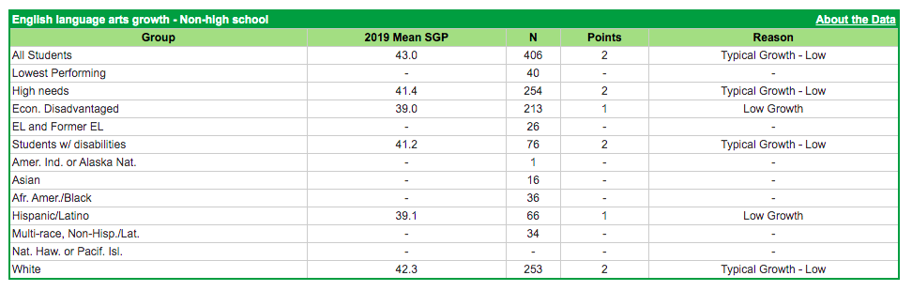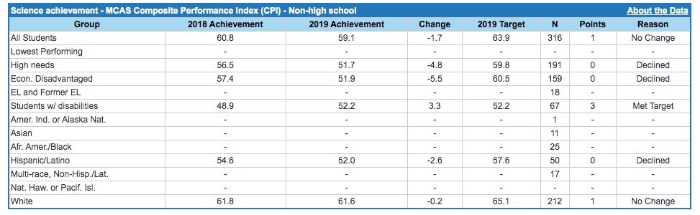**Table highlighting MCAS average composite scaled score for high school student subgroups in Mathematics achievement. Weblink for table is

https://profiles.doe.mass.edu/accountability/report/district.aspx?linkid=30&orgcode=39020000&orgtypecode=5&&fycode=2019**

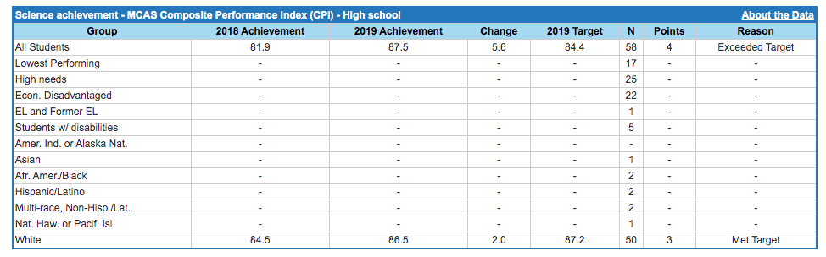

**Table highlighting English language arts growth for high school student subgroups. Weblink for table is 
https://profiles.doe.mass.edu/accountability/report/district.aspx?linkid=30&orgcode=39020000&orgtypecode=5&&fycode=2019**

**Table highlighting Mathematics growth for non-high school student subgroups. Weblink for table is 
https://profiles.doe.mass.edu/accountability/report/district.aspx?linkid=30&orgcode=39020000&orgtypecode=5&&fycode=2019**

**Table highlighting Mathematics growth for non-high school student subgroups. Weblink for table is 
https://profiles.doe.mass.edu/accountability/report/district.aspx?linkid=30&orgcode=39020000&orgtypecode=5&&fycode=2019**

**Table highlighting four-year cohort graduation rates for high school student subgroups in 2017 and 2018.  Weblink for table is 
https://profiles.doe.mass.edu/accountability/report/district.aspx?linkid=30&orgcode=39020000&orgtypecode=5&&fycode=2019**

**Table highlighting extended engagement rates for high school student subgroups in 2016 and 2017.  Weblink for table is 
https://profiles.doe.mass.edu/accountability/report/district.aspx?linkid=30&orgcode=39020000&orgtypecode=5&&fycode=2019**

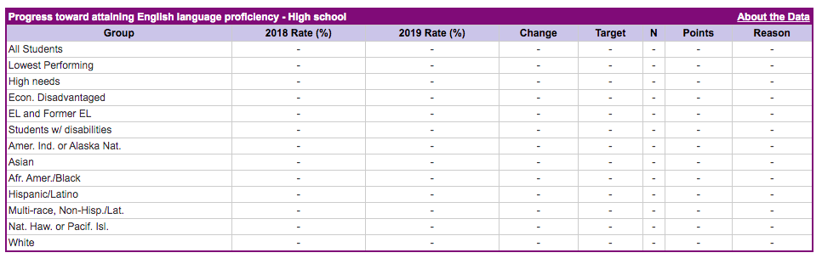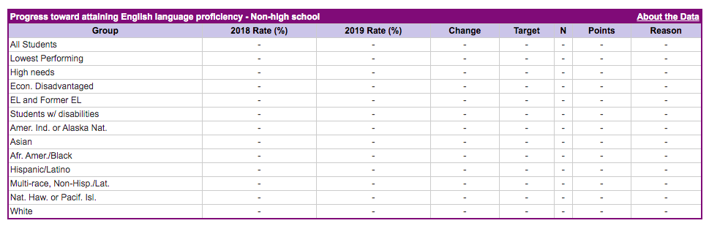**Table highlighting annual dropout  rates for high school student subgroups in 2017 and 2018.  Weblink for table is 
https://profiles.doe.mass.edu/accountability/report/district.aspx?linkid=30&orgcode=39020000&orgtypecode=5&&fycode=2019**

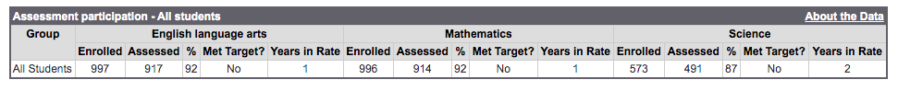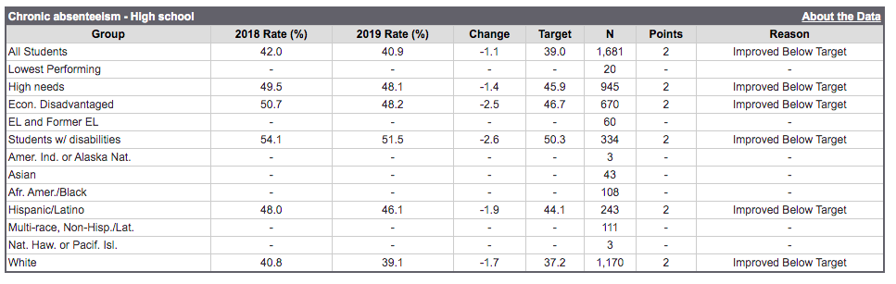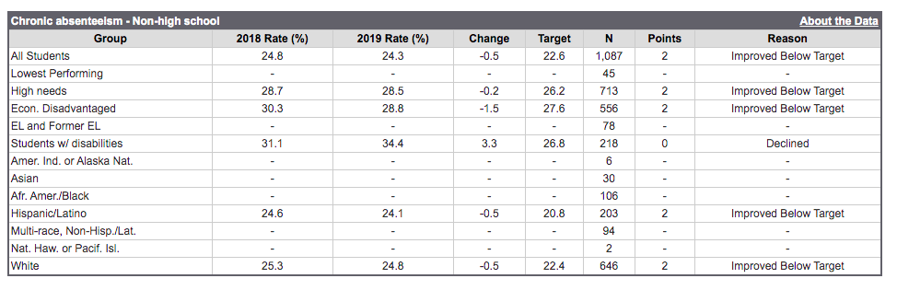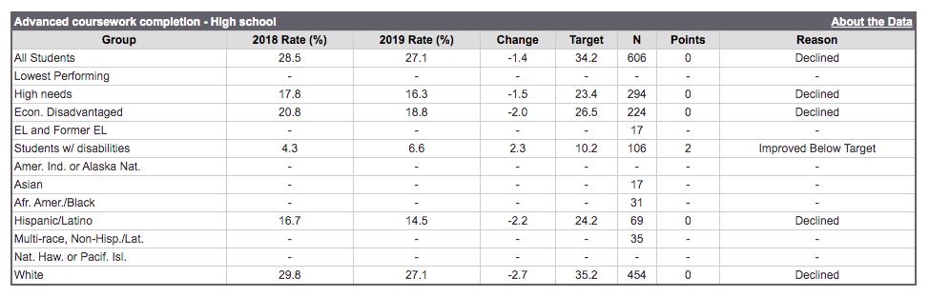

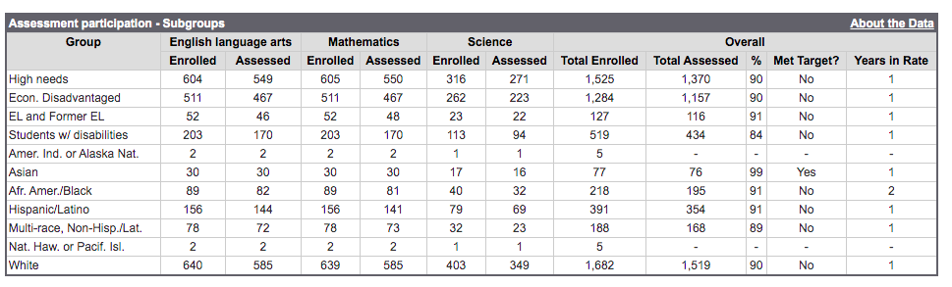

# Appendic B: Finance

5-year financial summary infographic for the school summarizing key financial metrics and audit indicators. 

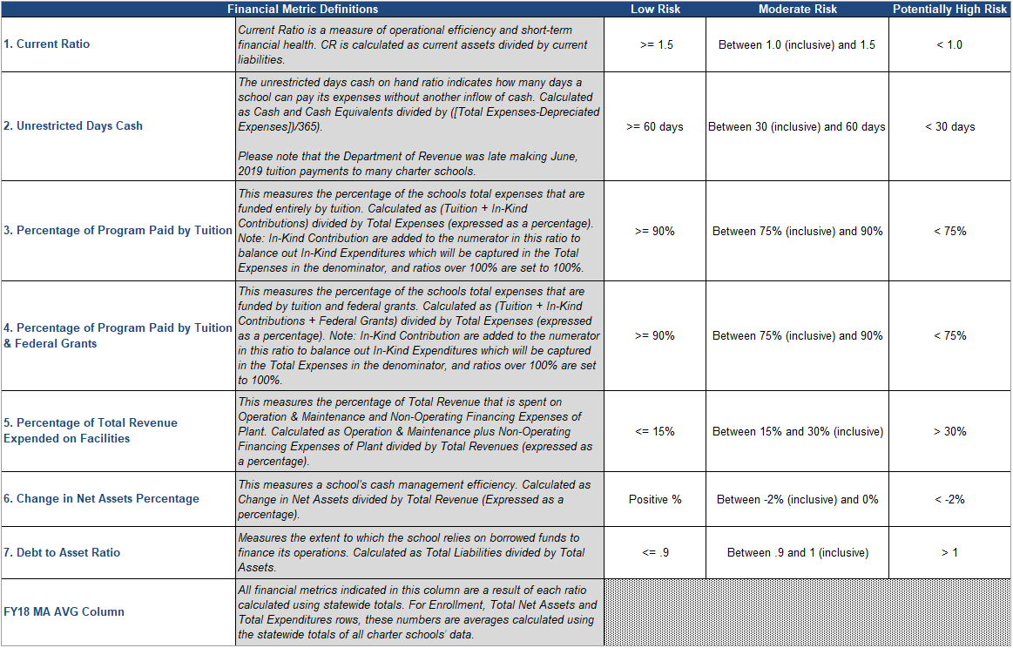

# Appendic C: school’s reponse to accountability review report

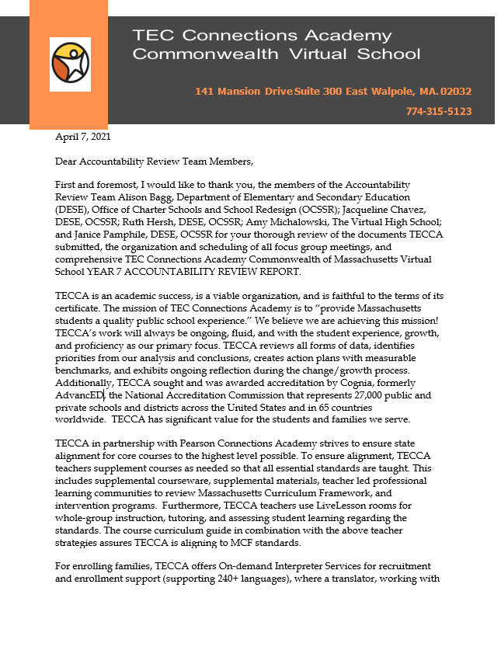

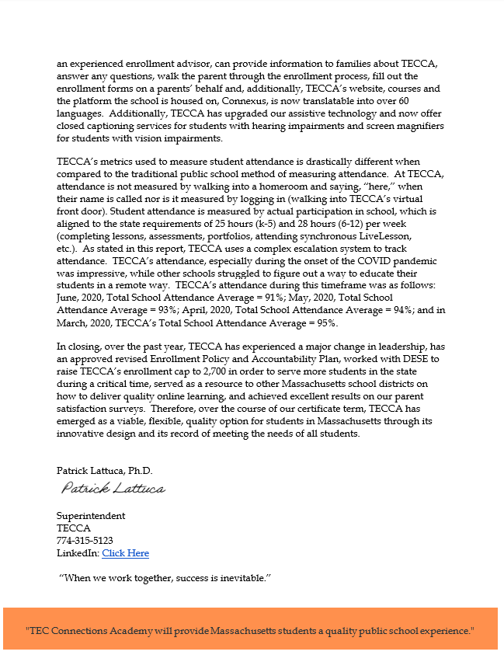

1. Rating Key:

   ** Exceeds:** The school fully and consistently meets the criterion and is a potential exemplar in this area.

   ** Meets:** The school generally meets the criterion and/or minor concern(s) are noted.

   ** Partially Meets:** The school meets some aspects of the criterion but not others and/or moderate concern(s) are noted.

   ** Falls Far Below:** The school falls far below the criterion and/or significant concerns are noted.
2. This is the number as of October 1, 2020. Source: [Profiles](https://profiles.doe.mass.edu/general/general.aspx?topNavID=1&leftNavId=100&orgcode=39020900&orgtypecode=6)
3. This is the number as of March 31, 2021. Source: TECCA enrollment update submitted to the Department after the accountability review
4. Source: [Profiles](https://profiles.doe.mass.edu/profiles/student.aspx?orgcode=39020000&orgtypecode=5&leftNavId=305&)
5. Source: [Profiles](https://profiles.doe.mass.edu/profiles/student.aspx?orgcode=39020000&orgtypecode=5&leftNavId=305&)
6. After the accountability review, the school shared that starting in the 2020-21 school year TECCA will provide all students with laptops regardless of families eligibility for free or reduced-price lunch.
7. The [Massachusetts Curriculum Frameworks](http://www.doe.mass.edu/frameworks/) for Mathematics and English Language Arts and Literacy issued in 2011, and revised in 2017, incorporate the Common Core State Standards. Additionally, schools are expected to integrate the World-class Design and Assessment English Language Development (WIDA ELD) standards into ELD curriculum materials and content area curricula of classes in which English learners participate.
8. Source: [Profiles](https://profiles.doe.mass.edu/profiles/teacher.aspx?orgcode=39020000&orgtypecode=5&)