Commissioner Martinez School Visits 2025
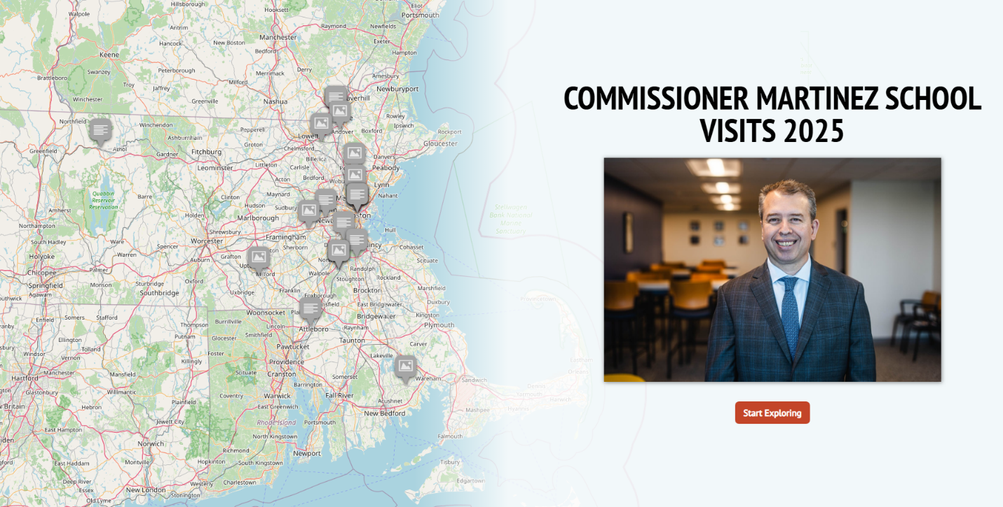

1. Ralph C. Mahar Regional in Orange. August 1, 2025. With Congressman Jim McGovern, Secretary Tutwiler, and Project bread, Commissioner Martinez visited summer meal sites in Greenfield and Orange during the 11th annual Summer Food Rocks Tour.
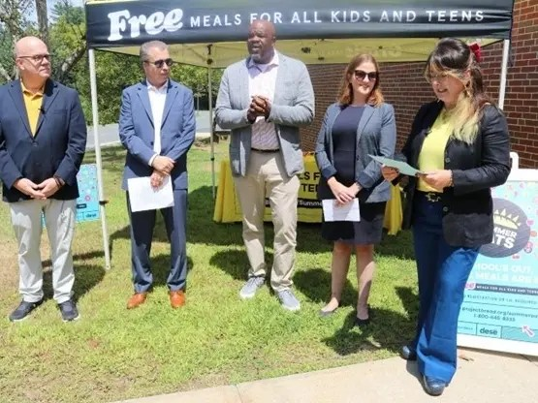

2. Oliver Elementary School in Lawrence. August 12, 2025. Ribbon Cutting. Full album here.
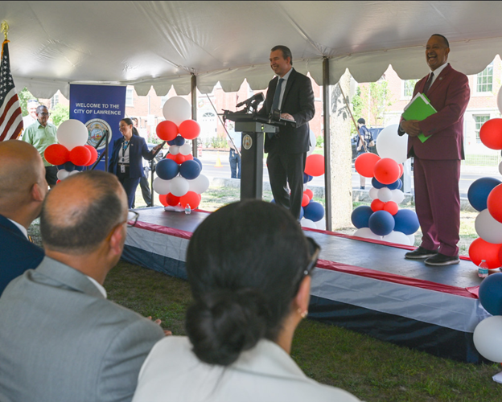

3. Lawrence High School in Lawrence. August 22, 2025. Staff Opening Day Ceremony.
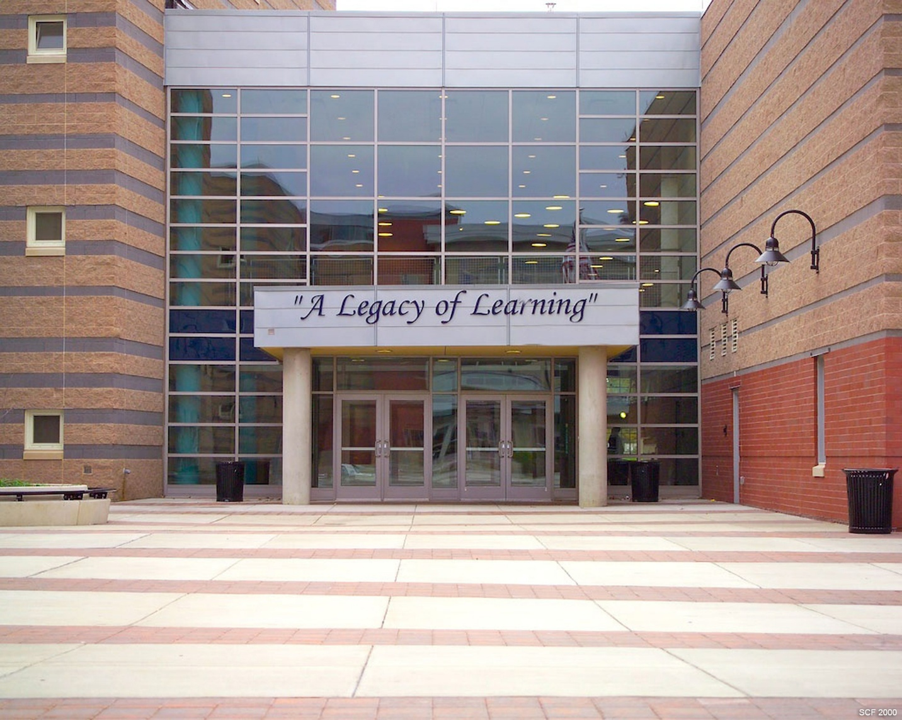

4. Hopedale Junior Senior High School in Hopedale. August 26, 2025. First Day of School.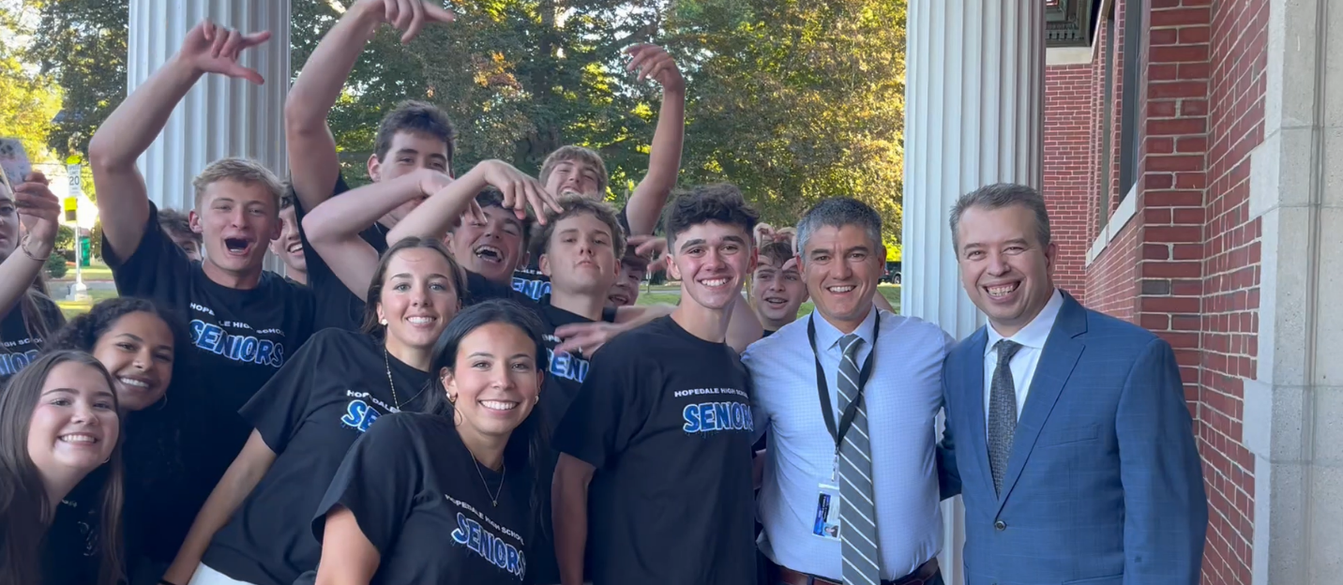
5. John D. Hardy School in Wellesley. August 27, 2025. First Day of School.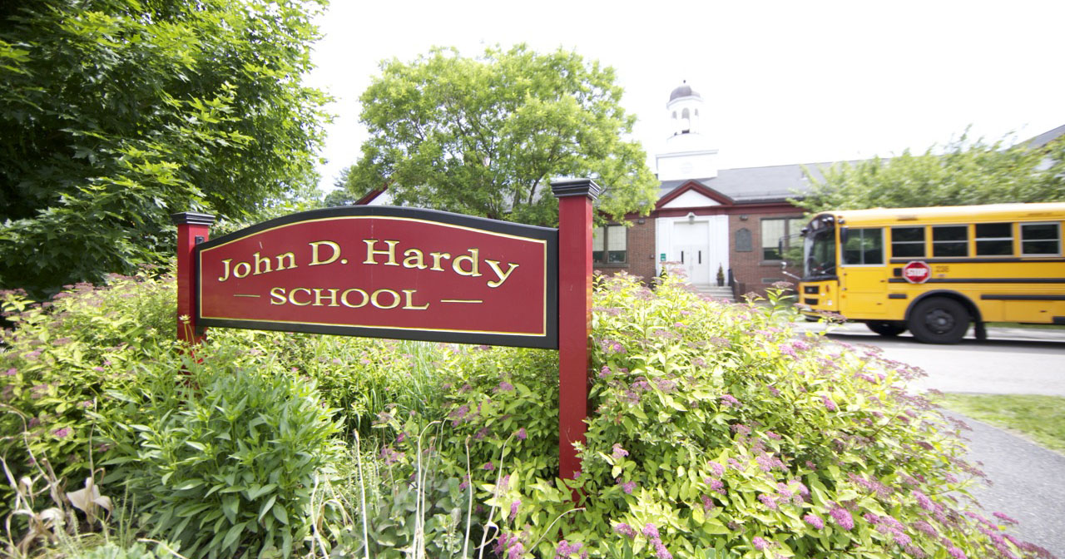

6. Beebe School in Malden. August 27, 2025. First Day of School.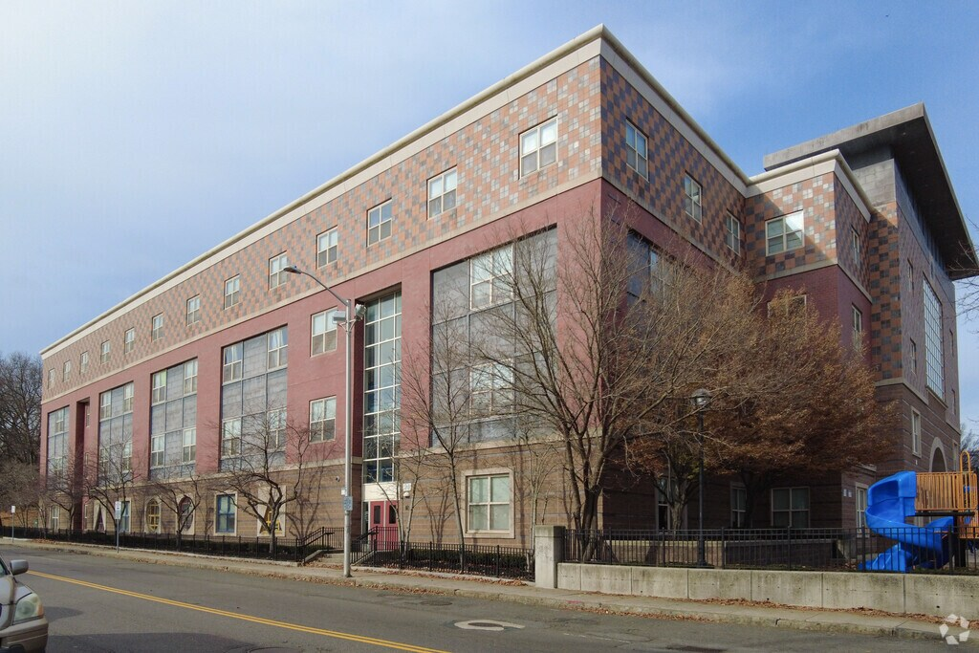

7. Northeast Metropolitan Regional Vocational High School in Wakefield. August 28, 2025. Commissioner Martinez received a map from students on the First Day of School. 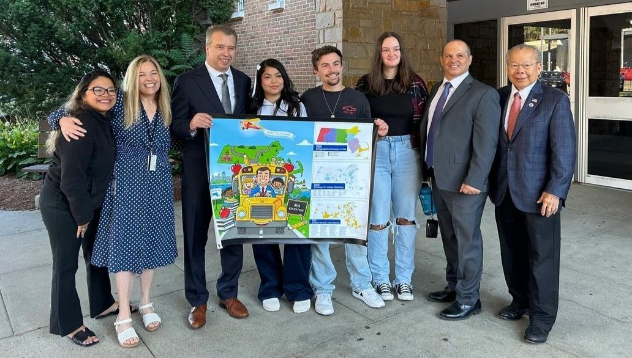
8. North Randolph Elementary School in Randolph. September 2, 2025. First Day of School.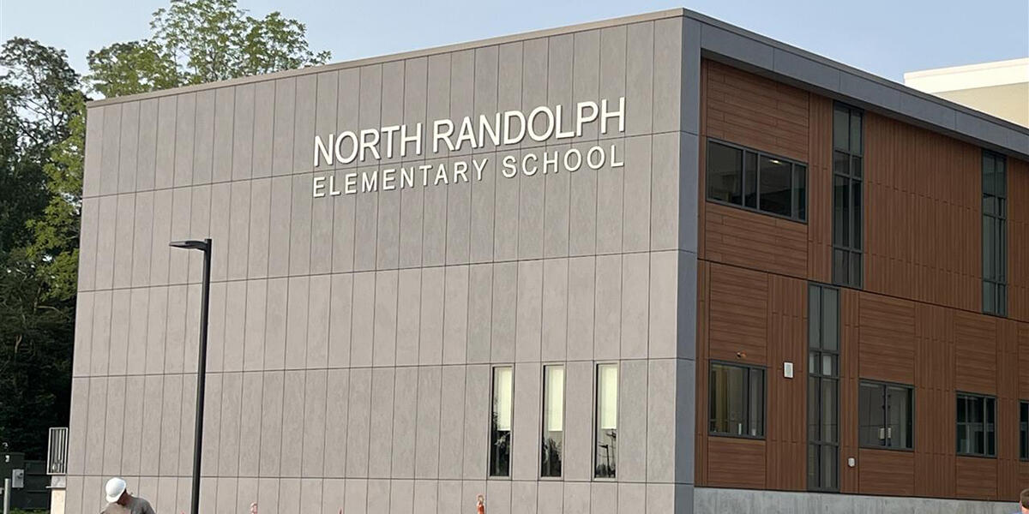

9. John F. Kennedy School in Canton. September 2, 2025. First Day of School.
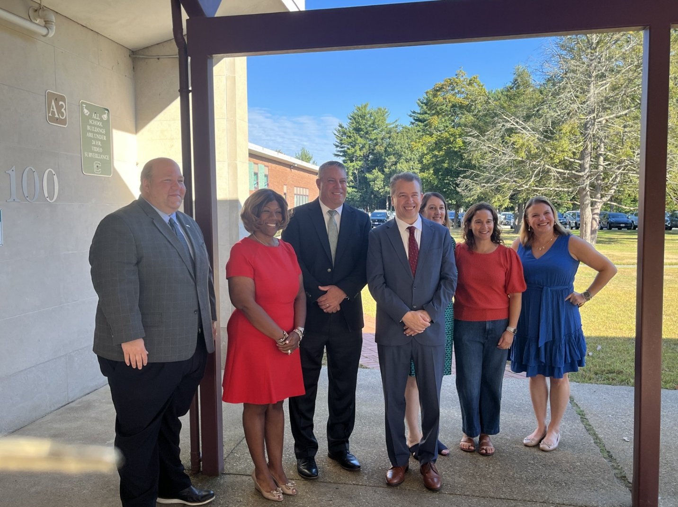

10. Loella F. Dewing Elementary in Tewksbury. September 2, 2025. Commissioner Martinez joined Governor Healey and Secretary Tutwiler to celebrate the state’s high-dosage early literacy tutoring.


11. Old Colony Regional Vocational Technical High School in Rochester. September 2, 2025. On the first day of school, Commissioner Martinez toured Old Colony, accompanied by Superintendent Aaron Polansky. More photos from the day: https://brandfolder.com/s/6km9rx67nnqcj9m4cq7c25 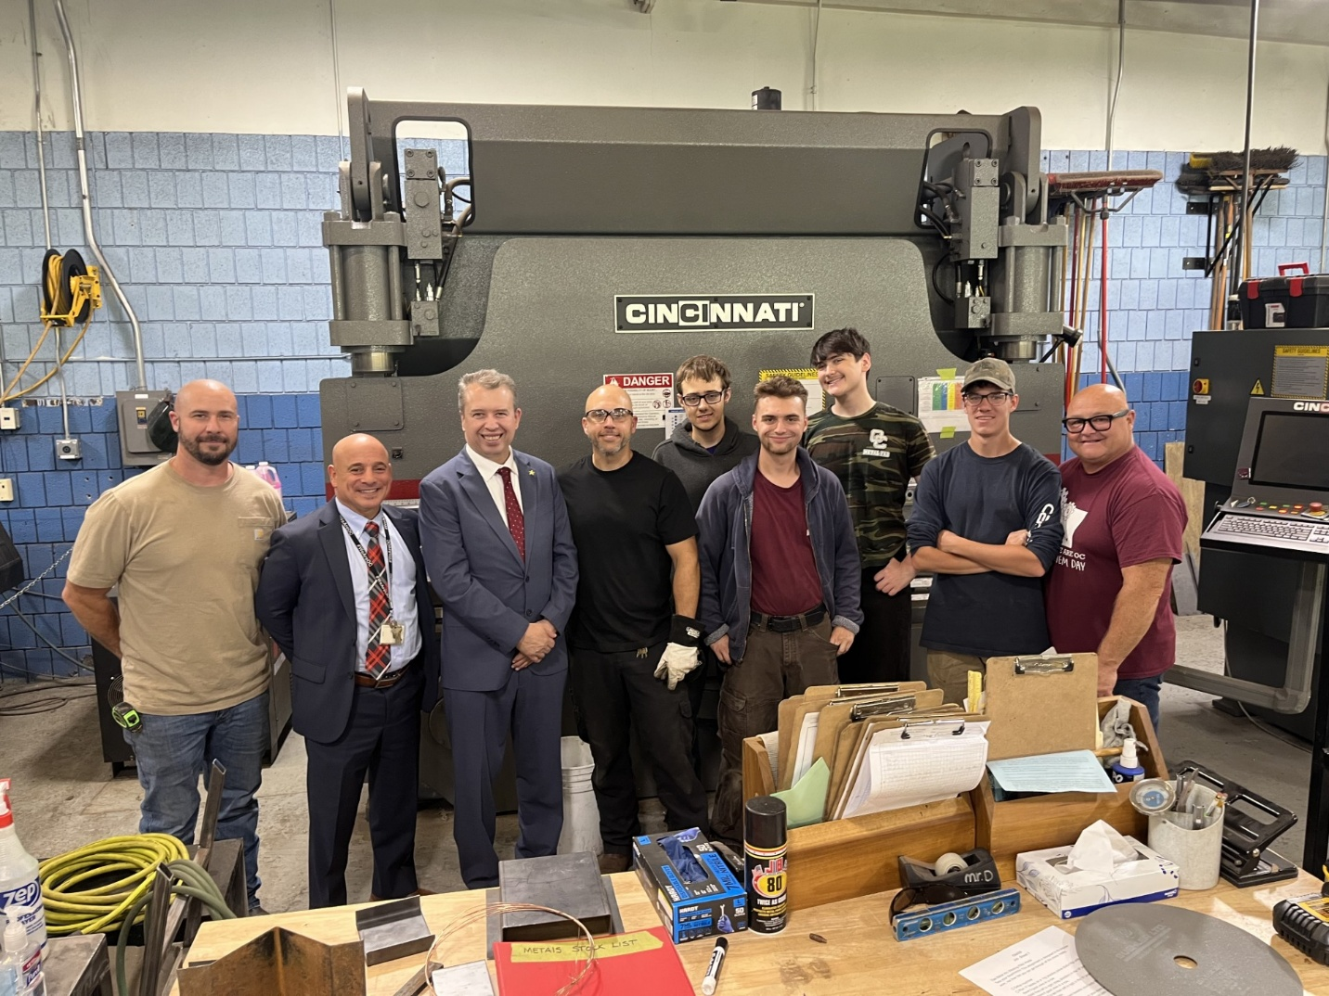

12. Orchard Gardens K-8 School in Boston. September 4, 2025. First Day of School.
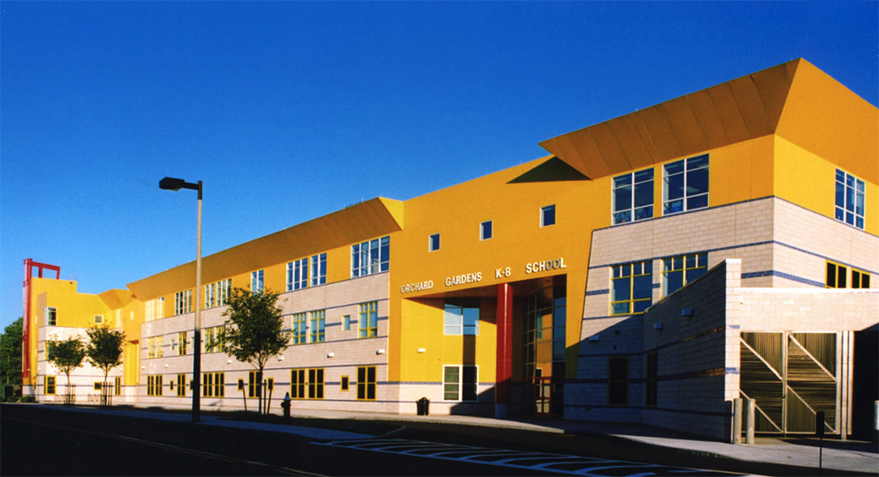

13.Trotter Elementary School in Boston. September 4, 2025. First Day of School.
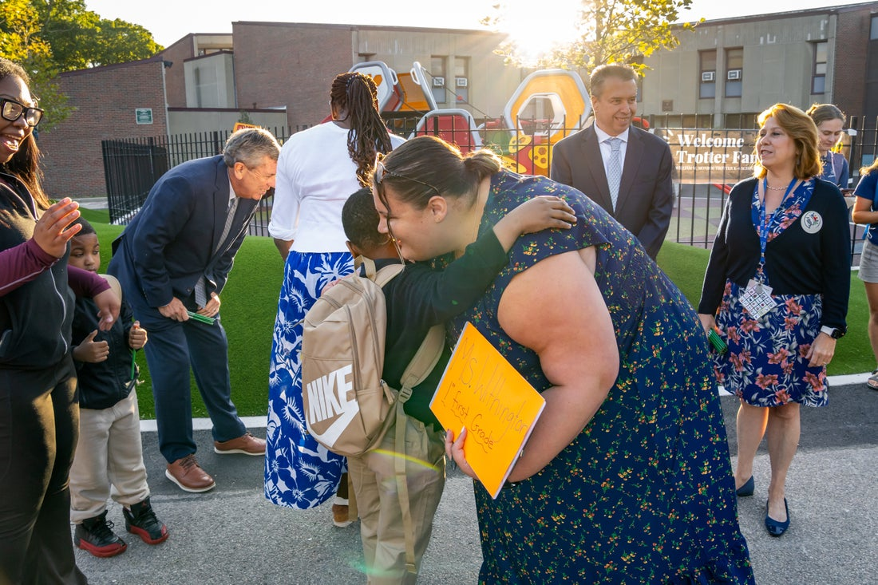

14. TechBoston Academy in Boston. September 4, 2025. First day of school. 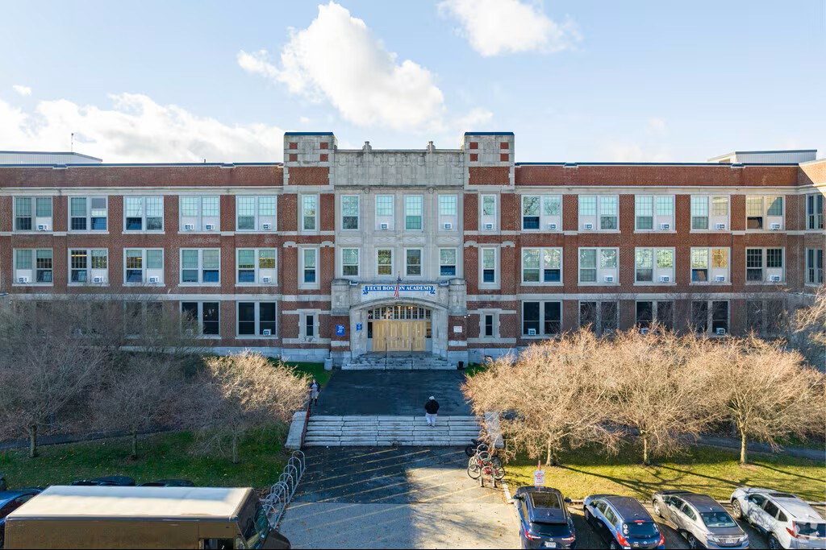

15. Newton Public Schools Central Office and Family Welcome Center in Newton. September 10, 2025. Central Office Back-to-School Open House.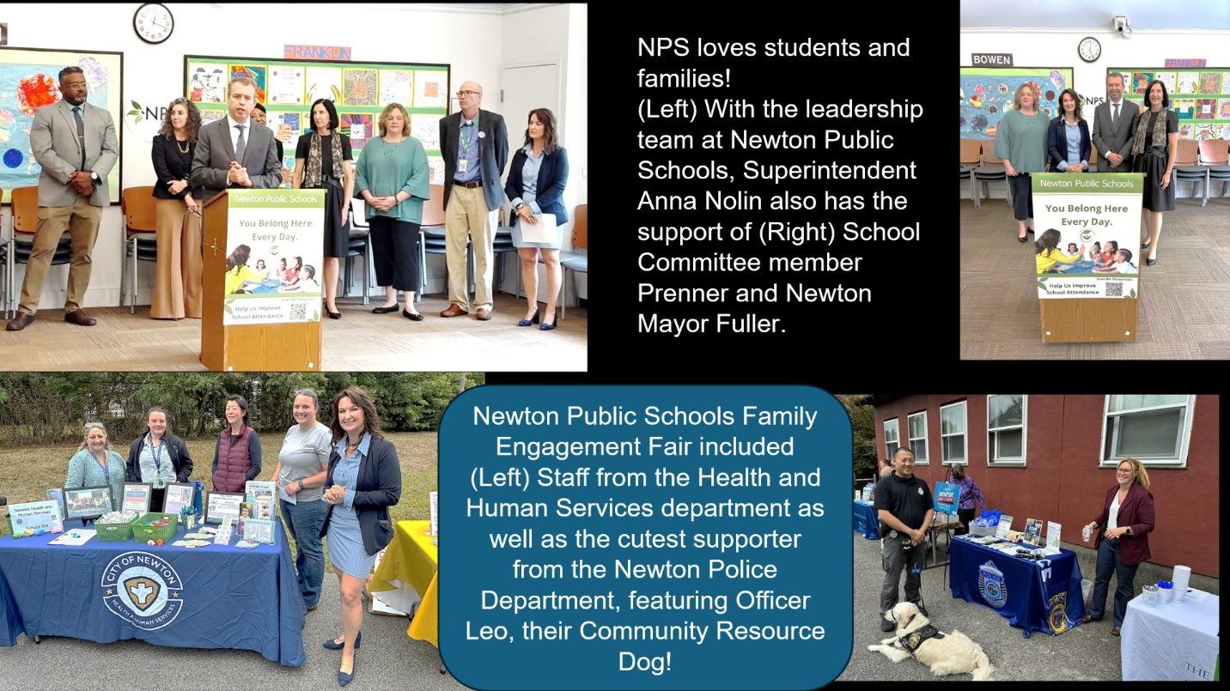

16. Shawsheen School in Andover. September 12, 2025. Students at the new Shawsheen Preschool in Andover led the Pledge of Allegiance during the ribbon-cutting ceremony for the school. ￼

17. Pappas Rehabilitation Hospital for Children in Canton. September 19, 2025. During Commissioner Martinez’s visit, educators shared how they teach self-advocacy skills to their students. One teacher stated that “many students are visible with their wheelchairs in public, but at Pappas, they are truly seen.” 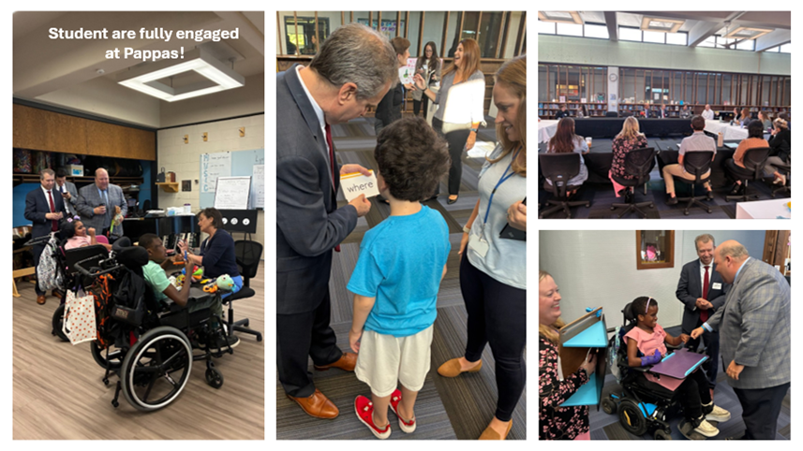

18. Academy of the Pacific Rim Charter Public School in Boston. September 19, 2025. School tour.
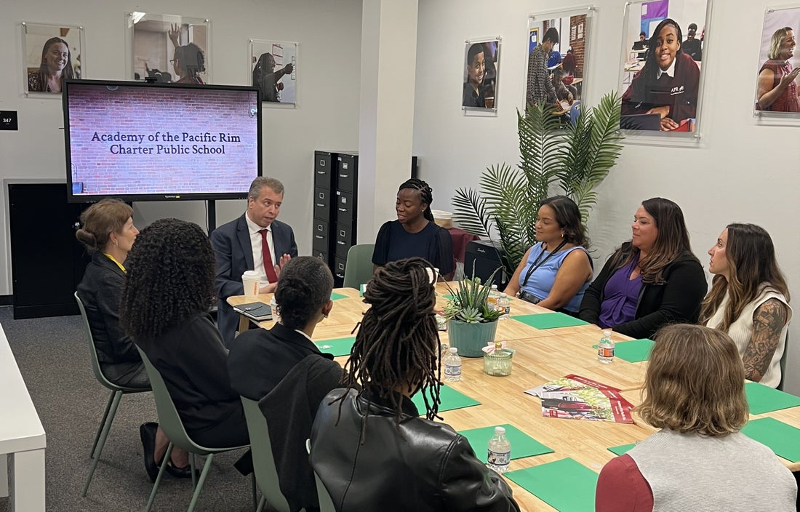

19. Attleboro High School in Attleboro. September 24, 2025. Lieutenant Governor Driscoll, Secretary Tutwiler, Commissioner Martinez, Higher Education Commissioner Ortega, and others toured Attleboro High School and announced the Vision of a Massachusetts Graduate.
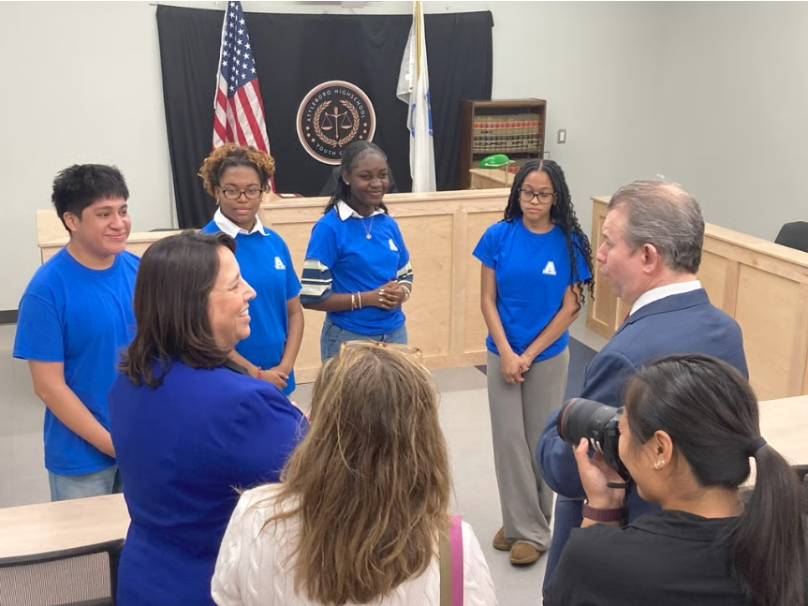

20. Tobin Montessori School and Darby Vassall Upper School and Community Complex Cambridge in Cambridge. October 18, 2025. Ribbon cutting. 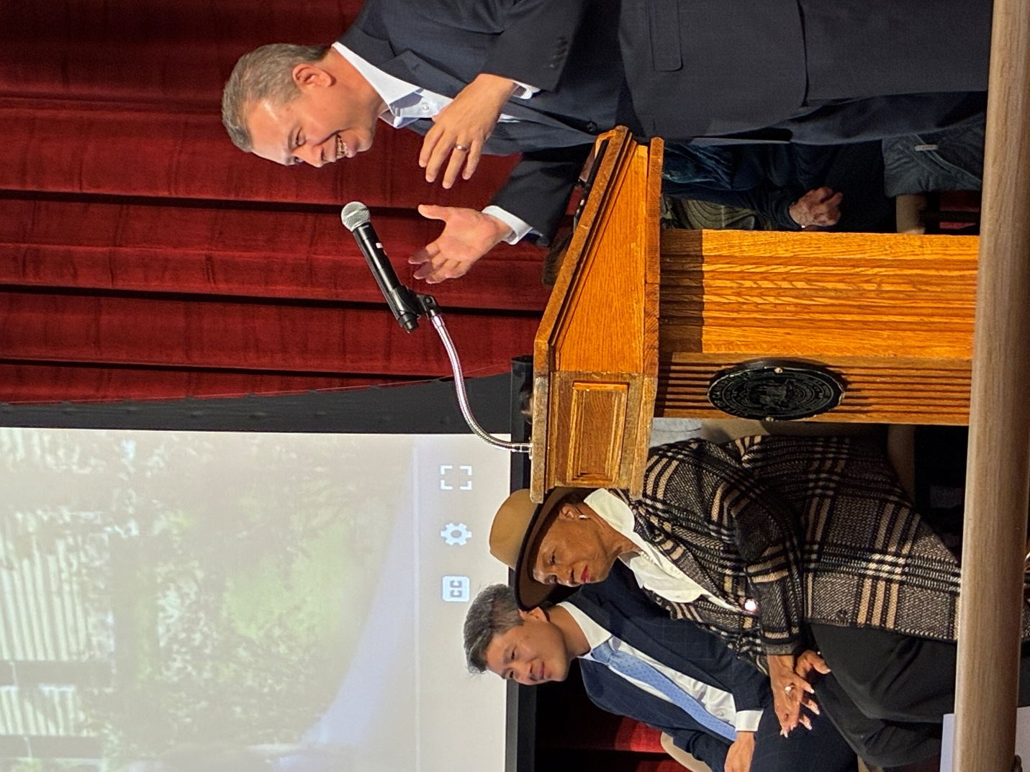

21. Essex North Shore Agricultural & Technical School in Danvers. October 21, 2025. Classroom visits. 