

Model Procedures for Interacting with Civil Law Enforcement
On August 5, 2026, Governor Maura Healey signed into law the PROTECT Act. Stat. 2026, c. 163, §§ 1–24 (Act). It is now the law in Massachusetts that, except as required by state or federal law or as required for the Commonwealth or its subdivisions to administer a state or federally supported or funded program, civil arrests, including for federal immigration enforcement, are not allowed in the following nonpublic areas: school grounds during operating hours (defined below) without a Judicial Warrant or Judicial Order.
As required by the Act, these model procedures outline a process for employees to follow when interacting with law enforcement officers engaged in civil law enforcement. The model procedures promote schools that are safe and accessible for students, staff, and residents. The model procedures should apply equally to all forms of law enforcement and should be focused on maintaining student safety.
The model procedures shall be implemented, wherever applicable, in alignment with District Emergency Operations Plans, as well as with Medical and Behavioral Health Emergency Response Plans.

Definitions for the Model Procedures
These Model Procedures use the following words and phrases consistent with the PROTECT Act:
Civil Arrest: means an arrest that is not for the purpose of preparing the person subject to such arrest for criminal prosecution for an alleged violation of a state or federal criminal law. Civil arrests may be authorized by, among other things: (1) a parole warrant issued under G.L. c. 127, § 149A, or a probation warrant issued under G.L. c. 279, § 3; (2) state law permitting protective custody for incapacitated and intoxicated persons, G.L. c. 111B § 8, or (3) an administrative warrant issued by a federal agency like the United States Immigration and Customs Enforcement (ICE) agency for violations of the federal Immigration and Nationality Act, or related civil immigration enforcement efforts.
- Civil law enforcement: means efforts to investigate, enforce or assist in the investigation or enforcement of state or federal civil law, including, but not limited to, any federal civil immigration law. For added context, civil law enforcement often relates to preventative detention for an individual’s safety or security, enforcement of civil actions in court, or immigration law enforcement. In contrast, criminal law enforcement involves the investigation and enforcement of state or federal criminal laws (like those outlawing theft and assault). Note that law enforcement officers (defined below) can engage in civil law enforcement and/or criminal law enforcement.
- Judicial Warrant or Judicial Order: refers to an arrest warrant or other judicial order, signed by a judge or magistrate sitting in the judicial branch of a local or state government or of the federal government, authorizing an arrest.

- Law enforcement officer or officer: means any agent or officer of a federal, state, county, municipal, or district law enforcement agency, including but not limited to local police departments, sheriffs, constables, the Massachusetts State Police, the United States Immigration and Customs Enforcement (ICE) agency, the United States Custom and Border Protection (CBP) agency, and the United States Department of Homeland Security (DHS).

- Operating hours: means regular school hours, student drop off and pick up windows, before-school and after-school programming, and school-sponsored events.

- School: means a school administered by the school department of a city, town or regional school district; a county agricultural school; an independent vocational school or a vocational school operated by a county; a Commonwealth charter school or a Horace Mann charter school established under G.L. c. 71, § 89 (“charter school”); a special day school or other day facility or a short or long term residential school providing educational programs for children with disabilities established pursuant to chapter 71B and in accordance with chapter 766 of the acts of 1972; or a school operated by an education collaborative established under G.L. c. 40, § 4E (“collaborative school”).

- School district: means the school department of a city or town, a regional school district, an independent vocational school or a vocational school or agricultural school operated by a county.

- School grounds: means the main school building(s) and any other building or property owned or controlled by a school or school district and used by the school in direct support of or in a manner related to the school’s educational or athletic purpose. This includes playgrounds, fields, parking lots, recreation areas, athletic fields, courts, competition areas and other locations owned or controlled and used for school-related purposes, whether or not physically connected to the main school building(s). During operating hours, as defined above, school grounds are nonpublic.

Interactions with Law Enforcement Officers Engaged in Civil Law Enforcement
Civil arrests are not permitted on school grounds during operating hours unless Law Enforcement Officers (Officers) have a valid Judicial Warrant or Judicial Order. For purposes of these procedures, school grounds are defined above.

General Procedures for District/School Staff Interacting with Law Enforcement Officers Engaged in Civil Law Enforcement
- Staff should remain calm and professional when encountering Officers conducting civil law enforcement and should use the language outlined in these procedures.
- Staff should never attempt to physically interfere with Officers conducting civil law enforcement activities, nor should they feel compelled to approach an Officer or engage with them first.
- If employees and staff feel unsafe engaging with Officers, they can decline to interact with them and instead rely on administrators, as described below.

Designated Senior Administrators to Serve as Contact Persons
The Superintendent or Executive Director has identified the following senior administrator from the Superintendent/Executive Director’s office as the designated district-level contact person for any situation in which Officers are engaged in civil law enforcement on school grounds.
District-level contact:
[Name],
[title],
[cell phone]
The Superintendent or Executive Director, in coordination with each school, has identified the following senior administrator(s) from the Principal’s Office as the designated school-level contact person at each school for any situation in which Officers are engaged in civil law enforcement on school grounds
[for each school, include the name, title, and cell phone number of the identified senior administrator from the Principal’s Office]
The Superintendent or Executive Director will determine the district’s process for calling the district’s attorney when Officers are on-site (see step iv of the escalation protocol, below), including whether the district-level contact person or the school-level contact person will call the district’s attorney. That decision will be communicated to all district-level and school-level contacts.

Escalation Protocol

- If Officers arrive on site and there are no apparent exigent (emergency) circumstances, staff should inform the Officers that the staff will contact an administrator to assist them and that the Officers should wait where they are (ideally outside, away from students and families).

- When staff encounter or become aware of Officers engaged in civil law enforcement on school grounds, they should immediately notify the school-level contact person.

- Once notified, the school-level contact person should immediately notify the district-level contact person and go to the location where the Officers are waiting.

- Consistent with the district’s process, the school-level contact person or the district-level contact person will call the district’s attorney for advice. If possible, the school-level contact person will connect the attorney with the district-level contact person on a three-way call.

- The school-level contact person will ask the Officers for their identification, and record their names, agencies, and badge numbers.

- The school-level contact person will ask to view any warrant or other documentation. The school-level contact person—with assistance from an attorney, if available, and/or the district-level contact person—should review the documents to determine whether the Officers have a valid Judicial Warrant or Judicial Order. See Review of Warrant, below.

- If the Officers have a valid Judicial Warrant or Judicial Order authorizing an arrest or entry to search or both, the school-level contact person will inform the Officers that they may enter the school grounds; however, they will request that where feasible, the Officers avoid any areas where students are present.

- If the Officers do not have a valid Judicial Warrant or Judicial Order, or they only have an administrative warrant, the school-level contact person will inform the Officers that they are not authorized to conduct an arrest on school grounds and ask them to leave.

- If the Officers proceed to conduct a civil arrest in these areas in violation of the PROTECT Act, no one should attempt to physically interfere with them. Rather, staff should follow the guidance for bystanders in Guidance for K-12 Schools Related to Interacting with Civil Law Enforcement at Part IV. If there is an imminent threat to the safety of a child, staff member, family member, or other person, program staff should not hesitate to call 9-1-1 for assistance.

- After the Officers have left the school grounds, the school should report the event to the Attorney General’s Office Civil Rights Division.

Review of Warrant
The school-level contact person, with assistance from the district-level contact person and the district/school attorney, if available, will review any warrants or orders.￼ The district-level contact person and school-level contact persons will be generally familiar with the concept of a judicial warrant and judicial order based on the information in the Guidance for K-12 Schools Related to Interactions with Civil Law Enforcement. A sample judicial warrant is included in the appendix for these model procedures.
Judicial Warrants and Judicial Orders are documents issued by a judge or magistrate sitting in the judicial branch of state or federal government. These documents authorize a search of a specific place or an arrest of a specific person based on sufficient information to support that a crime has been committed (“probable cause”). Note that other judicial orders can include subpoenas or summons, but they do not allow physical access into nonpublic places.
A Judicial Warrant is: (1) signed by a judge, magistrate, or assistant clerk magistrate and dated; (2) issued by a court; and (3) includes the location to be searched or the persons or items to be seized/arrested.
A Judicial Order may take many forms but should include: (1) the caption of a court case; (2) the name of the court; and (3) a judge, clerk magistrate, or assistant clerk magistrate’s signature, with a date.

Guidance on Language
District/school staff should use the language below when interacting with Officers when they request to conduct civil law enforcement on the school grounds:
- “I am not authorized to allow you to enter the school. Please wait here while I contact an administrator.”
- “I am not authorized to discuss specific individuals or to speak with you about this student/child/employee. I am going to contact an administrator who will discuss this further with you.”
- “I am not permitted to discuss/disclose private information to you.”

Documentation of Interactions
Employees, staff, administrators, and the designated contact person(s) are to document interactions with law enforcement officers engaged in civil law enforcement, and are encouraged to wait until they feel safe to write down what happened. This may be after the officers leave the school grounds. Schools should use an existing form or create a new one to record interactions with law enforcement officers and keep those records as they would any other school records, in the normal course. A sample form is included as Appendix B.
Under the escalation protocol described above, employees, staff, administrators, and the designated contact person(s) may interact with law enforcement officers in different ways and at different times. The following procedures reflect those roles, but are not intended to limit what any particular person should write down from the interaction. For example, if an employee happened to see an officer’s name and badge number, they should write that down too. Likewise, if the designated contact person counted the number of vehicles used by law enforcement, they should write that down too. Everyone is encouraged to document the impact on any students/children/employees/staff (after any immediate issues have been addressed) and any follow up actions needed to support them. Everyone should be advised to write down what they remember of the incident, including but not limited to the following information:
- Date and time when law enforcement officers arrived on school grounds or made the information request;
- The names and badge numbers of the officers, and the agency they represented;
- The number of vehicles and license plate numbers, if visible;
- The names of witnesses, students, or other staff involved;
- Steps taken to notify the school-level contact person, the district-level contact person, or the school’s attorney, as the case may be;
- The actions of the law enforcement officers, including whether the officers complied with school instructions;
- Whether the law enforcement officers had a valid Judicial Warrant or Judicial Order, or some other documentation;
- Whether a civil arrest was made on school grounds; and
- Impact on any students/children/employees/staff (after any immediate issues have been addressed) and any follow up actions needed to support them.
Bystanders, including employees and staff, can openly (not secretly) videorecord the interaction, but they must not interfere.

Law Enforcement Activities Near School Grounds
If law enforcement or civil immigration enforcement activities occur near school grounds, the District/school will refer to the Emergency Operations Plan to determine whether student and staff safety may be impacted. If safety concerns are identified, appropriate safety measures will be implemented, which may include delaying dismissal times. Communication with families will follow accordingly.

School Transportation
The District will review its Emergency Operations Plans with school bus companies to promote student safety in the event of any type of law enforcement activity at bus stops or on school grounds. This includes special education transportation. Additionally, schools should review school transportation contracts and communicate with school transportation companies regarding policies and protocols for bus drivers in the event of active law enforcement activity near a school bus stop. This includes considerations for special education transportation. Transportation-related procedures should focus on maintaining child and resident safety and avoiding dangers associated with dropping a child or resident near an active crime scene or any law enforcement arrest or operation.

School Resource Officer(s) (if applicable)
The District will ensure that the School Resource Officer Memorandum of Understanding (MOU) complies with the mandatory statewide model, and includes information about the roles and responsibilities of a School Resource Officer in the district/schools, including in circumstances where law enforcement officers are conducting civil law enforcement on school grounds.

Parental Notice
When a school confirms the presence of Officers engaged in civil law enforcement on school grounds, the school will notify students’ parents and guardians, teachers, administrators, and school personnel. The notice to parents and guardians will be translated into the languages other than English most commonly spoken in the school district’s community. The school will provide this notice in a manner that protects the confidentiality and privacy of any potentially identifying information. A template email notice is included in Appendix C to these Model Procedures.
Each school will designate a staff member who will notify families if Officers conducting civil law enforcement are trying to reach a student or seeking information about a student. Staff members will notify the student directly if the student is 18 years old or older. A template email notice is included in Appendix D to these Model Procedures.

Protection of Personally Identifiable Information
The district/school cannot disclose personally identifiable information about a student to third parties, including Officers and the media, either orally or in writing unless: the district/school has the parent or guardian’s specific, informed consent (or, in the case of a student who is at least 18 years old or emancipated, the specific, informed consent of the student); it is pursuant to a Judicial Warrant, Judicial Order, or subpoena; or there is a health or safety emergency. Generally, schools should also respect the privacy preferences and concerns of a student's parent or guardian (or the student themself if over 18 years old or emancipated) in response to media inquiries and, to the extent consistent with the law, interactions of law enforcement officers that may implicate students.
Parents/guardians (and students who are at least 18 years old or emancipated) have the right to opt out of being included in directory information. District/school limits what information is included in the directory (e.g., by excluding the student’s address and place of birth), and limits disclosure to the school community. Under federal law, schools are required to notify students and their families at least once per year of what information is included in the directory, and to permit parents to opt out of including information in the directory at any time. The District will communicate this information using translation or interpretation services to parents/guardians with limited English proficiency.

Caregiver Plans and Contact Information
The district/school will keep emergency contact information, alternative caregiver contacts, and authorized pick-up contacts up to date for all students. The district/school will allow parents/guardians to list more than one person as an emergency contact. The district/school will keep associated documentation on file, such as an authorization of another caregiver, temporary agent, or guardian.

Support for Students
The district/school will offer culturally responsive counseling and other supports to students experiencing increased anxiety as a result of civil law enforcement activity.

Support for Families
The district/school will offer support and connections to community resources to families affected by civil law enforcement activity, as appropriate. The district/school will engage with families to address barriers to student attendance, behavioral challenges in school, or other concerns. Communications with families will be made in their primary language, including by using interpreters if needed. The district/school will also host information sessions for families, utilizing interpreters as appropriate, to share the district’s protocol and communication plans for when civil law enforcement activity occurs.

Trainings Regarding Interactions with Civil Law Enforcement
The district/school will conduct trainings on implementation of these procedures and best practices to support the safety of all students, staff, families and authorized visitors within all the school facilities. DESE, in consultation with EOE, the Massachusetts Office for Refugees and Immigrants, and the Massachusetts Attorney General, will develop a model training on these Model Procedures, as well as the Model Policy and Guidance for K-12 Schools Related to Interacting with Civil Law Enforcement. The district/school may use that model training or develop its own training, so long as the content is consistent with the model training.

Existing Obligations
Nothing in these Model Procedures alters the school’s obligations to comply with state and federal laws or existing policies or procedures.
Nothing in these Model Procedures prohibits appropriate cooperation with authorities, including police, fire departments, emergency medical services, child protective authorities, or other public safety officials responding to an emergency, protecting a child from abuse or neglect, or otherwise exercising lawful authority unrelated to civil immigration enforcement. If there is an imminent physical threat to the safety of a child, staff member, family member, or other person, program staff should not hesitate to call 9-1-1 for assistance.

Posting on District’s website
The District’s procedures and policy will be posted on the District’s website translated into the primary languages of families in the District.

Additional Resources for District/School Students and Families
The Massachusetts Attorney General’s Office and the Massachusetts Office for Refugees and Immigrants have created the following resources for the public to learn more about their rights.
Massachusetts Attorney General: Resources for Immigrants in Massachusetts
Massachusetts Office for Refugees and Immigrants: Community Resource Toolkit
Massachusetts Attorney General Guidance: KNOW YOUR RIGHTS: ICE Enforcement An Updated Guide for Immigrants, Families, and Communities (available in Spanish, Portuguese, Haitian Creole, Chinese, Vietnamese)
Massachusetts Attorney General Guidance: General Information for Massachusetts Service Providers Regarding Immigration Enforcement (available in Spanish, Portuguese, Haitian Creole, Chinese, Vietnamese)
Massachusetts Attorney General Guidance: K-12 Schools' Obligations to Protect Students and Their Information
Massachusetts Attorney General Flyer: Immigrant Students’ Right to Attend School: A Guide for Families (available in Spanish, Portuguese, Haitian Creole, Vietnamese, Chinese)
Massachusetts Attorney General Flyer: K-12 Schools on Protections for Students and their Information
Emergency Planning Guide for Parents with Uncertain Immigration Status (available in Spanish, Portuguese, Haitian Creole, Simplified Chinese)
Emergency Planning Fact Sheet for Parents with Uncertain Immigration Status (available in Spanish, Portuguese, Haitian Creole, Simplified Chinese)
Attorney General’s Advisory Regarding Equal Access to Public Education for All Students Irrespective of Immigration Status
Upholding the Rights of Immigrant Students to Enroll in School: Guidance for School Committees and Districts

APPENDIX A: Sample Judicial Warrants and Administrative Warrants
Figure 1: State Court Judicial Warrant
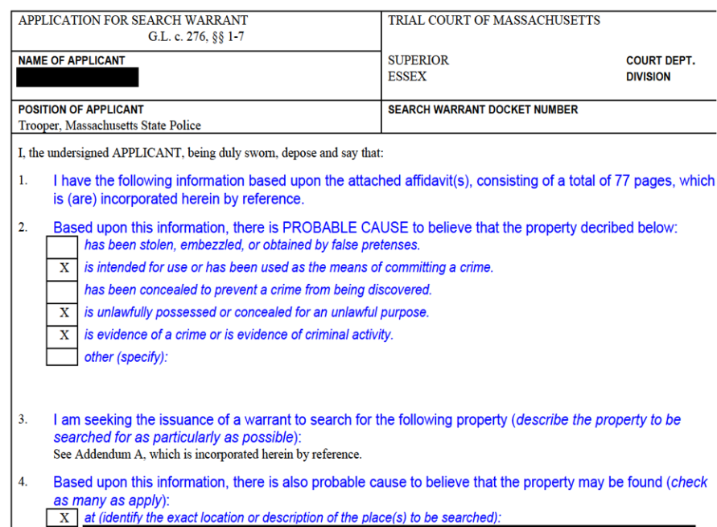
Figure 2: Federal Court Judicial “search warrant” (left) & Administrative “ICE Warrant” (right)
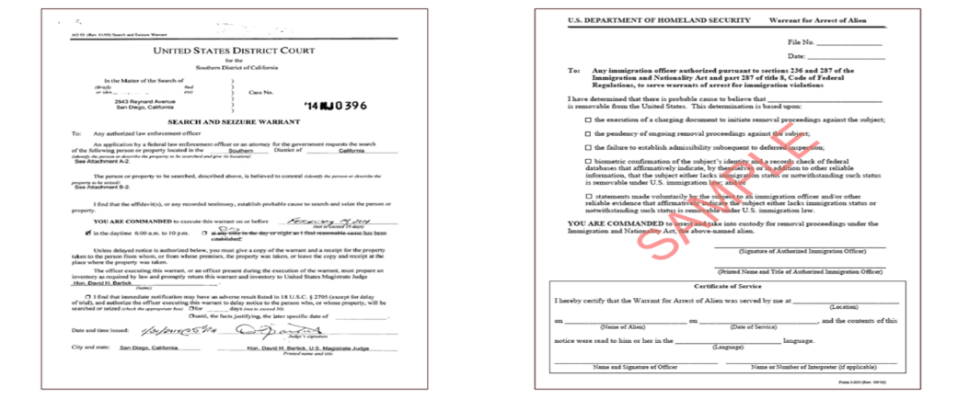
Appendix B: Sample Civil Law Enforcement Interaction Documentation
Date: __________________
Time: __________________
Location: __________________
Agent Name(s): __________________
Badge/Identification Number: __________________
Agency: _____________ _____
Supervisor/Contact Information: __________________
Purpose stated by agent:
Person, records, or area requested:
Document presented:
☐ Judicial warrant
☐ Judicial order
☐ Subpoena
☐ Administrative immigration warrant
☐ Immigration detainer
☐ Other: __________________
☐ No document presented
School-level contact notified: ☐ Yes ☐ No
District-level contact notified: ☐ Yes ☐ No
School attorney contacted: ☐ Yes ☐ No
School-level response:

Information or records disclosed, if any:
Any arrest/detention or other enforcement action:
Impact on children/school operations:
Any other observations:

Person completing report: __________________
Date completed: __________________

APPENDIX C
Template for notifying families and school community about confirmed presence of law enforcement officers engaged in civil law enforcement on school grounds

Dear Families:

We are writing to inform you that civil law enforcement agencies, specifically [INCLUDE THE NAME OF THE AGENCY IF AVAILABLE], were present at [SCHOOL/LOCATION] on [DATE].

Per the PROTECT Act signed on August 5th, 2026, it is now the law in Massachusetts that civil arrests for civil law enforcement, including federal immigration enforcement, are not allowed on school grounds during school hours, during before- and after-school programming, and during school-sponsored events without a judicial warrant or judicial order.

Our district has clear procedures and policies in place to follow the PROTECT Act, which you can see [INSERT LINKS]

If you are looking for additional legal assistance or information, please use the resources below.

For general legal help please access legal assistance here:
Massachusetts Legal Resource Finder

For legal assistance with regard to immigration issues, please access legal assistance here:
The Legal Representation Fund (LRF) -- For those recently detained by ICE.
Detained Hotline: (617) 637-8195
Family & Friends Hotline: (617) 396-7143
The Massachusetts Access to Counsel Initiative (MACI) -- For those facing deportation currently in Immigration court proceedings.
Intake: 508-505-4588

MIRA Immigration Helpline
miracoalition.org/news/immigration-helpline/
Nationwide Immigration Lawyer Search
ailalawyer.com

APPENDIX D
Template for notifying family members or students age 18 or emancipated about specific requests from law enforcement officers engaged in civil law enforcement
Dear __________:
As the parent or legal guardian of ____________________, this email is to notify you that civil law enforcement agencies, specifically [INCLUDE THE NAME OF THE AGENCY IF AVAILABLE] was [either trying to reach your child OR sought specific information about your child].

You may reach out to [CONTACT PERSON] at [PROGRAM] with any questions about this incident, but please be aware that our program may not have any more information than what has already been provided above.

Per the PROTECT Act signed on August 5th, 2026, it is now the law in Massachusetts that civil arrests for civil law enforcement, including federal immigration enforcement, are not allowed on school grounds during school hours, during before- and after-school programming, and during school-sponsored events without a judicial warrant or judicial order.

Our district has clear procedures and policies in place to follow the PROTECT Act, which you can see [INSERT LINKS]

For general legal help, please access legal assistance here:
- Home | Massachusetts Legal Resource Finder

For legal assistance with regard to immigration issues, please access legal assistance here:
- The Legal Representation Fund (LRF) -- For those recently detained by ICE.
- Detained Hotline: (617) 637-8195
- Family & Friends Hotline: (617) 396-7143
- The Massachusetts Access to Counsel Initiative (MACI) -- For those facing deportation currently in Immigration court proceedings.
- Intake: 508-505-4588

- MIRA Immigration Helpline
- miracoalition.org/news/immigration-helpline/
- Nationwide Immigration Lawyer Search
- ailalawyer.com

Although bus stops are generally not considered “school grounds,” please see the Section on School Transportation for recommendations on how to handle law enforcement activity at bus stops.
As noted in the Section on Existing Obligations, below, nothing in these Model Procedures prohibits appropriate cooperation with authorities, including police, fire departments, emergency medical services, child protection authorities or other public safety officials, responding to an emergency, protecting a child from abuse or neglect, or otherwise exercising lawful authority unrelated to civil law enforcement.
In rare circumstances, Officers may identify a clear and immediate health or safety threat that qualifies as an exception to the warrant requirement.

