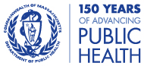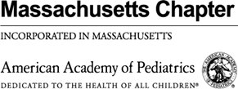

December 22, 2022

Dear Parents and Guardians:

On December 9, 2022, the Centers for Disease Control and Prevention (CDC) expanded the use of updated (bivalent) COVID-19 vaccines for children ages 6 months through 5 years. Now virtually all children across the Commonwealth are eligible to get the updated vaccine.

The Department of Public Health and the Massachusetts Chapter of the American Academy of Pediatrics remind you to have your child vaccinated, especially in advance of upcoming holidays. The COVID-19 vaccine has been shown to be safe and effective in protecting against serious illness, hospitalization, and death.

The Massachusetts Department of Public Health (DPH) is also alerting residents that flu activity is much higher than usual for this time of year – in the Commonwealth and nationally – and urging residents of all ages to also get vaccinated against influenza. DPH and AAP remind you that COVID and flu shots may be given in the same visit.

While families may feel most comfortable getting their youngest children vaccinated by their primary care provider, please note that some retail pharmacies are also able to vaccinate children ages 3 and older. More information is available at www.mass.gov/CovidVaccineyoungkids.

As a reminder: the COVID vaccine is safe, free for all, and no ID or insurance is needed to be vaccinated.

Getting your family vaccinated against COVID and flu is the best way to protect yourself and your loved ones. We appreciate your help to keep our communities safe and healthy.

Sincerely,

Margret R. Cooke, Commissioner, Massachusetts Department of Public Health

Mary Beth Miotto, President, American Academy of Pediatrics - Massachusetts Chapter

Jeffrey C. Riley, Commissioner, Department of Elementary and Secondary Education

Amy Kershaw, Acting Commissioner, Department of Early Education and Care

