For highlighted text, districts and schools should fill in the appropriate information or choose the correct option.
TEMPLATE OPT-IN LETTER FOR FAMILIES
Dear parent/caregiver:

At [Name of District], keeping your students safe and in school is our top priority. We are writing to let you know, in accordance with the Department of Elementary and Secondary Education (DESE) and the Department of Public Health (DPH), our district is updating our COVID-19 Testing Program, effective XX. We are opting into an at-home testing program that will increase testing of our participating students and staff, regardless of vaccination status. For more information about this update to the statewide testing program, please click here. The at-home testing option will begin [during the week of XX]. In addition to this new at-home antigen test option, we will continue with [routine COVID safety checks and/or symptomatic testing] during the week. As part of this shift in the program, we are discontinuing Test and Stay and contact tracing for in-school close contacts. This means that if your child is a potential contact in school, they may continue to come to school and do not have to quarantine. This new at-home testing opportunity is voluntary and only those who opt-in will receive tests. We strongly encourage you to fill out the form by XX to opt-in. If you have questions, please contact your school’s nurse.

COVID-19 Testing Programs in our Schools:
- At-Home Rapid Antigen Testing on [day of the week] (NEW opt-in form)
- Routine COVID Safety Checks every week (If you have not yet signed up, click here)
- Symptomatic Testing (If you have not yet signed up, click here)

Overview: At-Home Rapid Testing Program
- About the Test: iHealth is a 15-minute at-home FDA Emergency Use Authorized antigen test.
- Opt-In: To participate, you must opt in by completing the [online form]. By opting in, you will agree to review the training materials for test administration, report positive test results to your student’s school, and administer the tests according to [School District’s] guidelines.
- Weekly: Every two weeks you will receive an iHealth at-home rapid test kit. Each kit contains two individual tests. Your student will administer one test each week on [day of the week].
- Reporting Positive Test Results: If your student tests positive on an at-home antigen test, you will inform their school of the positive result using the [Positive Test Result Notification form]. The school will keep the results confidential and will not make individual results public. In addition, it is strongly recommended that you inform your healthcare professional of the positive result.
- Easy, Free, and Flexible: This test is administered at home (not at school), reducing the burden on school staff and time to administer tests and increasing a family’s flexibility to do testing in the home for free.

How do I administer the test?
- Click here for a full “how to” written guide in various languages
- Click here for a video of an individual self-testing
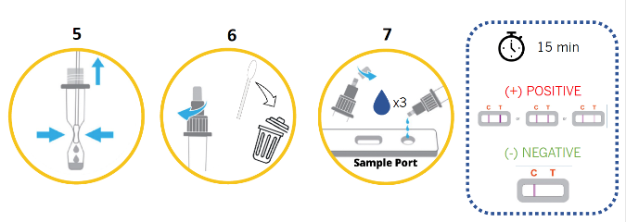

How do I submit results?
- Submit Results: You must submit positive test results to your student’s school. [Click here] to submit positive test your results.
- Confidentiality: Positive test results are shared with your school district for informational purposes only. Individual results will remain confidential, and they will never be made public.

