For highlighted text, districts and schools should fill in the appropriate information or choose the correct option.

TEMPLATE OPT-IN LETTER FOR STAFF

Dear STAFF MEMBER:

We are writing to let you know, in accordance with the Department of Elementary and Secondary Education (DESE) and the Department of Public Health (DPH), our district is updating our COVID-19 Testing Program, effective XX. We are opting into an at-home testing program that will increase testing of our participating students and staff, regardless of vaccination status. For more information about this update to the statewide testing program, please [click here](https://www.doe.mass.edu/covid19/on-desktop/2022-0118new-testing-program.pdf). The at-home testing option will begin [during the week of XX]. In addition to this new at-home antigen test option, we will continue with [routine COVID safety checks and/or symptomatic testing] during the week. As part of this shift in the program, we are discontinuing Test and Stay and contact tracing for in-school close contacts. This means that if you are a potential contact in school, you may continue to come to school and do not have to quarantine. This new at-home testing opportunity is voluntary and only those who opt-in will receive tests. We strongly encourage you to fill out the form by [XX] to opt-in. If you have questions, please contact your supervisor.

**COVID-19 Testing Programs in our Schools:**

1. **At-Home Rapid Antigen Testing** on [day of the week] *(NEW [opt-in form])*
2. **Routine COVID Safety Checks** every week *(If you have not yet signed up,* [*click here*](https://www.cic-health.com/consent/ma#consent)*)*
3. **Symptomatic Testing** *(If you have not yet signed up,* [*click here*](https://www.cic-health.com/consent/ma#consent)*)*

**Overview: At-Home Rapid Testing Program**

* **About the Test**: [iHealth](https://ihealthlabs.com/) is a 15-minute at-home FDA Emergency Use Authorized antigen test.
* **Opt-In:** To participate, you must opt in by completing the [online form]. By opting in, you will agree to review the training materials for test administration, report positive test results, and administer the tests according to [School District’s] guidelines.
* **Weekly**: Every two weeks you will receive an iHealth at-home rapid test kit. Each kit contains two individual tests. You will administer one test each week on [day of the week].
* **Reporting Positive Test Results:** If you test positive on an at-home antigen test, you will report the positive result using the [positive result notification link]. The district will keep the results confidential and will not make individual results public. In addition, it is strongly recommended that you inform your healthcare professional of the positive result.
* **Easy, Free, and Flexible**: This test is administered at home (not at school), reducing the burden on school staff and time to administer tests and increasing your flexibility to do testing in the home for free.

**How do I administer the test?**

* [Click here](https://www.mass.gov/lists/covid-19-self-test-at-home-instructions-graphic) for a **full “how to”** written guide in various languages
* [Click here](https://www.youtube.com/watch?v=XAzos3k6aCY&t=14s) for a **video** of an individual self-testing

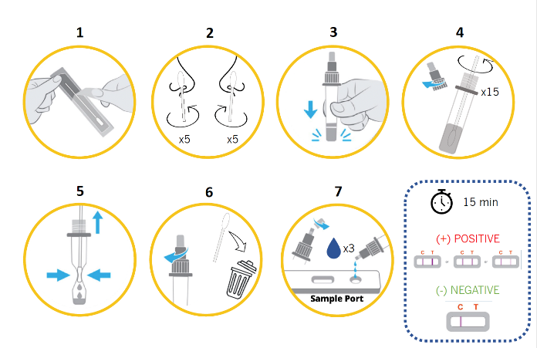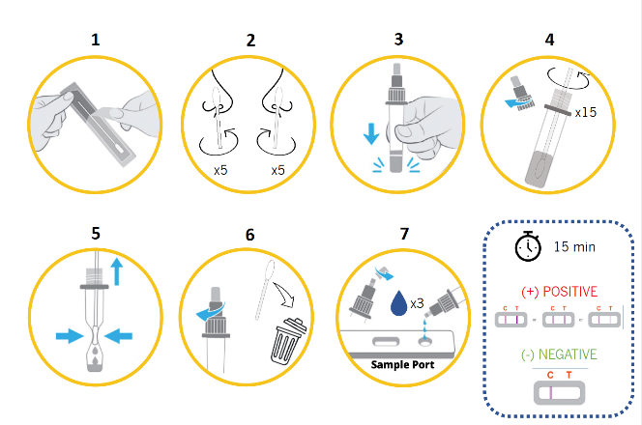

**How do I submit results?**

* **Submit Results**: You must submit positive test results. [Click here] to submit positive test your results.
* **Confidentiality**: Positive test results are shared with the district for informational purposes only. Individual results will remain confidential, and they will never be made public.