Instructional Leadership Team (ILT) Framework

This ILT Framework is organized around 5 interconnected focus areas, which were synthesized from pre-existing frameworks, tools, and research on instructional leadership.
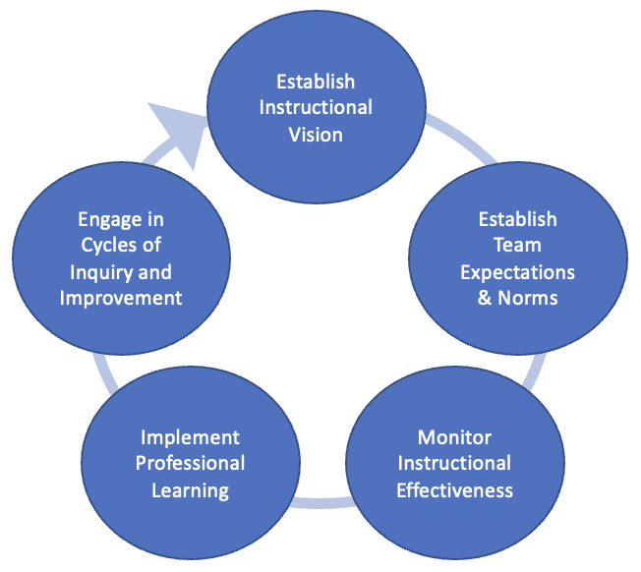
Each focus area includes a set of actions for district-level and school-level ILTs. District and school teams can use this resource to reflect and identify specific actions they could take to establish or improve ILTs. The actions included are not all-encompassing of everything effective district and school leadership teams do, but are rather identified as important and high-leverage actions of Instructional Leadership. Other systems and structures that contribute to and/or enable effective ILTs can be found in the Coherence Guidebook’s “Leveraging Systems and Structures” section. District and school ILT members can reflect on their ILT structures using the self-assessment template on pages 3-6.

Focus Area | Description | District ILT Actions | School ILT Actions
- Establish a shared instructional vision | - Defines a vision for high-quality school and classroom practices that reflect culturally responsive grade-appropriate instruction and a sense of belonging for all students. | - Develops and clearly communicates a unifying vision and definition for effective instruction.  - Collaboratively establishes district-wide priorities and goals for instructional practice and student experience and outcomes.  - Develops and monitors strategy to recruit, hire and retain staff in alignment with vision for effective instruction. | - Establishes/Reinforces shared set of expectations for effective and inclusive instructional practices.  - Establishes school-specific instructional goal(s) that is aligned to district vision and priorities.  - Ensures all teachers understand instructional expectations and priorities.
- Establish Team Expectations & Norms | - Establishes a formal team with clear purpose, roles, and responsibilities.  - Develops team systems that enable distributive leadership and accountability for outcomes. | - Establishes and shares purpose and expectations for district and school ILTs.  - Holds regular meetings that have a clear focus and result in specific actions related to district priorities that are monitored for implementation and effectiveness.  - Attends school ILT meetings to monitor for effective implementation and provides coaching when needed. | - Establishes/Reinforces a clear purpose, agreed-upon norms, and expectations for the ILT.  - Employs distributed leadership through a team that represents all relevant specialties, including MLs and SWDs.  - Establishes clear roles and responsibilities for team members, on which they execute consistently.  - Holds regular meetings that have a clear focus and results in specific actions related to instructional goal(s) that are monitored for implementation and effectiveness.
- Monitor Instructional Effectiveness | - Has a process in place to observe implementation of the instructional vision and progress towards aligned goals. | - Participates in joint learning walks or observations and aligns on strengths, areas for growth, and next steps.  - Coaches principals/school ILTs on effective instructional leadership practices. | - Utilizes a plan, schedule, and tool to regularly observe instruction with a particular focus on historically marginalized student populations, including MLs and SWDs.  - Reviews student tasks and work samples.  - Provides observation feedback and lesson planning support to teachers.  - Tracks data from observations and student work reviews and uses information to identify and align on strengths and areas for improvement.
- Design & Implement Professional Learning | - Crafts and facilitates high-quality professional learning aligned to instructional vision and priorities. | - Provides high-quality PD related to instructional vision and priorities.  - Allocates resources and allows flexibility for schools to create and deliver tailored PD plans aligned to school-specific priorities, goals, and needs. | - Uses instructional effectiveness data to determine PD needs throughout the year, with a particular focus on historically marginalized student populations, including MLs and SWDs.  - Provides high-quality PD that is aligned to school priorities.  - Creates structures for and leads dedicated cycles of inquiry among teacher teams (e.g., PLCs).  - Provides differentiated coaching based on individual needs.  - Monitors implementation and impact of professional learning to make adjustments where needed.
- Engage in Cycles of Inquiry and Improvement | - Uses a variety of data to inform decisions and adjust strategy in a way that results in improved practice and student experience and outcomes. | - Regularly collects and analyzes data to monitor the current state of instruction and achievement district-wide and to inform strategy adjustments.  - Creates data systems to efficiently collect, analyze, and share data aligned to school ILT needs.  - Allocates resources to directly support instructional vision, priorities, and goals. | - Sets short-term goals and identifies implementation and outcome measures in order to monitor progress, with a particular focus on historically marginalized student populations, including MLs and SWDs.  - Regularly collects and analyzes a range of data related to goals (instructional, student work, student experience, teacher perspective, outcomes, etc.) and identifies root causes to successes and challenges.  - Meetings result in substantial new actions to current strategy that address specific root causes.

ILT Framework Self-Assessment Template – DISTRICT ILT
Each member of the district ILT should complete an individual reflection on the extent to which each of these actions is:
- 0 – Not present
- 1 – Present, but implemented inconsistently and/or ineffectively
- 2 – Present and implemented mostly consistently and effectively
- 3 – Present and implemented consistently and effectively
Additionally, school leaders and/or school ILT members should be invited to provide a rating and notes for the district ILT to determine the extent to which the school experience is consistent with the district’s reflections and to identify opportunities to strengthen district ILT practices.

Focus Area | District ILT Actions | Rating and Notes
- Establish a shared instructional vision | Develops and clearly communicates a unifying vision and definition for effective instruction.
 | Collaboratively establishes district-wide priorities and goals for instructional practice and student experience and outcomes.
 | Develops and monitors strategy to recruit, hire and retain staff in alignment with vision for effective instruction.
- Establish Team Expectations & Norms | Establishes and shares purpose and expectations for district and school ILTs.
 | Holds regular meetings that have a clear focus and result in specific actions related to district priorities that are monitored for implementation and effectiveness.
 | Attends school ILT meetings to monitor for effective implementation and provides coaching when needed.
- Monitor Instructional Effectiveness | Participates in joint learning walks or observations and aligns on strengths, areas for growth, and next steps.
 | Coaches principals/school ILTs on effective instructional leadership practices.
- Design & Implement Professional Learning | Provides high-quality PD related to instructional vision and priorities.
 | Allocates resources and allows flexibility for schools to create and deliver tailored PD plans aligned to school-specific priorities, goals, and needs.
- Engage in Cycles of Inquiry and Improvement | Regularly collects and analyzes data to monitor the current state of instruction and achievement district-wide and to inform strategy adjustments.
 | Creates data systems to efficiently collect, analyze, and share data aligned to school ILT needs.
 | Allocates resources to directly support instructional vision, priorities, and goals.

ILT Framework Self-Assessment Template – SCHOOL ILT
Each member of the school ILT should complete an individual reflection on the extent to which each of these actions is:
- 0 – Not present
- 1 – Present, but implemented inconsistently and/or ineffectively
- 2 – Present and implemented mostly consistently and effectively
- 3 – Present and implemented consistently and effectively
Additionally, district ILT members should provide a rating and notes to provide additional perspective and to identify school-specific and district-wide opportunities to strengthen ILT practices.
Focus Area | School ILT Actions | Rating and Notes
- Establish a shared instructional vision | Establishes/Reinforces shared set of expectations for effective and inclusive instructional practices.
 | Establishes school-specific instructional goal(s) that is aligned to district vision and priorities.
 | Ensures all teachers understand instructional expectations and priorities.
- Establish Team Expectations & Norms | Establishes/Reinforces a clear purpose, agreed-upon norms, and expectations for the ILT.
 | Employs distributed leadership through a team that represents all relevant specialties, including MLs and SWDs.
 | Establishes clear roles and responsibilities for team members, on which they execute consistently.
 | Holds regular meetings that have a clear focus and results in specific actions related to instructional goal(s) that are monitored for implementation and effectiveness.
- Monitor Instructional Effectiveness | Utilizes a plan, schedule, and tool to regularly observe instruction with a particular focus on historically marginalized student populations, including MLs and SWDs.
 | Reviews student tasks and work samples.
 | Provides observation feedback and lesson planning support to teachers.
 | Tracks data from observations and student work reviews and uses information to identify and align on strengths and areas for improvement.
- Design & Implement Professional Learning | Uses instructional effectiveness data to determine PD needs throughout the year, with a particular focus on historically marginalized student populations, including MLs and SWDs.
 | Provides high-quality PD that is aligned to school priorities and goals.
 | Creates structures for and leads dedicated cycles of inquiry among teacher teams (e.g., PLCs).
 | Provides differentiated coaching based on individual teacher needs.
 | Monitors implementation and impact of professional learning to make adjustments where needed.
- Engage in Cycles of Inquiry and Improvement | Sets short-term goals and identifies implementation and outcome measures in order to monitor progress, with a particular focus on historically marginalized student populations, including MLs and SWDs.
 | Regularly collects and analyzes a range of data related to goals (instructional, student work, student experience, teacher perspective, outcomes, etc.) and identifies root causes to successes and challenges.
 | Meetings result in substantial new actions to current strategy that address specific root causes.

