The Massachusetts Equity Plan for 2015 - 2019 details ESE’s plan to close gaps in access to excellent teachers and school leaders. Data analysis shows low income and minority students have less exposure to experienced, prepared, and effective educators.
Overview of the MA Equity Plan

- Response to July 2014 USED requirement of state plans to ensure equal access to excellent educators for low income and minority students
- About increasing student experiences with excellent educators; not about redistributing teachers
- Defines “excellent educator” as a combination of characteristics, which often include student impact, experience, and highly qualified status; definition not based on a “one size fits all” metric or formula
- Promotes equitable access through diverse approaches; does not require specific additional actions from districts/schools
- ESE will continue to provide updates to and solicit feedback from stakeholders

Stakeholders Involved in Development of the Plan

- District and school leaders
- Teachers
- Other school personnel
- Parents
- Representatives of English Language Learners and Students with Disabilities
- Educator Preparation Programs

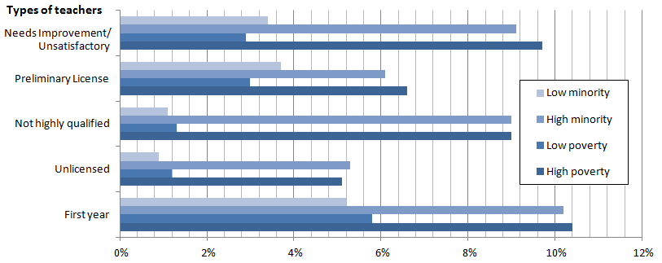
Gaps Between Schools in Highest and Lowest Quartiles
of Minority and Low-Income Students

Source: Educator Personnel Information System (EPIMS) 2013-2014 Data Collection

Data analysis also showed gaps in principal access. Please see the full Equity Plan for more information.

Four Key Strategies Highlighted
- Educator Preparation – changes and additions to approval of EPPs and monitoring of outcomes
- Educator Evaluation System – state supports districts and schools in effective implementation
- Student Learning Experience Report – provides district- and school-level data on proportion of students’ experiences with different categories of teachers; sorts by subgroups including race, English Language Learners and Students with Disabilities
- Educator Evaluation Guidebook for Inclusive Practices – tools to improve teaching of diverse learners and increase inclusion of Students with Disabilities in general education classrooms
These and other strategies for closing equity gaps align with and support work schools and districts are already doing to meet ongoing goals such as improving educator quality, closing achievement gaps, enhancing hiring practices, and meeting the needs of diverse learners.

Root Cause Analysis
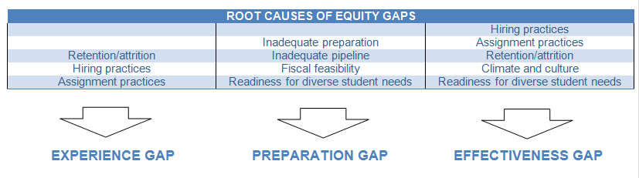
Stakeholder feedback, data analysis, and national research provided insight into causes of equity gaps. The relationships among root causes and equitable access gaps are often cyclical, and several root causes affect multiple equity gaps. The following list is not exhaustive, but represents several major root causes addressed in the Equity Plan.
Next Steps for Districts
To pursue more equitable access and close gaps, districts can:
- Read the Equity Plan; share with local school leaders and other stakeholders
- Use Edwin Analytics and District Profiles to get a picture of equitable access in your district (see the Equitable Access website for links to data)
- Conduct root cause analysis of equity gaps (see Stakeholder Engagement and Analysis of Equity Gap Data sections of the plan)
- Monitor whether and how school leaders respond to equity data
- Identify resources and strategies from the plan that address equitable access gaps and that align with current district objectives, such as recruiting qualified new educators or decreasing turnover
- Consult District and School Assistance Centers/Office of District and School Turnaround for support
- Use local educator evaluation data to inform decisions
- Districts that are interested in adopting two or more of the plan’s key strategies, and in doing so with the support of the Equitable Access Professional Learning Network, can contact the Office of Educator Effectiveness (see bottom of page)

Although these steps are not required, districts can benefit:
- Strategies are aligned with and support work districts are already doing to pursue ongoing goals
- The plan aims to close achievement gaps
- Districts can more precisely target their limited time, effort and resources
- Access to excellent educators affects virtually all the other school-level issues. We know that the quality of educators is the most important in-school factor, and it mitigates the success of other initiatives. Attempts to improve student learning are compromised without quality educators to implement them.

If the Plan Doesn’t Require Additional Actions from Districts, What is its Purpose?
- Inform leaders of statewide equitable access gaps and major root causes
- Unify disparate, agency-wide efforts that address equity gaps
- Identify and describe key statewide strategies that address equity gaps
- Identify and describe optional strategies and resources districts can use to address equity gaps
- Through PLN, ongoing progress monitoring, and Annual Reports, identify and share district best practices
- Set up plan for consistently communicating with diverse stakeholders statewide about equity and strategies
- Set up plan for monitoring state- and local-level progress toward closing equity gaps spotlight and share successful practices and identify districts that can use additional support

Next Steps for ESE
- Inform a range of stakeholders of the plan
- Communicate strategies and resources to DSACs and ODST, so they are prepared to support districts in closing equity gaps
- Pilot use of key strategies, and share outcomes with district leaders
- Create website and Annual Report to share outcomes of strategies and changes to the plan

