The Department of Elementary and Secondary Education found that the schools with large populations of low income and minority students employed fewer teachers/principals who are experienced, effective, and teaching in the subjects where they are qualified.

- Compared to a student in a low poverty school, the average student in a high poverty school is more than 3 times as likely to have teacher with an “ineffective” evaluation

- On average, students in high poverty and high minority schools have about twice as many first year teachers as do students in low poverty and low minority schools.

- High minority schools have more than 8 times as many teachers who teach classes outside of their subject, compared to low minority schools
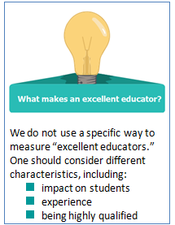

ESE compared the 25% of schools with the largest proportion of students who are eligible for free and reduced price lunch (high poverty schools) to the 25% with the smallest proportion of low income students (low poverty schools). The same applies to high and low minority schools.

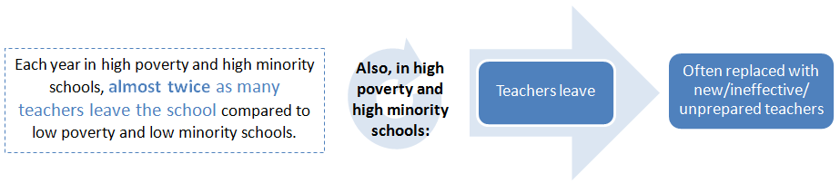

The Equitable Access Plan aims to make sure every student, regardless of background, has access to excellent teachers and principals.
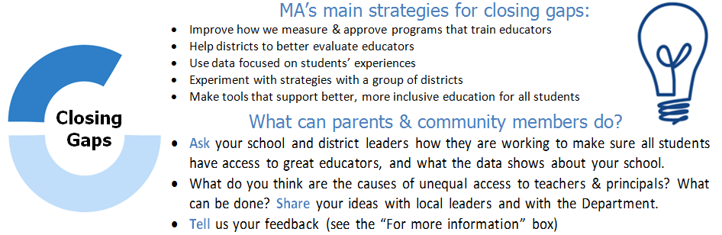

Who was involved in making the plan?
- District and school leaders
- Teachers
- Parent and community groups
- Representatives of English Language Learners and Students with Disabilities
- Educator Preparation Programs
The Department will continue to communicate with and get advice from these groups.

