Stakeholder Involvement
ESE involved stakeholders, including teachers, principals, and parents, in identifying root causes and strategies.

All root causes highlighted in the plan were identified by stakeholders, especially educators.

Examples of how stakeholder feedback affected the Equity Plan:
- Educators’ capacity to serve needs of diverse learners, particularly students with behavioral issues
- Educator turnover
- Lack of school-wide, tiered academic and social-emotional support systems
Overview of MA Equity Plan

- Response to July 2014 USED requirement of state plans to ensure equal access to excellent educators for low income and minority students
- About increasing student experiences with excellent educators; not about redistributing teachers
- Defines “excellent educator” as a combination of characteristics, which often include student impact, experience, and highly qualified status; definition not based on a “one size fits all” metric or formula
- Promotes equitable access through diverse approaches; does not require specific additional actions from districts/schools
- ESE will continue to provide updates to and solicit feedback from stakeholders
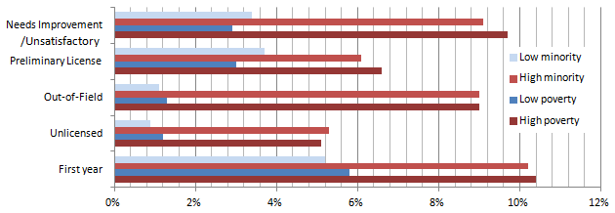
Type of teacher
Gaps in Student Access to Teachers, Between Schools in
Highest and Lowest Quartiles of Minority and Low Income Students
ESE compared the 25% of schools with the largest proportion of low income students (high poverty) to the 25% with the smallest proportion of low income students (low poverty). The same applies to high and low minority schools.
Data Source: Educator Personnel Information System (EPIMS) 2013-2014 Data Collection

Analysis showed similar equity gaps for principals. See the full Equity Plan for more information.

Note on educator experience gap: Analysis of this data is not meant to imply that less-experienced educators are necessarily lower-quality educators. This data is included to draw attention to the statewide, substantial inequity in low income and minority students’ access to experienced educators.
Types of teachers

When high minority schools employ nearly twice as many first year teachers as do low minority schools, then regardless of the success of some first year teachers we are facing an equity gap that must be closed.

What the Equity Plan Means for Teachers
The Equity Plan provides strategies and resources to help districts and schools meet goals they are already pursuing, such as closing achievement gaps, improving educator quality, recruiting qualified and effective new educators, and reducing educator turnover. Meeting these goals will also increase poor and minority students’ access to effective educators.

Teachers committed to equitable access can do any of the following:
- In discussions of school goals and plans: ask leaders about the school’s equitable access data and how the school will respond; share your perspective on root causes of school equity gaps
- Identify how you or your team can benefit from Equity Plan strategies such as the Massachusetts Tiered System of Supports and the Educator Evaluation Guidebook for Inclusive Practices
- Teachers involved in their school’s hiring process: review the Root Causes and Strategy 1 sections of the Equity Plan, and forthcoming resources on recruiting and retaining diverse educators
- Teachers in Level 5 schools: review the sample strategies described on p. 36-37 of the Equity Plan, which have been found to increase teacher job satisfaction and equitable access
- Provide feedback on strategies and root causes by emailing educatordevelopment@doe.mass.edu

Four Key Strategies Highlighted in the MA Equity Plan
- Educator Preparation – changes to state approval of Ed Prep Programs and monitoring of outcomes
- Educator Evaluation System – state supports for districts and schools in effective implementation
- Student Learning Experience Report – provides actionable data for school & district leaders on proportion of students’ experiences with teachers who are inexperienced, rated Unsatisfactory/Needs Improvement, and not Highly Qualified, among other categories; users can compare the last few years of students’ teacher experiences among individual students, grades, schools, and subgroups of students, such as English Language Learners and Economically Disadvantaged students
- Educator Evaluation Guidebook for Inclusive Practices – tools for educators and evaluators to better teach diverse learners and boost inclusion of students with disabilities in general education classrooms

Next Steps for ESE
- Meet regularly with diverse stakeholders groups to provide updates and solicit feedback
- Communicate strategies and resources included in the plan to ESE offices that directly support schools and districts, so they are prepared to help schools to close equity gaps
- Pilot use of key strategies, and share outcomes with school and district leaders
- Create webpage and Annual Report to share outcomes of strategies and changes to the plan

