Recruitment & Retention: Educators in hard-to-staff roles
Certain teaching roles, such as special education, English as a Second Language (ESL), and Science, Technology, Engineering and Math (STEM) can be harder to recruit and retain. Teacher turnover costs schools time, labor and money, and can cause particular obstacles when schools lose teachers in hard-to-staff positions. In Massachusetts, new teachers in these subjects are in high demand, compared to other certification areas.

More than half of districts in a national survey faced challenges recruiting and retaining special education and STEM teachers.

More than 90% of districts serving primarily students of color reported such challenges.⁵
Difficulties in recruiting and retaining hard-to-staff roles can disadvantage historically underserved students. Massachusetts English learners and students with disabilities face performance gaps compared to their peers, and predicted state shortages of special education and ESL teachers threaten to compound those gaps. One-year retention rates for STEM teachers are lower in Level 4 schools than Level 1-3 schools, and students in Level 4 schools are particularly in need of experienced, stable teachers.
Statewide, diverse districts are responding to the challenge of recruiting and retaining educators in hard-to-staff roles. In the 2016-17 Induction and Mentoring Report, they reported on such approaches.
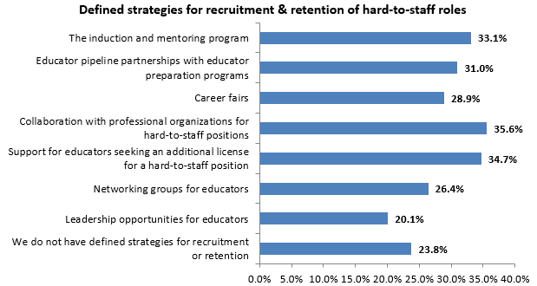
About three-quarters of responding districts identified one or more recruitment and retention strategies, and some elaborated with the following:
Partnerships with educator preparation programs

Formal partnerships with educator preparation programs can include student teacher placements and fellowship/residency programs. Such relationships allow districts to communicate their staffing needs to preparation programs, and to have early access to teaching candidates in hard-to-staff positions. For example, through a fellowship program with Merrimack College, Andover was often able to hire new ESL and special education teachers. Asst. Supt. Nancy Duclos advises that districts arrange teacher candidate placements early, clearly communicate expectations to preparation programs, help candidates prepare for the district’s specific hiring process, and provide strong mentors.

For further examples of Massachusetts district-preparation program partnerships, see:
- Endicott Teaching Fellows
- UTeach at UMass Lowell for STEM teachers
- Urban Teacher Pathways Program at Mount Holyoke College

Collaborating with other organizations
Educational collaboratives can be resources for finding and supporting special educators. Several districts mentioned the value of working with collaboratives to recruit and support special educators. For example, Lower Pioneer Valley Educational Collaborative provides opportunities for nearby districts to network and problem solve together. Districts can also contact professional organizations representing educators in hard-to-staff fields, such as the Massachusetts Association of Teachers of Speakers of Other Languages or the Massachusetts Association of Science Teachers, in order to share job openings.

Opportunities for professional growth in their field can help to attract and retain teachers in hard-to-staff positions. For example, one district pairs hard-to-staff positions with job-alike mentors, and differentiates required trainings to meet the needs of educators with diverse roles. Another reported using targeted professional development for educators in shortage-area positions as a retention strategy.
Training & leadership

Collaboration among educators doesn’t end after induction and mentoring. Teacher leadership opportunities help leverage teachers’ expertise and increase job satisfaction.
Grow your own
The approach of “growing your own” teachers–by supporting paraprofessionals who seek teacher licensure–is often used to diversify the teacher workforce. This can also be useful for recruiting for hard-to-staff positions and leveraging paraprofessionals’ special education experience. For example, through tuition reimbursement and supervised internships, Walpole has supported several paraprofessionals in becoming special education and ESL teachers. Holyoke’s partnership with Mount Holyoke College allows paraprofessionals and current teachers to obtain a license in Moderate Disabilities or ESL, with significantly reduced tuition.

Gary, B., Crowe, D. & Schaefer, B. (2007). The Cost of Teacher Turnover in Five School Districts: A Pilot Study. National Commission on Teaching & America’s Future.; Ingersoll, R. (2014). On the Path to Equity: Improving the Effectiveness of Beginning Teachers. Alliance for Excellent Education.
From Educator License and Recruitment (ELAR) data
Levin, J., et. al. (2015). Massachusetts Study of Teacher Supply and Demand: Trends and Projections. American Institutes for Research. http://www.air.org/sites/default/files/downloads/report/Massachusetts-Study-of-Teacher-Supply-and-Demand-December-2015_rev.pdf
Massachusetts Department of Elementary and Secondary Education (MA ESE). (2013). Status of the Massachusetts Educator Workforce: Focus on First-Year Teachers. http://www.doe.mass.edu/research/reports/2013-12EducatorReport.docx ⁵Goldhaber, D., et al. (2015) Refueling STEM and special education teacher pipelines: colleges and policy makers have access to solutions that could reduce the shortage of STEM and special education teachers. Phi Delta Kappan. 97 (4): 56-62.

