As part of the 2016 MA Induction and Mentoring Report, school districts listed two components of their mentoring and induction programs that are going well (based on feedback from mentors, mentees, administrators and other stakeholders). Districts also listed two areas that they aimed to improve. The most popular responses on both lists included providing adequate opportunities for mentors and mentees to meet – particularly finding time in everyone’s busy schedules. Thus, ESE asked those districts who experienced success with this topic to share their advice for other districts.
Making Time for Mentoring
How Massachusetts school districts ensure opportunities for
mentor-mentee interactions
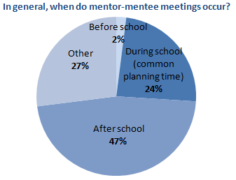
The Guidelines for Mentoring and Induction Programs recommend “regular” mentor-mentee meetings, but the frequency of these meetings is at the district’s discretion. In their responses on the statewide induction and mentoring report, more than half of districts responded that their mentors and mentees meet weekly. These meetings aren’t necessarily one-on-one, but can include small groups or meetings of all mentors and mentees. Some meetings are regularly scheduled (i.e. same time and day each week), while in many districts mentors and mentees have difficulty finding convenient times to meet.
From responses to the 2016 statewide Induction and Mentoring Report

Districts vary widely in how prescriptive they are with mentor-mentee schedules. One district described this as “a balance between providing structure and giving freedom.” Sometimes a mentor coordinator or building administrator arranges times for longer mentor-mentee interactions such as observations. In other cases, the district requires a certain number of observations and frequency of meetings, and mentors and mentees arrange the times themselves.

Some creative ways that districts have found time for mentors and mentees to meet include:
- Designate mentor-mentee collaboration time in early release schedules, faculty meetings, orientation, and PD days
- Build one-on-one meeting time into mentor-mentee trainings throughout the year
- Schedule times throughout the year for all mentors and mentees to come together; they can meet in pairs and/or discuss shared topics of interest with other teams
- During the initial meeting of all mentors and mentees, provide a blank meeting schedule and time for pairs to fill it out
- Bear in mind that some mentoring interactions come in brief conversations rather than 60-minute meetings
  - “These are valuable opportunities to conduct mentoring conversations no matter how hectic the teachers’ days become… they can make good mentoring happen in all kinds of different settings.”

Mentor coordinators can regularly check mentors’ meeting logs. If mentor pairs aren’t meeting enough, the mentor coordinator can contact them to learn why and try to address any obstacles.

Ensuring that mentors and mentees have opportunities for classroom observations can be especially tricky, because they occur during the school day. One mentor coordinator recommended the books Mentoring in Action and The First Years Matter as resources on structuring meeting times, and on mentoring generally.

A few districts described how they had developed a culture that values mentoring, and therefore administrators are ready and willing to provide substitutes when mentors and mentees leave the classroom for observations. One district recommended automatically allocating a certain number of days/hours of substitute coverage for each mentoring pair, and another explained that “we have found that the cost of a substitute is so minor compared to the learning experience and success in [retention] via bonding our mentees in their first two years.”

