Enhancing Professional Development in Lexington Public Schools
Continuous Learning for Every Educator, Every Day
Lauren E. Clymer, American Institutes for Research
Jane G. Coggshall, Ph.D., American Institutes for Research

May 2015

Executive Summary
The Lexington Public School (LPS) District serves more than 6,750 students and is located approximately 15 miles outside of Boston. A professional staff of nearly 780 teach in this Level 2 district, which includes six elementary schools, two middle schools, and one high school. Seven percent of the students in the district are from low-income families, 6 percent are identified as English language learners (ELLs), and roughly 30 percent are from non-English-speaking families.
LPS district officials have been working to design and implement a high quality system of professional learning in the district for the better part of a decade. Through “perseverance, patience, and redundancy,” in the words of Carol Pilarski – the assistant superintendent for curriculum, instruction, and professional development – LPS educators have increasing access to high quality professional development aligned with their professional practice goals, as well as school and district goals for student learning. District professional development (PD) leaders have come close to achieving Superintendent Paul Ash’s vision of “teachers learning every day, every place, continuously.”

A Shared Vision: Ensuring High Achievement for All Students
The current professional development system in Lexington took shape over a decade ago, when Superintendent Ash identified significant and consistent gaps in student achievement. For example, in 2006, 50 percent of LPS’s African-American students were in special education. Digging into this statistic, the superintendent found that these students were not placed in special education because they had learning disabilities, but because they had trouble reading. He concluded that LPS educators were not meeting the needs of all students, and individual teachers were running out of new ideas. Superintendent Ash believed that if teachers and administrators could work together to transform the school system into “a learning organization,” all students would be better served. In order to do this, he and his leadership team decided that they would “have to raise the knowledge and skills and mindsets of the people who are in the district,” and that to do this, they would need to build a better professional learning system.

A Framework for A Better Professional Learning System
Given that LPS’s guiding mission is high achievement for all students, the district wanted to ensure that this professional development would have an impact on student outcomes. Professional learning became the foundation for the four pillars on which LPS’s mission rests: 1) curriculum, 2) instruction, 3) assessment, and 4) interventions and extensions (Figure 1).
Figure 1: Visual Used to Describe the Role of Professional Learning in LPS’s Mission
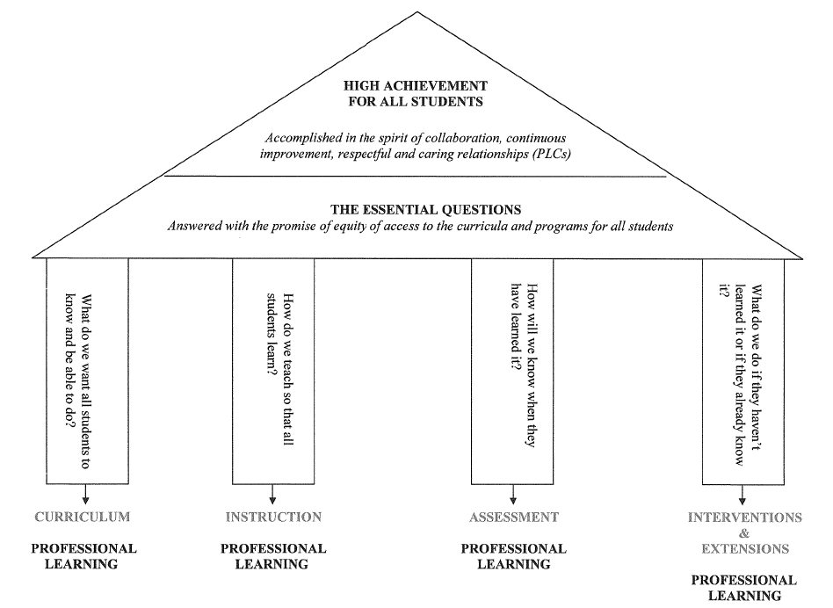
With this mission in mind, LPS staff developed a through-line from the district goals to curriculum, instruction, assessment, interventions, and extensions. This through-line continues to professional learning and site-based goals, and extends to classrooms, teachers, students, and the community.
Sandra Trach, an elementary school principal on LPS’s professional development committee, explained that the clear line from the district vision through the four pillars guides all school improvement plans. This line helps to provide “common ground” for all staff, allowing them to see the connections between the district’s mission and curriculum, instruction, assessments, interventions, extensions, and professional learning. Professional learning is no longer seen as a separate entity or add-on, but rather as an integral aspect of Lexington schools’ work to close achievement gaps and ensure high achievement for all students.
Leveraging Expertise From Within
The superintendent wanted to create a program that did not necessarily bring in outside expertise, but instead aimed to create expertise from within. As he explained: “What’s different here than you’ll find probably most any place else is that the professional learning program is designed to raise the skills and the capacity of people who achieve the district schools’ goals.” He sought to establish a system that would allow educators’ knowledge to “defuse to their [professional learning communities], to their departments, to their schools, to the entire school system.” Today, professional development at LPS consists of the following key components:
(1) common planning and learning time, including professional learning communities (PLCs);
(2) teacher-created courses and workshops focused on specific topics, many of which have a follow-up component;
(3) coaching;
(4) lesson studies, which include a video and coaching component;
(5) comprehensive new teacher induction; and
(6) external consultants, who conduct in-class modeling and teaching and provide coaching for more specialized professional development, such as adaptive physical education.
A professional development committee helps district leaders rely heavily on multiple forms of data to plan and assess these activities.
LPS’s efforts to strengthen curriculum, instruction, assessment, and interventions through a coherent professional learning system correlate with narrowing achievement gaps between students of color and students from low-income families and the overall population of students, which have now almost completely closed. District leaders consider the professional development system to be an essential component of this change.
To learn more about the implementation process and professional development management structures in Lexington Public Schools, view full report.

