PHASE I: SET PD GOALS
The PD planning process should be anchored by a set of goals. What new skills or knowledge will educators learn? How will this learning help educators improve their practice? To ensure that PD is meeting the needs of educators and students, PD teams should start the goal-setting process by conducting a needs assessment and use the results of the needs assessment to develop goals.

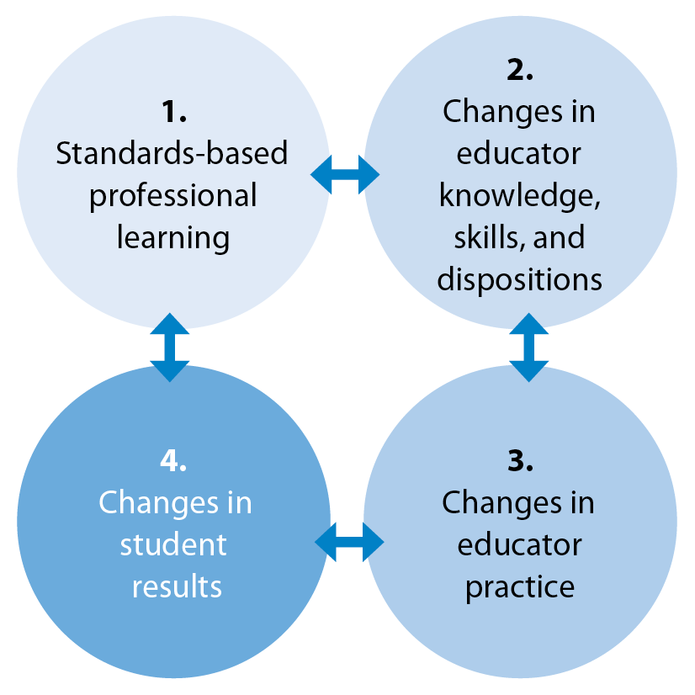
Step 1: Identify PD needs
HQPD: Desired Outcomes
- What areas of strength and need can be identified by reviewing data (e.g., educator evaluation data, student assessment data, outcome data from previous PD offerings)?

Step 2: Prioritize PD needs
- Which identified needs are best aligned to educator, school, and district goals?

Step 3: Examine potential root causes for PD needs
- What are potential causes for the identified PD needs (e.g., curriculum deficiencies, changes in student demographics, shifts in school culture)?

Step 4: Identify PD solutions to address root causes
- Which potential PD solutions do educators believe will best meet identified needs? Is there data (e.g., academic research, testimonials from colleagues in neighboring districts, educator survey data) to support one set of PD solutions over another?

Step 5: Write PD goals
- What are specific intended student outcomes for the PD that should be reflected in PD goals?
- What changes in educator knowledge, skills, and/or practice should be reflected in PD goals?
- The Massachusetts Standards for Professional Development include the following recommendations:
  - PD goals specify intended student outcomes
  - PD learning objectives specify changes in knowledge, skills, and/or practices necessary to achieve the intended student outcomes
  - Learning objectives are written in SMART format

The following school-level example is a modification of a PD goal from Easthampton High School, Easthampton, MA.
SCHOOL GOAL | PD GOAL
Student performance on complex learning tasks in grades 9-12, in all content areas, will increase by 10% over the next year. (The school will measure this goal through pre-, mid-, and post-testing on the district’s interim assessment.) | Over the next year, 90% or more of teachers will implement complex learning tasks in classroom instruction.  In addition, over the next year, the school will:  - Define complex learning tasks and increase staff exposure to complex tasks.  - Foster an understanding of what complex learning looks like and how to achieve it.  - Establish protocols for how staff will model and promote complex learning in classrooms.  - Use student data to identify challenges in teaching and student learning.  - Identify possible solutions to complex learning challenges.  Successful fulfillment of the goal will be measured by looking at learning walkthrough data. In addition, the school will examine student performance on complex tasks at mid-year and end-of-the-year (post) assessments. Teachers will also use the complex learning rubric throughout the year to determine student progress.

